**Mila University Center**  **2024/2025  
Department of Letters and Foreign Languages**

**Module: Reading (L 1/S2)**

**Dr. Rania Khelifa Chelihi**

**Compare and Contrast**

1. **What is a compare and contrast essay?**

Compare and contrast is a rhetorical style that discusses the similarities and differences of two or more things: ideas, concepts, items, places, etc. This rhetorical style is one that you’ll see often as a complete essay, but you may also use it quite a lot within paragraphs of any kind of essay in which you need to make some kind of comparison to help illustrate a point.

A compare and contrast essay does two things: It discusses the similarities and differences of at least two different things. First, you must find a basis of comparison to be sure that the two things have enough in common.

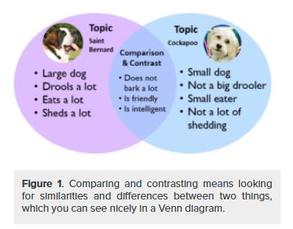

1. **Discovering similarities and differences**

Making a Venn diagram or a chart can help you quickly and efficiently compare and contrast two or more things or ideas. To make a Venn diagram, simply draw some overlapping circles, one circle for each item you’re considering. In the central area where they overlap, list the traits the two items have in common.9-+Assign each one of the areas that doesn’t overlap; in those areas, you can list the traits that make the things different. Here’s a very simple example, using two pizza places:

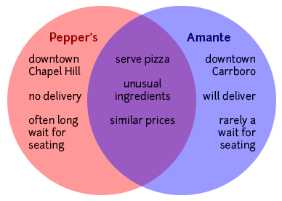

1. **Why is comparing and contrasting texts an important skill?**

Here are a few reasons why comparing and contrasting texts is an important skill for upper elementary readers:

* It requires an attention to detail, which is important for comprehension.
* It helps students organize information.
* It is a foundational skill to many higher-level critical thinking skills, such as synthesizing.

Comparing and contrasting is huge for comprehending and synthesizing texts. Students need to be able to focus on essential details, analyze what they are reading, and make connections and comparisons between multiple texts.

1. **Key Words for Compare and Contrast**
2. The following words signal that two pieces are being compared:

|  |  |  |  |  |  |
| --- | --- | --- | --- | --- | --- |
| also | both | In the same way | In addition | Most important | Similarly |
| As well as | comparatively | Just as | like | The same as | too |

1. **The following words signal that two pieces are being contrasted:**

|  |  |  |  |  |  |  |
| --- | --- | --- | --- | --- | --- | --- |
| although | besides | Conversely | Even tough | however | Similarly | |
| but | Compared with | differ | furthermore | In contrast to | instead | |
| Less tan | More than | nevertheless | notwithstanding | On the other hand | otherwise | |
| Rather than | regardless | Though | unless | unlike | while | yet |

**References**

[**http://www.corwin.com/**](http://www.corwin.com/)

[**https://www.phrasebank.manchester.ac.uk/compare-and-contrast/**](https://www.phrasebank.manchester.ac.uk/compare-and-contrast/)

[**https://letstalkscience.ca/educational-resources/teaching-stem/comparing-contrasting**](https://letstalkscience.ca/educational-resources/teaching-stem/comparing-contrasting)