***DW4***

**Exercise 1**

A beam with simple supports at A and B supports a force F at its center.

1. Calculate the cohesion wrench in the cross-section G1near A and deduce the type of solicitation in this area.
2. Assuming a uniform distribution of the shear stress in the section G1​, calculate its value.

Neglect the weight of the beam. Given: F=50 kN.

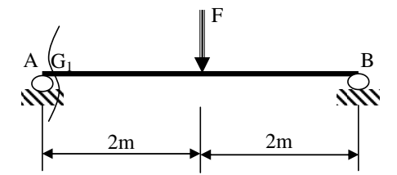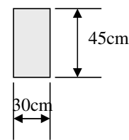

**Exercise 2**

A punching machine is used to manufacture washers by shearing mild steel sheets.

Calculate the force F required for the cutting operation.

Given:

* Diameter of the washers: d=20 mm
* Thickness of the sheet: e=2 mm
* Shear strength of the steel: τm=70 MPa

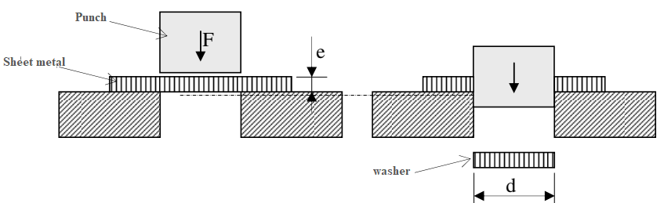

**Exercise 3**

A shaft A transmits a torque C=2 kN.m to a second shaft B via bolted plates. The shafts are connected to the plates by keys.

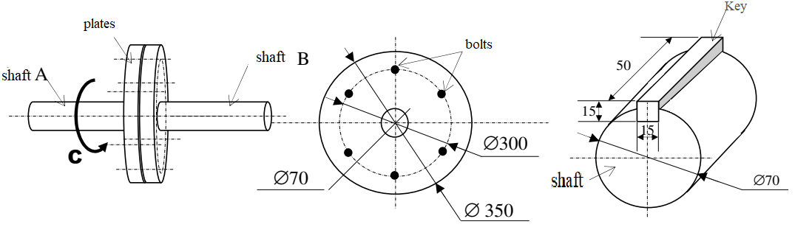

1. The bolts are considered as simple sheared pins. Calculate the diameter of a bolt if its shear yield strength is τe=100 MPa.
2. Calculate the shear stress in the key.