**Phylum Platyhelminthes**

**(Platy=flat , helminth=worm)**

**Characteristics of Platyhelminthes**

Platyhelminthes have the following important characteristics:

1. They are **triploblastic, acoelomate, and bilaterally symmetrical.**
2. They may be free-living or parasites.
3. The body has a soft covering with or without cilia.
4. Their body is dorsoventrally flattened without any segments and appears like a leaf.
5. They are devoid of the anus and circulatory system but have a mouth.
6. They respire by simple diffusion through the body surface.
7. They have an organ level of organization.
8. They do not have a digestive tract.
9. The space between the body wall and organs is filled with connective tissue parenchyma which helps in transporting the food material.
10. They are hermaphrodites, i.e., both male and female organs are present in the same body.
11. They reproduce sexually by fusion of gametes and asexually by regeneration by fission and regeneration. [Fertilization](https://byjus.com/biology/internal-external-fertilization/) is internal.
12. The life cycle is complicated with one or more larval stages.
13. They possess the quality of regeneration.
14. The flame cells help in excretion and osmoregulation.
15. The nervous system comprises the brain and two longitudinal nerve cords arranged in a ladder-like fashion.

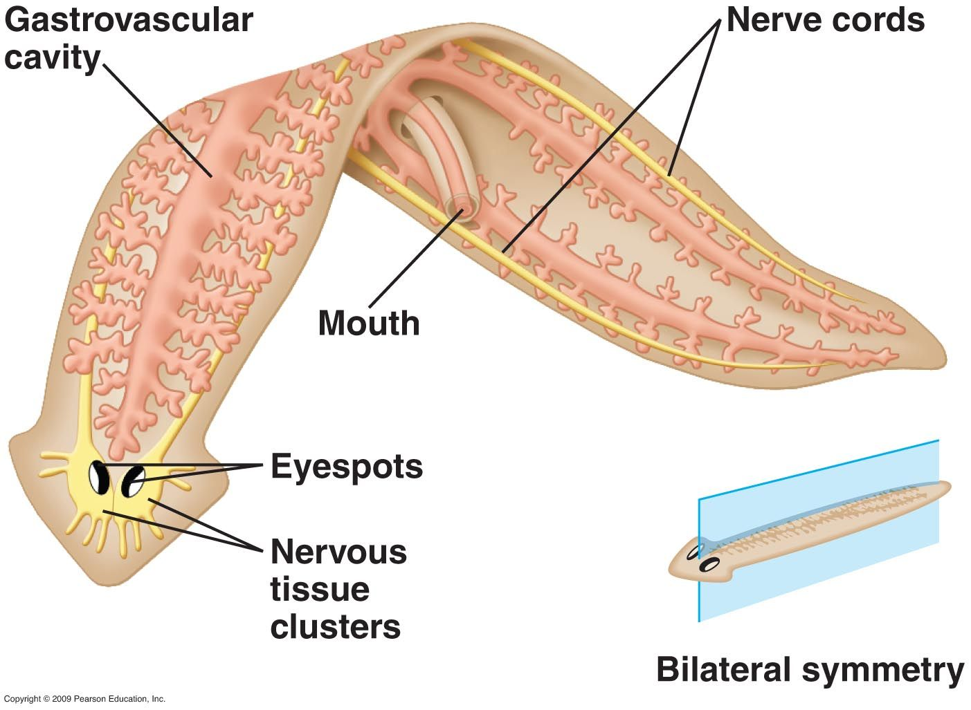

**Unique Characteristics of Platyhelminthes**

Some of the characteristics that distinguish the organisms belonging to phylum Platyhelminthes from others are:

* Presence of flame cells.
* Ladder-like nervous system.
* Presence of parenchyma in the body cavity.
* Self-fertilization

**Classification of Platyhelminthes**

The classification of Platyhelminthes are given below:

* Turbellaria
* Trematoda
* Cestoda

1. **Turbellaria**

* These are free-living organisms found mostly in fresh water.
* The body is dorsoventrally flattened.
* Hooks and suckers are not present.
* For eg., *Planaria, Otoplana*

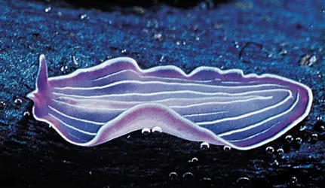

**2.Trematoda**

* These are mostly parasitic.
* Hooks and suckers are usually present.
* Eg., *Fasciola hepatica, Diplozoon*

The trematodes **Fasciola hepatica** (also known as the common liver fluke or the sheep liver fluke) and Fasciola gigantica are large liver flukes (F. hepatica: up to 30 mm by 15 mm; F. gigantica: up to 75 mm by 15 mm), which are primarily found in domestic and wild ruminants (their main definitive hosts) but also are causal agents of fascioliasis in humans.

Although F. hepatica and F. gigantica are distinct species, “intermediate forms” that are thought to represent hybrids of the two species have been found in parts of Asia and Africa where both species are endemic. These forms usually have intermediate morphologic characteristics (e.g. overall size, proportions), possess genetic elements from both species, exhibit unusual ploidy levels (often triploid), and do not produce sperm. Further research into the nature and origin of these forms is ongoing.

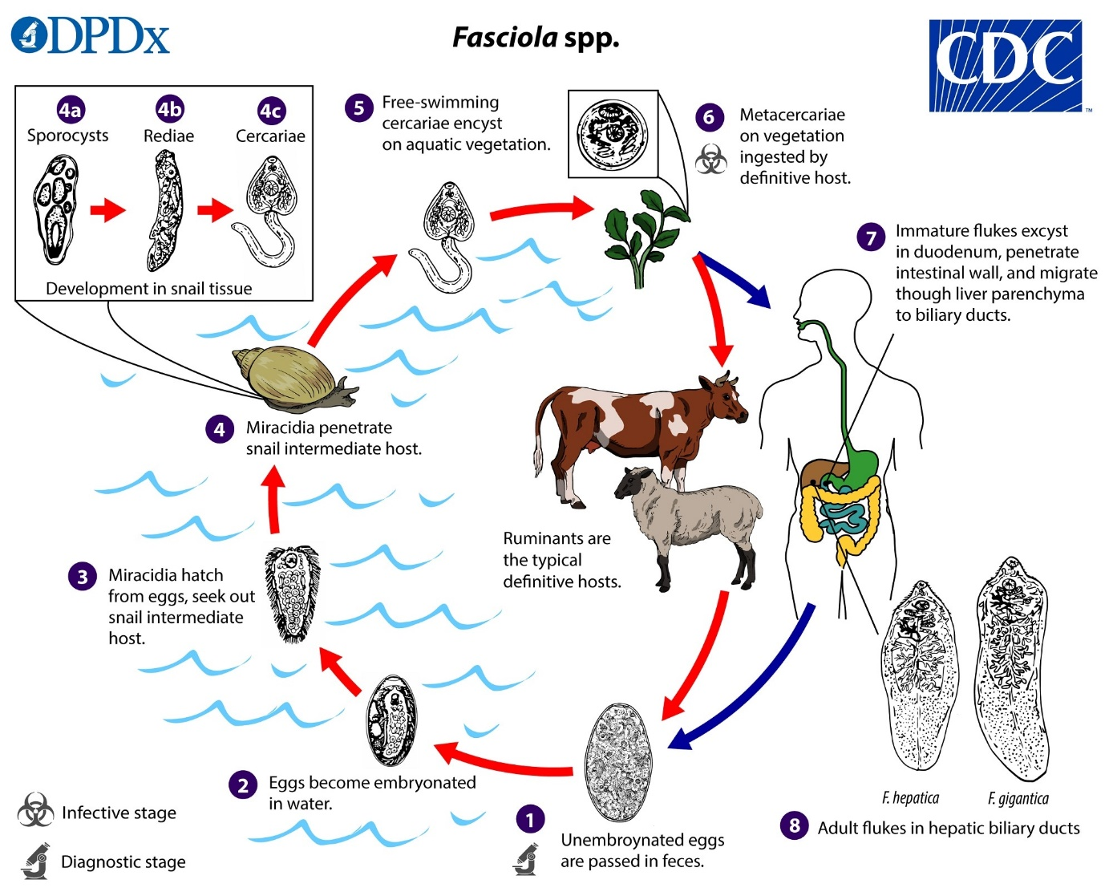

Immature eggs are discharged in the biliary ducts and passed in the stool image . Eggs become embryonated in freshwater over ~2 weeks image ; embryonated eggs release miracidia image , which invade a suitable snail intermediate host image . In the snail, the parasites undergo several developmental stages (sporocysts  , rediae  , and cercariae  ). The cercariae are released from the snail image and encyst as metacercariae on aquatic vegetation or other substrates. Humans and other mammals become infected by ingesting metacercariae-contaminated vegetation (e.g., watercress) image . After ingestion, the metacercariae excyst in the duodenum image and penetrate through the intestinal wall into the peritoneal cavity. The immature flukes then migrate through the liver parenchyma into biliary ducts, where they mature into adult flukes and produce eggs image . In humans, maturation from metacercariae into adult flukes usually takes about 3–4 months; development of *F. gigantica*may take somewhat longer than *F. hepatica*.

**3.Cestoda**

* These are exclusively parasitic.
* They have hooks and suckers.
* Eg., *Taenia spp*., *Convoluta*

A few organisms belonging to these species cause severe diseases such as Schistosomiasis, or snail fever. It is one of the most dangerous diseases in tropical countries. [Taeniasis](https://byjus.com/biology/taeniasis/) is another disease caused by Tapeworms.

**Example;**

The cestodes *Taenia saginata* (beef tapeworm), *T. solium* (pork tapeworm) and *T. asiatica* (Asian tapeworm). *Taenia solium* can also cause cysticercosis.

**Life Cycle**

Taeniasis is the infection of humans with the adult tapeworm of *Taenia saginata*, *T. solium* or *T. asiatica*. Humans are the only definitive hosts for these three species. Eggs or gravid proglottids are passed with feces The number 1; the eggs can survive for days to months in the environment. Cattle (*T. saginata*) and pigs (*T. solium* and *T. asiatica*) become infected by ingesting vegetation contaminated with eggs or gravid proglottids The number 2. In the animal’s intestine, the oncospheres hatch The number 3, invade the intestinal wall, and migrate to the striated muscles, where they develop into cysticerci. A cysticercus can survive for several years in the animal. Humans become infected by ingesting raw or undercooked infected meat The number 4. In the human intestine, the cysticercus develops over 2 months into an adult tapeworm, which can survive for years. The adult tapeworms attach to the small intestine by their scolex The number 5 and reside in the small intestine The number 6. Length of adult worms is usually 5 m or less for *T. saginata* (however it may reach up to 25 m) and 2 to 7 m for *T. solium*. The adults produce proglottids which mature, become gravid, detach from the tapeworm, and migrate to the anus or are passed in the stool (approximately 6 per day). *T. saginata* adults usually have 1,000 to 2,000 proglottids, while *T. solium* adults have an average of 1,000 proglottids. The eggs contained in the gravid proglottids are released after the proglottids are passed with the feces. *T. saginata* may produce up to 100,000 and *T. solium* may produce 50,000 eggs per proglottid respectively.

