**Chapter 2: Cohesion Tensor and the Notion of Stress**

1. **Cohesion Tensor**

1.1. **Definition**

In what follows, we consider that the concepts stated in Chapter 1 are acquired.

Let’s consider a beam in equilibrium under the influence of external forces (Fig. 1).

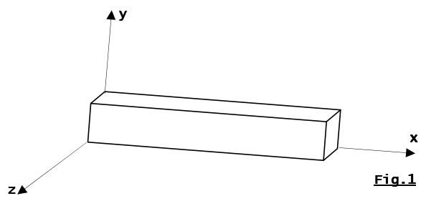

We virtually make a cut in this beam (Fig. 2) and analyze the equilibrium of the two resulting segments.

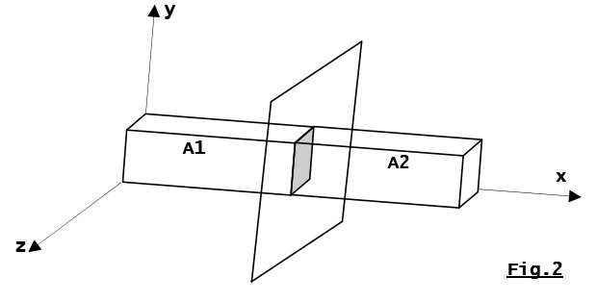

The segments A1​ and A2​ exert actions on each other that maintain cohesion between the two parts (Fig. 3). These actions can be represented by a tensor called the tensor of internal forces or cohesion tensor {τi​}.

To account for this tensor, let’s choose a sign convention:

{τi}={τ(A2→A1}=−{τ(A1→A2​}

Where:

* {τ(A2→A)1} is the tensor of the forces exerted by part A2​ on part A1
* {τ(A1→A)2} is the tensor of the forces exerted by part A1 on part A2.

Let’s express this tensor using the fundamental principle of statics. We apply this principle to segment A1​: {τ(Aext→A1)}+{τ(A2→A1)}={0} Or: {τ(Aext→A1)}+{τi}={0}

Where {τ(Aext→A1​} is the tensor of external forces on segment A1

From this, we deduce that {τi}=-{τ(Aext→A1}

The same principle applied to segment A2 gives: {τi} = {τ(Aext→A2)}

**1.2. Composition of the Cohesion Tensor**

The connection between segments A1 and A2 ​is assumed to be perfect, and it is therefore modeled as a fixed connection. The cohesion tensor then takes the most general form (Fig. 3a and Fig. 3b):

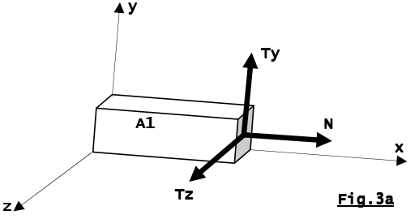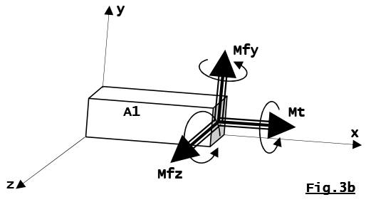

Where:

* N: normal force; a force directed tangentially to the average curve.
* T: shear force; a force perpendicular to the average curve that causes shearing:
  + Ty​: shear force in the y direction,
  + Tz​: shear force in the z direction.
* Mf​: bending moment; a moment whose vector is perpendicular to the average curve and causes bending:
  + Mfy​: bending moment in the y direction,
  + Mfz​: bending moment in the z direction.
* Mt​: torsion moment; its vector is directed along the x axis.

### 1.3. Special Cases of the Cohesion Tensor

In practice, the cohesion tensor is simpler because several of its components are zero. We then encounter elementary loadings, which will be treated in detail in the following chapters. A summary of these loadings is presented below.

|  |  |  |  |  |  |
| --- | --- | --- | --- | --- | --- |
| **Cohesion tensor** | **Nature of the loads** | **Values of the components** | | | |
| **Normal force** | **Shear force** | **Torsional moment** | **Bending moment** |
|  | Tension (N˃0)  Compressin (N˂0) | N≠0 | Ty=0  Tz=0 | Mt=0 | Mfy=0  Mfz=0 |
|  | Simple shear | N=0 | Ty≠0  Et/ou  Tz≠0 | Mt=0 | Mfy=0  Mfz=0 |
|  | torsion simple | N=0 | Ty=0  Tz=0 | Mt ≠0 | Mfy=0  Mfz=0 |
|  | flexion pure | N=0 | Ty=0  Tz=0 | Mt=0 | Mfy ≠0  Et/ou  Mfz ≠0 |

### 1.4. Diagrams

The cohesion tensor is modified when the cut moves along the beam. We then study several cuts, particularly when encountering: a geometric discontinuity (change in the direction of the average line) or a discontinuity related to concentrated forces or a connection.

The plot of the different values taken by a component of the cohesion tensor along the average line of the beam, depending on the position of the cut, is called a diagram. The plotting of these diagrams allows us to locate the most stressed sections of the beam and, consequently, to size the beam to withstand external loads. This is one of the objectives of resistance of materials.

### 2. Notion of Stress

#### 2.1. Definition

The cohesion tensor defined previously is a global entity for the considered section of the beam and does not account for the local distribution of forces over this section. Let’s consider a point M on this section and denote ΔS as a surface element with a normal surrounding this point (Fig. 4).

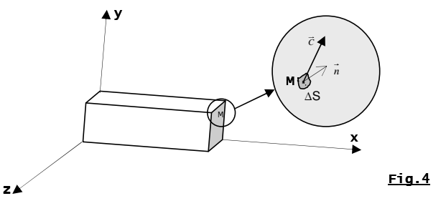

Let be the action exerted on ΔS. We define the stress vector at point M relative to ΔS as:

The unit of the stress vector is the ratio of force to unit area, which is in N/m² or Pa, with 1 Pa=1 N/m2. Since the Pa is a small unit, a multiple of the Pa is often used in mechanics and civil engineering: the MPa, where 1 MPa=106 Pa=1 N/. We also have 1 bar=105 .

#### 2.2. Normal and Shear Stress

The projection of the stress vector CCC onto the normal n and the surface ΔS yields two vectors (Fig. 5), respectively called:

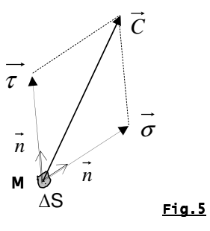

* **Normal Stress :** the projection of C on
* **Shear Stress :** the projection of C on

We have, of course: