***Chapter II :***

***Les granulats***

***II.1. Introduction :***

Aggregates, also called granulates, are fragments of rock typically ranging in size from 0 to 80 mm (according to standard P18 304) and are used in conjunction with a binder (cement, bitumen, etc.) in the construction of civil engineering infrastructures, buildings, and structures.

***II.2. Définition***

Aggregates are generally made up of mineral particles and are often considered inert materials that are incorporated into the cement or bitumen matrix.

The choice of aggregates in a construction project is very important as they influence the properties of the composite material, such as strength, durability, aesthetic appearance, density, elasticity, thermal conductivity, and more.

Aggregates can be natural, manufactured, or recycled. Their size and shape can vary and can be classified accordingly. An aggregate is defined from a granulometric point of view by its class d/D, where "d" represents the minimum grain diameter and "D" the maximum diameter. If "d" is less than 0.5 mm, the aggregate is designated as 0/D. If only one number is mentioned, it refers to the maximum diameter "D," expressed in millimeters.

Aggregates are essential in construction projects and must comply with quality standards and specifications specific to each application. Comprising the framework of concrete, they generally represent about 80% of the total weight of the concrete.

The use of aggregates in concrete production is justified both economically—since they reduce the amount of binder, which is more expensive—and technically—since they improve dimensional stability (shrinkage, creep) and have superior strength compared to the cement paste.

Overall, aggregates play a crucial role in many aspects of construction, and their selection must take into account both the technical requirements of the project and environmental implications.

***II.3. Graularity:***

Granularity refers to the scale or level of detail of a set of parts or a system. This concept can be used in various fields such as computer science, materials science, and project management.

In the context of materials, granularity refers to the size or degree of division of the particles in a material. For example, regarding aggregates used in construction, granularity might refer to the size of sand, gravel, or stone particles used.

***II.4. Classification and types of aggregates :***

The classification of aggregates can be done based on various criteria, including their origin, size, density, and shape. Here’s a general description of these classifications::

1. **According to origin :**
   * **Natural aggregates**: Extracted from quarries and can be alluvial (rivers, beaches) or from solid rock (granite, limestone, sandstone).
   * **Artificial aggregates**: Produced from industrial materials such as blast furnace slag, glass, fly ash, etc.
   * **Recycled aggregates**: Sourced from the demolition of old concrete or asphalt structures.
2. **According to size (granulometric classification) :**

Aggregate size can vary. They can be classified into fine aggregates (sand), medium aggregates (gravel), and coarse aggregates (stones). The size of the aggregate used will depend on the type of construction project.

* + **Fine Aggregates**: Diameter is less than 4.75 mm. Includes sand and fines.
  + **Medium Aggregates**: Diameter ranges from 4.75 mm to 20 mm.
  + **Coarse Aggregates**: Diameter is greater than 20 mm. Includes gravel and pebbles.

1. **According to density :**
   * **Light Aggregates**: Have a low density, generally less than 2000 kg/m³, such as expanded polystyrene or perlite.
   * **Normal Aggregates**: Have an average density that typically ranges from 2000 kg/m³ to 3000 kg/m³, such as granite, limestone, sandstone.
   * **Heavy Aggregates**: Have a high density, generally over 3000 kg/m³, such as iron or lead. They are primarily used for radiation protection or to increase the weight of concrete structures.
2. **According to Shape:**
   * **Rounded Aggregates**: Have a rounded shape due to natural erosion (e.g., river pebbles).

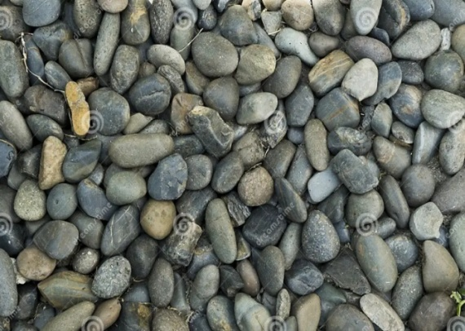 

 

***Figure II.1.*** *Rounded Aggregates.*

* + **Angular Aggregates**: Have a more angular shape, generally due to crushing (e.g., aggregates from solid rock).

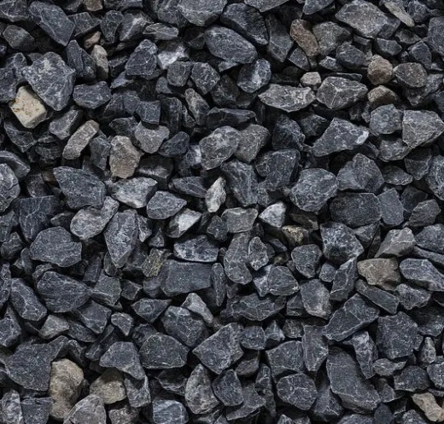 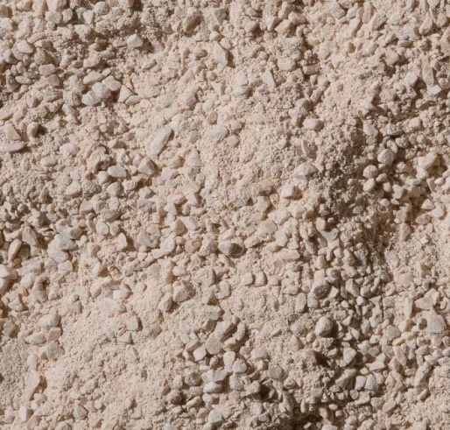

***Figure II.2.*** *Angular aggregates*

The classification of aggregates is important as their properties directly influence the quality, strength, workability, and durability of the construction materials in which they are used.

***II.5. Characteristics of Aggregates:***

The characteristics of aggregates, such as hardness, strength, shape and texture, density, and water absorption, can significantly influence the properties of the material into which they are incorporated. For instance, in concrete, the size, shape, and texture of aggregates can affect the strength, durability, and aesthetic appearance of the finished concrete.

Several tests have been developed to calculate these various characteristics, which we will study in this chapter. These tests complement those we have already studied in the previous chapter.

**II.5.1. Measurement of Cleanliness:**

Cleanliness refers, on one hand, to the content of clay fines or other particles adhering to the surface of the grains (which can be verified on-site by the marks they leave when rubbing the aggregates between the hands), and on the other hand, to impurities that could harm the quality of the concrete, such as slag, coal, wood particles, dead leaves, and root fragments. Two methods can be adopted for calculating cleanliness depending on the diameter of the aggregates.

**Principle:**

Gravel, for example, has relatively coarse granular classes. The separation of aggregates from fine elements can be done by simple washing with water.

**Procedure :**

* Weigh a mass M (about 1000g) of gravel and place it in a sieve (mesh of 0.5 mm).
* Wash the sample until the water passing through the sieve becomes clear.
* Wipe off the excess water with a cloth and weigh the new mass, denoted M′.

The cleanliness is then deduced from the following expression:

***P(%) = ((M- M′)/M)).100***

**Sand Equivalent test:**

This test aims to measure the cleanliness of sand. The test is performed on the 0/5 mm fraction of the material being studied. Sieving is done by wet method to avoid losing fine elements. The sample is washed according to a standardized process using a washing solution that separates the clay fines and causes flocculation. After decantation, the height of the flocculated fines (clean sand + fine elements = hi) and the height of clean sand (h2 if measured by piston or h2′​ if measured by ruler) are recorded.

**Procedure:**

* Fill the washing solution up to the first mark.
* Introduce a mass of 120g (dry) of sand into the test tube.
* Soak the sand in the washing solution for 10 minutes.
* Shake the test tube (60 cycles in 30 seconds), wash the sand with the washing solution, and refill up to the second mark.
* Start the decantation, lasting 20 minutes.
* Measure the height of the sand hi​ of the total flocculate + sand.
* Measure the height of the sand h2 ​by piston.

With:

|  |  |
| --- | --- |
| **Visual Sand Equivalent (VSE):** **ESV(%)** 100 | **Sand Equivalent (SE):** 100**(%) ES** |

**Table 2:** Sand Equivalent Values (ESV) and Quality of Sand

| **ESV (%)** | **ES (%)** | **Quality of Sand** |
| --- | --- | --- |
| ESV < 65 | ES < 60 | Clayey sand: Risk of shrinkage or swelling; to be rejected for quality concrete. |
| 65 ≤ ESV < 75 | 60 ≤ ES < 75 | Slightly clayey sand: Acceptable cleanliness for quality concrete, provided there is no significant risk of shrinkage. |
| 75 ≤ ESV ≤ 85 | 70 ≤ ES ≤ 80 | Clean sand: Low percentage of clay fines; perfectly suitable for high-quality concrete. |
| ESV ≥ 85 | ES ≥ 80 | Very clean sand: Almost total absence of clay fines, which may lead to a plasticity defect in the concrete; adjustments may require an increase in water dosage. |

This classification helps determine the suitability of sand for various construction applications, particularly in concrete production.

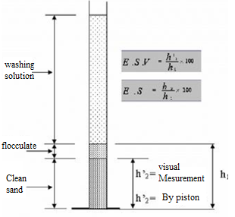

**Figure II.3.** Sand equivalent test

**II.5.2. Granulometric Analysis**

Granulometric analysis is a method used to determine the particle size distribution in a sample of aggregate. This analysis is crucial as it influences the physical and mechanical properties of the final material, whether it be concrete, asphalt, or any other construction product.

The procedure for granulometric analysis may vary slightly depending on the standard used, but it generally involves the following steps:

1. **Sample Preparation**: The aggregate sample is prepared by drying it to remove any moisture that could affect the results of the analysis.
2. **Sieving**: The sample is passed through a series of sieves of different sizes. The sieves are usually stacked with the largest on top and the smallest on the bottom, and the sample is placed on the top sieve. Sieving can be done manually or using a sieving machine that shakes the stack for more effective sieving.

The sieve openings should preferably be square-shaped, and their dimensions range from 0.02 mm to 120 mm following a geometric progression with a factor of representing the Renard series.

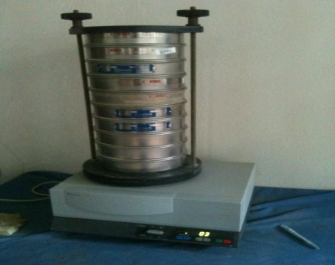

***Figure II.4.*** *Granulometric analysis*

1. **Weighing**: After sieving, the material that passes through the sieve is called the sieve fraction, and the aggregates retained on each sieve are called the oversize. These weights are then used to calculate the percentage of the total sample represented by particles of each size.
2. **Results Analysis**: The results of the granulometric analysis are typically presented in tabular form and then as a graph showing the distribution of particle sizes. The continuity or discontinuity of a granulometric curve is an important indicator. For example, curves representing sands are generally continuous, while the curve for a gravel mix of 5/31.5 shows a discontinuity. This discontinuity, especially the plateau between 10 mm and 20 mm, indicates that this type of aggregate lacks particles whose size varies between 10 mm and 20 mm. This can help determine if the sample meets specifications for a particular application.

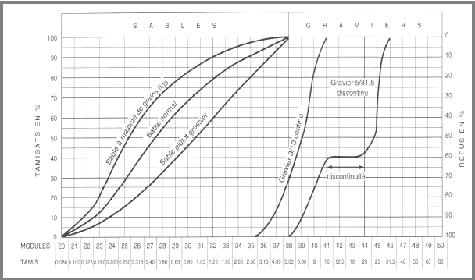

***Figure II.5.*** *Granulometric analysis graph*

Granulometric analysis is an important tool for engineers and construction technicians to ensure that the aggregates used in a project are suitable and meet required quality standards.- Haut du formulaire

* **Modul of fineness**

The modulus of fineness (MF) is a measure of the grain size distribution of sand. It is calculated by summing the cumulative percentages retained on standard sieves (with openings of 0.16, 0.315, 0.63, 1.25, 2.5, 5, 10, 20, 40, 80 mm) and dividing the total by 100.

The modulus of fineness is used to determine whether the sand is fine, medium, or coarse.

* A modulus of fineness below 2.2 indicates fine sand.
* A modulus of fineness between 2.2 and 2.8 indicates medium sand.
* A modulus of fineness above 2.8 indicates coarse sand.

This classification helps determine whether a particular sand is suitable for a specific construction application. Generally, a higher modulus of fineness indicates a broader grain distribution, which can affect the final material's properties, such as workability and strength.

* **Hazen Coefficients (Uniformity and Curvature)**
* Coefficient d'uniformité ou de Hazen : Cu=D60/D10
* Coefficient de Courbure : Cc=(D60)2/(D10.D30)

Where D10, D30, D60 represent the diameters of the particles corresponding to 10%, 30% and 60% cumulative passing, respectively.

According to Caquot and Kérisel:.

- For Cu < 2 the grain size distribution is said to be uniform or tight.

- For Cu > 2 the grain size distribution is said to be spread.

- For: 1 < Cc < 3 the grain size distribution is said to be well-graded (well-distributed continuity).

- For: 1 > Cc > 3 the grain size distribution is said to be poorly graded (poorly distributed continuity).

* **Flattening Coefficients**

The flattening coefficient, also known as the "flatness index" in English, is a measure that characterizes the shape of particles in an aggregate. It is generally used to determine the proportion of flat, elongated, or flat and elongated particles in a sample of aggregate.

The shape of an aggregate is defined by:

* Length L: the minimum distance between two parallel planes tangent to the ends of the aggregate.
* Thickness E: the minimum distance between two parallel planes tangent to the aggregate.
* Size G: the dimension of the smallest square mesh sieve that allows the aggregate to pass.

The flattening coefficient is calculated by taking the ratio of the percentage of aggregates passing through a certain number of sieves to the nominal size of the sieve. Specifically, the flattening coefficient is the mass percentage of aggregates whose thickness is less than 0.6 times the nominal size.

The flattening coefficient, denoted "A," is calculated by performing two sievings. The first sifting is done through a series of square mesh sieves used for grain size analysis. Then, a second sifting is performed on the particles retained during the first sifting, using a series of parallel slot screens. The flattening coefficient "A" represents the weight percentage of particles whose ratio of the larger dimension G to the smaller dimension E is greater than 1.56.

A high flattening coefficient indicates that many aggregates are flat or elongated. Generally, an aggregate with a high flattening coefficient is not ideal for use in concrete or asphalt mixtures, as it can affect the workability and strength of the mixture. It is important to note that the flattening coefficient is a quality criterion for aggregates, and it must comply with the specifications of construction standards for use in a particular application.

* **Foaming (bulking) of the sand**

Foaming of sand is a phenomenon that occurs when sand is manipulated, resulting in an increase in its volume due to air trapped between the grains. This often happens during pouring or moving sand, which can affect the apparent weight and density.

**Calculation of Foaming**

Foaming is generally expressed as a percentage and can be calculated based on the relationship between the volume of sand in a compacted state and the volume of sand in a foamed state.

**Formula:**

Foaming (%) = ((Vf−Vc)/Vc) ×100

where:

* Vf​ = volume of foamed sand
* Vc = volume of compacted sand

**II.5.3. Mechanical Properties:**

Aggregates must be durable and resistant to the environmental conditions they will be exposed to. This includes resistance to freeze-thaw cycles, erosion, and other forms of wear.

* **Hardness:**

This is the essential mechanical property for aggregates. The hardness of aggregates is a measure of their resistance to wear or degradation. It is a very important property as it directly affects the durability and performance of the final material, whether it is concrete, asphalt, or other types of construction.

The hardness of an aggregate can be measured in various ways, but the two most common methods are the Los Angeles test and the Micro-Deval test.

1. **Los Angeles test** : This is a test that measures the resistance of aggregates to fragmentation. The aggregate sample (4/6.3 - 6.3/10 - 10/14 mm) is placed in a cylindrical drum with steel balls, and the drum is then rotated a certain number of times (500 revolutions) at a speed of 31 - 33 rpm. The amount of material that degrades and passes through a specified sieve (1.6 mm) is then weighed, and this value is used to calculate the Los Angeles index (LA) using the following formula:

**LA= (weight passing through the 1.6 mm sieve / initial weight of the sample) × 100**

A high Los Angeles index indicates that the aggregate is more likely to fragment and is therefore considered less hard.

1. **Micro-Deval test** : This is a test that measures the abrasion resistance of aggregates in the presence of water. A sample (500 g) of aggregate (4/6.3 - 6.3/10 - 10/14 mm) is placed in a steel drum with water and steel balls (10 mm) weighing between 2 to 5 kg. The drum is then rotated for a specified number of revolutions (10 minutes). The amount of material that degrades and passes through a specified sieve (2 mm) is then weighed, and this value is used to calculate the Micro-Deval index (MDE):

***MDE = 100 × (P / 500)***

A high Micro-Deval index indicates that the aggregate is more susceptible to degradation due to abrasion and is therefore considered less hard.

In general, hard aggregates are preferred for applications such as roads and sidewalks, where wear resistance is particularly important.

1. **Freeze-Thaw Test**: Haut du formulaire

Haut du formulaire

For aggregates that may be subjected to freeze-thaw effects, the Los Angeles index (LA) can be measured after a series of 25 freeze-thaw cycles (-25°C, +25°C) in a saturated atmosphere. The freeze-thaw susceptibility is expressed as: