***DW6***

**Exercise 1**

The beam AB with a rectangular cross-section is simply supported at both ends and is subjected to a uniformly distributed load q along its entire length L.

1. Plot the diagrams of the non-zero components of the internal force system (torseur of cohesion) along the beam. From this, deduce the most critical sections.
2. Calculate the maximum normal stress and verify the beam's strength.

Given: σe=160 N/mm2

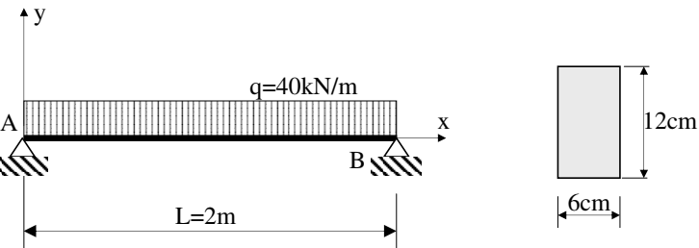

**Exercise 2**

Redo the questions from Exercise 1 for the following beam

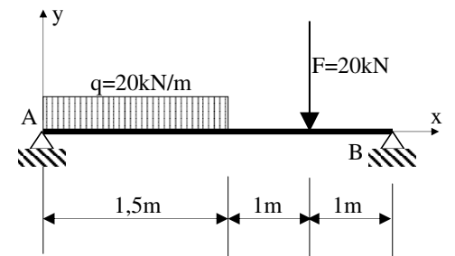

**Exercise 3**

The beam AB is fixed at point A and subjected to a concentrated force F at point B.

1. Plot the diagrams of the non-zero components of the internal force system (torseur of cohesion) along the beam.
2. Determine the expression for the deflection v(x) (equation of the deformation) and deduce the maximum deflection.
3. Check for the three given sections whether the deflection exceeds the limitvalue: vlim=1 mm with a safety factor s′=2.

Given: E=200,000 MPa

