**Chapter 7: Simple Bending**

1. **Definition**

A beam or a section of a beam is said to be subjected to simple bending if the internal force system at each straight section is reduced to:

Where:

* Ty​: Shear force in the y direction
* Mfz​: Bending moment around the z-axis.

If in addition, Ty=0, the bending is pure bending.

1. **Relationship between normal stress and bending moment**

Consider a beam subjected to bending. It is experimentally observed that the fibers located above the neutral axis shorten, while the fibers located below the neutral axis elongate. The neutral axis itself does not change in length and is referred to as the neutral fiber.

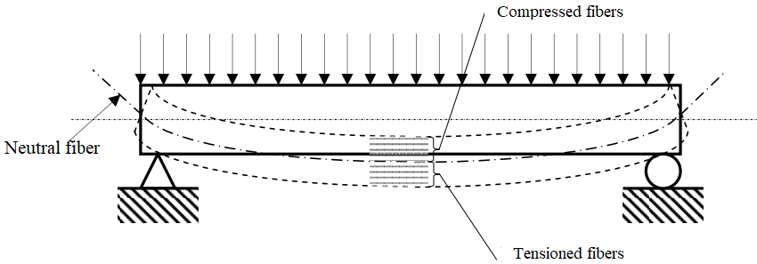

Let's study a segment dx of the beam before and after deformation:

The relative deformation of the fiber ab, located at a distance y from the neutral axis, is given by:

The length of the neutral fiber is given by dx=R⋅dθ.

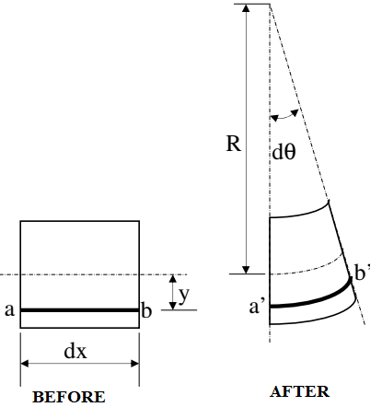

Knowing that the material obeys Hooke’s Law:

 ; Then

The normal stresses distributed across the cross-section

of the beam are statically equivalent to the bending moment:

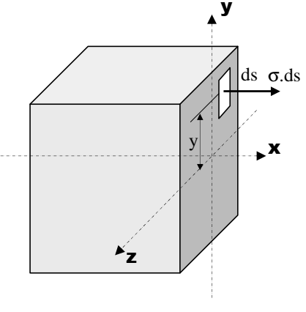

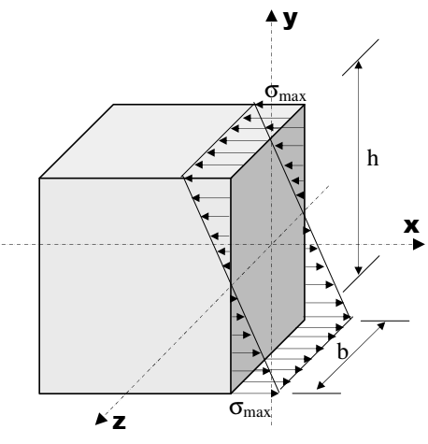

Mf = ∫s y.σ.ds

Where: Mf = ∫s .y2.ds = ∫s.y2.ds = . IGZ

We can express the bending moment as:

Where IGZ=∫s y2 ds is the second moment of area or quadratic moment

(also called the area moment of inertia) of the section S about the Oz-axis:

This formula leads to the relationship between the normal stress

σ and the bending moment Mf​:

σ=Mf⋅y/IGZ

This equation informs us about the distribution of the normal stress

across the cross-section of the bent beam.

The stress is zero at the neutral fiber (y=0) and maximum at the extreme fibers (y=h/2, where h is the height of the section).

Thus, the maximum normal stress is:

σmax=Mf⋅h/(2⋅IGZ)

**3. Relationship between Shear Stress and Shear Force**

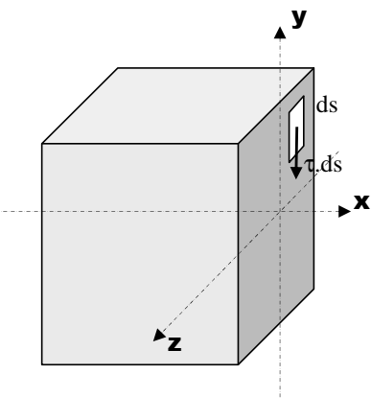

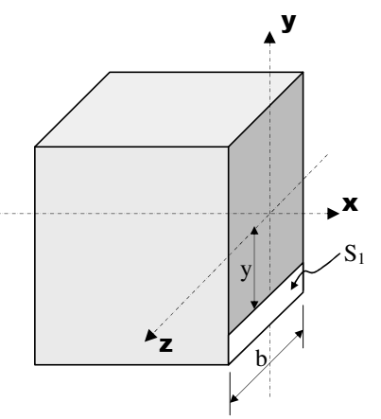

The shear stresses distributed across the cross-section of the beam

are statically equivalent to the shear force:

Ty=∫s τ.ds

If we assume the shear stress is uniformly distributed across

the entire section, then the average shear stress can be expressed as:

τ = Ty/S

Where:

* T is the shear force,
* S is the cross-sectional area,
* τ is the shear stress at a point at distance yyy from the neutral axis.

In the general case, we have:

τ(y)=Ty⋅A(y)/ (B(y).IGZ)

Where:

* T is the shear force,
* b(y) is the width of the beam at distance y from the neutral axis.
* A(y) is the static moment of the section S1 at a distance y from the neutral axis,
* IGZ​ is the second moment of area (area moment of inertia) of the section.

**4. Deformation of Bent Beams**

The neutral axis of a bent beam is called the *deformed line*, and the value of the deflection at a point is called the *deflection* v(x). The deflection v(x) is determined by double integration of the equation:

E⋅IGZ⋅v′′(x)=MfZ

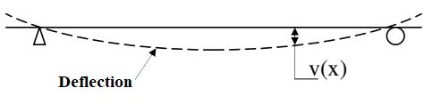

Where:

* E is the Young's modulus of the material,
* IGZ​ is the second moment of area of the cross-section,
* v′′(x) is the second derivative of the deflection function (related to the curvature),
* MfZ​ is the bending moment as a function of x.

The boundary conditions must be applied when solving this equation.

**5. Design Criteria**

As with tension, two criteria can be used to calculate the transverse dimensions of a beam subjected to simple bending: the stress criterion and the deformation criterion.

* **Stress Criterion**: This criterion ensures that the material remains within the elastic domain (with a safety factor). It is given by:

σmax≤σe/s

Where:

* σmax​ is the maximum applied stress,
* σe​ is the yield strength of the material,
* s is the safety factor (which is ≥1).
* **Deformation Criterion**: This criterion ensures that the maximum deflection does not exceed a given limit:

fmax≤flim/S′

Where:

* fmax​ is the calculated maximum deflection,
* flim​ is the given limit on deflection,
* S′ is the safety factor (which is ≥1).