**Chapter II: Morphology of higher plants**

**Introduction**

***Plant Morphology*** or ***Phytomorphology*** is a branch of botany that focuses on describing the

shape and external structure of plants and their organs. It plays a vital role in understanding

plant form and function **(Esau, 1977).**

**II.1. Root morphology**

The **root** is a non-chlorophyllous, underground organ characterized by endogenous branching.

Its main functions are to anchor the plant and absorb water and dissolved mineral nutrients from

the soil **(Raven *et al.,* 2013).**

**II.1.1. Organization of the root system**

The root system is divided into several zones, starting from the top and progressing downward

(see **Figure 17) (Esau, 1977):**

• ***Collar****:* The junction between the root and the stem, usually aligned with ground level.

• ***Branching Zone (Zone of Maturation)****:* Located just above the root hairs, this is where

lateral roots emerge.

• ***Absorbent Hairs (Root Hairs)****:* Tiny hair-like extensions responsible for absorbing water

and dissolved minerals from the soil.

• ***Elongation Zone****:* This region lies between the root cap and the root hairs and is where the

root elongates due to the activity of the lateral and apical meristems.

• ***Meristematic Zone (Zone of Division)****:* Situated at the root tip, where active cell division

occurs, contributing to root growth.

• ***Cap****:* A protective organ that covers the tip of the root, allowing the root to penetrate the

soil and safeguarding the delicate, developing tissues beneath **(Raven *et al.,* 2013).**

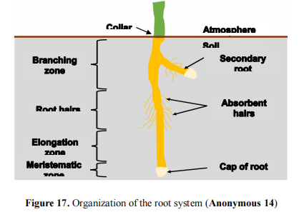

**II.1.2. Different types of root**

Plants exhibit three main types of root systems, with additional specialized forms that provide

adaptations to various environments:

**a) Taproot**: A large, vertical root branching into numerous secondary roots. This system

provides strong anchorage, enabling the plant to withstand environmental forces such as

wind, gravity, and water runoff. Example: Fruit trees like apricot, citrus, and pomegranate

(**Raven *et al.,* 2013**) **(Figure 18)**.

**b) Fibrous**: This system consists of several roots of equal size that develop close to the soil

surface. It enhances soil fixation and increases the contact surface for nutrient and water

absorption. Example: Wheat, barley (**Raven *et al.,* 2013**). (**Figure 19**).

**c) Adventitious**: Roots that grow from any plant part other than the roots, such as stems or leaves.

Example: Strawberry, many gymnosperms like pine (Esau, 1977). (**Figure 20**).

**d) Others forms of adaptation roots:** There are eight distinct types of specialized roots adapted

for specific environments or functions:

• ***Tubers Root:*** Found in biennial plants, these hypertrophied roots store reserves that allow

the plant to resume vegetative growth after adverse seasons. Example: Carrots, beets **(**see

**Figure 21.a) (Raven *et al.,* 2013).**

• ***Holdfasts Root:*** Aerial adventitious roots that provide firm attachment to surfaces like walls

or trees. Example: Climbing ivy **(**see **Figure 21.b) (Esau, 1977).**

• ***Respiratory Roots (Pneumatophores):*** Aerial roots that supply oxygen to roots growing in

oxygen-poor environments, such as swamps. Example: White mangrove tree (see **Figure**

**21.c**) (**Raven *et al.,* 2013**).

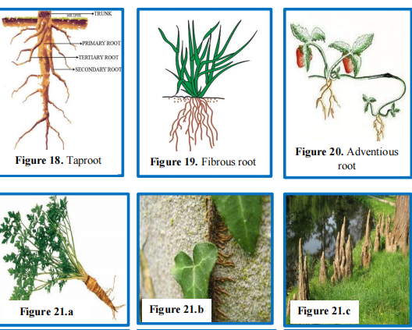

**Figure.** (a) Tubers root, (b) Holdfasts root, (c) Respiratory root, (d) Stilts root, (c)

**II.1.3. Root function**

Roots perform several vital functions in plants:

• ***Anchorage****:* Roots anchor the plant firmly to the soil, providing mechanical stability and

support, ensuring the plant remains upright (**Raven *et al.,* 2013**).

• ***Absorption:*** Roots absorb water and dissolved minerals from the soil and transport them

upward through the plant’s vascular system to support various physiological processes

(**Esau, 1977**).

• ***Storage****:* Roots serve as storage organs for carbohydrates produced during photosynthesis,

which can be utilized during periods of low energy availability (**Esau, 1977**).

• ***Hormone Production****:* Roots produce and export plant hormones such as cytokinins and

gibberellins. Cytokinins promote cell division, while gibberellins stimulate plant growth

and elongation (**Raven *et al.,* 2013**).

**II.2. Stem morphology**

The **stem** is generally the aerial part of the plant’s axis, supporting the leaves and reproductive

organs. It continues from the root, and the region where the root and stem connect is known as

the collar (**Esau, 1977**).

**II.2.1. Organization of the stem system**

In a stem system, several parts can be distinguished (see **Figure 22)** (**Esau, 1977**):

**a) *Node****:* The point where leaves and buds are attached.

**b) *Internode****:* The space between two nodes.

**c) *Bud****:* These are stem meristems covered by protective scales. There are three types of buds:

• **Terminal Bud (Apical)**: Located at the end of the main axis, responsible for the plant’s

length growth and the formation of axillary buds.

• **Axillary Bud (Lateral)**: Found in the leaf axils on the stem, responsible for producing

leafy branches or flowers.

• **Adventitious Buds**: These do not have a specific position and can appear in unexpected

areas.

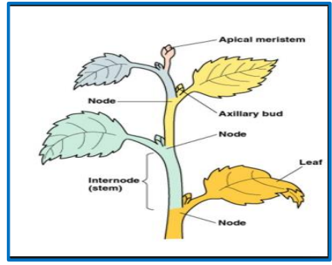

**Figure 22.** Organization of stem system

**II.2.2. Different types of stem**

***a) Erect Stems:*** These stems grow vertically, which is the most common growth habit for stems

(**Raven *et al.,* 2013**).

***b) Creeping Stems:*** These stems spread horizontally and are often involved in vegetative

propagation. They can either grow on the surface (like stolons) or beneath the ground (like

suckers) (see **Figure 23)** (**Esau, 1977**).

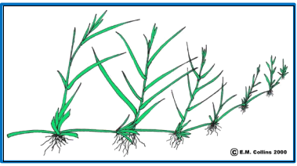

**Figure.** Creeping stems (stolons of strawberry)

***c) Climbing stems***

These stems enable plants to climb over other structures or plants through various mechanisms:

• **Simple climbing stems:** Often equipped with holdfasts such as adventitious roots that

allow the plant to attach to surfaces (**Raven *et al.,* 2013**). (**Figure 21.b)**.

• **Twining stems:** These stems wrap around their support, using a coiling mechanism

(**Esau, 1977**). (**Figure 24.a)**.

• **Tendril stems:** Tendrils are specialized organs that help the plant attach to structures

for support. Tendrils wind around their support in response to contact, a phenomenon

called haptotropism. Tendrils may originate from the stem, as seen in grapevines, or

from leaves, as in legumes (**Raven *et al.,* 2013**). (**Figure 24.b)**.

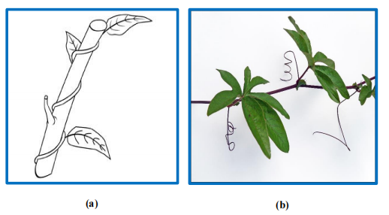

**Figure. (a)** Twining stem, and **(c)** Tendril stem

**d) *Succulent stems:*** found in plants such as cacti and some species of *Euphorbia*, store water

to help the plant survive in arid, desert environments. This water storage is a key adaptation

to drought conditions, allowing these plants to maintain hydration during prolonged dry

periods (**Esau, 1977; Raven *et al.,* 2013**). **(Figure 25)**

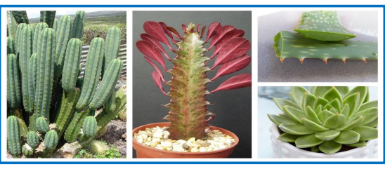

**Figure 25.** Succulent stem **(Anonymous 31)**

**e) *Others forms of stems adaptation***:

• **Rhizomes:** These are underground, most often horizontal stems, characterized by scaly

leaves and short nodes. Rhizomes periodically emit aerial branches (see **Figure 26.a**).

Example: ginger (*Zingiber officinale*) (**Raven *et al.,* 2013**).

• **Tubers:** Underground stems that are swollen due to the storage of nutrients, with internodes

that are closer together than those in rhizomes (see **Figure 26.b**). Example: potato (*Solanum*

*tuberosum*) (**Esau, 1977**).

• **Bulbs:** A short underground axis with fleshy leaves that store nutrients (see **Figure 26.c**).

Example: onion (*Allium cepa*) (**Raven *et al.,* 2013**).

• **Aquatic Stems:** These stems differ structurally from aerial stems and can remain fully or

partially submerged in water (see **Figure 26.d**) (**Esau, 1977**).

• **Stemless Plants:** These plants have very short internodes, resulting in a rosette arrangement

of leaves (see **Figure 26.e**). Example: lettuce (*Lactuca sativa*) (**Raven *et al.,* 2013**).

• **Thorns:** In some species, stems are transformed into thorns, serving as a defense

mechanism against herbivores (see **Figure 26.f**). Example: hawthorn (*Crataegus*) (**Esau,**

**1977**).

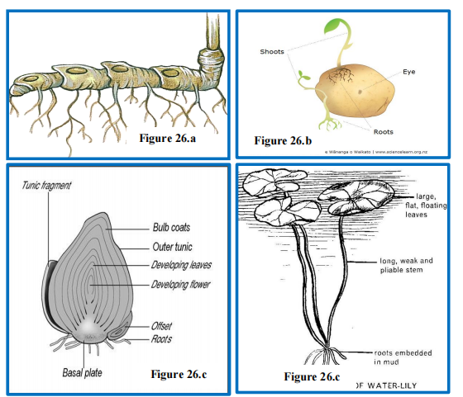

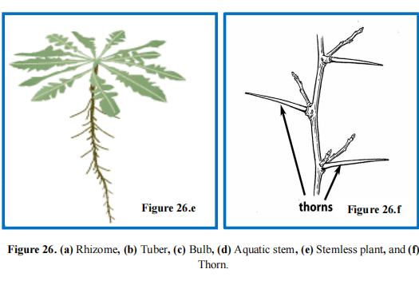

**II.2.3. Stem function**

The stem plays a fairly complex role; it supports, through wood fibers, the branches, leaves,

flowers and fruits. It carries sap from the roots to the leaves, fruits and storage organs for the

wood vessels.

**II.3. Leaf morphology**

Leaves form from the terminal bud during stem growth.

**II.3.1. Morphological organization of the leaf**

The morphology of leaves encompasses their physical structure, arrangement, and variations

among different plant species. Understanding leaf morphology is crucial for identifying plant

species and understanding their adaptations to different environments. Basic parts of leaves are

(see **Figure 27)** :

**a) Limb (Blade):** it is a thin green broad (large) portion of the leaf with variable shape and

seize. We distinguish the following parts:

• **Apex:** Leaf tip.

• **Margin:** Leaf edge boundary area. Margins can be smooth, jagged (toothed), lobed, or parted

• **Midrib:** Vascular tissue bundles that support the leaf and transport nutriments, it is a central main vein arising from petiole.

• **Veins and veinlets:** branch from the midrib.

• **Base:** area of the leaf that connects the blade to the petiole

**b) Petiole:** thin stalk that attaches the leaf to a stem

**c) Accessory elements of the leaf base:** leaf-like structures at the leaf base, such as:

• **Sheath:** this is the enlarged part of the base of the petiole which envelops the stem.

*Example*: It is very developed in Monocotyledons and mainly in the family Poaceae

(Wheat, Rice …etc.) and Cyperaceae.

• **Stipule:** these are 2 small green blades, located at the base of the petiole.

• **Ligule:** it is a splitting of the limb at the point of attachment to the sheath. It is found

mainly in Poaceae (*Example*: Wheat, Barley …etc.)

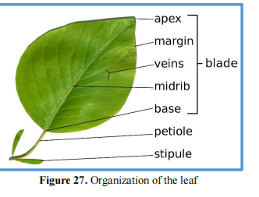

**II.3.2. Different types of leaves**

**II.3.2.1. Grouping of leaves**

**a) Simple Leaf**: A simple leaf consists of a single, undivided blade connected to the stem by a

petiole. Examples include *Mangifera indica* (Mango) and *Psidium guajava* (Guava) **(Esau,**

**1977)**.

**b) Compound Leaf**: A compound leaf is made up of two or more leaflets attached to a single

petiole. The midrib (rachis) of the leaf branches into different leaflets. An example is *Pisum*

*sativum* (Pea) **(Fahn, 1990).**

Compound leaves can be further classified as follows:

• ***Palmately Compound Leaf****:* In a palmately compound leaf, the leaflets are attached at a

common point at the tip of the petiole (see **Figure 28 to 29) (Esau, 1977).** This type can be

divided into:

❖ **Unifoliate**: These leaves have only one leaflet. Example: *Citrus spp.* **(Fahn, 1990).**

❖ **Bifoliate**: These leaves have two leaflets. Example: *Balanites aegyptiaca* **(Metcalfe &**

**Chalk, 1950)**.

❖ **Trifoliate**: These leaves have three leaflets emerging from the same point. Example:

*Oxalis spp.* **(Fahn, 1990).**

❖ **Quadrifoliate**: These leaves have four leaflets. Example: *Marsilea quadrifolia*

**(Metcalfe & Chalk, 1950).**

❖ **Multifoliate**: These leaves have multiple leaflets arising from a common point.

Example: *Bombax ceiba* **(Esau, 1977).**

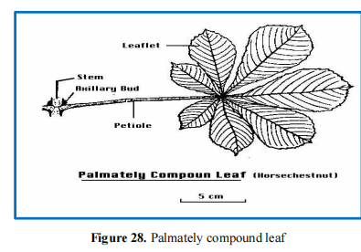

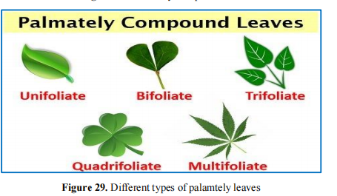

• ***Pinnately Compound Leaf****:* In a pinnately compound leaf, the midrib (rachis) is divided

into multiple leaflets, all attached along a common central axis. An example is *Azadirachta*

*indica* (Neem) (see **Figure 30) (Esau, 1977).** Pinnately compound leaves can be further

classified into:

❖ **Pinnate**: A compound leaf where leaflets are arranged on both sides of a common axis.

Example: *Juglans regia* (Walnut) **(Fahn, 1990).**

❖ **Unipinnate**: A leaf with leaflets arranged on either side of the central axis. Example:

*Cassia spp.* **(Metcalfe & Chalk, 1950).**

❖ **Bipinnate**: A leaf with a secondary axis bearing leaflets emerging from the central axis.

Example: *Acacia spp.* **(Esau, 1977).**

❖ **Tripinnate**: A leaf where a tertiary axis bearing leaflets arises from the secondary axis.

Example: *Moringa oleifera* **(Fahn, 1990).**

❖ **Decompound**: A leaf with more than three pinnate divisions. Example: Older leaves of

*Coriandrum sativum* (Coriander) **(Metcalfe & Chalk, 1950).**

❖ **Paripinnate**: A pinnate leaf without a terminal leaflet. Example: *Cassia spp.* **(Esau,**

**1977).**

❖ **Imparipinnate**: A pinnate leaf with an odd, terminal leaflet. Example: *Pisum sativum*

(Pea) **(Fahn, 1990).**

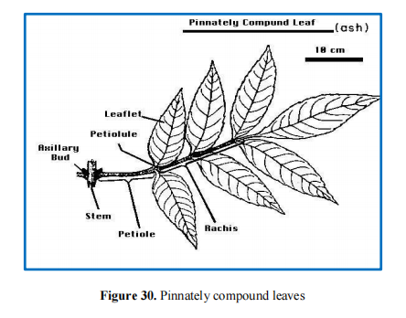

**II.3.2.2. Venation**

**Venation** is the arrangement of veins and veinlets in leaves. Different plants exhibit distinct

venation patterns (see **Figure 31)**. Generally, there are two main types:

• **Reticulate Venation**: In reticulate venation, the veinlets form a complex,

interconnected network. This type is characteristic of dicotyledonous plants. An

example is the rose plant (*Rosa spp.*) **(Esau, 1977).**

• **Parallel Venation**: In parallel venation, the veinlets run parallel to one another,

typically seen in monocotyledonous plants. An example is paddy (*Oryza sativa*) **(Fahn,**

**1990).**

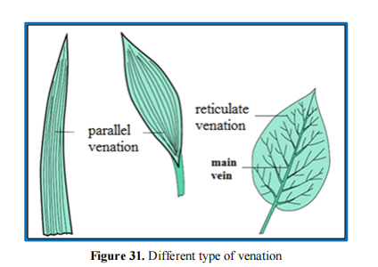

**II.3.2.3. Phyllotaxy**

**Phyllotaxy** refers to the pattern of leaf arrangement on the stem (see **Figure 32)**. Plants exhibit

three main types of phyllotaxy: alternate, opposite, and whorled.

• ***Alternate phyllotaxy****:* In this type, a single leaf develops at each node in an alternating

pattern. Example: *Hibiscus rosa-sinensis* (China rose) **(Esau, 1977).**

• ***Opposite phyllotaxy****:* In opposite phyllotaxy, a pair of leaves arises at each node,

positioned directly opposite to one another. Example: *Psidium guajava* (Guava**) (Fahn,**

**1990).**

• ***Whorled phyllotaxy****:* In this type, more than two leaves develop at each node, forming

a whorl around the stem. Example: *Alstonia scholaris* **(Metcalfe & Chalk, 1950)**

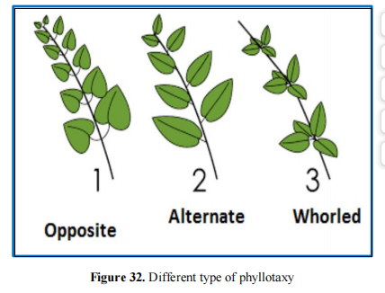

**II.3.2.4. Modification of leaves**

• **Storage Leaves**: Xerophytic plants and members of the Crassulaceae family have thick,

succulent leaves that store water in their tissues, allowing them to survive in arid

environments. These specialized leaves help the plants retain moisture during droughts

**(Fahn, 1990).**

• **Leaf Tendrils**: In plants with weak stems, leaf tendrils are modified leaves that coil around

nearby objects, such as sticks or walls, providing structural support to the plant. This

adaptation helps the plant climb toward sunlight **(Esau, 1977).**

• **Leaf Spines**: In some plants, the leaves are modified into spines, which are sharp, needle

like structures. These spines serve dual functions: they act as defense mechanisms against

herbivores and reduce water loss through transpiration. An example is *Opuntia* **(Fahn,**

**1990).**

• **Scale Leaves**: Scale leaves are thin, membranous structures that lack stalks and are typically

brownish or colorless. In some plants, like *Allium cepa* (Onion), they can be fleshy and

thick, storing food and water. Examples of plants with scale leaves include *Casuarina* and

*Asparagus* **(Metcalfe & Chalk, 1950).**

• **Leaflets Hook**: In certain plants, the terminal leaflets are modified into hook-like structures

that assist the plant in climbing. An example is *Bignonia unguiscati* **(Esau, 1977).**

• **Leaf Roots**: In some aquatic plants, leaves at the nodes are modified into adventitious roots

that help the plant float on the water's surface. An example is *Salvinia* **(Fahn, 1990).**

• **Phyllode**: In some plants, the petiole becomes flattened and takes on the appearance of a

leaf, often turning green to assist with photosynthesis. This modification is seen in *Acacia*

*spp.* (Australian Acacia) **(Metcalfe & Chalk, 1950).**

• **Insectivorous Leaves**: Certain plants, often found in nutrient-poor soils, have leaves

modified to trap and digest insects. This adaptation allows the plant to obtain nitrogen,

essential for growth **(Esau, 1977).**

**II.3.3. Leaf function**

Leaves perform several critical functions that support the survival and growth of plants:

• **Photosynthesis**: Leaves are the primary sites of photosynthesis, where they convert

sunlight into chemical energy by producing glucose, which fuels the plant's growth and

metabolism **(Fahn, 1990).**

• **Transpiration**: Through the process of transpiration, leaves regulate water movement

within the plant. Water absorbed by the roots travels through the xylem to the leaves, where it evaporates into the atmosphere, helping to cool the plant and maintain the flow of nutrients **(Esau, 1977).**

• **Guttation**: Guttation involves the removal of excess water from the xylem at the edges of

the leaves, especially when stomata are closed at night. This process helps prevent internal

pressure buildup in the plant. It is common in plants like grasses **(Fahn, 1990).**

• **Storage**: Some leaves, particularly in succulent plants, are adapted to store water and

nutrients. These thick, fleshy leaves help the plant survive during periods of drought by

retaining moisture **(Metcalfe & Chalk, 1950).**

• **Defense**: In some plants, leaves are modified into spines that serve as a defense

mechanism, protecting the plant from herbivores. An example is *Opuntia* (Prickly pear

cactus), where spines reduce water loss and deter animals from feeding on the plant **(Esau,**

**1977).**

**II.4. Flower morphology**

Flowers are colorful and often fragrant structures in flowering plants that serve as the primary

reproductive organs. They facilitate seed formation through pollination and fertilization **(Esau,**

**1977).** The different parts of a flower—such as petals, sepals, stamens, and carpels—work

together to attract pollinators, ensuring reproductive success **(Fahn, 1990).** The diversity in

flower shape, size, and color has evolved to enhance their appeal to various pollinators,

contributing to the plant's genetic diversity **(Thien, 1979).**

**II.4.1. Organization of the flower**

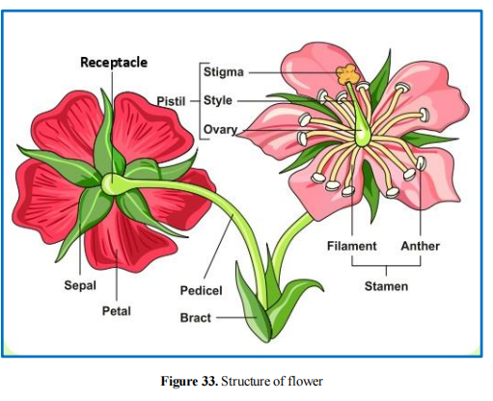

The structure of a flower is broadly divided into several parts, often arranged in a whorled

pattern (see **Figure 33)**:

**a) Bract**: A modified leaf associated with a flower or inflorescence, providing protection or

support **(Fahn, 1990).**

**b) Pedicel**: The stalk of the flower that connects it to the main stem.

**c) Receptacle**: The base of the flower located above the pedicel, which supports all the other

parts of the flower **(Esau, 1977).**

**d) Perianth**: This is composed of two structures:

• **Calyx**: The outermost whorl, made up of individual sepals that resemble leaves,

providing protection to the developing flower.

• **Corolla**: The inner whorl, consisting of petals that attract pollinators with their color

and fragrance **(Fahn, 1990).**

• **Floral fusion;** In many flowers, the petals, sepals, and stamens often exhibit **fusion** to

form specialized structures:

❖ **Gamopetalous**: When the petals are fused together, they form a tubular structure,

known as a **corolla tube**. This fusion can enhance the flower’s efficiency in

attracting pollinators by creating a more distinct and unified floral shape **(Esau,**

**1977).**

❖ **Staminal Tube**: When the stamens are fused together, they form a **staminal tube**.

This structure can help ensure efficient pollen transfer by concentrating the

reproductive organs **(Fahn, 1990).**

**e) Androecium**: The male reproductive system of the flower, made up of one or more stamens

(see **Figure 34)**. Each stamen consists of:

• **Filament**: A slender, tube-like structure that holds the anther at its tip.

• **Anther**: The pollen-producing part, which contains four chambers or segments known

as pollen sacs. During development, the anthers produce microspores, which form

pollen grains that carry male gametes.

The pollen grains have a double-layered protective covering: the inner layer, called the **intine**,

and the outer layer, called the **exine**. Pollen grains are released by the anthers and can undergo

self-pollination (pollinating the same flower) or cross-pollination (pollinating a different

flower**)** (see **Figure 35) (Thien, 1979).**

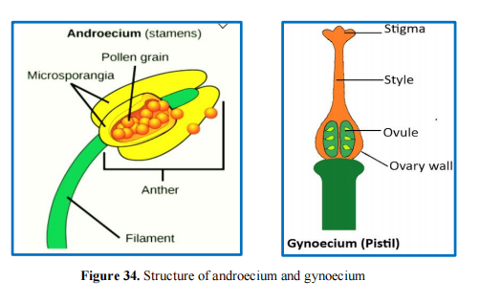

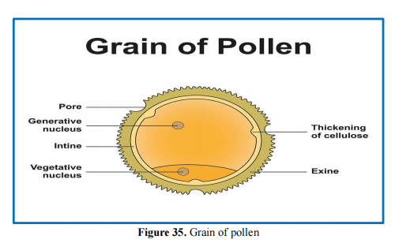

one or more pistils or carpels (see **Figure 34)**. Each pistil consists of several structures:

• **Stigma**: The sticky terminal part of the style that captures pollen grains during

pollination, allowing fertilization to occur **(Esau, 1977).**

• **Style**: A slender, tube-like structure that connects the stigma to the ovary. It provides a

pathway for pollen tubes to grow from the stigma to the ovary **(Fahn, 1990).**

• **Ovary**: The swollen basal portion of the flower that contains one or more ovules, which

house the female gametes. The ovary develops into the fruit after fertilization, enclosing

the seeds **(Thien, 1979).**

The **gynoecium** plays a central role in plant reproduction by facilitating the union of male and

female gametes, ultimately leading to seed formation.

Based on the **position of the ovary** in relation to other flower whorls, the gynoecium can be

classified into three main types (see **Figure 36**) :

• **Hypogynous (superior ovary)**: In this arrangement, the ovary is positioned above all

other floral whorls (sepals, petals, and stamens). Flowers with hypogynous ovaries

typically have a more exposed ovary. Example: *Brassica* **(Esau, 1977).**

• **Perigynous (intermediate ovary)**: Here, the ovary is located at the same level as the

other flower whorls, neither entirely above nor below them. The floral parts (sepals,

petals, and stamens) arise around the ovary, forming a cup-like structure. Example: *Rosa*

**(Fahn, 1990).**

• **Epigynous (inferior ovary)**: In this type, the ovary is positioned below the other flower

whorls and is often surrounded or embedded within the receptacle. This arrangement

helps protect the ovary as the flower develops. Example: *Apple* **(Thien, 1979).**

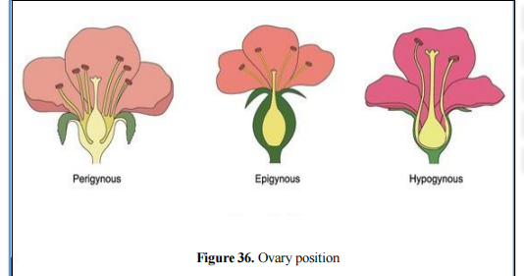

**II.4.2. The inflorescences**

So far we have learned about single or solitary flowers. But, in many plants, the flowers exist in a

bunch on a branch along the same or different floral axis. These clusters or bunches of flowers are

known as an inflorescence. Though the overall structure of the flowers in an inflorescence remains

the same as seen in a solitary flower, the arrangement of these clusters of flowers varies depending

on the type of arrangement of the floral axis.

The two main types of inflorescences are:

• Indetermination inflorescence (Racemose inflorescence)

• Determination inflorescence (Cymose inflorescence)

**II.4.2.1. Indeterminate inflorescence** (Racemose inflorescence)

**Indeterminate inflorescences** are characterized by continuous growth of the main axis, with

flowers developing progressively along the axis, from the base toward the tip (see **Figure 37**).

Below are some common types of indeterminate inflorescences:

• **Spike**: An elongate, unbranched inflorescence in which the flowers are **sessile** (without

stalks). Example: *Plantago* **(Fahn, 1990).**

• **Spikelet**: A small spike, characteristic of grasses and sedges. Each spikelet may contain one

or more flowers. Example: Grasses like *Oryza sativa* **(Esau, 1977).**

• **Raceme**: An elongate, unbranched inflorescence with **pedicelled flowers** (flowers with

stalks). The flowers are arranged along the central axis in an acropetal order (youngest at

the top). Example: *Lupinus* **(Thien, 1979).**

• **Panicle**: A branched raceme, where the main axis produces lateral branches that bear

pedicelled flowers. Example: *Oat* **(Esau, 1977).**

• **Corymb**: A flat-topped or slightly rounded raceme in which the pedicels of lower flowers

are longer, so all flowers reach the same level. Example: *Iberis* **(Fahn, 1990).**

• **Compound Corymb**: A branched corymb with lateral corymbs arising from the central

axis, creating a more complex arrangement. Example: *Hawthorn*.

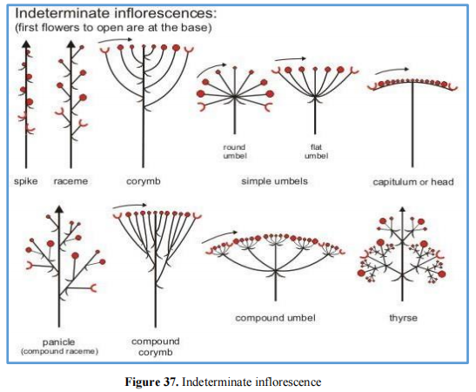

• **Umbel**: A flat-topped or rounded inflorescence where the **pedicels** of all flowers originate

from a common point. Umbels can be determinate or indeterminate. Example: *Allium*

**(Esau, 1977).**

• **Compound Umbel**: A more complex umbel with primary rays originating from a common

point, and secondary umbels (or umbels of umbels) arising from the tip of the primary rays.

Example: *Carrot* (*Daucus carota*).

• **Capitulum (Head)**: A dense, vertically compressed inflorescence with **sessile flowers**

crowded on a common receptacle, often subtended by an involucre of phyllaries

(specialized bracts). This structure is characteristic of the **Asteraceae** family. Heads can be

determinate or indeterminate. Example: *Sunflower* (*Helianthus annuus*) (Fahn, 1990).

• **Thyrse**: A complex, many-flowered inflorescence with an indeterminate central axis and

multiple lateral **dichasia** (determinate clusters of flowers). It is a mixed inflorescence,

exhibiting both determinate and indeterminate growth. Example: *Vitex*.

**II.4.2.2. Determinate inflorescence (Cymose inflorescence)**

In **determinate inflorescences**, also known as **cymes**, the main axis terminates in a flower, and

further growth continues from lateral branches. The flowers develop in a **basipetal** order,

meaning the youngest flowers are at the bottom and the oldest at the top. A classic example of

this type of arrangement is seen in **Jasmine *(*Esau, 1977*).***

• **Simple Cyme or Dichasium**: This is a determinate inflorescence in which the central

flower is flanked by two dichotomous lateral branches. The pedicels (flower stalks) of all

flowers are of equal length, giving the inflorescence a symmetrical appearance. Example:

*Dianthus*.

• **Compound Dichasium**: A **branched dichasium**, where each lateral branch develops its

own dichasium, creating a more complex structure. Example: *Silene*.

• **Compound Cyme**: A **determinate thyrse**, where the lateral branches consist of smaller

cymes, forming a highly branched inflorescence. Example: *Sambucus*.

• **Helicoid Cyme (Bostryx)**: A determinate cyme where only one side of the axis develops,

leading to a coiled or spiral appearance. The branches develop on one side due to the

abortion of the opposing paired bud, resulting in an inflorescence that appears simple.

Example: *Forget-me-not* (*Myosotis*).

• **Cincinnus**: A modified helicoid cyme where the pedicels are very short, causing the flowers

to form a compact, tight structure. Example: *Heliotropium*.

• **Scorpioid Cyme (Rhipidium)**: A determinate cyme with a zig-zag arrangement. The

branches develop alternately on opposite sides of the rachis due to the abortion of the

opposing paired bud, giving the inflorescence a scorpion-like curve. Example: *Ranunculus*.

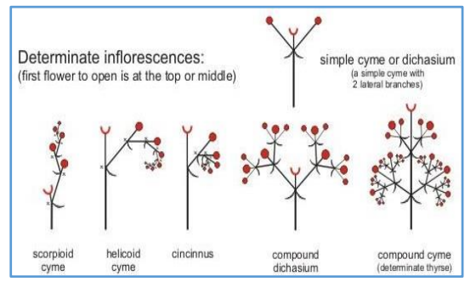

**Figure 38.** Determinate inflorescence

**II.5. Seed morphology**

A **seed** is a fundamental unit of plant reproduction, developing from the **ovules** after

fertilization ***(*Esau, 1977*).*** It consists of a **seed coat** for protection and an **embryo**, which

includes the **radicle** (the embryonic root), **embryonal axis**, and either one or two **cotyledons**.

Monocotyledonous plants, such as wheat and maize, have one cotyledon, while dicotyledonous

plants, like beans and peas, have two ***(*Raven *et al.,* 2005*)***. Seeds are usually housed inside a

fruit, and under suitable conditions, they germinate to form new plants. Thus, the seed is critical

for the dispersal and survival of plant species ***(*Taiz & Zeiger, 2010*).***

**II.5.1. Types and structure of seeds**

**II.5.1.1. Structure of a Monocotyledonous Seed**

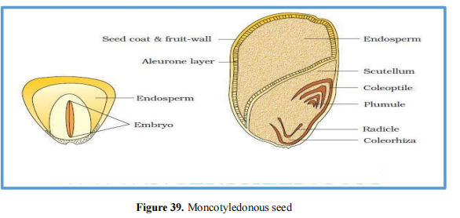

A **monocotyledonous seed**, as the name implies, contains only one **cotyledon (Esau, 1977)**. It has a single outer layer of the **seed coat**, which is often thin and fused with the fruit wall,

forming a protective structure known as the **hull** or **husk (Raven *et al.,* 2005).** The major parts

of a monocot seed include (see **Figure 39)** :

• **Seed Coat**: In cereals like maize, the seed coat is membranous and fused with the fruit wall.

• **Endosperm**: This bulky tissue stores food and provides nourishment to the developing

seedling. Most monocotyledonous seeds are **endospermic**, though some (e.g., orchids) lack

an endosperm **(Taiz & Zeiger, 2010).**

• **Aleurone Layer**: This protein-rich layer forms the outer boundary of the endosperm and

separates it from the embryo.

• **Embryo**: The embryo is small and located in a groove at one end of the endosperm.

• **Scutellum**: The large, shield-shaped cotyledon, specialized for absorbing nutrients from the

endosperm.

• **Embryonal Axis**: Contains the **plumule** (which develops into the shoot) and the **radicle**

(which forms the root).

• **Coleoptile and Coleorhiza**: The plumule and radicle are each enclosed in protective

sheaths, called the **coleoptile** (for the shoot) and **coleorhiza** (for the root), respectively.

**II.5.1.2. Structure of a Dicotyledonous Seed**

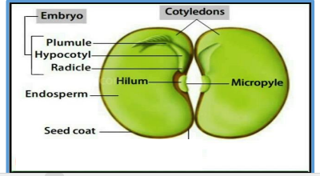

**Figure 40.** Dicotyledonous seed

Unlike monocotyledonous seeds, **dicotyledonous seeds** have two **cotyledons** (see **Figure 40)**

**(Esau, 1977).** The major parts of a dicot seed include:

• **Seed coat**: The protective outer covering of a seed, which consists of two layers—the outer

**testa** and the inner **tegmen**.

• **Hilum**: A scar on the seed coat that marks where the seed was attached to the fruit.

• **Micropyle**: A small pore above the hilum, allowing water absorption during germination.

• **Embryo**: The embryo consists of an embryonal axis and two cotyledons, which are

typically fleshy and store nutrients **(Raven *et al.,* 2005).**

• **Cotyledons**: These contain reserve food materials for nourishing the developing plant.

**Radicle and Plumule**: The radicle, which forms the root, and the plumule, which forms the

shoot, are located at opposite ends of the embryonal axis.

• **Hypocotyl**: The part of the embryonic axis between the radicle and plumule, which

develops into the future stem.

• **Endosperm**: Some dicot seeds, such as castor, are **endospermic**, meaning they retain the

endosperm to store food. In non-endospermic seeds, such as beans and peas, the endosperm

is absent at maturity **(Taiz & Zeiger, 2010).**

**II.5.2. Function of seed**

Seeds serve several important functions beyond germination and food storage:

• **Perennation**: Seeds help plants survive harsh conditions through dormancy, allowing them

to withstand unfavorable environmental factors **(Sundararajan & Mahesh, 2014).**

• **Genetic Diversity**: Seeds promote genetic variation, aiding adaptability and resilience to

changing environments **(Ellstrand *et al.,* 2010).**

• **Dispersal**: Seeds enable plants to spread and colonize new areas via wind, water, animals,

or mechanical forces, preventing overcrowding and enhancing survival **(Howe &**

**Smallwood, 1982).**

• **Ecological Role**: Seeds provide food for many organisms, supporting food webs and overall

ecosystem health **(Gurnell, 1999).**

• **Dormancy**: Seeds can delay germination until conditions are optimal for survival, which is

crucial for timing their growth **(Baskin & Baskin, 2014).**

• **Agricultural Value**: Seeds are essential for crops like wheat, rice, and beans, playing a

vital role in global food security and economic stability **(FAO, 2020).**

**II.5.3. Dispersion of seed**

Seeds are dispersed through different agents and mechanisms:

• Wind

• Animals

• Water

• Explosion

**II.6. Fruit morphology**

After fertilization, the **ovules** develop into seeds, and the **ovary wall** transforms into the

**pericarp** (fruit wall), forming the fruit ***(*Esau, 1977*).*** The fruit's role is to protect the seed and

aid in its dispersal. Occasionally, parts of the plant such as the **bracts**, **calyx**, **style**, and **stigma**

may persist after fertilization.

**Parthenocarpy**, a process where fruits form without fertilization, results in seedless fruits like

bananas and seedless oranges ***(*Raven *et al.,* 2005*).***

**II.6.1. Structure of the fruits walls**

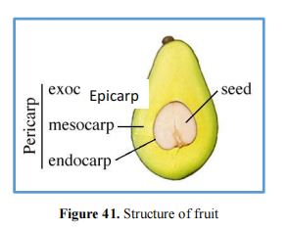

The fruit wall, known as the pericarp, consists of three distinct layers (see **Figure 41**):

• ***Epicarp***: Outermost layer

• ***Mesocarp***: Middle layer

• ***Endocarp***: Innermost layer

**II.6.2. Different types of fruit**

**II.6.2.1. Fruit simple**

Developed from a ***single flower***, with an ovary generally ***mono*** or ***gamocarpellary.***

***a) Indehiscent dried fruits***

These more recent fruits are ***Monosperms (uniseminate)***. The wall of these fruits is

membranous, and more or less lignified (dry pericarp). There are 5 types:

• ***Caropsis***. : ***Samara:*** ***Achene; Nut: ;*** ***Schizocarp***:

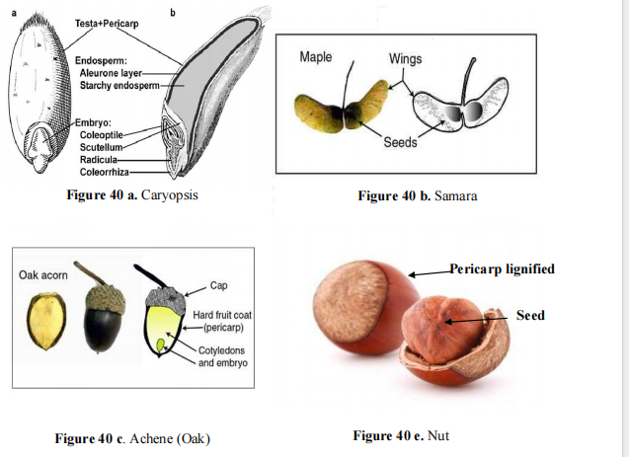

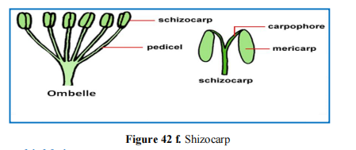

***b) Dehiscent dried fruits***

These fruits are considered the most primitive and are typically multiseminated (polysperms),

containing numerous seeds whose dispersal is facilitated by the fruit's dehiscence. The main types

include:

• **Follicle**:

• **Pod**:

• **Capsule**:

❖ **Septicidal Capsule**:.

❖ **Loculicidal Capsule**:

❖ **Pyxis Capsule**:

❖ **Poricidal Capsule**: .

**Silique**:

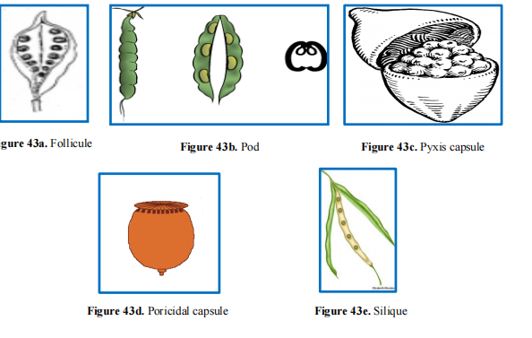

**c) Fleshy fruits (fleshy mesocarps)**

• ***Drupe***: A drupe is a fruit with a fleshy epicarp and mesocarp, and a hardened (lignified)

endocarp. It can be categorized based on the number of seeds **(Esu, 1977; Raven *et al.,***

**2005**

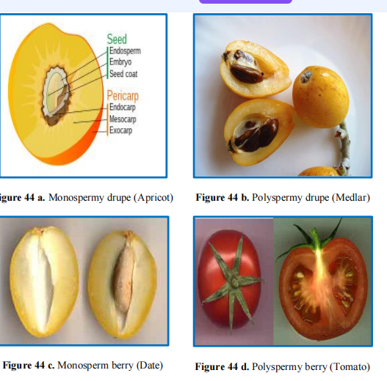

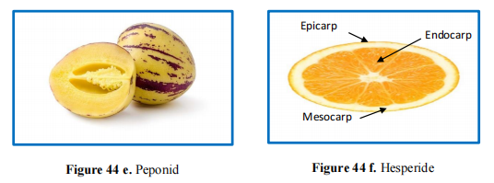

**II.6.2.2. Multiple fruits**

Developed from a single flower, with a dialycarpellate ovary **(Esu, 1977; Raven *et al.,* 2005)**

Developed from the same inflorescence. The unit fruits resulting from the transformation of

each flower can be inseparable, to which can be added the floral receptacle, the axis of the

inflorescence and the floral bracts (*Example*: Pineapple), (see **Figure 47**).

**II.6.2.4. Complex fruits**

Combination of the ovary of the same flower with other floral parts **(Esu, 1977; Raven *et al.,***

**2005)**.

