1. **Algerian standards NA (IANOR)**
2. **Introduction**

The Algerian Institute of Standardization (IANOR), part of the Algerian Industry Ministry, was founded to promote standardization through conformity certifications and to strengthen its presence in international standardization organizations. Standardization involves the creation of standards, defined by consensus among all stakeholders. These standards, although voluntary, may be rendered mandatory by legislation.

IANOR was established to meet Algeria’s specific standardization needs. Its objective is to make Algerian standards compatible with international standards, in particular those of ISO and IEC, to facilitate Algeria’s integration into the global economy.

1. **IANOR standards categories**

The Algerian Institute for Standardization (IANOR) offers an extensive catalogue of more than 11,000 Algerian standards. They are regularly updated and available for sale via the IANOR standards sales service. Some of the IANOR standards are voluntary standards, freely adopted by companies to meet quality, market or customer requirements; While other are mandatory standards, imposed by legislation to protect public interests such as health, safety or the environment. The latter define the minimum criteria to be met by products, goods or services. However, IANOR standards fall into three categories according to their origin and scope:

1. **The Algerian standards (NA)**

Developed by IANOR and stakeholders to meet the country’s standardization needs, these standards are often based on international, regional or Islamic standards, adapted to the Algerian context. They are identified by the prefix NA, followed by a numerical code and a publication date. Example: NA 17001-1:2019, Quality Management Systems - Requirements.

1. **Adopted international standards (NA ISO, NA IEC, etc.)**

These standards are those developed by international standards bodies such as ISO or IEC and adopted by IANOR without modification. They have the prefix NA, followed by the acronym of the organization, the numerical code and the date of publication of the original standard. Example: NA ISO 9001:2015, Quality Management Systems - Requirements.

1. **Adopted foreign standards (NA NF, NA DIN, etc.)**

These standards come from foreign standards bodies such as AFNOR or DIN and are adopted without modification by IANOR as Algerian standards. They are identified by the prefix NA, followed by the acronym of the foreign organization, the numerical code and the date of publication. Example: NA NF EN 206-1:2014, Concrete - Specification, performance, production and compliance.

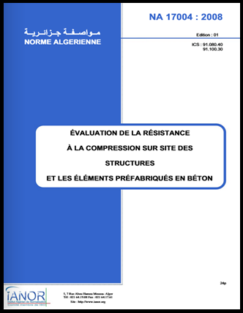

1. **IANOR national technical committees**

IANOR Standardization Institute offers an extensive catalogue of more than 11,000 Algerian standards. These standards, developed by 72 national technical committees, cover a multitude of sectors such as agri-food, construction, energy, environment, health and safety, among others. Here are some examples of committees belonging to the field of civil engineering:

CTN 01 Fundamental standards

CTN 07 Materials

CTN 37 Binders concrete

CTN 39 Building construction

CTN 51 Public works

1. **Algerian standards DTR**
2. **Introduction**

Regulatory Technical Documents (DTR) are official documents that contain the necessary technical information for design, calculation, and construction with various materials in Algeria. These documents are issued by the National Center for Integrated Studies and Research in Buildings (CNERIB) under the authority of the Ministry of Housing, Urban Planning, and the City.

1. **DTR standards categories**

Regulatory Technical Documents can be classified into two main families: construction documents and execution documents. The first family deals with the calculation method, load estimation, and theoretical design purposes, while the second family deals with execution strategies, techniques, and practical guidelines. The contents of these two groups are listed in tables below:

1. **Regulatory technical design documents**

|  |  |  |  |
| --- | --- | --- | --- |
| 1. | DTR BC-2.1 | General verification principles of the building safety | Decree of 07.11.88 |
| 2. | DTR BC-2.2 | Dead loads and live loads | Decree of 07.11.88 |
| 3. | DTR BC-2.31 | Provisional nomenclature of soils and rocks | Decree of 02.08.92 |
| 4. | DTR BC-2.32 | Sol investigation and soils testing methods | Decree of 02.08.92 |
| 5. | DTR BC-2.331 | Calculation regulations of shallow foundations | Decree of 02.11.91 |
| 6. | DTR BC-2.332 | Calculation methods of deep foundations | Decree of 14.08.94 |
| 7. | DTR BC-2.34 | Conception rules of shaft lining | Decree of 31.07.05 |
| 8. | DTR BC-2.4.10 | Conception and design of steel-concrete composite structures | Decree of 31.07.05 |
| 9. | DTR BC- 2.41 | Design and calculation regulations of RC structures CBA93 | Decree of 29.12.93 |
| 10. | DTR BC-2.42 | Design and calculation regulations of shuttered walls and interfaces | Decree of 10.12.97 |
| 11. | DTR BC- 2.44 | Design and calculation regulations of steel structures CCM 97 | Decree of 10.12.98 |
| 12. | DTR BC- 2.48 | Algerian earthquake resistant regulations RPA 99 Version 2003 | Decree of 11.01.04 |
| 13. | DTR C- 2.4 5 | Design and calculation regulations of masonry structures | Decree of 24.07.96 |
| 14. | DTR C -2.4 6 | Design and calculation regulations of wood structures | Decree of 24.01.09 |
| 15. | DTR C -2.4 7 | Snow and wind regulation RNV 1999 | Decree of 25.07.99 |
| 16. | DTR C-3.1.1 | Sound insulation of walls from airborne noise - Calculation regulation | Decree of 27.03.04 |
| 17. | DTR C-3.2 | Regulation for calculating heat loss: Booklet 1 | Decree of 10.12.97 |
| 18. | DTR C-3.31 | Natural ventilation - for residential buildings purposes | Decree of 14.11.05 |
| 19. | DTR C-3.4 | Calculation regulations of input heating of buildings | Decree of 18.08.98 |
| 20. | DTR VRD | Design and implementation of Roads and Miscellaneous Networks | Decree of 14.11.05 |

1. **Regulatory technical execution documents**

|  |  |  |  |
| --- | --- | --- | --- |
| 21. | DTR BE- 1.1 | Sol investigation and soils testing works | Decree of 24.07.96 |
| 22. | DTR BE- 1.2 | Execution regulation of buildings earthworks | Decree of 02.11.91 |
| 23. | DTR BE- 1.31 | Execution regulation of shallow foundations | Decree of 02.11.91 |
| 24. | DTR BE- 1.32 | Deep foundations works | Decree of 29.12.93 |
| 25. | DTR BE- 2.1 | Execution regulation of RC building construction | Decree of 20.02.91 |
| 26. | DTR BE-2.1a | Execution regulation of screeds and slabs based on hydraulic binders | Decree of 27.03.04 |
| 27. | DTR BE-2.1b | Special design regulation for precast RC slabs and flights stairs on horizontal supports | Decree of 27.03.04 |
| 28. | DTR BE- 2.2 | Execution regulation of shuttered walls and interfaces construction | Decree of 20.02.91 |
| 29. | DTR BE- 2.3 | General regulation for the manufacture, transport and installation of exterior walls by prefabricated panels. | Decree of 27.03.04 |
| 30. | DTR E- 2.4 | Small elements masonry works | Decree of 18.01.97 |
| 31. | DTR E- 4.1 | Waterproofing of flat and pitched roofs | Decree of 18.01.97 |
| 32. | DTR E- 4.2 | Sealing joints in large-panel prefabricated buildings | Decree of 24.07.96 |
| 33. | DTR E-4.4 | Thermal insulation and waterproofing of ribbed sheet steel roofs | Decree of 27.03.04 |
| 34. | DTR E- 5.1 | Wood joinery works | Decree of 27.03.04 |
| 35. | DTR E- 5.2 | Steel joinery works | Decree of 18.01.97 |
| 36. | DTR E- 6.1 | Building coating works | Decree of 18.08.98 |
| 37. | DTR E- 6.2.1 | Interior plaster coating work | Decree of 27.03.04 |
| 38. | DTR E- 6.2.3 | Execution of plasterboard cladding: Vertical elements | Decree of 27.03.04 |
| 39. | DTR E- 6.3 | Floor covering installation rules | Decree of 18.08.98 |
| 40. | DTR E- 6.6 | Painting works for buildings | Decree of 29.12.09 |
| 41. | DTR E- 8.1 | Plumbing and sanitary works | Decree of 14.11.05 |
| 42. | DTR E- 10.1 | Execution of electrical installation for residential buildings | Decree of 29.12.09 |
| 43. | RETAB | Algerian technical building regulations RETAB | Edition 2007 |

1. **European standards EUROCODES**
2. **Introduction**

The Eurocodes are the ten European standards (EN; harmonized technical rules) specifying how structural design should be conducted within the European Union (EU). These standards, developed by the European Committee for Standardization, are mandatory for the specification of European public works. Therefore, the Eurocodes replace the existing national building codes published by national standard bodies. Thus, each country is expected to issue a National Annex to the Eurocodes that will need to be referenced for a particular country. The motto of the Eurocodes is "Building the future". Hence, the second generation of the Eurocodes (2G Eurocodes) is being prepared.

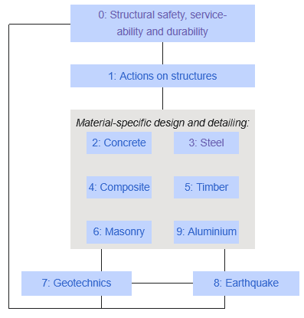

1. **Eurocodes list:**

The Eurocodes are published as a separate European Standards, each having a number of parts. By 2002, ten sections have been developed and published:

* [Eurocode 0](https://en.wikipedia.org/wiki/Eurocode_0:_Basis_of_structural_design): Basis of [structural design](https://en.wikipedia.org/wiki/Structural_design)   (EN 1990)
* [Eurocode 1](https://en.wikipedia.org/wiki/Eurocode_1:_Actions_on_structures): Actions on [structures](https://en.wikipedia.org/wiki/Structure)   (EN 1991)

Part 1-1: Densities, self-weight, imposed loads for buildings   (EN 1991-1-1)

Part 1-2: Actions on structures exposed to fire   (EN 1991-1-2)

Part 1-3: General actions - Snow loads   (EN 1991-1-3)

Part 1-4: General actions - Wind actions   (EN 1991-1-4)

Part 1-5: General actions - Thermal actions   (EN 1991-1-5)

Part 1-6: General actions - Actions during execution   (EN 1991-1-6)

Part 1-7: General actions - Accidental Actions   (EN 1991-1-7)

Part 2: Traffic loads on bridges   (EN 1991-2)

Part 3: Actions induced by cranes and machinery   (EN 1991-3)

Part 4 : Silos and tanks   (EN 1991-4)

* [Eurocode 2](https://en.wikipedia.org/wiki/Eurocode_2:_Design_of_concrete_structures): Design of concrete structures   (EN 1992)

Part 1-1: General rules, and rules for buildings   (EN 1992-1-1)

Part 1-2: Structural fire design   (EN 1992-1-2)

Part 1-3: Precast Concrete Elements and Structures   (EN 1992-1-3)

Part 1-4: Lightweight aggregate concrete with closed structure   (EN 1992-1-4)

Part 1-5: Structures with unbonded and external prestressing tendons   (EN 1992-1-5)

Part 1-6: Plain concrete structures   (EN 1992-1-6)

Part 2: Reinforced and prestressed concrete bridges   (EN 1992-2)

Part 3: Liquid retaining and containing structures   (EN 1992-3)

Part 4: Design of fastenings for use in concrete   (EN 1992-4)

* [Eurocode 3](https://en.wikipedia.org/wiki/Eurocode_3:_Design_of_steel_structures): Design of [steel](https://en.wikipedia.org/wiki/Steel) structures   (EN 1993)

Part 1-1: General rules and rules for buildings   (EN 1993-1-1)

Part 1-2: General rules - Structural fire design   (EN 1993-1-2)

Part 1-3: General rules - Supplementary rules for cold-formed members and sheeting   (EN 1993-1-3)

Part 1-4: General rules - Supplementary rules for stainless steels   (EN 1993-1-4)

Part 1-5: Plated structural elements   (EN 1993-1-5)

Part 1-6: Strength and Stability of Shell Structures   (EN 1993-1-6)

Part 1-7: General Rules - Supplementary rules for planar plated structural elements with out of plane loading   (EN 1993-1-7)

Part 1-8: Design of joints   (EN 1993-1-8)

Part 1-9: Fatigue   (EN 1993-1-9)

Part 1-10: Material Toughness and through-thickness properties   (EN 1993-1-10)

Part 1-11: Design of Structures with tension components   (EN 1993-1-11)

Part 1-12: High Strength steels   (EN 1993-1-12)

Part 2: Steel Bridges   (EN 1993-2)

Part 3-1: Towers, masts and chimneys   (EN 1993-3-1)

Part 3-2: Towers, masts and chimneys - Chimneys   (EN 1993-3-2)

Part 4-1: Silos   (EN 1993-4-1)

Part 4-2: Tanks   (EN 1993-4-2)

Part 4-3: Pipelines   (EN 1993-4-3)

Part 5: Piling   (EN 1993-5)

Part 6: Crane supporting structures   (EN 1993-6)

* [Eurocode 4](https://en.wikipedia.org/wiki/Eurocode_4:_Design_of_composite_steel_and_concrete_structures): Design of composite steel and concrete structures   (EN 1994)

Part 1-1: General rules and rules for buildings   (EN 1994-1-1)

Part 1-2: Structural fire design   (EN 1994-1-2)

Part 2: General rules and rules for bridges   (EN 1994-2)

* [Eurocode 5](https://en.wikipedia.org/wiki/Eurocode_5:_Design_of_timber_structures): Design of [timber](https://en.wikipedia.org/wiki/Timber) structures   (EN 1995)

Part 1-1: General – Common rules and rules for buildings   (EN 1995-1-1)

Part 1-2: General – Structural fire design   (EN 1995-1-2)

Part 2: Bridges   (EN 1995-2)

* [Eurocode 6](https://en.wikipedia.org/wiki/Eurocode_6:_Design_of_masonry_structures): Design of [masonry](https://en.wikipedia.org/wiki/Masonry) structures   (EN 1996)

Part 1-1: General – Rules for reinforced and unreinforced masonry structures  (EN 1996-1-1)

Part 1-2: General rules – Structural fire design   (EN 1996-1-2)

Part 2: Design, selection of materials and execution of masonry   (EN 1996-2)

Part 3: Simplified calculation methods for unreinforced masonry structures   (EN 1996-3)

* [Eurocode 7](https://en.wikipedia.org/wiki/Eurocode_7:_Geotechnical_design): [Geotechnical](https://en.wikipedia.org/wiki/Geotechnical) design   (EN 1997)

Part 1: General rules   (EN 1997-1)

Part 2: Ground investigation and testing   (EN 1997-2)

Part 3: Design assisted by field testing   (EN 1997-3)

* [Eurocode 8](https://en.wikipedia.org/wiki/Eurocode_8:_Design_of_structures_for_earthquake_resistance): Design of structures for [earthquake](https://en.wikipedia.org/wiki/Earthquake) resistance   (EN 1998)

Part 1: General rules, seismic actions and rules for buildings   (EN 1998-1)

Part 2: Bridges   (EN 1998-2)

Part 3: Assessment and retrofitting of buildings   (EN 1998-3)

Part 4: Silos, tanks and pipelines   (EN 1998-4)

Part 5: Foundations, retaining structures and geotechnical aspects   (EN 1998-5)

Part 6: Towers, masts and chimneys   (EN 1998-6)

* [Eurocode 9](https://en.wikipedia.org/wiki/Eurocode_9:_Design_of_aluminium_structures): Design of [aluminium](https://en.wikipedia.org/wiki/Aluminium) structures   (EN 1999)

Part 1-1: General structural rules   (EN 1999-1-1)

Part 1-2: Structural fire design   (EN 1999-1-2)

Part 1-3: Structures susceptible to fatigue   (EN 1999-1-3)

Part 1-4: Cold-formed structural sheeting   (EN 1999-1-4)

Part 1-5: Shell structures   (EN 1999-1-5)

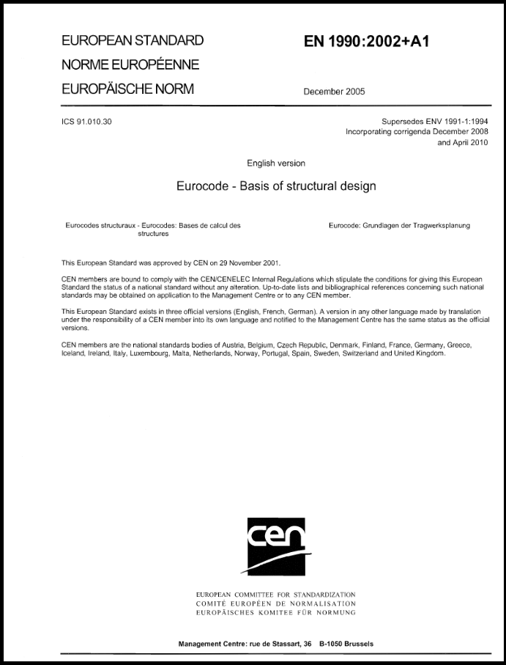

1. **Basis of** [**structural design**](https://en.wikipedia.org/wiki/Structural_design)
2. **Introduction**

Eurocodes provide the principles and requirements for safety and serviceability and outline general guidelines for the structural design and verification of buildings and civil engineering structures. The fundamental requirements stipulate that a structure must be designed and built for its intended lifespan, ensuring that the following is guaranteed:

* The structure should sustain all actions and influences likely to occur during its construction and use, with an appropriate degree of reliability, and remain fit for the use for which it is required, while being constructed in an economical way.
* The structure will not be damaged by events such as explosion, impact or the consequences of human error, to an extent which is disproportionate to the original cause.

The code also defines ways by which potential damage can be avoided or limited. These include:

* avoiding, eliminating or reducing the hazards to which the structure may be subjected;
* selecting a structural form which has low sensitivity to the hazards identified;
* designing the structure to survive adequately the accidental removal of an individual member or a limited part of the structure, or the occurrence of acceptable localized damage;
* avoiding as far as possible structural systems that can collapse without warning;
* tying the structural members together.

In addition, the basic requirements are met by:

* choosing suitable materials;
* appropriate design and detailing;
* specifying control procedures for design, production, construction and use that are relevant to the particular project.

These requirements should be satisfied for the entire design working life of the building.

Table II - 1: Indicative design working lives for various structure types

|  |  |  |
| --- | --- | --- |
| Design working life category | Indicative design  working life (years) | Examples |
| 1 | 10 | Temporary structures |
| 2 | 10 to 30 | Replaceable structural parts, e.g. gantry girders, bearings |
| 3 | 15 to 25 | Agricultural and similar structures |
| 4 | 50 | Building structures and other common structures, not limited elsewhere in this table |
| 5 | 120 | Monumental building structures, highway and railway bridges, and other civil structures |

1. **Design situations**

Design according to the structural Eurocodes follows ‘Limit State’ principles. The two principal limit states for which the structure needs to be designed are the ultimate limit state (ULS) and the serviceability limit state (SLS).

1. **Ultimate limit state (ULS)**

The ultimate limit state concerns the safety of people and the structure. However, it also concerns the protection of the contents such as certain chemicals, nuclear or even masterpieces in a museum. The conditions that should be checked under ULS are given as follows:

* Loss of static equilibrium (EQU) of the structure (or any part of it) when considered as a rigid body. This can be thought of as ‘overturning’.
* Internal failure or excessive deformation of the structure or its structural members, including footings, piles, basement walls, etc. This generally concerns the strength of the materials of a structure, or the stability of its members.
* Failure or excessive deformation of the ground or foundations on which the structure sits.
* The other condition covered in general terms is the fatigue failure of the structure or its structural members.

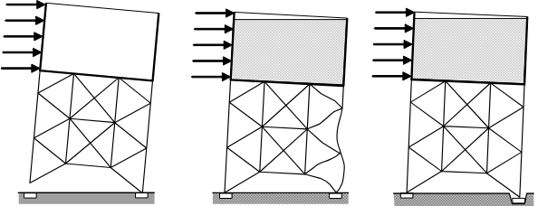

Figure II - 1 : Ultimate limit state conditions

The design situations under which ULS design checks may be performed are:

* persistent design situations, which concern the conditions of normal use.
* transient design situations, which concern temporary conditions applicable to the structure (e.g. during construction or repair).
* accidental design situations, which concern exceptional conditions applicable to the structure or to its exposure (e.g. fire, explosion, impact or the consequences of localized failure).
* seismic design situations, which concern conditions applicable to the structure when subjected to earthquake and other seismic events.

1. **Serviceability limit state (SLS)**

The serviceability limit state (SLS) concerns the comfort of people and the deformation of the structure and its structural members, if they allow the building to function properly in its normal intended use. However, it also concerns the appearance of the finished building.

Checking of serviceability limit state should be based on criteria concerning:

* deformations (deflections) which affect the appearance of the building, the comfort of users, or the way of building structure (including machines or services within it) functions.
* deformations which cause damage to finishes (e.g. cracking of plaster) or non-structural members.
* vibrations which cause discomfort to people, or which limit the functional effectiveness of the building.

1. **Actions**

The term action is used in the Eurocodes in order to group together generically all external influences on a structure’s performance. It encompasses loading by gravity and wind, but includes also vibration, thermal effects, fire and seismic loading.

Separate combinations of actions are used to check the structure for the design situation being considered. For each of the particular design situations an appropriate representative value for each action is used. These main actions are:

* permanent actions G: self-weight of structures and fixed equipment.
* variable actions Q: imposed loads on building floors and beams, snow loads on roofs, wind loading on walls and roofs.
* accidental actions A: fire, explosions, seismic and impact.

1. **Permanent actions**

The characteristic value of a permanent action (Gk) may be a single value if its variability is known to be low (e.g. the self-weight). If the variability of G cannot be considered as small, and its magnitude may vary from place to place in the structure, then an upper value Gk,sup and a lower value Gk,inf may occasionally be used.

1. **Variable actions**

Up to four types of representative value may be needed for the variable and accidental actions. The types most commonly used for variable actions are:

* the characteristic value Qk and combinations of the characteristic value with other variable actions, multiplied by different combination factors:
* the combination value Qk
* the frequent value Qk
* the quasi-permanent value Qk

Explanations of the representative values and the design situations in which they arise are given below. The ‘’ factors generally reduce the value of a variable action present in an accidental situation compared with the characteristic value.

The combination value is used for checking the ultimate limit states and the irreversible serviceability limit states (e.g. deflections which fracture brittle fittings or finishes). The combination factor reduces Qk because of the low probability of the most unfavorable values of several independent actions occurring simultaneously.

The frequent value is used for checking the ultimate limit states involving accidental actions and the reversible serviceability limit states, primarily associated with frequent combinations. In both cases the reduction factor multiplies the leading variable action.

The frequent value Qk of a variable action Q is determined so that the total proportion of a chosen period of time during which Q exceeds Qk is less than a specified small part of the period.

The quasi-permanent value is used for checking the ultimate limit states involving accidental actions and reversible serviceability limit states. Quasi-permanent values are also used for the calculation of long-term effects (e.g. cosmetic cracking of a slab) and to represent combinations of variable seismic actions. The quasi-permanent value Qk is defined so that the total proportion of a chosen period of time during which Q exceeds Qk is a considerable part (more than half) of the chosen period.

1. **Load combinations for design**
2. **Principal**

Design values (Ed) of the effects of actions are determined by combining the values of actions (e.g. self-weight and imposed occupancy loads) which are considered by the designer to be capable of occurring simultaneously.

The simplest, and most common, design case for ULS of an isolated structural member, such as a beam or slab, is a factored combination of the primary permanent and variable loadings:

‘Dead + Imposed’ … (Eq II-1)

in which and are the partial safety factors for the permanent and principal variable actions Gk and Qk respectively.

If wind force is combined with dead and imposed loadings, then the effect of wind acting simultaneously with these gravity-induced loads is reduced because of the relatively low probability of extreme values of all the elements of the combination.

‘Dead + Imposed+ Wind’ … (Eq II-2)

The ‘combination factor’ is an example from a range of such factors specified in Eurocode 0. In both previous equations the imposed load Qk,1 is the leading variable action; wind loading is classified as an accompanying action, and thus acquires a combination factor.

Table II - 2: Recommended values of factors for buildings

|  |  |  |  |
| --- | --- | --- | --- |
| **Action** |  |  |  |
| Imposed loads in buildings, category  Category A : domestic, residential areas  Category B : office areas  Category C : congregation areas  Category D : shopping areas  Category E : storage areas  Category F : traffic area, vehicle weight ≤30kN  Category G : traffic area, 30kN < vehicle weight ≤ 160kN  Category H : roofs | **0.7**  **0.7**  **0.7**  **0.7**  **1**  **0.7**  **0.7**  **0** | **0.5**  **0.5**  **0.7**  **0.7**  **0.9**  **0.7**  **0.5**  **0** | **0.3**  **0.3**  **0.6**  **0.6**  **0.8**  **0.6**  **0.3**  **0** |
| Snow loads on buildings  Sites located at altitude H > 1000 m a.s.l.  Sites located at altitude H ≤ 1000 m a.s.l. | **0.7**  **0.5** | **0.5**  **0.2** | **0.2**  **0** |
| Wind loads on buildings | **0.6** | **0.2** | **0** |
| Temperature (non-fire) in buildings | **0.6** | **0.5** | **0** |

**Note:** In creating design load combinations, each combination of actions should include a permanent action and a leading variable action.

1. **General combinations of simultaneous actions for STR and GEO limit states**

In Eurocode 0 the various possibilities of design load combinations for persistent or transient design situations for the STR and GEO limit states are presented in the following very general form in which: “+” implies to be combined with and “Ʃ” implies the combined effect of.

… (Eq II-3)

Where the results are sensitive to variations of the magnitudes of permanent actions from place to place in the structure, the unfavorable and favorable parts of this action are considered individually. Consequently, the load case should be taken as the less favorable of:

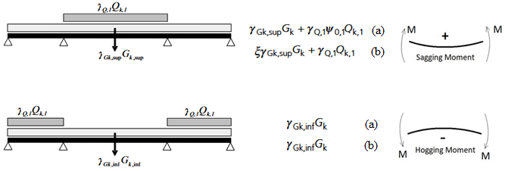 … (Eq II-3-a)

… (Eq II-3-b)

: is a reduction factor for unfavorable permanent actions G

1. **Partial safety factors for different persistent and transient design situations**

As discussed above, each design situation requires selection of appropriate partial safety factors for its analysis. The subsequent tables present various partial safety factors for analysis at ULS

Table II - 3: Design values of actions(EQU)

|  |  |  |  |  |  |
| --- | --- | --- | --- | --- | --- |
| Persistent and transient design situations | Permanent actions | | Leading  variable  action | Accompanying variable  actions | |
| Unfavorable | favorable | Main (if any) | Others |
| (Eq II-3) |  |  |  |  |  |
| = 1,10  = 0,90  = 1,50 where unfavorable (0 where favorable).  = 1,50 where unfavorable (0 where favorable). | | | | | |

Table II - 4: Design values of actions(STR/GEO)- for structural members

|  |  |  |  |  |  |
| --- | --- | --- | --- | --- | --- |
| Persistent and transient design situations | Permanent actions | | Leading  variable  action | Accompanying variable  actions | |
| Unfavorable | favorable | Main (if any) | Others |
| (Eq II-3) |  |  |  |  |  |
| (Eq II-3-a) |  |  |  |  |  |
| (Eq II-3-b) |  |  |  |  |  |
| = 1,35  = 1,00  = 1,50 where unfavorable (0 where favorable).  = 1,50 where unfavorable (0 where favorable).  = 0,85 (so that = 0,85 x 1,35 = 1,15). | | | | | |

Table II - 5: Design values of actions (STR/GEO)- for nonstructural members

|  |  |  |  |  |  |
| --- | --- | --- | --- | --- | --- |
| Persistent and transient design situations | Permanent actions | | Leading  variable  action | Accompanying variable  actions | |
| Unfavorable | favorable | Main (if any) | Others |
| (Eq II-3) |  |  |  |  |  |
| = 1,00  = 1,00  = 1,30 where unfavorable (0 where favorable).  = 1,30 where unfavorable (0 where favorable). | | | | | |

1. **Partial safety factors for different accidental and seismic design situations**

The partial factors for actions for the ultimate limit states in the accidental and seismic design situations should be 1,0. values are given in Table (II-2).

Table II - 6: Design values of actions for use in accidental and seismic combinations of actions

|  |  |  |  |  |
| --- | --- | --- | --- | --- |
| Permanent actions | | Leading variable action | Accompanying variable actions | |
| Unfavorable | favorable | Main (if any) | Others |
|  |  |  | or |  |
|  |  |  |  | |

1. **Partial factors for actions in serviceability limit states**

For serviceability limit states the partial factors for actions should be taken as 1,0 except if differently specified in EN 1991 to EN 1999.

Table II - 7: Design values of actions for serviceability limit states

|  |  |  |  |  |
| --- | --- | --- | --- | --- |
| Combination | Permanent actions *G*d | | Variable actions *Q*d | |
| Unfavorable | favorable | Leading | Others |
| Characteristic |  |  |  |  |
| Frequent |  |  |  |  |
| Quasi-permanent |  |  |  |  |

**Example**

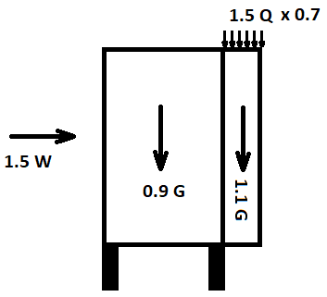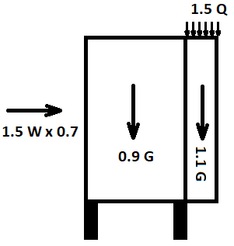

Wind is the leading variable action Life loads is the leading variable action