***DW2***

**Exercise 1**

A concrete pole with a circular cross-section resting vertically on a rigid foundation is subjected to a force F acting along its axis.

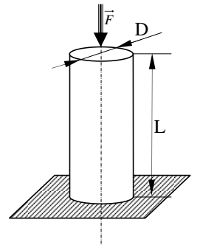

1. What type of load is the pole subjected to?
2. Calculate the normal stress in the pole.
3. Check the strength of the pole.
4. Calculate the axial deformation of the pole.
5. Calculate the change in length ∆L.

Given: IFI = 106 N, D = 30 cm, L = 3 m, σe = 25 MPa, E = 104 N/mm².

**Exercise 2**

A trailer is towed by a steel hitch bar with a square cross-section, and it is subjected to the force F.

1. What type of load is the bar subjected to?
2. Find the minimum cross-section of the bar so that it can withstand the force F.
3. Calculate the change in length ∆L.

Given: F = 8000 N, L = 2 m, σe = 36 daN/mm², E = 2 × 10⁵ N/mm², Safety factor = 3.

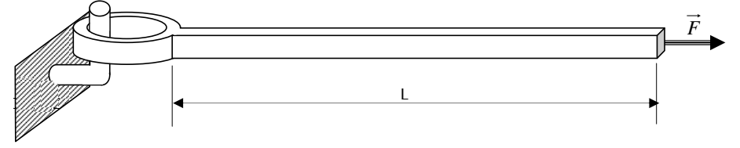

**Exercise 3**

A steel cable of length L, made up of 7 twisted wires each with a diameter d, lifts a load Q.

1. What type of load is the cable subjected to?
2. Calculate the stress in the cable.
3. Check the strength of the cable.
4. Calculate the axial deformation of the cable.
5. Calculate the change in length of the cable.

Given: Q = 1.2 t, d = 2.5 mm, L = 10 m, E = 210,000 MPa, σe = 420 MPa, safety factor = 1.2.

