***DW3***

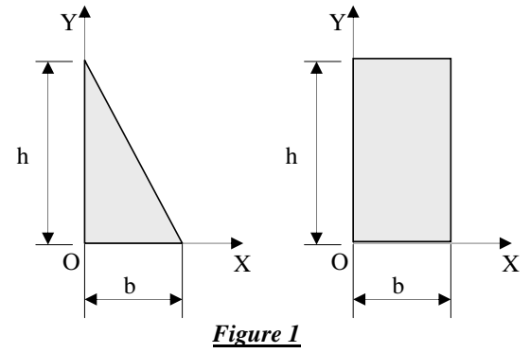

**Exercise 1**

* Calculate the coordinates XG and YG of the centers of gravity of the sections of Figure 1.

**Exercise 2**

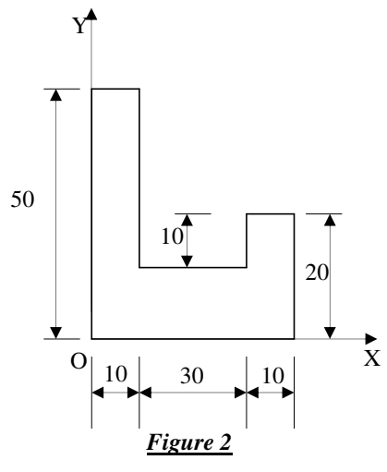

1. Calculate the coordinates XG and YG of the centers of gravity of the sections of Figure 2.
2. Calculate the quadratic moments IOX and IOY of the section in Figure 2 (cm)

**Exercise 3**

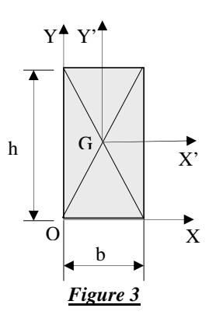

1. Calculate the quadratic moments IGX' and IGY' of the section in Figure 3.
2. Calculate the quadratic moments IOX and IOY of this section.