**Module: American Civilization**

**Lesson 1: Colonial Period**

**Level: Second Year**

**Groups: 1/2/3/4**

**Lecturer: Dr. Rania Khelifa Chelihi**

1. **Objectives:**

By the end of this lesson, students will be able to:

1. Identify the major groups of settlers in the British colonies and their reasons for migration.
2. Compare and contrast the economic, social, and political structures of the New England, Middle, and Southern colonies.
3. Analyze the relationship between European settlers and Native Americans.
4. Explain how British political changes influenced colonial self-government.
5. **Pre-requisites:**

To be able to properly follow the lesson of American Early Cultures, the students must have some prior knowledge, likewise:

* Students should be familiar with regions like the Southwest and Midwest, and how the environment shaped different cultures.
* Learners should be familiar with one or more groups of Native American peoples.

**Warm-up:**

1. What do you already know about the American colonies?
2. Why do you think European countries wanted to colonize North America?
3. How might colonization have affected the Indigenous peoples living there?

**Introduction**

The **Colonial Period of American history** was a time of **exploration, settlement, and transformation. Beginning in 1607 with the establishment of Jamestown** and culminating in the years leading up to **the American Revolution**, this era saw the rise of European colonies in **North America**. Most settlers who came to the British colonies in the 1600s were **English.** Others came from The **Netherlands, Sweden, Germany, France**, and later from **Scotland and Northern Ireland**. Some **left their homelands to escape war, political oppression, religious persecution, or a prison sentence**. Some left as s**ervants** who expected **to work their way to freedom**. **Black Africans** were sold into **slavery and arrived in shackles**. By **1690**, the population was **250,000**. Less than 100 years later, it had climbed to **2.5 million**.

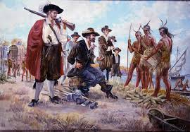

1. **Settlement and Demographics**

Most settlers who came to the British colonies in the **1600s** were **English**. Others came from The **Netherlands, Sweden, Germany, France, and later from Scotland and Northern Ireland**. Some left their homelands **to escape war**, political oppression, religious persecution, or a prison sentence. Some left as servants who expected to work their way to freedom. **Black Africans were sold into slavery and arrived in shackles.**

By **1690**, the population was **250,000**. Less than **100 years later**, it had climbed to **2.5 million.**

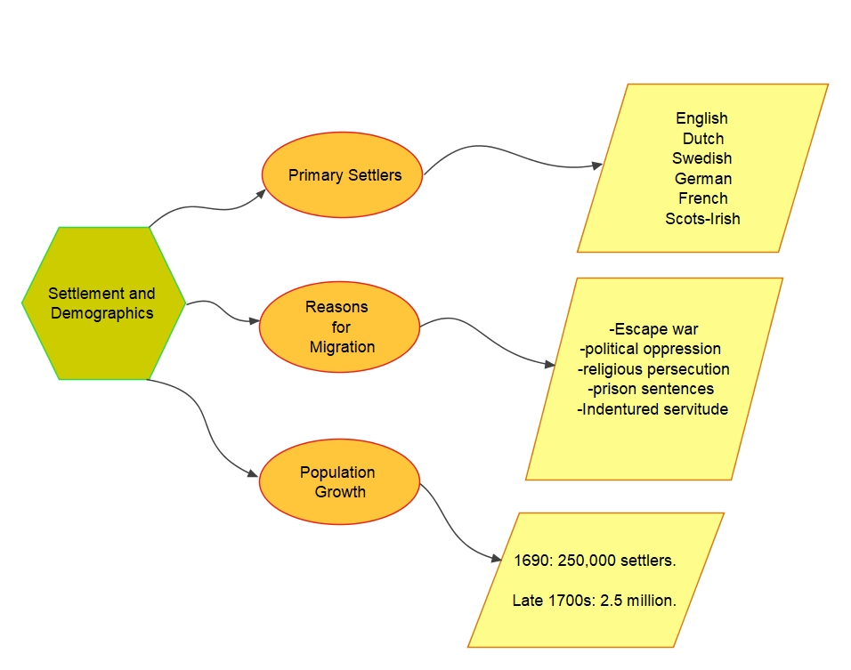

Figure 1Settlement and Demographics

1. **Regional Differences Among Colonies**

The settlers had many different reasons for coming to America, and eventually 13 distinct colonies developed here. Differences among the three regional groupings of colonies were even more marked.

[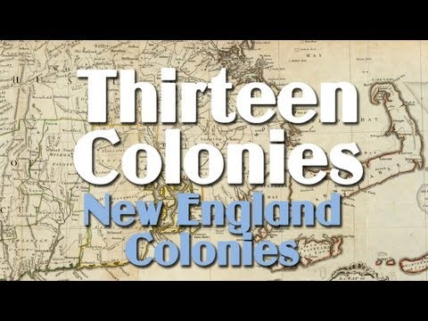](https://www.youtube.com/watch?v=4ScZh2-QLOE)

1. **New England Colonies (Massachusetts, Connecticut, Rhode Island)**

The first settlements were built along the Atlantic coast and on the rivers that flowed to the ocean. In the Northeast, settlers found hills covered with trees and soil filled with stones left behind when the Ice Age glaciers melted. Water power was easy to harness, so “New England” — including Massachusetts, Connecticut, and Rhode Island — developed an economy based on wood products, fishing, shipbuilding, and trade.

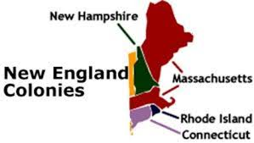

|  |  |
| --- | --- |
| **Geography** | Rocky soil, forests, harsh winters. |
| **Economy** | Shipbuilding, fishing, timber, trade. |
| **Society** | Religiously homogeneous (Puritans), less slavery. |

1. **Middle Colonies (New York, Pennsylvania, New Jersey, Delaware)**

The middle colonies including (New York and Pennsylvania) had a milder climate and more varied terrain. Both industry and agriculture developed there, and society was more varied and cosmopolitan. In New York, for example, one could find Bohemians, Danes, Dutch, English, French, Germans, Irish, Italians, Norwegians, Poles, Portuguese, Scots, and Swedes.

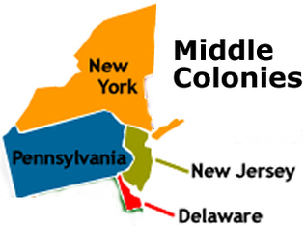

|  |  |
| --- | --- |
| **Geography** | Fertile soil, milder climate. |
| **Economy** | Mixed farming (wheat, corn), trade, small industries. |
| **Society** | Ethnically diverse (Dutch, German, Irish, Scandinavian, etc.). |

1. **Southern Colonies (Virginia, Carolinas, Georgia)**

The Southern colonies (Virginia, Georgia, and the Carolinas) had a long growing season and fertile soil, and the economy was primarily agricultural. There were both small farmers and wealthy aristocratic landowners who owned large plantations worked by African slaves.

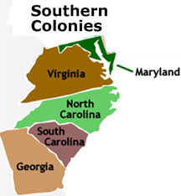

|  |  |
| --- | --- |
| **Geography** | Warm climate, fertile soil, long growing season. |
| **Economy** | Cash crops (tobacco, rice, indigo), plantation system. |
| **Society** | Wealthy landowners vs. small farmers; reliance on enslaved labor. |

1. **Settler-Native American Relations**

Relations between settlers and Native Americans, who were called Indians, were an uneasy mix of cooperation and conflict. Certain areas saw trade and some social interaction, but in general, as the new settlements expanded, the Indians were forced to move, often after being defeated in battle.

For more details, visit this website: <https://education.nationalgeographic.org/resource/native-americans-colonial-america/>

[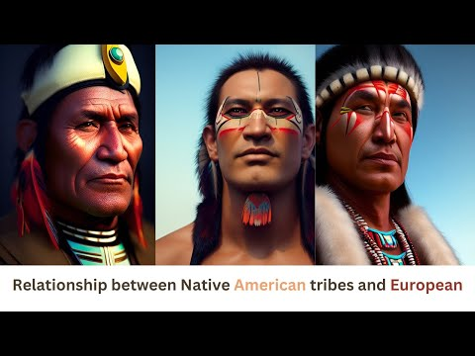](https://www.youtube.com/watch?v=AhmZnWQsgF8)

1. **Colonial Governance**

Settlement of the colonies was directly sponsored not by the British government, but by private groups. All except Georgia emerged as companies of shareholders or as proprietorships chartered by the king. Some were governed rigidly by company leaders, but in time, all developed a system of participatory government based on British legal precedent and tradition.

Years of political turmoil in Britain culminated with the Glorious Revolution of 1688-89 that deposed King James II and led to limits on the monarchy and greater freedoms for the people. The American colonies benefited from these changes. Colonial assemblies claimed the right to act as local parliaments. They passed measures that limited the power of royal governors and expanded their own power.

Over the decades that followed, recurring disputes between the governors and assemblies awakened colonists to the increasing divergence between American and British interests. The principles and precedents that emerged from these disputes became the unwritten constitution of the colonies.

At first, the focus was on self-government within a British commonwealth. Only later came the call for independence.

**Conclusion**

The American British colonies developed distinct regional identities via geography, economy, and culture. Settlers and Native Americans both worked together and conflicted with one another, as colonial self-government grew in British neglect. These initial pillars of diversity, autonomy, and resistance would be the catalyst for the American independence movement.

Exercise: Watch the video and answer the following questions (submission deadline 20/04/2025)

[**https://youtu.be/YOIWRc-kmk0?si=ytiUdIgW0uDvCKzX**](https://youtu.be/YOIWRc-kmk0?si=ytiUdIgW0uDvCKzX)

[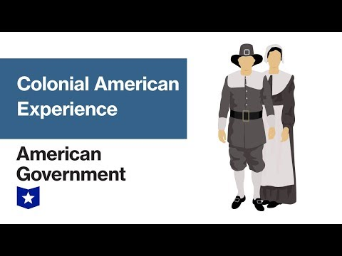](https://www.youtube.com/watch?v=YOIWRc-kmk0)

1. According to the video, what were two major reasons Europeans migrated to the colonies?
2. How did the video describe the economy of the Southern Colonies compared to New England? Give one key difference.