**Haut du formulaire**

Haut du formulaire

Haut du formulaire

***Chapter IV :***

***Mortars***

**IV.1. Introduction**

Mortar has been an essential building material for millennia, evolving over time both in terms of composition and application techniques.

1. **Ancient Civilizations:**

* The earliest traces of mortar usage date back to Ancient Mesopotamia, where clay mortars were used to bind clay bricks together.
* The ancient Chinese used lime-based mortars to construct some of their most famous buildings, including the Great Wall of China.

1. **Roman Civilization:00**

* The Romans perfected the art of mortar-making. They introduced a material known as *pozzolanic cement*, which combined lime with pozzolana (volcanic ash). This mixture was not only strong but also had the ability to harden underwater, enabling the construction of underwater structures like harbors.

1. **The Middle Ages:**

* During the Middle Ages, lime-based mortar was widely used across Europe. However, the quality of mortar often varied depending on local techniques and available materials.

1. **19th Century:**

* The discovery and commercialization of Portland cement in the 19th century marked a revolution in mortar composition. Portland cement provided much higher strength and durability than traditional lime-based mortars.

1. **Modern Era:**

* Today, mortar technology continues to evolve. Additives and plasticizers are commonly mixed into mortar to enhance its workability, setting time, and other properties.

Throughout history, mortar has played a crucial role in the construction of durable and resilient structures. Its formulation and application have been refined over the centuries, reflecting technological advancements and the changing needs of civilizations.

**IV.2. Definition**

Mortar is one of the construction materials used to bind elements together, ensure the stability of the structure, and fill the gaps between building blocks.

Mortar is obtained by mixing a binder (lime or cement), sand, water, and, optionally, additives. Various mortar compositions can be created by adjusting different parameters: binder (type and dosage), admixtures and additives, and water content. Regarding the binder, all types of cement and lime can be used; their choice and dosage depend on the structure to be built and its environment.

The mixing time should be optimal in order to achieve a homogeneous and consistent mixture.

Mortars can be:

* Prepared on-site by measuring and mixing the various components, including admixtures.
* Prepared on-site using pre-mixed dry industrial mortars, where only the required amount of water needs to be added before use.
* Delivered from a batching plant: these are ready-to-use mortars.

Industrial mortars have developed significantly in recent years, helping to avoid the storage and mixing of components on construction sites

**IV.3. Composition**

Mortar is one of the construction materials that contains cement, water, sand, admixtures, and optionally, additives. These components can vary greatly from one mortar to another depending on the nature and percentages of the constituents, the mixing process, the application, and the curing method. Mortars are made from mixtures of:

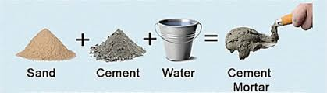

**Figure IV.1.** Mortar components

* Binder (cement or lime)
* Water
* Sand
* Admixtures

**Binders:**  
 Generally, the following binders can be used:

* Standardized cements (gray or white)
* Special cements (such as fused alumina, etc.)
* Natural hydraulic limes
* Slaked limes

**Sand:**  
 Typically, the sand used is referred to as "standardized sand." Sand of good granulometry should contain fine, medium, and coarse grains. The fine grains fit into the gaps between the larger grains, filling the voids. They play an important role: they reduce volume variations, the heat released during curing, and even the cost. Dosages are usually measured by weight rather than by volume, to avoid dosage errors due to the volume increase of wet sand.

Certain sands should be avoided, particularly "rabbit sands," which are usually very fine, raw sands that lack fines, and sands from dunes or the sea, which contain salts harmful to cement constituents. However, the sand should always be clean.

The maximum diameter of the grains of sand used for mortar is as follows:

* Extra-fine: up to 0.8 mm (on a sieve), or 1 mm (on a mesh)
* Fine: up to 1.6 mm
* Medium: up to 3.15 mm
* Coarse: up to 5 mm

**Admixtures:**  
 Admixtures are chemical products used in concrete applications. They modify the properties of the concrete and mortar to which they are added in small proportions (around 5% of the weight of the cement). Mortars can contain various types of admixtures:

* Plasticizers (water reducers)
* Set modifiers (retarders, accelerators)
* Water repellents (hydrophobic agents)

In all cases, special care must be taken to ensure that the mortar is free of bleeding and remains homogeneous from one batch to the next.

**Additives:**

Additives used in mortars include:

* Fine pozzolanic powders (such as ashes, silica fume, etc.)
* Fibers of various types
* Dyes (natural or synthetic)
* Polymers

**VI.4. Different Types of Mortar:**

In public works, different types of mortar are used:

* **Cement Mortars:**

Cement mortars are highly resistant, setting and hardening quickly. The typical mix ratio of cement to sand is volumetric, 1:3, and the water-to-cement ratio is about 0.35. Additionally, the high cement content makes these mortars almost impermeable.

* **Lime Mortars:**

Lime mortars are less resistant compared to cement mortars. The hardening time for lime mortars is slower than for cement mortars.

* **Composite Mortars (Bâtards):**

These are mortars where the binder is a mixture of cement and lime. Typically, lime and cement are used in equal parts, but sometimes the amount of one or the other is adjusted depending on the intended use and desired quality.

. **VI.4.1. Mortars Made on Site:**

These are prepared with the cement and sand available on-site. The cement used is usually a standard CPA or CPJ cement. The sand is typically rolled (silico-calcareous nature), sometimes crushed, and mixing is done either manually with a shovel or using a small concrete mixer. As a result, these mortars are not very consistent, and the sand may vary from one delivery to another. However, the sand must be clean and have good granulometry.

The sand is generally measured by weight (which is preferable) or by volume (in the case of small projects). In the latter case, it is essential to account for the phenomenon of sand bulking (expansion when wet).

**IV.4.2. Industrial Mortar:**

Industrial mortars are made from carefully selected dry components, packaged in bags, controlled in factories, and highly consistent. To use this type of mortar, you simply add the required amount of water and mix it before applying. Industrial mortars may contain various binders, sands, admixtures, and sometimes colorants. Manufacturers of industrial mortars offer a wide range of products designed for various applications, including:

* Plastering mortars
* Waterproofing mortars
* Thermal insulation mortars
* Grouting mortars
* Repair mortars
* Tile adhesives for plaster or cement bases, etc.

**VI.5. Main Characteristics of Mortars:**

The primary characteristics of mortars are:

* Workability
* Setting time
* Mechanical strength
* Shrinkage and swelling, etc.

To evaluate mortar characteristics, the standard reference mix is often used: a 1:3 mix by weight, consisting of one part cement and three parts of standardized sand, with grain sizes ranging from 80 microns to 2 mm, passing through a well-defined grading zone. The water-to-cement ratio is typically 0.45. This mortar is mixed and placed into metal molds according to standardized methods. Rheological tests, and possibly setting time and heat of hydration, are carried out on this mortar. Many laboratory tests are done on prisms measuring 4 x 4 x 16 cm (including tests for mechanical strength, shrinkage, swelling, capillary absorption, freeze-thaw resistance, and resistance to aggressive water).

**VI.5.1. Workability:**

The workability of a mortar is measured using various apparatus, with the most well-known being the **shock table**. After the mortar is placed and demolded from a conical mold, it receives 15 shocks over 15 seconds. The diameter of the resulting spread is then measured. The spread, expressed as a percentage, is given by the formula:

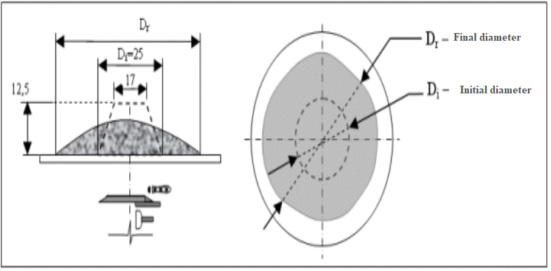

**Figure.IV.2.** shock table test

Spread %=((Dr−Di)/Di)×100

Where:

* Dr ​ = final diameter
* Di ​ = initial diameter

**VI.5.2. Setting Time:**

The setting time is typically measured on pure cement paste of normal consistency (24 to 30% water) using a Vicat apparatus, according to the relevant standards. It is also possible to measure the setting time of mortar using the same apparatus, but with a 700-gram weight placed on the upper platform. The needle used for penetration weighs 1,000 grams.

* **Initial setting time** is when the needle stops 2.5 mm from the bottom of the mold (the size of the largest sand grains).
* **Final setting time** is when the needle stops 2.5 mm from the top of the mold.

**VI.5.3. Mechanical Strength:**

Tests are often conducted on 4 x 4 x 16 cm prismatic specimens, which are kept in water at 20°C. The specimens are broken by flexural tensile testing and then by compression. The strength values, both for flexural tensile and compression, progress roughly as a logarithmic function of time (from 1 to 28 days).

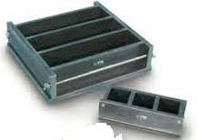

**Figure.IV.3.** Mold for casting mortar specimens

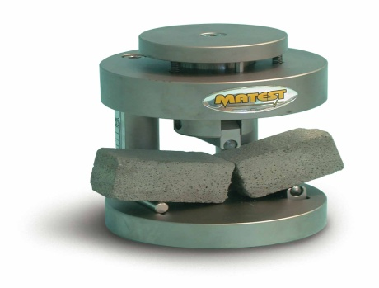

**FigureIV.4.** Device for flexural strength testing

The strength of mortars (similar to concrete) depends on many factors, including:

* The nature and dosage of the cement
* The water-to-cement ratio
* The granulometry and type of sand
* The mixing energy and application method
* Protection during the first few days of curing

**VI.5.4. Shrinkage and Swelling:**

Shrinkage is measured on 4 x 4 x 16 cm prisms of 1/3 mortar (one part cement to three parts sand). After demolding, the prisms are kept in a chamber at 20°C and 50% relative humidity. Mortar tends to shrink faster than pure cement paste, but its shrinkage is generally 2 to 3 times lower than that of pure paste (using the same cement).

Swelling (which occurs when the mortar is kept in water) is measured using the same 4 x 4 x 16 cm specimens kept submerged in water at 20°C. Swelling is usually quite low.

**Apparatus for measuring shrinkage**

**Important Notes:**

* Mortar should be used immediately, before it begins setting.
* Any mortar that has dried out or started to set cannot be used.
* The practice of "reworking" (re-tempering) mortar is not allowed.
* The flatness of finished surfaces must not exceed a tolerance of 5 mm over a 2-meter length