**Chapter 1: Introduction and Hypotheses**

1. **Introduction**

In statics, we study the equilibrium of systems assumed to be rigid, without concerning ourselves with the magnitude of the mechanical forces they are subjected to. However, in reality, we know that systems can only safely withstand limited forces; otherwise they risk deforming dangerously or even breaking. The science that studies the resistance and deformation of structures is called the resistance of materials or strength of materials. An essential tool for engineers and technicians, this science is approximately 400 years old; Galileo, Hooke, Bernoulli, Coulomb, and Navier are its main founders.

Strength of Materials has three essential objectives:

* Understanding the characteristics of materials,
* Studying the strength of parts and structures,
* Studying the deformations of parts and structures.

1. **Hypotheses**

The SM requires simplifying hypotheses regarding the geometry and materials of the objects studied for its correct application.

* 1. **Geometry**

The most studied solid in SM is the beam, which is the subject of this course. A beam is a solid generated by a plane surface (S) (fig. 1) whose center of gravity describes a curve called the neutral axis, which must satisfy the following two conditions:

* Its radius of curvature must be at least 5 times greater than the largest dimension of (S).
* Its length must be at least 5 times greater than the largest dimension of (S).

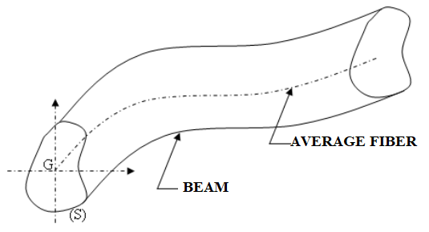

***Fig.1****: A beam*

In the general case, (S) can vary along the average fiber. If (S) is constant, then the beam is said to have a constant section. (Fig. 2)

In the general case, the average fiber is curved. If the average fiber is a straight line, the beam is said to be straight.

The "average fiber" of a beam refers to an imaginary line that runs along the length of the beam, representing the neutral axis where the material experiences no tension or compression during bending. This concept is essential in understanding how beams deform under loads. The average fiber helps in analyzing stress distribution and determining how the beam will behave structurally.

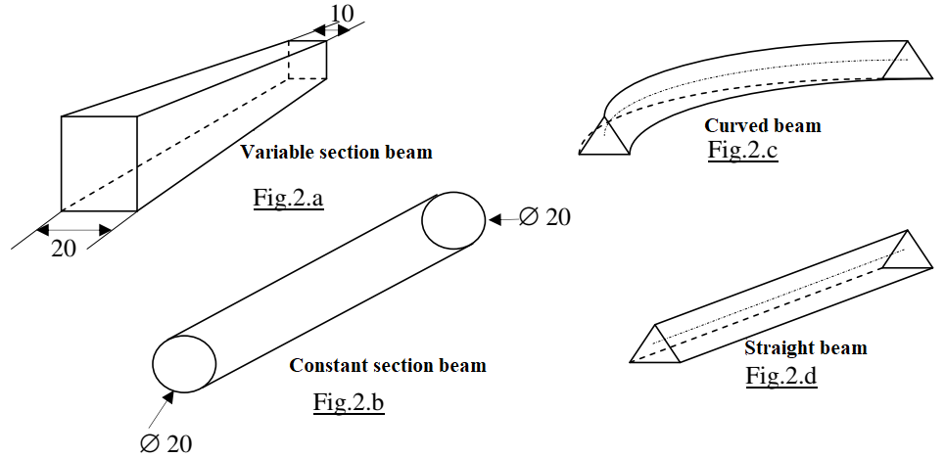

***Fig. 2:*** *Special Cases*

* 1. **Material**

The solids studied in Strength of Materials (SM) must be made from homogeneous, isotropic, and linear elastic materials.

* + 1. **Homogeneity**

A material is considered homogeneous "at a certain scale" if it exhibits constant properties at each point at that scale. For studying a heterogeneous material (like concrete), one must choose specimens or structural elements whose largest transverse dimension is at least ten times greater than the largest heterogeneity (aggregate). At this scale, the material can be modeled as homogeneous.

* + 1. **Isotropy**

A material is said to be isotropic if it possesses the same properties in all directions.

* + 1. **Elasticity**

A material is considered elastic if it returns to its original dimensions after being loaded and then unloaded. It is classified as linear elastic if the deformations are proportional to the applied forces.

* 1. **Additional Assumptions**

In addition to the stated assumptions, the solids studied must meet the following additional criteria:

* **Navier-Bernoulli Assumptions**: The plane sections along the average fiber must remain flat after deformation.
* **Saint-Venant Principle**: The results obtained from strength calculations only apply at a sufficiently distant location from the concentrated force application areas and joints.
* **Small Deformation Assumption**: The deformations must be small compared to the dimensions of the beam.

1. **Supports**

The beams studied are connected externally by supports, which generate reactions at their points of contact. The reactions and applied loads form a system of forces in equilibrium.

The classification of supports is based on the number of degrees of freedom (DOF) they allow the beam and the nature of the reactions they can exert. In a planar context, three types of supports are distinguished:

**a) Simple Support**

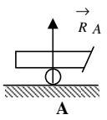

A simple support is characterized by 2 degrees of freedom

and 1 component of reaction.

The two degrees of freedom are:

* Rotation around the support,
* Translation parallel to the support.

The reaction is known by its point of application (the contact point with the support) and its direction (perpendicular to the support). Only the intensity remains to be determined.

**b) Double Support (Hinge)**

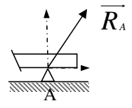

A double support or hinge is characterized by 1 degree of freedom

and two components of reaction.

The degree of freedom is:

* Rotation around the support.

The reaction of the support is known only by its point of application (the contact point with the support). The reaction is decomposed into two perpendicular directions, with both components needing to be determined.

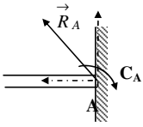

**c) Fixed Support**

A fixed support is characterized by no degrees of freedom

and three components of reaction:

* Two components along two perpendicular directions passing through point A,
* A couple applied at point A.