**CHAPTER1  
THE ENVIRONMENT AND ITS ELEMENTS**

**1. Concept of Ecological Niche**

Organisms of a given species can only maintain viable populations under certain conditions, for specific resources, in a given environment, and during particular periods. The overlap of these factors describes **the niche**, which is the position that the organism occupies in its environment, including the conditions in which it is found, the resources it uses, and the time it spends there.

Organisms can change niches as they develop.

**Example:** Common toads occupy an aquatic environment (feeding on algae and detritus) before metamorphosing into adults, where they become terrestrial (feeding on insects).

**2. Concept of Habitat**

Unlike the niche, the habitat of an organism is the physical environment in which an organism is found.

Habitats contain many niches and support numerous different species.

**Example:** A forest contains a vast number of niches for a variety of birds (nuthatches, woodcocks), mammals (wood mice, foxes), insects (butterflies, beetles, aphids), and plants (wood anemones, mosses, lichens).

**3. Concept of Environmental Factors**

An "ecological factor" is any element of the environment that can directly affect living beings.

Ecological factors are of two types:

**Abiotic factors:** The set of physical-chemical characteristics of the environment such as climatic factors (temperature, rainfall, light, wind...), edaphic factors (soil texture and structure, chemical composition,...)...

**Biotic factors:** The set of interactions that exist between individuals of the same species or different species: predation, parasitism, competition, symbiosis, commensalism, etc.

**4. Interaction of the Environment and Living Beings**

The reactions of living beings to variations in the physical-chemical factors of the environment affect morphology, physiology, and behavior.

Living beings are either completely eliminated, or their numbers are greatly reduced when the intensity of ecological factors is close to or exceeds the limits of tolerance.

A. **Law of Tolerance (Range of Tolerance)**

Stated by Shelford in 1911, the law of tolerance states that for every environmental factor, there is a range of values (or tolerance range) within which any ecological process dependent on that factor can proceed normally. It is only within this range that the life of a particular organism, population, or biocenosis is possible. The lower bound along this gradient marks death by deficiency, the upper bound marks death by toxicity. Within the tolerance range, there is an optimal value, called the "preferendum" or "ecological optimum," at which the metabolism of the species or community in question proceeds at maximum speed (Fig.01).

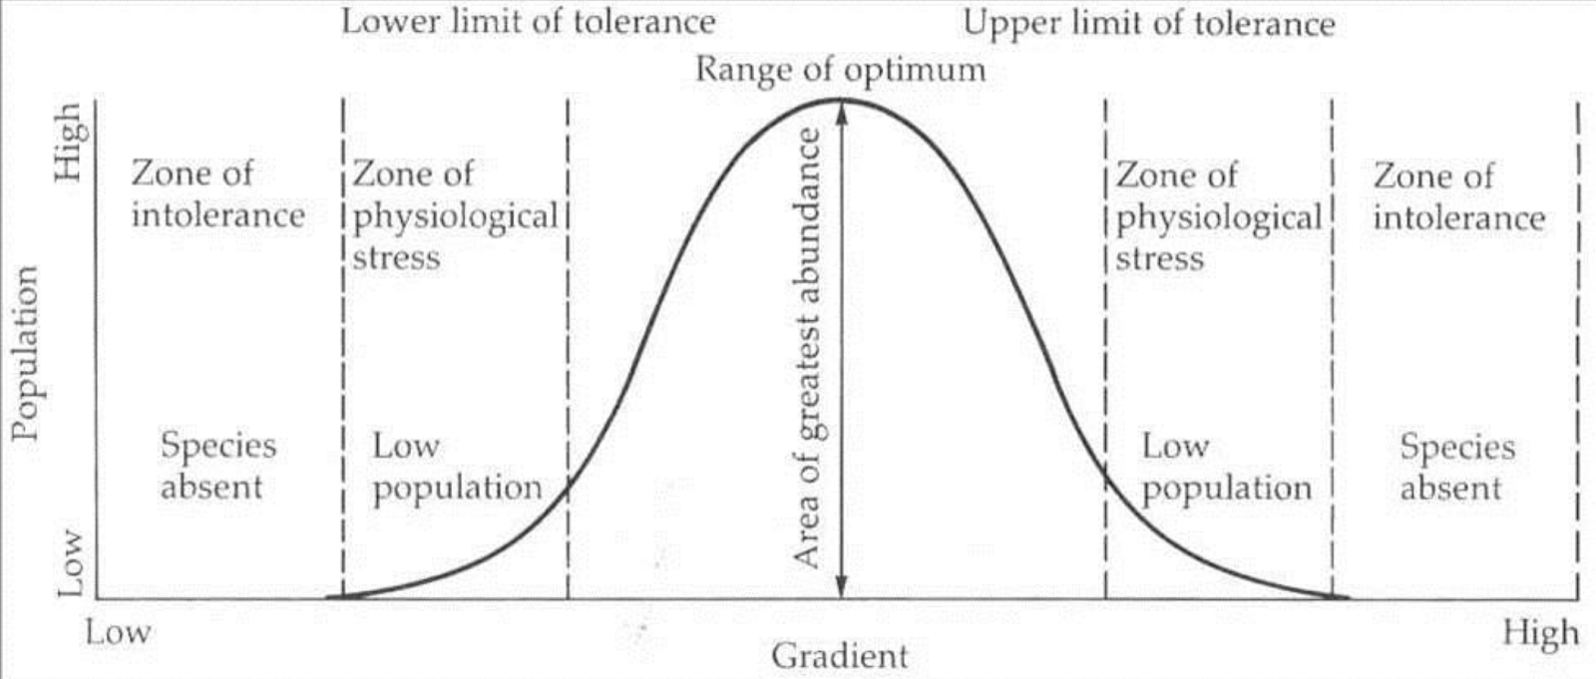

***Figure 01:****Tolerance limits of a species as a function of the intensity of the ecological factor studied.*

The ecological valence of a species represents its ability to withstand more or less significant variations of an ecological factor. It represents the ability to colonize or populate a given biotope.

* A species with high ecological valence, i.e., capable of populating very different environments and withstanding significant variations in the intensity of ecological factors, is called **euryoecious.**
* A species with low ecological valence can only withstand limited variations in ecological factors and is called **stenoecious**.
* A species with medium ecological valence is called **mesoecious**.

B. **Law of the Minimum**

Liebig (1840) formulated the law of the minimum, which states that the growth of a plant is only possible if all the elements necessary for its growth are present in sufficient quantities in the soil. It is the deficient elements (whose concentration is below a minimum value) that condition and limit growth.

Liebig's law is generalized to all ecological factors in the form of a law called the "law of limiting factors."

C. **Limiting Factor**

An ecological factor acts as a limiting factor when it is absent or reduced below a critical threshold or when it exceeds the maximum tolerable level. It is the limiting factor that will prevent the establishment and growth of an organism in an environment.