

CELL BIOLOGY TP0

Work and safety rules - Presentation of equipment

In each area of work there are methods and safety rules that allow us to work in complete safety and achieve good results.

1. Purpose of the TP

* Give some safety rules and the working method in a laboratory.
* Presentation of material
* Pictograms

1. The method of working in a laboratory and the safety rules
   1. Working methods
2. Each student must wear a blouse. 2- Each student must have a practical workbook.
3. Only minimal quantities must be used during reactions.
4. We must always cap the reagent bottles after taking the indicated quantity.
5. Never pour excess reagents into the initial bottle. 6- We take the dry reagents using a spatula.
6. At the end of the work, you must always wash (the tubes, test tubes, etc.), and return the

equipment in order and in place.

1. Keep the work surface clean.
2. the work in the laboratory must end with a practical work report.

2.2. Security rules 1- Wear a cotton blouse.

1. Carry out all operations very carefully.
2. Never pipette by mouth, but using a propipette.
3. It is forbidden to point towards oneself (the face) the openings of the test tubes or a container in which a reaction occurs.
4. Never eat or smoke in a laboratory.
5. Never bring a flame near flammable products.
6. Any reaction with toxic substances must be carried out under the hood.
7. Never move your authorization.
8. It is prohibited to carry out planned work. 10- Never take hot objects with your hand.

11- Prohibited from heating gaseous substances in closed containers.

# Definition of some handling equipment

* 1. The graduated pipette

The pipette allows you to measure liquid volumes. Pipettes are generally used with a pro pipette.



Using the pipette

* Pour the liquid into a beaker.
* Adjust the pro pipette to the pipette.
* Aspirate to raise the liquid to the desired graduation.
* Allow the liquid to flow into a second container.

## Test piece

There are several sizes of graduated cylinders and graduated name.



* 1. The burette



The burette allows you to measure cumulative volumes. The burette is mainly used for dosages.

* 1. The volumetric pipette (with one or two marks)

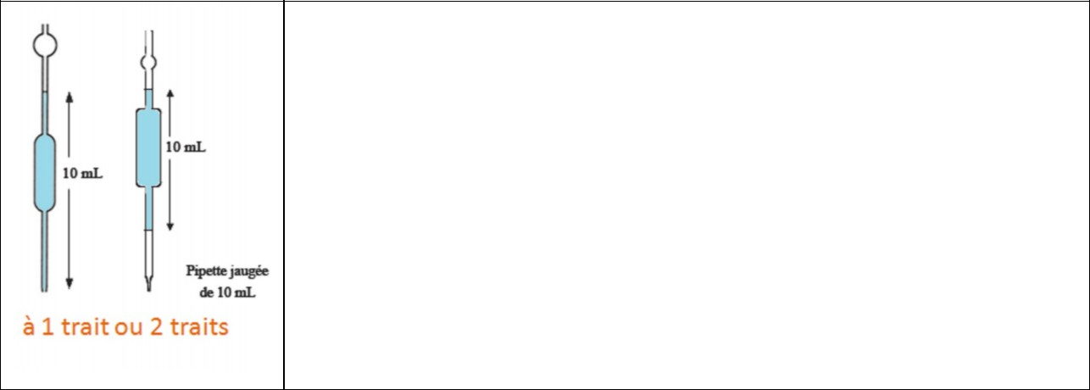

The volumetric pipette allows you to accurately measure small volumes of liquids.

There are only certain volumetric pipette volumes: 2 mL, 5 mL, 10 mL and 20 mL.

There are several pipette sizes. Pay attention to reading: parallax and meniscus.

The volumetric pipette is generally used with a pro pipette.

* 1. The volumetric flask



The volumetric flask allows you to measure a volume with good precision. Thus, it is used for:

* Preparation of solution of given concentration.
* The dilution of a solution.
* Reading is done at the level of the gauge line.
  1. The spatula



The spatula allows you to take samples of solids in

powder or in small pieces.

* 1. The propipette

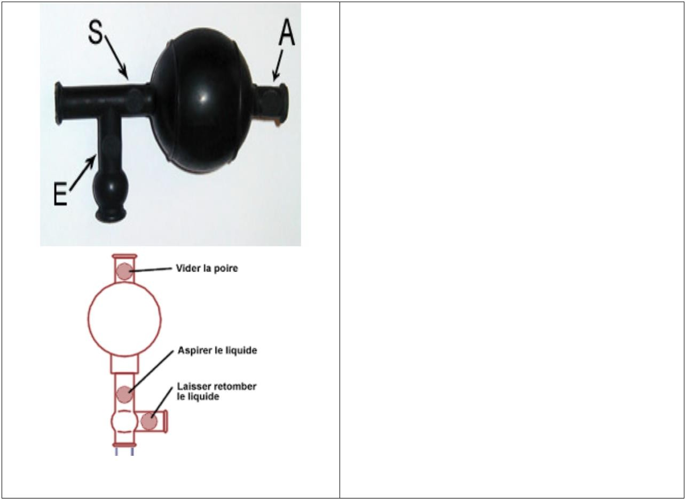

The pro pipette is used with a graduated pipette or a volumetric pipette. It allows you to aspirate to raise the liquid in the pipette, to maintain or let this liquid flow.

Using the propipette Preparing the propipette: Attach the pro pipette to the pipette (on the side opposite the bulb). Tap locationHASand press on the pear to empty it. Pressing the locationSallows the liquid to be sucked up. Pressing the locationE allows the liquid to flow.

* 1. The wooden clamp



Wooden tongs allow you to handle glassware

hot.

## Test tubes

* 1. The Beaker



The test tube is used for reactions involving

small amounts of reagents. A test tube can receive a

cork. In addition it can be heated.



The beaker used for:

- Store chemicals (before sampling for example).

- Make some reactions. -Although graduated, the Beaker cannot

used to measure a volume of liquid. In fact the graduations do not

are only indicative.

* 1. The Erlenmeyer flask

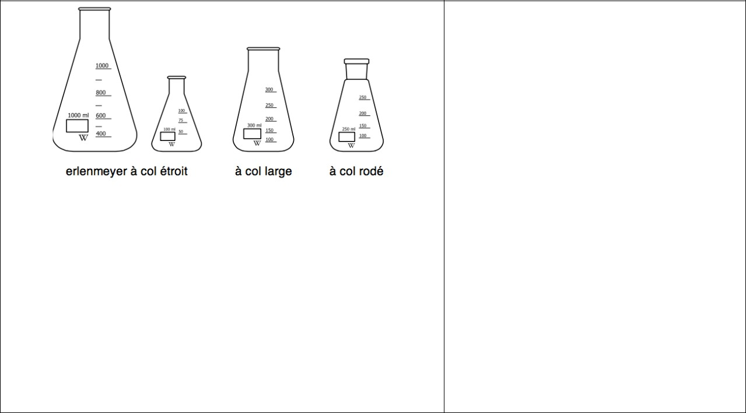

GOOD

that

graduated,

The Erlenmeyer flask is often used with a stopper.

It allows:

* to temporarily store volatile chemicals,
* to carry out chemical reactions with

volatile compounds.

The Erlenmeyer cannot be used to measure a volume of liquid. In fact the graduations are

indicative only. Finally, the

Erlenmeyer flask allows (in

general) use

of a

wooden clamp, and therefore

heating its contents.

* 1. The stemmed glass



Graduated and graduated name. The stemmed glass is generally used

as trash.

1. 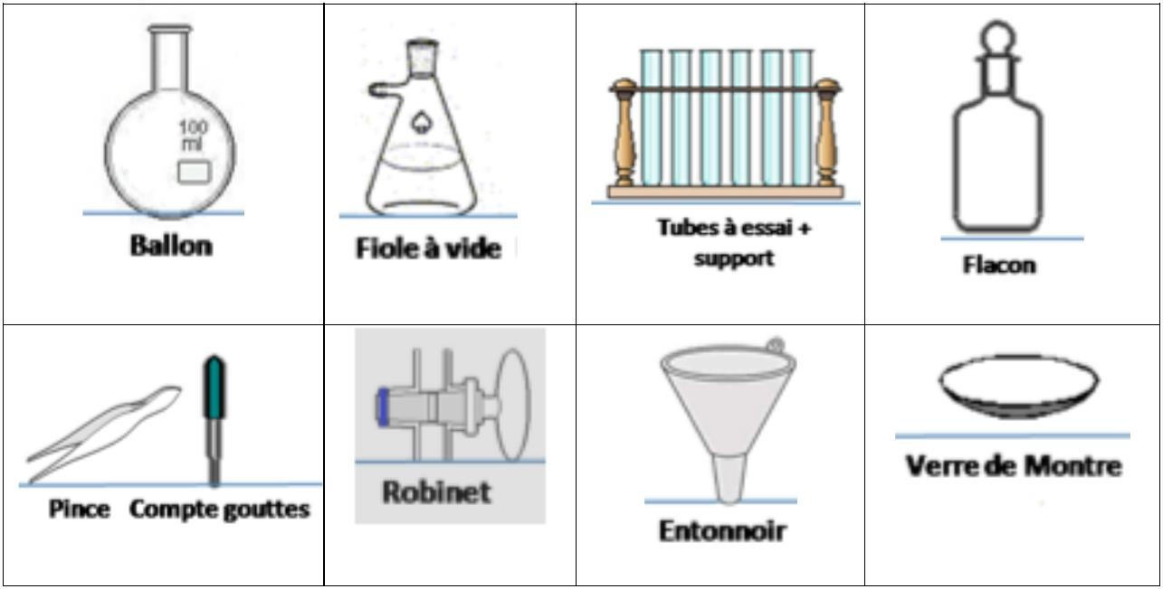Other glassware

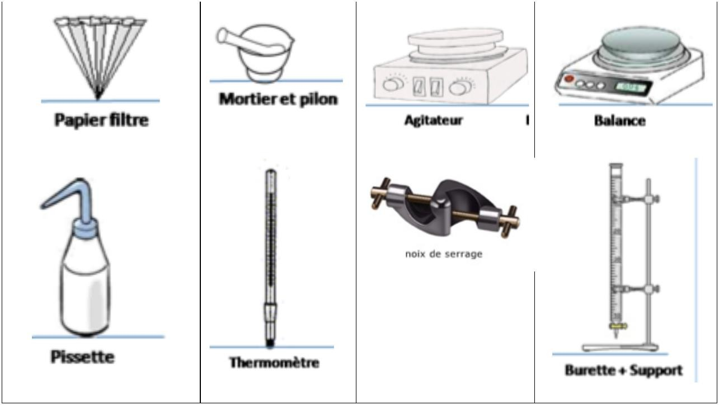

# Safety pictograms in the lab

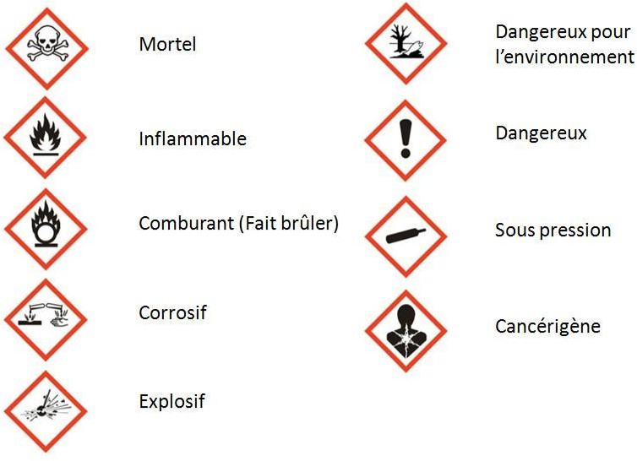

## CONCLUSION

At the end of each practical session, you must tidy up the bench, wash your hands with soap and remove the gown just before leaving the room.