### Chapter 1: The Microbial World

### ****Introduction****

Microbiology is the scientific study of microorganisms, which are organisms too small to be seen with the naked eye. These microorganisms, often referred to as microbes, include bacteria, unicellular fungi (e.g., yeasts and molds), protozoa, certain algae, and viruses. A common characteristic of all microorganisms is that they can only be observed under a microscope due to their size (1 µm). Viruses, being the smallest, require an electron microscope for detailed observation (10- 100nm). The field of microbiology focuses on understanding these microscopic life forms, including their structure, physiology, reproduction, and ecological roles. Microorganisms have existed for billions of years and exhibit remarkable diversity. They can exist as single cells, in colonies, or in populations that interact with one another. While bacteria, fungi, protozoa, and algae are living organisms capable of independent life processes, viruses are acellular and depend entirely on host cells for reproduction.

**1-** **Historical background**

**1-1- The theory of spontaneous generation**

In ancient times, the theory of spontaneous generation suggested that living organisms could arise from **non-living matter** or inanimate matter (Mud, food scraps, decaying wood, stagnant water..etc) . This idea was widely accepted until it was disproven by **Francesco Redi** (1626-1697). Through experiments with decaying meat, Redi showed that maggots came from fly eggs and not from the meat itself, challenging the spontaneous generation theory.

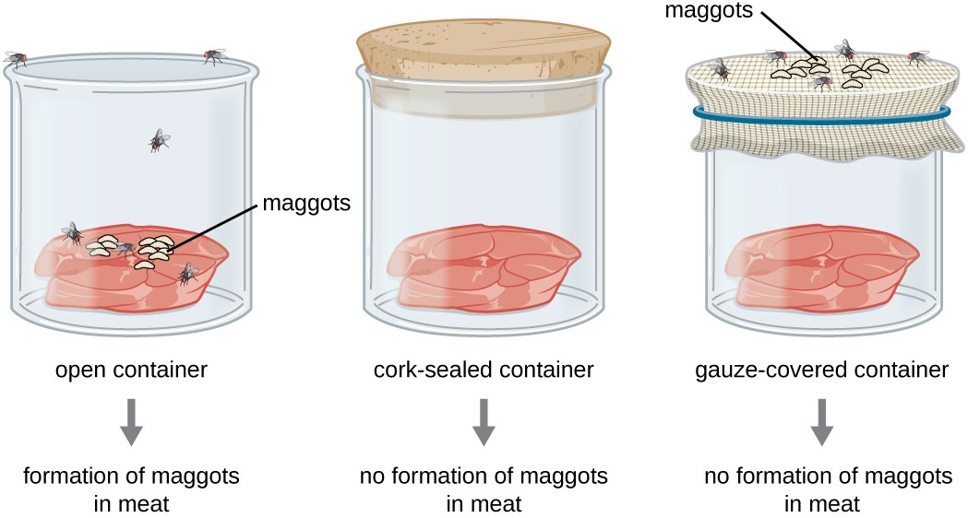

**Figure 1** : Maggot Formation in Open, Sealed, and Mesh-Covered Containers in Francesco Redi's Experiment

**1-2- The First Observation of Microorganisms**

**Antonie van Leeuwenhoek** (1632-1723) made significant contributions by designing simple microscopes and being the first to observe microorganisms. He described these tiny life forms as "animalcules," revealing the existence of a previously unseen world.

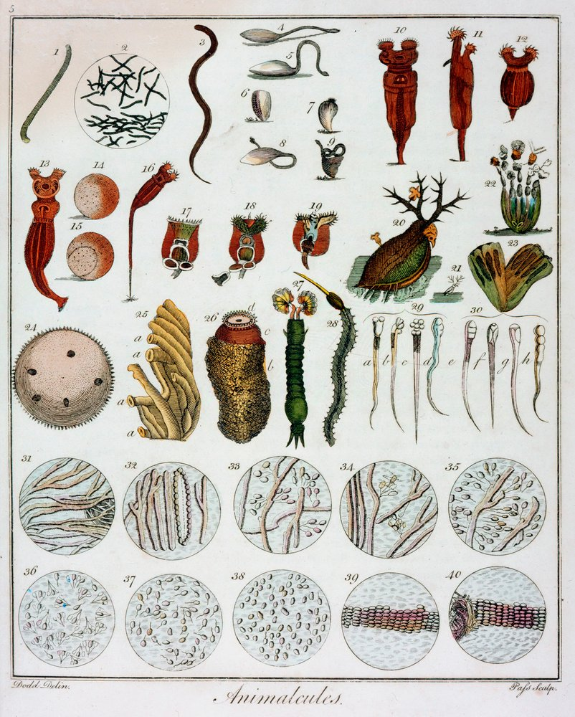

**Figure 2:** Animalcules observed by **Leeuwenhoek** (1632-1723).

**1-3- The 19th century: The birth of modern microbiology**

**Louis Pasteur** (1822-1895) and **Robert Koch** (1843-1910) are considered pioneers in microbiology. Pasteur’s experiments disproved spontaneous generation and showed that microorganisms originate from the air, not inanimate matter. He also developed pasteurization and vaccines, contributing to the microbial theory of infectious diseases.

**Robert Koch** developed techniques for isolating and culturing bacteria, which allowed him to identify ***Bacillus anthracis*** as the causative agent of anthrax and ***Mycobacterium tuberculosis*** as the cause of tuberculosis. His work laid the foundation for medical microbiology and public health

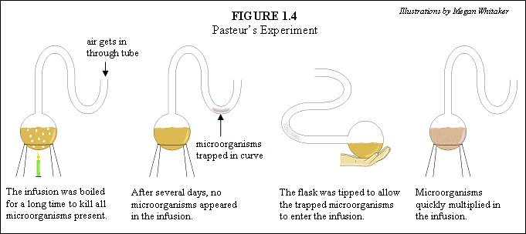

**Figure 3:** Pasteur’s experiment

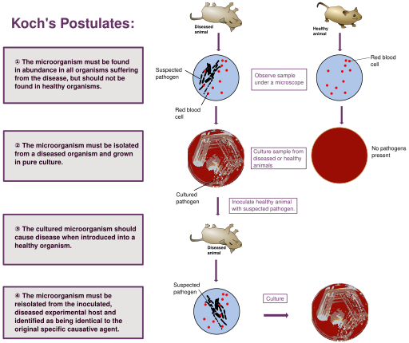

**Figure 4** : Koch’s postulates

**1-4- Additional contributions**

* **Edward Jenner** (1796) developed the first vaccine for smallpox, which marked a major milestone in the prevention of infectious diseases.
* **Alexander Fleming** (1928) discovered **penicillin**, a groundbreaking antibiotic that revolutionized the treatment of bacterial infections.
* In modern times, **Craig Venter** (1995) and his team sequenced the first bacterial genome (***Haemophilus influenzae***), marking the advent of molecular microbiology and genomic studies.

**2- The position of microorganisms in the living world**  
Microorganisms are incredibly diverse, and classifying them has always been a challenge. Initially, they were simply categorized as plants or animals. However, this approach was too basic, as some microorganisms have traits of both. For example, some move like animals but also have cell walls or perform photosynthesis like plants.  
To address this complexity, several scientists proposed new systems of classification:

**2-1- Carl von Linné (1735): Introduced the first two-kingdom system**

* Plantae: Plants
* Animalia: Animals

**2-2-** **Karl von Nägeli (1857): Suggested placing bacteria and fungi in the plant kingdom**

* Because of their cell walls

**2-3-** **Ernst Haeckel (1866): Created a third kingdom, Protista**

* Protista included algae, protozoa, fungi, and bacteria

**2-4-** **Edouard Chatton (1937): Made an important distinction between two types of cells**

* Eukaryotic cells: Complex cells with a nucleus surrounded by a membrane (e.g., algae, fungi, protozoa)
* Prokaryotic cells: Simpler cells without a nucleus (e.g., bacteria and blue-green algae)

**2-5-** **R.G.E. Murray (1968): Divided life into two main groups**

* Eucaryotae: All organisms with eukaryotic cells
* Procaryotae: All organisms with prokaryotic cells (also called Monera)

**2-6-** **Robert Whittaker (1969): Proposed a five-kingdom system**

* Animalia (animals)
* Plantae (plants)
* Fungi
* Protista (unicellular eukaryotes like algae and protozoa)
* Monera (prokaryotes like bacteria)



**Figure 5 :** Wittaker’s five kingdom model

**2-7-** **Carl Woese (1979): Revolutionized classification with the three-domain system, based on DNA studies**

* Bacteria: Common prokaryotes like *E. coli*
* Archaea: Unique prokaryotes found in extreme environments
* Eukarya: All organisms with eukaryotic cells, including plants, animals, fungi, and protists



**Figure 6:** Three domains of life

**3- Protists**

Protists are a diverse group of organisms characterized by their small size and relatively simple cellular structure. While most protists are unicellular, some are multicellular. In multicellular protists, the cells are structurally similar and do not show significant differentiation. Protists differ from animals and plants in terms of their biological organization, physiology, and ecological roles. They are divided into higher Protists or Eukaryotes, which have a nucleus surrounded by a membrane. These have a more complex morphology and include algae (except blue-green algae), protozoa, and fungi. Lower Protists or Prokaryotes, on the other hand, have a simpler morphology compared to eukaryotic cells and lack a nucleus. These include blue-green algae (or Cyanophyceae), bacteria (or Schizomycetes), and Archaebacteria, which were recently discovered and possess characteristics that resemble neither eukaryotes nor prokaryotes, forming a third class of protists.

**3-1-** **Structure and function**

Protists are typically smaller than animal and plant cells, which allows them to operate independently, unlike animals or plants that require more complex structures to sustain life. This reduced size confers several physiological advantages, particularly a higher surface-to-volume ratio, which facilitates more efficient exchange of materials with their environment. Additionally, this enables protists to disperse and occupy various ecological niches with remarkable efficiency.

**3-2- Reproduction**

Protists, especially bacteria, exhibit rapid and simple modes of reproduction. For example, *Escherichia coli* undergoes binary fission, dividing into two daughter cells in approximately 20 minutes under optimal laboratory conditions. This rapid reproduction enables microorganisms to achieve high population densities in short periods, contributing to their ecological significance and their capacity to drive metabolic processes in various ecosystems.

**3-3-** **Metabolism**

A defining characteristic of microorganisms, particularly bacteria, is their metabolic diversity. Each microorganism is adapted to metabolize specific substrates, which allows for their widespread distribution in diverse environmental conditions. Microorganisms are capable of metabolizing both natural and synthetic organic compounds, a process that plays a crucial role in nutrient cycling and environmental sustainability. Furthermore, bacteria can produce enzymes in response to the presence of specific substrates, a metabolic adaptation that enhances their ability to thrive in varying environmental conditions.

**3-4-** **Ecology**  
Microorganisms are ubiquitous and play vital roles in various ecosystems:

* **Marine ecosystems**: Microorganisms form the base of the marine food chain and provide essential nutrients to higher trophic levels.
* **Soil ecosystems**: Microorganisms contribute to the decomposition of organic matter, nitrogen fixation, and the mineralization of nutrients. They also regulate atmospheric gases, including oxygen (O₂), carbon dioxide (CO₂), and methane (CH₄).
* **Animal gastrointestinal systems**: In the digestive tracts of animals, microorganisms, particularly bacteria, assist in the digestion of complex food substances and protect the host from pathogenic microorganisms. These microbial populations are initially acquired from the mother and the environment, and they evolve throughout the lifetime of the host.

**4- Biological Organization of Protists**  
Protists can be classified based on their biological organization into three categories:

* + **Unicellular**: Protists composed of a single cell.
  + **Multicellular**: Protists composed of multiple cells.
  + **Coenocytic**: Protists that possess multiple nuclei within a single cell, lacking cellular compartmentalization.

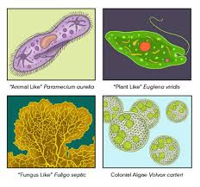

**Figure 7:** Protists range from single-celled amoebas to multicellular seaweed. Protists may be similar to animals, plants, or fungi.

**5- Types of protists**

**5-1- Higher Protists (Eukaryotes)**  
These are microorganisms that possess a nucleus. There are three groups of eukaryotic protists: fungi, algae, and protozoa.

**A- Fungi:**  
Fungi or mycetes are eukaryotes, meaning they have a nucleus surrounded by a nuclear membrane, as well as various types of cytoplasmic organelles bounded by membranes. They are larger than bacteria and can form large assemblies. They reproduce by fission, and their cell wall is made of chitin, not peptidoglycan. There are two categories of fungi: molds and yeasts.

* **Molds:** These are multicellular organisms found on fruits, bread, etc. They are made up of filaments called hyphae, which in turn form mycelium (thallus). Fungi have a rigid wall mainly composed of chitin (various polysaccharides). Many fungi are pathogenic to plants (phytopathogenic). Others are pathogenic to humans and animals but do not cause significant harm (e.g., digestive mycoses).
* **Yeasts:** Yeasts are unicellular organisms (e.g., *Saccharomyces cerevisiae*); they are the most widely used microorganisms in the world due to their extraordinary metabolism. They are heterotrophic and possess a rigid chitinous cell wall.

**B- Algae:**  
Algae are microscopic organisms (microalgae, as opposed to macroalgae) that are phototrophic. They perform plant-like photosynthesis (producing oxygen) and can be unicellular or multicellular, either mobile or immobile. They have a cellulose-based cell wall and belong to marine ecosystems: freshwater and seawater.

**C- Protozoa:**  
Protozoa are higher protists made up of a cell similar to animal cells (eukaryotic). Their cell does not have a wall. Most protozoa are mobile, using cilia, flagella, or pseudopodia (retractable extensions of the cytoplasm). Protozoa classification is based on morphological and biological traits, and they are also often divided into mucosal pathogens and tissue and blood pathogens.

**5-2- Lower Protists (Prokaryotes)**  
These are microorganisms that do not possess a nucleus. They also lack certain organelles, such as the Golgi apparatus.

**A- Bacteria:**  
Bacteria are unicellular organisms that are relatively simple, with genetic material in the form of a single circular chromosome that is not contained within a nuclear membrane (called the nucleoid).

**B- Viruses:**  
Viruses are the smallest microorganisms. Their size is on the order of a few nanometers, and they are only visible under an electron microscope. They are not living organisms. Viruses are obligatory parasites of all living cells in animals, plants, and bacteria. Their growth and multiplication can only occur inside a living cell, which usually leads to the destruction of the host cell. Bacteria-infecting viruses are called bacteriophages.

**Table 1:** Differences between prokaryotes and eukaryotes cells

|  |  |  |
| --- | --- | --- |
| **Characteristic** | **Prokaryotes** | **Eukaryotes** |
| **Size of cell** | Typically 0.2-2.0 m in diameter | Typically 10-100 m in diameter |
| **Nucleus** | No nuclear membrane or nucleoli (nucleoid) | True nucleus, consisting of nuclear membrane & nucleoli |
| **Membrane-enclosed organelles** | Absent | Present; examples include lysosomes, Golgi complex, endoplasmic reticulum, mitochondria & chloroplasts |
| **Flagella** | Consist of two protein building blocks | Complex; consist of multiple microtubules |
| **Glycocalyx** | Present as a capsule or slime layer | Present in some cells that lack a cell wall |
| **Cell wall** | Usually present; chemically complex (typical bacterial cell wall includes peptidoglycan) | When present, chemically simple |
| **Plasma membrane** | No carbohydrates and generally lacks sterols | Sterols and carbohydrates that serve as receptors present |
| **Cytoplasm** | No cytosketeton or cytoplasmic streaming | Cytoskeleton; cytoplasmic streaming |
| **Ribosomes** | Smaller size (70S) | Larger size (80S); smaller size (70S) in organelles |
| **Mesosomes** | Present | Absent |
| **Chromosome arrangement** | Single circular chromosome; lacks histones | Multiple linear chromosomes with histones |
| **Extrachromosomal DNA** | Plasmid | Mitochondria and chloroplast |
| **Cell division** | Binary fission | Mitosis |
| **Sexual reproduction** | No meiosis; transfer of DNA fragments only (conjugation) | Involves meiosis |
| **Site for cellular respiration** | Cell membrane | Mitochondria |
| **Locomotion** | Rotating flagella and gliding | Undulating flagella and cilia, and also amoeboid movement |
| **Pili** | Sex or attachment pili present | absent |