***DW1***

**Exercise 1**

A beam simply supported at B and hinged at A supports a force F at D.

1. Calculate the support reactions.
2. Calculate the internal force vector in the straight sections G1 and G2.

Given: F = 5000 N

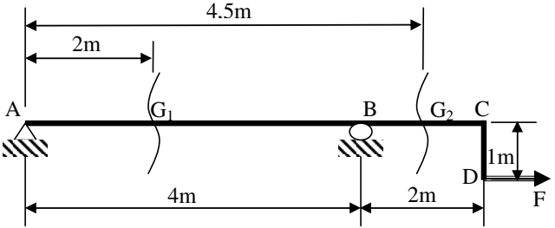

**Exercise 2**

A beam simply supported at B and hinged at A supports a force F at D and at H.

1. Calculate the support reactions.
2. Calculate the internal force vector in the straight sections: G1, G2, and G3.
3. Deduce the type of loading in these sections.

Given: F = 5000 N

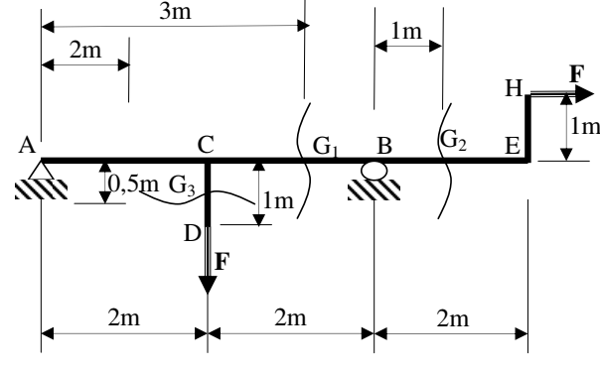

**Exercise 3**

A reinforced concrete beam is fixed at A, supports its own weight, and two forces F1 and F2 at B.

1. Calculate the value of the distributed load q per linear meter due to its own weight.
2. Calculate the support reactions.
3. Calculate, as a function of x, the internal force vector in section G.
4. Draw the diagrams of the non-zero components of the internal force vector along the beam.

Given:

F1=3000N, F2=2500N, volumetric weight of reinforced concrete = 25000 N/m3, section of the beam = 30×20 cm2

