Endosomal system and peroxisomes
The endosomal system is a set of intracellular compartments that plays a crucial role in the endocytosis, degradation and recycling of internalized molecules, including proteins, lipids, nutrients and other substances. This system is essential for the management of elements transported in the cell and for the regulation of many cellular functions.

1. Endosome Structure

An endosome is a small spherical structure (a vesicle) bounded by a lipid membrane located in the cytoplasm of eukaryotic cells, close to the cell plasma membrane.

2. Stages of Endocytosis and Endosome Formation:
Endocytosis is a process that allows the cell to absorb particles, fluids, or molecules. It is divided into several stages:
*Vesicle Induction and Formation : The plasma membrane folds to encompass particles or liquids, forming a vesicle.
*Internalization : The vesicle detaches from the membrane and enters the cell, joining the endosomal system for its processing.

4. Types of endosomes and their phases
There are several types of endosomes, mainly classified according to their phases in the endocytosis cycle:
Early endosomes: Soon after their formation, these endosomes are involved in sorting recycled molecules to the plasma membrane or sent to late endosomes for degradation.
Late endosomes: These structures are more closely related to lysosomes and are often involved in the maturation of enzymes needed for content degradation.

Lysosome : An organelle where molecules are broken down by acidic enzymes. It plays a key role in the elimination of cellular waste and the management of metabolism.

5. Endosomal System Functions :
- Sorting and recycling : Some molecules such as receptors are recycled and returned to the plasma membrane for new use.
- Degradation : Molecules destined for destruction, such as cellular debris or pathogens, are sent to lysosomes to be degraded and eliminated.
- Vesicle maturation : During their maturation, endosomes become increasingly acidic, which is necessary to activate degradation enzymes and efficiently sort molecules.

6. Regulation and Associated Mechanisms :
*Rab proteins : These G proteins are essential for the regulation of vesicular trafficking and the fusion of vesicles with endosomes. For example, Rab5 is involved in the early endosome and Rab7 in the late endosome.
*Clathrin and caveolin/ This protein is involved in the formation of vesicles during receptor-mediated endocytosis, forming a clathrin and caveolin network that allows the formation of the vesicle from the plasma membrane.

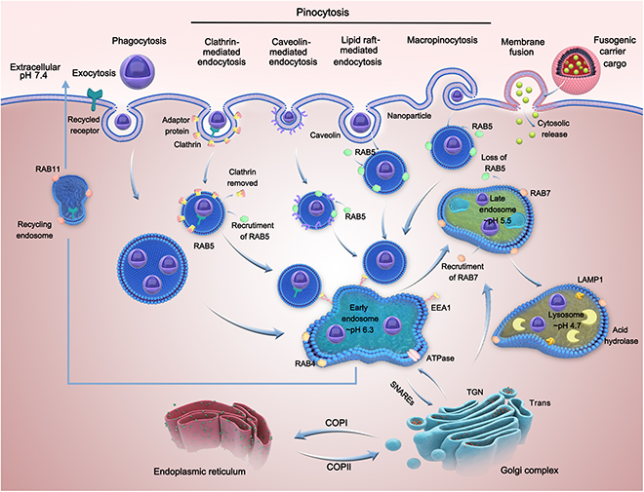

7. Impact of Endocytosis on the Cell:
The endosomal system plays a critical role in:
Regulation of cell signaling : Internalized receptors can modulate signaling pathways important for cell growth, immune system activation, and stress response.
Cellular homeostasis : By controlling the absorption and recycling of molecules, it allows the cell to maintain its metabolic balance and eliminate waste.

1. Introduction: What is a peroxisome?
- The peroxisome is a cellular organelle found in eukaryotic cells.
- It is involved in essential metabolic processes, including the degradation of peroxides and other metabolites.
- Peroxisomes are very small, surrounded by a simple membrane, and are found in the cytoplasm of many cells.

2. Structure of the Peroxisome
Simple membrane : The peroxisome is surrounded by a lipid membrane that delimits its contents.
Internal material : The interior of the peroxisome contains several enzymes, mainly peroxidases, that allow the degradation of peroxides (especially hydrogen peroxide, H₂O₂).
Lack of a genome of their own : Unlike mitochondria, peroxisomes have no DNA and therefore depend on the proteins encoded by the cell's nuclear DNA.

3. Functions of the Peroxisome

a. Peroxide degradation / maintenance of redox balance
a.Peroxisome degrades potentially toxic substances. It contains enzymes such as catalase, which converts hydrogen peroxide (H₂O₂) into water (H₂O) and oxygen (O₂), which protects the cell from the harmful effects of this oxidizing compound.
b. Energy metabolism via the β-oxidation of very long-chain fatty acids. This process breaks down fatty acids to provide energy to the cell.
They are also involved in lipid synthesis, participating in metabolic pathways related to lipid production.

c. Detoxification of toxic substances
Peroxisomes participate in the detoxification of certain molecules, such as bile acids or ethanol, using specific enzymes.

4. Peroxisome Formation
Peroxisomes are formed from the endoplasmic reticulum and are then divided to multiply.
They contain enzymes that are synthesized in the cytoplasm and then imported into the peroxisome.

6. Peroxisome-related pathologies
The peroxisome is an organelle that is essential to the cell. Disruptions in its functioning can lead to serious diseases, highlighting the importance of peroxisomes in regulating cellular metabolism.
Diseases related to peroxisome dysfunction :
Peroxismosomes : These are rare genetic disorders, such as Zellweger's disease, where there is an absence of functional peroxisomes in the cells.
These pathologies cause metabolic disorders, neurological deficits and other symptoms related to poor lipid and peroxide metabolism.

