Exercise 1 :
1) How are parents' genes transmitted on to their offspring?
Through the process of meiotic cell division, each parent produces gametes that have 1/2 the genetic material (haploid) of a normal somatic cell. During the process of fertilization, two gametes combine (one male and one female cell) to form a zygote that has a complete set of chromosomes.

2) A cell contains the following chromosomes:
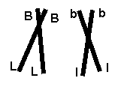
If crossing-over (intra-chromosomal recombination) occurs between the 2 homologous chromosomes, what is (are) the possible genotype(s) of the gametes that will be produced?
quel(s) est (sont) le(s) génotype(s) possible(s) des gamètes produits?
B
b
B
b

Méiosis I
L
l
l
L

B
B
b
b
Méiosis II
L
l
l
L

so 4 possible gentypes BL, Bl, bL, bl

Exercise 2 :
1) How many different chromosome combinations (interchromosomal recombination) can result during meiosis in a species that has a diploid number (2N) of 8 chromosomes (Assume no crossing-over (intrachromosomal recombination) occurs)?
Sixteen different combinations.
For example here each letter corresponds to a chromosome. The letters A, B, C and D correspond to the paternal chromosomes and the letters a, b, c and d are their maternal counterparts
So the different genotypes of the gametes will have the following possible chromosomal combinations:
ABCD ABCd ABcD ABcd AbCD AbCd AbcD Abcd
aBCD aBCd aBcD aBcd abCD abCd abcD abcd

2) Develop a mathematical formula that allows you to calculate the answer to question 3.
2^{n} , where n = number of chromosome pairs.

3) Using this formula, how many chromosome combinations can result from meiosis when the diploid number is 46 (as it is in humans)?
23² = 8,388,608 different combinations.

Exercise 3 :
Chromosomal nondisjunction during meiosis is the main cause of Down syndrome. Here is a schematic representation of meiosis and gametocyte fertilization.
1) Label the first and second divisions of meiosis.
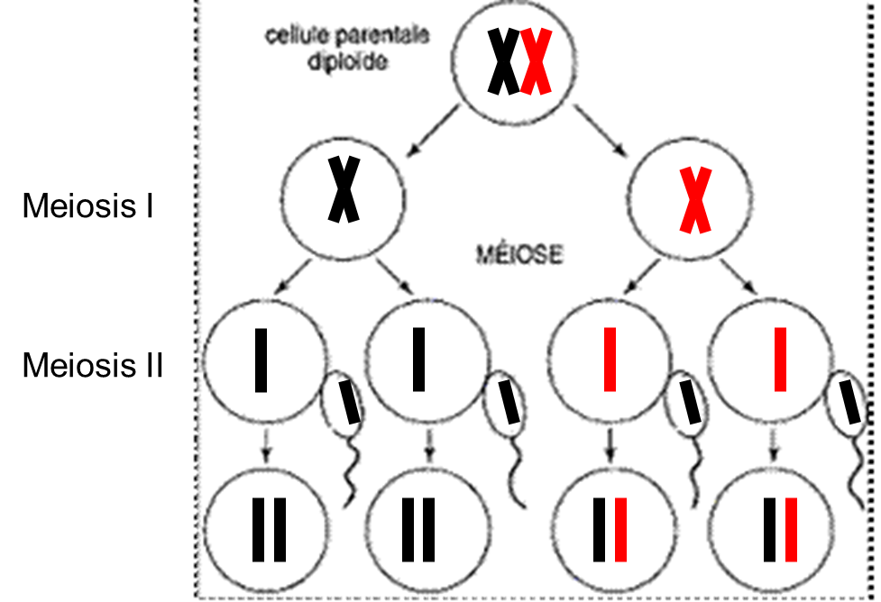
2) Complete the diagram in case of accidents in the second division of meiosis leading to trisomy 21 (only represent chromosome 21).
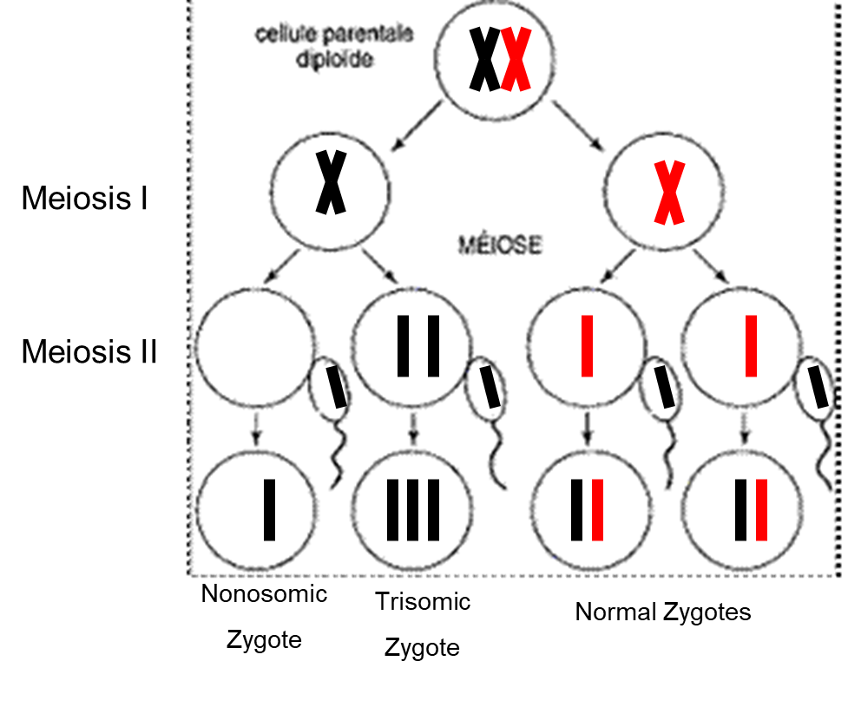

Exercise 4 :
You are runing an assisted reproduction clinic and provide genetic diagnostic services using high technology. A married couple who already had a child with cystic fibrosis approach you because they wish to have another child, but only if they can be assured that the child will not have cystic fibrosis. You genotype the woman and discover that she is a heterozygote for Del508, the most common mutation causing cystic fibrosis. You suggest that the couple consider first polar body testing, in which several unfertilized oocytes (each with its first polar body) are retrieved from the woman, the first polar bodies are removed, and PCR tests are conducted on DNA from each of the first polar bodies. The couple agrees, and you obtain the following results:
PCR test of first polar body DNA for presence of
Ovocyte N° PCR test of first polar body DNA for presence of | Mutation Del508 | wild-type sequence (wt = wild-type)
#1 | + | +
#2 | + | -
#3 | + | -
#4 | - | +
#5 | + | +
#6 | - | +
+, positive test.
-, negative test
Important note :
During ovulation, polar bodies (polar bodies) are small cells formed during meiosis of the oocyte. In meiosis I (reductional division) the oocyte is divided and produces a secondary oocyte and the first polar body which contains one chromosome from each pair, each composed of two chromatids. In meiosis II (equational division), the secondary oocyte is divided and produces the mature oocyte and the second polar body. What we will observe in this data is the genotype of the polar bodies that do not develop into a mature oocyte and therefore are not fertilized.

1) Propose an explanation for the observation that the polar bodies for oocytes #1 and #5 test positive for both Del508 and the wild type sequence, while the polar bodies for the other oocytes do not. (Do not appeal to nondisjunction.)
Illustrate your explanation with a sketch of meiosis in oocyte #1.
Polar body tests of oocytes #1 and #5 are positive for Del508 and normal sequence because a crossing-over occurred during meiosis I between the chromatids of the two duloqued homologous chromosomes, one chromosome carrying the mutation and its counterpart carrying the normal sequence. The crossing-over occurred at a point between the centromere and the cystic fibrosis gene. In the other oocytes this phenomenon did not occur.
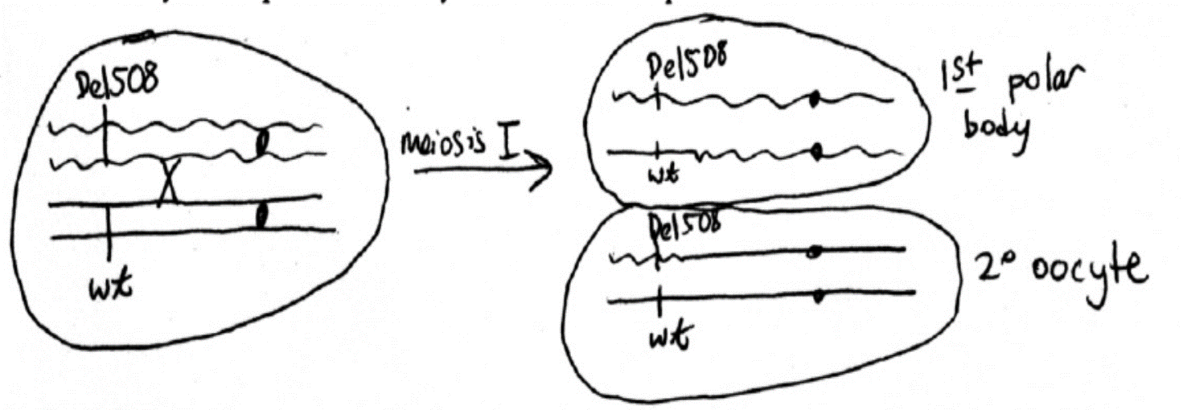

2) Given the couple's desire to have a child without cystic fibrosis, which oocytes would you employ in vitro fertilization? Briefly explain or illustrate your answer.
Because the polar bodies do not develop to produce an oocyte, we then want the first polar body to carry both copies of the mutation (the mutated chromosome without crossing-over), which means that the secondary oocyte carries the normal chromosome and will subsequently produce a normal mature oocyte, which is the case for oocytes #2 and #3 which are to be fertilized in vitro.
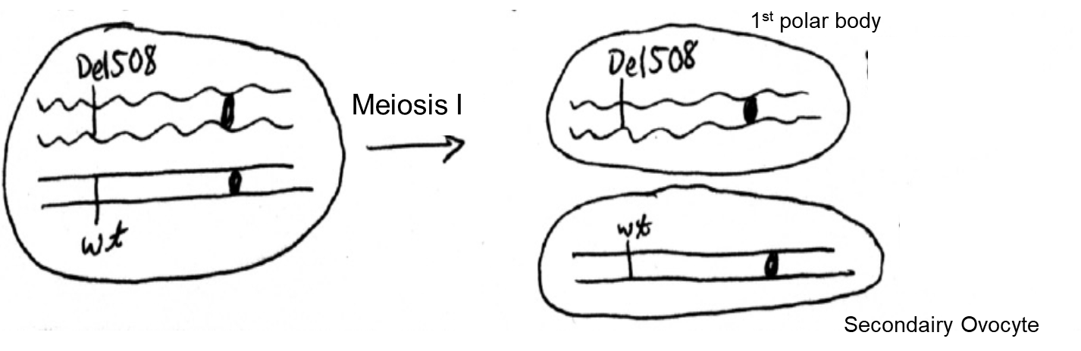
3) What additional eggs would you consider fertilizing if you could:
a) retrieve the second polar body for genetic testing and
b) selectively return “unaffected” embryos to the woman’s uterus? Briefly explain or illustrate your answer.

In meiosis II, the secondary oocyte is divided and produces the mature oocyte and the second polar body. If we can test the 2nd polar body and return the mature oocyte to the woman's uterus, then we can choose a mature oocyte to fertilize whose 2nd polar body carries the Del508 mutation to be sure that the mature oocyte only carries the normal sequence. This could be the case for oocytes #1 and #5.
