Exercise 1 :
1. Part of the coding strand (forward or sense strand) for a given gene has the sequence
5′ATGAGCGACTTTGCGGGATTA 3
a) Write the non-coding strand (antisense strand)? which strand is the transcribed strand?
b) What are the mRNA and protein sequences that would be produced during transcription and translation of this segment of DNA?
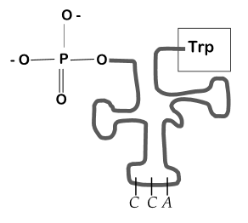
Exercise 2 :
1) What does this figure represent?
2) Determine the ends of this molecule?
3) What are the three nucleotides found at the 3' end of this molecule?
4) Write the nucleotides of the anticodon?

Exercise 3 :
Below is a schematic representation of the Y gene, which encodes the X protein. Transcription begins immediately after the promoter.
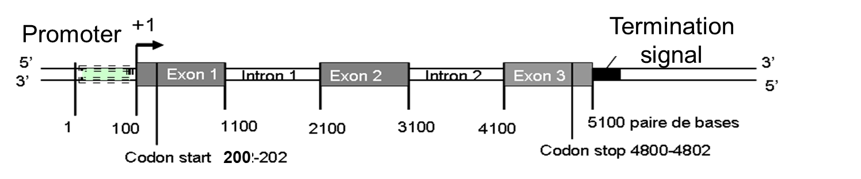
1) The primary transcript of this gene transcribed by RNA polymerase will have a length of approximately how many nucleotides?
2) Two different transcripts are produced from this gene, one is about 2000 nucleotides long, the other is about 3000 nucleotides long. Explain how two different transcripts can be produced from this gene?
3) Suppose each transcript produces a protein. Given the figure above, what is the approximate size of the protein produced by the main transcript of this gene?
4) Suppose that Y gene was mutated such that the G/C base pair found at position 2200 was replaced by an A/T. Transcription and translation of the mutated Y gene would still occur?
5) The protein produced would be the same length, shorter or longer than the protein produced by the wild type Y gene? Explain your answer.

Exercise 4 :
Here is a DNA sequence consisting of 210 consecutive base pairs that corresponds to the beginning of the X gene sequence. Transcription begins at the T/A base pair at position 60 (In bold)
1) What are the first 6 nucleotides of the mRNA of gene X?
2) What are the first 4 amino acids coded for by gene X? (A genetic code table is on the last page)

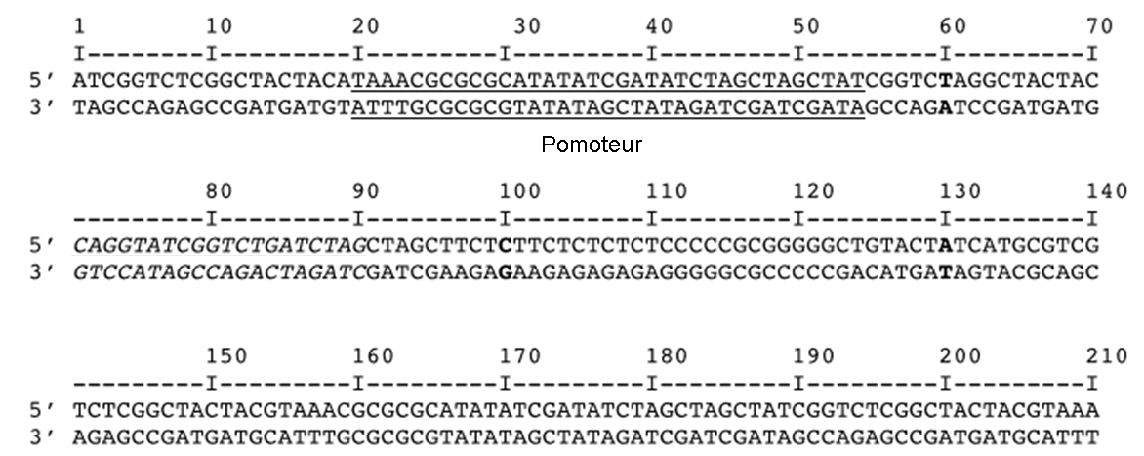
You found two different mutations of gene X, mutation 1 and mutation 2.
3) For mutation 1, there is an insertion of the three base pairs immediately after the C/G base pair at position 100 (in bold). 5’ TGT 3’
3’ ACA 5’
a) Would the mRNA expressed from this version of X gene be longer, shorter, or identical to the mRNA produced by the wild type X gene? Explain, and if longer or shorter, indicate the number of bases.
b) If the mRNA is translated, the protein produced would be longer, shorter, or the same size as that produced by the normal X gene? Will the protein produced have the same function as the normal X protein? Explain your judgment.
4) For mutation 2, there is a four base pair insertion immediately after the A/T base pair at position 130 (in bold). 5’ ATGT 3’
3’ TACA 5’
c) What are the first four amino acids that will be translated?
d) The protein produced would be longer, shorter, or the same size as that produced by the normal X gene? Will the protein produced have the same function as the normal X protein? Explain your judgment?
