Exercise 1 :
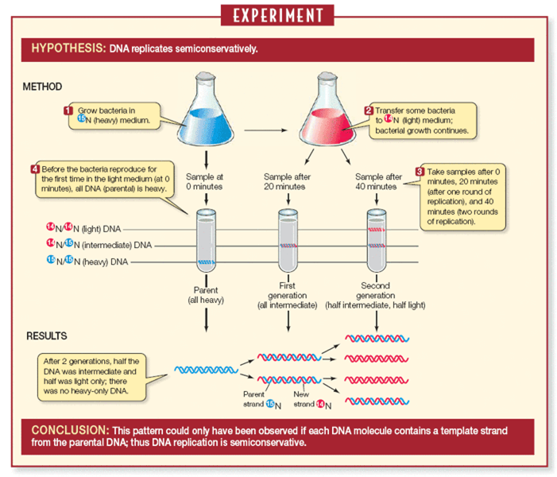

1) During the first DNA replication, the parent DNA molecule produces two daughter molecules. What will happen to each of the two strands of the parental double helix? What do we call the DNA obtained after this first episode of replication?
a) Each parental strand remains associated with the newly synthesized DNA strand (semi-conservative replication mode.
b) we obtain a hybrid DNA (one strand composed of N15 and the other strand composed of N14).

2) Use the following test tube images to indicate the location of the DNA band(s) observed in the Meselson and Stahl experiment at the beginning of the experiment, after 1 generation, after 2 generations and after three generations of replication.

Generations 0 1 2 3

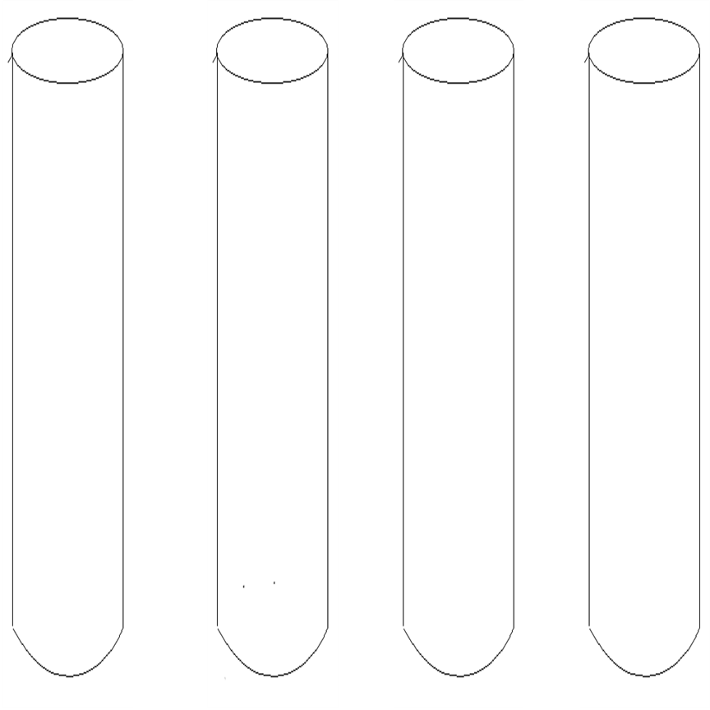
N15
N14
N15/N14

Exercise 2 :
Below is a diagram of DNA replication in a bacterial cell.
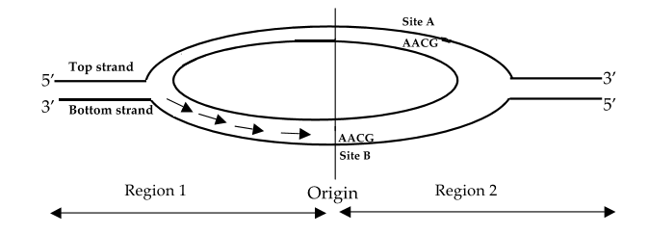
Strand 1
Strand 2
Brin 1
1) On the diagram, note the 5' and 3' ends of the 2 strands of the parental DNA.
See the figure

2) Which parental strand (strand 1 or strand 2) serves as a template for the synthesis of the leading strand in region 2?
Strand 2

3) At which site (site A, B, or both) can the 5' UUGC 3' primer bind?
Site B

4) Let's assume replication has not yet been initiated. Which strand (strand 1, strand 2, or both) in region 2 would not be replicated in the absence of primase? Explain?
Both strands would not be replicated. DNA polymerases are primer-dependent enzymes, requiring only one RNA primer for leading strand synthesis and multiple primers for lagging strand synthesis.

5) You perform a DNA replication in a test tube (in vitro) using single-stranded linear DNA as a template and the appropriate primer. What protein(s) (or enzyme(s)) are needed for one round of replication?
We will only need a DNA Polymerase (we will only synthesize the complementary strand in vitro)

Exercise 3:
Here is a simplified schema of DNA replication in prokaryotes. The numbers in the following questions correspond to the numbers in this figure.

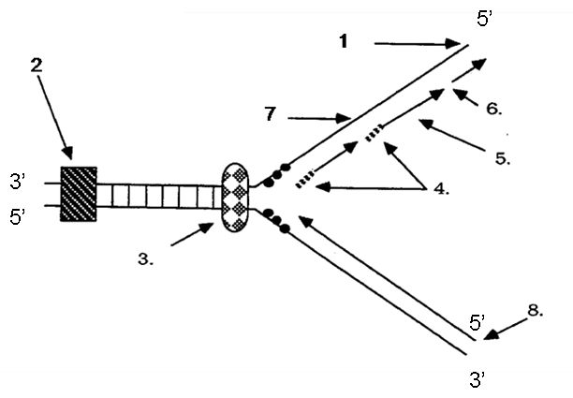
A. Which end (5' or 3') of the molecule is indicated by arrow number 1?
5’ . See the figure

B. Which end (5' or 3') of the molecule is indicated by arrow number 8?
5' (start of the newly synthesized strand)

C. What type of nucleic acid is indicated by arrow number 4? What is the enzyme that synthesizes it?
RNA (Primer)
Synthesized by primase and would then be degraded and replaced by DNA by DNA Polymerase I

D. What are the short fragments of DNA indicated by arrow number 5?
Okazaki fragments synthesized by DNA Polymerase III

E. What enzymatic function to join the short fragments indicated by arrow number 6?
DNA ligase

F. Which enzymes are indicated by arrows number 2, 3? What is their role?
Arrows 2: Topoisomerase: removes the super-turns of the double helix generated by the opening of the DNA.
Arrows 3: DnaA + Helicase (DnaB) opening of the two strands of DNA and breaking of the hydrogen bonds between the bases.

G. What is the name of the strand indicated by arrow number 7?
Lagging strand

E) Explain why the leading strand is replicated much faster than the lagging strand.
The leading strand is synthesized continuously from a primer while the lagging strand is synthesized from many smaller fragments (Okasaki fragment). This requires DNA polymerases to attach to the lagging strand repeatedly, which limits the rate of polymerization. On the other hand, each Okasaki fragment needs to have the RNA primer replaced by DNA and phosphodiester bonds must be formed between each fragment by a DNA ligase.

