Exercise 1 :
In their experiment, Meselson and Stahl used a form of heavy nitrogen (N15) to demonstrate semi-conservative DNA replication. Bacterial cells were grown in the presence of heavy nitrogen until all bases in the DNA were composed of nitrogen (N15). The bacteria were then transferred to a medium that contained only natural nitrogen (N14). At different time points, DNA was isolated from the bacteria and subjected to density gradient ultracentrifugation.
1) During the first DNA replication, the parent DNA molecule produces two daughter molecules. What will happen to each of the two strands of the parental double helix? What do we call the DNA obtained after this first episode of replication?
2) Use the following test tube images to indicate the location of the DNA band(s) observed in the Meselson and Stahl experiment at the beginning of the experiment, after 1 generation, after 2 generations and after three generations of replication.

Generations 0 1 2 3
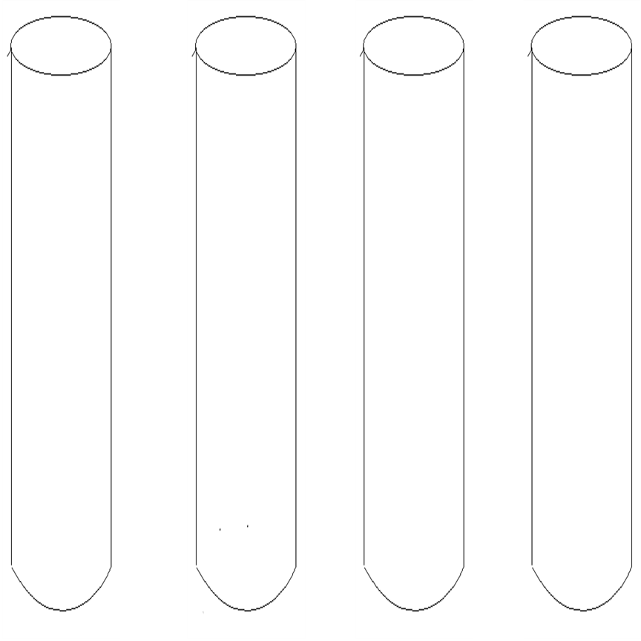

Exercise 2 :
Below is a diagram of DNA replication in a bacterial cell.
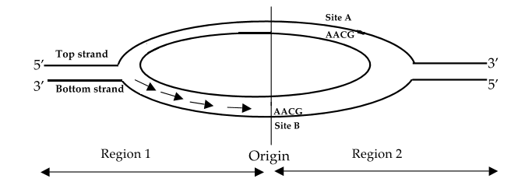
Strand 1
Strand 2
1) On the diagram, note the 5' and 3' ends of the 2 strands of the parental DNA.
2) Which parental strand (strand 1 or strand 2) serves as a template for the synthesis of the leading strand in region 2?
3) At which site (site A, B, or both) can the 5' UUGC 3' primer bind?
4) Let's assume replication has not yet been initiated. Which strand (strand 1, strand 2, or both) in region 2 would not be replicated in the absence of primase? Explain?
5) You perform a DNA replication in a test tube (in vitro) using single-stranded linear DNA as a template and the appropriate primer. What protein(s) (or enzyme(s)) are needed for one round of replication?

Exercise 3:
Here is a simplified schema of DNA replication in prokaryotes. The numbers in the following questions correspond to the numbers in this figure.

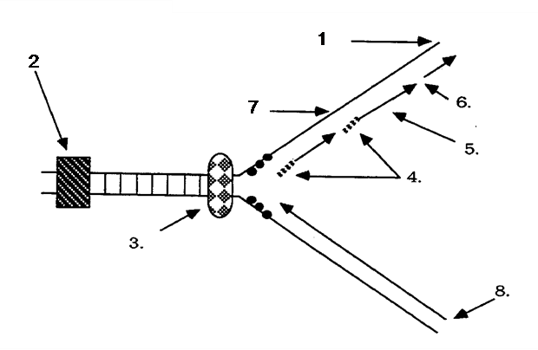
A. Which end (5' or 3') of the molecule is indicated by arrow number 1?
B. Which end (5' or 3') of the molecule is indicated by arrow number 8?
C. What type of nucleic acid is indicated by arrow number 4? What is the enzyme that synthesizes it?
D. What are the short fragments of DNA indicated by arrow number 5?
E. What enzymatic function to join the short fragments indicated by arrow number 6?
F. Which enzymes are indicated by arrows number 2, 3? What is their role?
G. What is the name of the strand indicated by arrow number 7?
E) Explain why the leading strand is replicated much faster than the lagging strand.

