Exercise 1
1. What are the 2 main types of nucleic acids?
2. For these two nucleic acid segments,
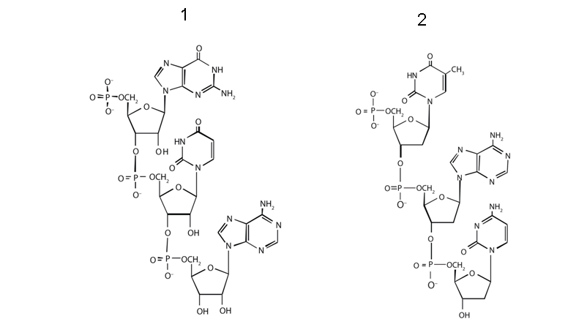

A. Define the type of nucleic acid for each of the two molecules 1 and 2. ? Justify your response?
B. Determine the 5’ and 3’ ends? Circle the atoms that form the backbone of the nucleic acid chain
C. Determine the nucleotide sequence of each of the two segments?

Exercise 2
1. What are the 3 main types of RNA and what is their percentage in cells?
2. What type of RNA contains codons? What type of RNA contains anticodon?

3. a part of a gene's template strand has the sequence 5 'CCATGGAATCGA 3'.
a) What is the sequence of the complementary strand??
b) What is the sequence of the RNA that is formed from this sequence?
Exercise 3
1) If we count the nucleotides of double-stranded (double-stranded) DNA, what is the correct statement?:
A = C / A+G = C+T / A+T = G+T / A = 2C / A = 2T ?

2) here the following single-stranded DNA: 5’-TACGCCTAGCTTACGCAT-3’
a) How many phosphodiester bonds are there in the double-stranded sequence?
b) How many hydrogen bonds are there in the double-stranded sequence?

3. a) What bases are likely to pair in the following single-stranded RNA strand?: 5’-AUGGAACGCCUUUACGUUC-3’

3. b) How many hydrogen bonds are there in the folded strand?

Exercise 4 (chromatin in eukaryotes)
1) Define the chromatin? What is the difference between DNA, chromatin and chromosomes?

2) If species A has 4 chromosomes and species B has 6 chromosomes. Could you tell from this information which species has more DNA? Can you tell which species has more genes?

3) The answer to question 2 implies that not all the DNA on a chromosome encodes genes. Could you give examples of chromosomal regions that contain relatively few genes?

4) How many centromeres are found in a typical chromosome?
5) What would happen if there were more than one centromere per chromosome?
6) What would happen if a chromosome has zero centromeres?
7) For a diploid with 2n=16 chromosomes, how many chromosomes and chromatids are found in the zygote and in the gamete?

