Grammar

Dr. KEBBOUT Houda
Abdelhafid Boussouf Mila University Centre
Faculty of Letters and Foreign Languages
Department of English
Email: h.kebbout@centre-univ-mila.dz

February 2023

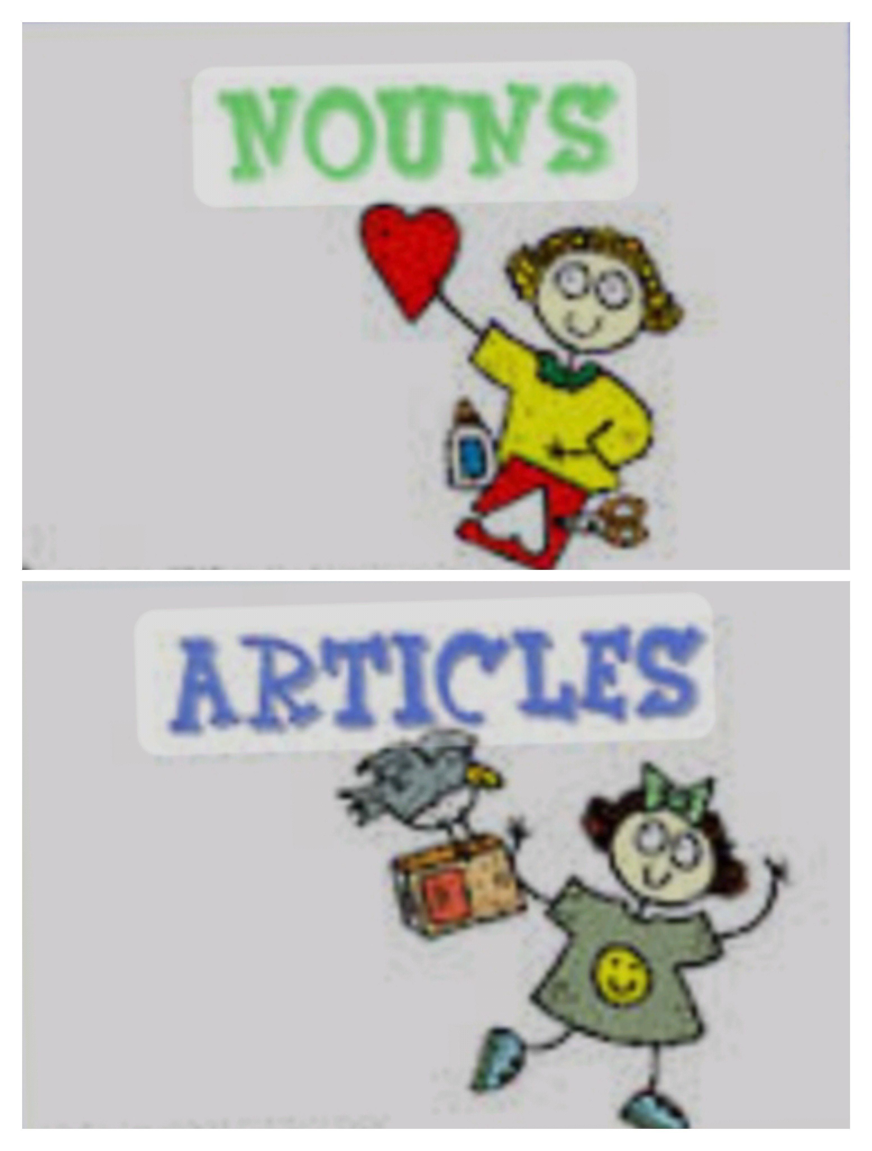

Table of contents

I- Articles 5
A. The Indefinite Articles: a / an 5
1. Use of a/an 6
2. Omission of a/an 8
3. Quiz: Fill in the gaps with a or an 9
B. The Definite Article : The 9
1. Form 9
2. Use of The 10
3. Omission of The 11
4. Quiz: insert The whenever necessary: 11
II- Nouns 13
A. What is a Noun? 13
B. Kinds and Functions of Nouns 13
1. Kinds 13
2. Functions 14
C. Gender 14
D. Number 15
E. Compound Nouns 16
F. Uncountable Nouns 17
Exercises solution 19
References 21
Bibliography 23

- Articles

I- Articles
I

The Indefinite Articles: a / an 5
The Definite Article : The 9

  - The Indefinite Articles: a / an

- The form a is used before a word beginning with a consonant, or a vowel with a consonant sound.
- The form an is used before words beginning with a vowel (a, e, i, o, u) or words beginning with a mute h.

    - Use of a/an

Note
a/an is used:book2
- Before a singular noun which is countable (i.e. of which there is more than one) when it is mentioned for the first time and represents no particular person or thing
- Before a singular countable noun which is used as an example of a class of things
- With a noun complement. This includes names of professions
- In certain expressions of quantity
- With certain numbers
- In expressions of price, speed, ratio etc
- In exclamations before singular, countable nouns
- a can be placed before Mr/Mrs/Miss + surname

Example
Clear examples are:
- I need a visa., they live in a flat, he bought an ice-cream.
- A car must be insured = All cars/Any car must be insured.
A child needs love = All children need/Any child needs love.
- It was an earthquake., she'll be a dancer., he is an actor.
- A great many, a dozen, a great deal of.
- A hundred, a thousand
- A half holiday, a half portion, a half share With 1/3 1/4, 1/5 etc, a third, a quarter
- What a pretty girl!
- a Mr Smith, a Mrs Smith, a Miss Smith

    - Omission of a/an

Note
a/an is omitted:[2]
- Before plural nouns
- Before uncountable nouns
- Before names of meals, except when these are preceded by an adjective
- The article is also used when it is a special meal given to celebrate something or in someone's honour

Example
to instantiate,
- The plural of a dog is dogs, and of an egg is eggs
- We have breakfast at eight
He gave us a good breakfast

Extra : a/an and one
- When counting or measuring time, distance, weight etc we can use either a/an or one for the singular.
- In other types of statement a/an and one are not normally interchangeable, because one + noun normally means 'one only/not more than one' and a/an does not mean this

Example
- £1 = a/one pound
£1,000,000 = a/one million pounds
- A shotgun is no good (It is the wrong sort of thing )
One shotgun is no good (I need two or three )

    - Quiz: Fill in the gaps with a or an

[Solution n°1 p 19]

- I have hour and a half for lunch.
- He looked at me with horror when I explained that I was double agent.
- Mr Jones called while you were out (neither of us knows this man). He wants to make complaint about article in the paper. He was in very bad temper.
- He broke leg in skiing accident.
- I want assistant with knowledge of French.
- I had amazing experience last night. I saw dinosaur eating meat pie in London park.
- I'll pay you hundred week. It's not enormous salary but after all you are completely unskilled man.
  - The Definite Article : The
    - Form

Reminder
The is the same for singular and plural and for all genders

Example
- The boy/ the girl/ the day
- The boys/ the girls/ the days

    - Use of The

Note
- When the object or group of objects is unique or considered to be unique
- Before a noun which has become definite as a result of being mentioned a second time:
- Before a noun made definite by the addition of a phrase or clause:
- Before a noun which by reason of locality can represent only one particular thing
- Before superlatives and first, second etc. used as adjectives or pronouns, and only.

Example
- The earth, the sea, the sky, the equator, the stars
- His car struck a tree; you can still see the mark on the tree
- The girl in blue the man with the banner, the boy that I met, the place where I met him
- The postman (the one who comes to us), the car (our car), the newspaper (the one we read).
- The first (week), the best day, the only way

Extra
- The + singular noun can represent a class of animals or things.[2]
- The + adjective represents a class of persons.
- The is used before other proper names consisting of adjective + noun or noun + of + noun
- The with names of people has a very limited use:
- The + plural surname can be used to mean 'the family'
- The is used before titles containing (the Duke of York)
- Letters written to two or more unmarned sisters jointly may be addressed The Misses + surname (The Misses Smith).

Example
- The whale is in danger of becoming extinct.
- The old = old people in general
- The Atlantic, the Netherlands, the Sahara
The City, the Mall
The Gulf of Mexico, the United States of America
The Arabian Sea, the New Forest
- The National Gallery, the Tower of London

    - Omission of The

Note
The definite article is not used:[2]
- Before abstract nouns except when they are used in a particular sense
- After a noun in the possessive case, or a possessive adjective
- Before names of meals
- Before names of games
- Before parts of the body and articles of clothing as these normally prefer a possessive adjective

Example
- Men fear death, but The death of the Prime Minister left his party without a leader
- The boy s uncle = the uncle of the boy
- The Scots have porridge for breakfast but
The wedding breakfast was held in her father s house
- He plays golf
- I patted his shoulder, I patted him on the shoulder

Extra
- Note that in some European languages the definite article is used before indefinite plural nouns but that in English the is never used in this way .
- Nature where it means the spirit creating and motivating the world of plants and animals etc is used without the
- Omission of the before home, before church, hospital, prison, school etc and before work, sea and town

Example
- Women are expected to like babies (i e women in general)
- If you interfere with nature you will suffer for it
- He is at home,
we go, to bed to sleep, to hospital as patients, to church to pray, to pnson as prisoners,
to court as litigants, to school/college/university to study.

Extra : Online Video on articles
https://youtu.be/uU-RbEEolw0

    - Quiz: insert The whenever necessary:

[Solution n°2 p 19]

- youngest boy has just started going to school; eldest boy is at college.
- He was sent to prison for six months for shop-lifting.
- I went to school to talk to headmistress. I persuaded her to let Ann give up
gymnastics and take ballet lessons instead.
- On Sundays my father stays in . bed till ten o'clock, reading Sunday papers.
- Then he gets up, puts on old clothes, has breakfast and starts work in garden.
- I'd like to see Mr Smith please.
Do you mean Mr Smith who works in box office or other Mr Smith?

- Nouns

II- Nouns
II

What is a Noun? 13
Kinds and Functions of Nouns 13
Gender 14
Number 15
Compound Nouns 16
Uncountable Nouns 17

  - What is a Noun?

Definition
A noun is a word that names a person, a place, a thing, or an idea. For Example, Sarah, lady, cat, New York, Canada, room, school, football, reading, motivation, happiness, love.

Example
- Emma passed the test.
- My parents are traveling to Japan next month.

  - Kinds and Functions of Nouns
    - Kinds

Fundamental
There are four kinds of noun in English:[2]
- Common nouns
- Proper nouns
- Abstract nouns
- Collective nouns

Example
- Dog, man, table
- France, Madrid, Mrs. Smith, Tom
- Beauty, chanty, courage, fear, joy
- Crowd, flock, group, swarm, teamM2.

    - Functions

Fundamental
A noun can function as:book 1
- The subject of a verb
- The complement of the verbs be, become, seem:
- The object of a verb
- The object of a preposition
- A noun can also be in the possessive case

Example
- Tom arrived
- Tom is an actor.
- / saw Tom
- / spoke to Tom.
- Tom's books.

  - Gender

Fundamental
A noun can be:
Masculinebook 1: men, boys and male animals (pronoun he/they).
Feminine:book 1 women, girls and female animals (pronoun she/they)
Neuter:book 1 inanimate things, animals whose sex we don't know and sometimes babies whose sex we don't know (pronoun it/they)

Note
- Ships and sometimes cars and other vehicles when regarded with affection or respect are considered feminine.
- Countries when referred to by name are also normally considered feminine

Example
The ship struck an iceberg, which tore a huge hole in her side Scotland lost many of her bravest men in two great rebellions

Reminder
The majority of nouns indicating occupation have the same form
artist, cook, driver, guide
assistant, dancer, doctor
some exceptions are,
- Some exceptions,
actor, actress/ host, hostess
conductor, conductress/ manager, manageress
heir, heiress/ steward, stewardess
hero, heroine/ waiter, waitress

Note
Domestic animals and many of the larger wild animals have different forms.

Example
- bull, cow/ duck, drake
- ram, ewe/ stallion, mare
- cock, hen/ gander, goos
- stag, doe/ tiger, tigress
- dog, bitch/ lion, lioness

  - Number

Fundamental
- The plural of a noun is usually made by adding s to the singular.
  - s is pronounced /s/ after the sounds /Ꝋ/ (months), /p/ (tapes), /k/ (forks) or /f/ (proofs). Otherwise, it is pronounced Izl.
  - When s is placed after ce, ge, se or ze an extra syllable (/iz/) is added to the spoken word.
- Nouns ending in o or ch, sh, ss or x form their plural by adding es.
- Nouns ending in y following a consonant form their plural by dropping the y and adding ies'
Nouns ending in y following a vowel form their plural by adding s-
- Twelve nouns ending in f or fe drop the f or fe and add ves .These nouns are calf, half, knife, leaf, life, loaf, self, sheaf, shelf, thief, wife, wolf.
- A few nouns form their plural by a vowel change: foot, feet/ louse, lice/ mouse, mice/ woman, women. The plurals of child and ox are children, oxen.
- Names of certain creatures do not change in the plural, fish is normally unchanged. Some types of fish do not normally change in the plural, carp, pike, salmon, trout....etc, but if used in a plural sense they would take a plural verb. Others add s.
- A few other words don't change.
- Words plural in form but singular in meaning include news, certain diseases, certain games.

Example
- day, days/ dog, dogs/ house, houses
- tomato, tomatoes/ brush, brushes/ box, boxes
dynamo, dynamos/ kimono, kimonos/ piano, pianos/ kilo, kilos
- baby, babies country, countries fly, flies lady, ladies
boy, boys day, days donkey, donkeys guy, guys
- loaf, loaves/ wife, wives/ wolf, wolves
- goose, geese/ man, men/ tooth, teeth
- crabs/ herrings/ sardines/ eels/ lobsters/ sharks
- aircraft, craft (boat/boats) quid (slang for £1), counsel (barristers working in court)
- The news is good, mumps rickets shingles, billiards darts draughts bowls dominoes

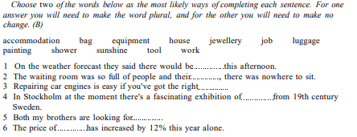
nouns: practice of number

  - Compound Nouns

Fundamental : Combinations
- Noun + noun
- Noun + gerund
- Gerund + noun

Example
- London Transport/ Fleet Street/ Tower Bridge/hall door/ traffic warden/ petrol tank
- fruit picking/ lorry driving/ coal-mining/ weight-lifting/ bird-watching/ surf-riding
- waiting list/ diving-board/ driving licence/ landing card/ dining-room/ swimming pool

Method : Some ways in which these combinations can be used:
- When the second noun belongs to or is part of the first
- The first noun can indicate the place of the second
- The first noun can indicate the time of the second:
- The first noun can state the material of which the second is made
- The first word can indicate the purpose of the second
- Work areas, such as factory, farm, mine etc , can be preceded by the name of the article produced.
- These combinations are often used of occupations, sports, hobbies and the people who practise them.

Example
- shop window / picture frame / college library
- city street/ corner shop/ country lane
- summer holiday/ Sunday paper/ November fogs
- steel door/ rope ladder/ gold medal
- coffee cup/ escape hatch/ chess board
- fish-farm/ gold-mine/ oil-rig
- sheep farming/ sheep farmer/ pop singer

  - Uncountable Nouns

Note
Uncountable nouns are also known as non-count nouns or mass nouns.[2]

Fundamental
Uncountable nouns generally include:
- Names of substances considered generally.
- Abstract nouns.
- Also considered uncountable in English.
- Uncountable nouns are always singular and are not used with a/an.
These nouns are often preceded by some, any, no, a little etc. or by nouns such as bit, piece, slice etc. + of.

Example
- bread, cream, gold, paper, tea.
- advice, experience, horror, pity
- baggage, damage, luggage, shopping
- I don't want (any) advice or help. I want (some) information. He has had no experience in this sort of work.
a bit of news a grain of sand a pot of jam

Reminder
Many of the nouns in the above groups can be used in a particular sense and are then countable.
They can take a/an in the singular and can be used in the plural. Some examples are given below.
- hair (all the hair on one's head) is considered uncountable, but if we consider each hair separately, we say one hair, two hairs etc.

Extra
Some abstract nouns can be used in a particular sense with a/an:
a help: My children are a great help to me. A good map would be a help.
a relief: It was a relief to sit down.
a knowledge + of: He had a good knowledge of mathematics.
a dislike/dread/hatred/horror/love + of is also possible: a love of music a hatred of violence
a mercy/pity/shame/wonder can be used with that-clauses introduced by it: It's a pity you were't here. It's a shame he wasn 't paid.
it + be + a pity/shame + infinitive is also possible: It would be a pity to cut down these trees
a fear/fears, a hope/hopes, a suspicion/suspicions

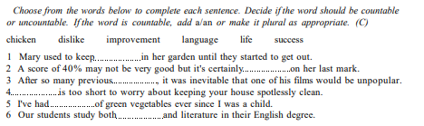
practice on countable and uncountable nouns

Extra : An online video on nouns
https://youtu.be/62X2omOnVjE

- Exercises solution

Exercises solution

> Solution n°1 (exercise p. 9)

- I have an hour and a half for lunch.
- He looked at me with horror when I explained that I was a double agent.
- a Mr Jones called while you were out (neither of us knows this man). He wants to make a complaint about an article in the paper. He was in a very bad temper.
- He broke a leg in a skiing accident.
- I want an assistant with a knowledge of French.
- I had an amazing experience last night. I saw a dinosaur eating meat pie in London park.
- I'll pay you a hundred a week. It's not an enormous salary but after all you are a completely unskilled man.

> Solution n°2 (exercise p. 11)

- the youngest boy has just started going to ...... school; the eldest boy is at . . . college.
- He was sent to . . . prison for . . . six months for . . . shop-lifting.
- I went to the school to talk to the headmistress. I persuaded her to let Ann give up . . .
gymnastics and take . . . ballet lessons instead.
- On . . . Sundays my father stays in the . bed till ten o'clock, reading the Sunday papers.
- Then he gets up, puts on . . . old clothes, has . . . breakfast and starts . . . work in the garden.
- I'd like to see . . . Mr Smith please.
Do you mean the Mr Smith who works in the box office or the other Mr Smith?

- References

References

[book 1] | Hewings, M. (1999).

[book2] | Thompson, A.J. & Martinet, A.V. (1986).

- Bibliography

Bibliography

[2] Thompson, A.J. & Martinet, A.V. (1986). A Practical English Grammar. Oxford University Press

