**Lesson Two: Designing Communicative Tasks**

The current interest in tasks stems from the communicative approach to language teaching. Here are some of the principles underpinning communicative language teaching:

- Everything that is done in the classroom is underpinned by the nature of language and about language learning. Recently there have been some dramatic shifts in attitudes toward both language and learning. This has resulted in contradictory messages.

- Language is seen more than a system of rules, it is seen as a dynamic resource for the creation of meaning. There is a need to distinguish between knowing grammatical rules and being able to use them effectively and appropriately when communicating.

- A great deal has been written about the communicative language, and each member claims to be communicative. There are disagreements between the members of the communicative community.

- There is a disagreement between designers about whether to produce ordered lists of instructional, functional, or notional items graded according to the difficulty, frequency, or pedagogic convenience. In other words, there is a process to be followed. Breen suggested that in communicative approaches to teaching, there should be a goal of the curriculum (individuals who are able to use the target language to communicate with others) and means (classroom activities which develop this capability) emerged. The syllabus must take account for both ends and means.

Here, issues about considering the place of grammar appeared. The status of grammar in the curriculum was uncertain. Some linguists claimed that it is not necessary to teach grammar, it will develop automatically if the learners were required to focus on meaning in the process of using language to communicate. Littlewood's view in his introduction to communicative language teaching is as follows:

1. The learner must attain as a high degree as possible of linguistic competence.
2. The learner must distinguish between the forms he has mastered as a part of his linguistic competence, and the communicative functions which they perform.
3. The learners must develop skills and strategies for using the language to communicate meaning as effective as possible in concrete situations. He must use feedback to judge his success.
4. The learner must became aware of the social meaning of language forms. this helps learners to use acceptable forms and avoid offensive ones.
5. Nunan clarified that any curriculum needs to take into consideration means and ends and must address both content and process.

**1. Curriculum Development and Learning Tasks**

Curriculum is used in a number of ways. In some contexts, it refers to particular program of study (science curriculum), (mathematics curriculum). In other contexts, it is used more widely. More recently, it has been suggested that at the very minimum, a curriculum should offer the following:

**\* In planning:**

- Principles for selection of content.

- What is to be learned and taught.

- Principles for the development of learning strategies (how to be taught).

- Principles for making the decision about sequence.

- Principles on how to diagnose strengths and weaknesses of individual students.

**\* In empirical study:**

- Principles on which to study and evaluate the progress of students.

- Principles on which to study and evaluate the progress of teachers.

- Guidance as to the feasibility of implementing the curriculum in varying schools and contexts.

- Information about the variability of effects in different contexts and on different learners and the understanding of the cause of variation.

1. **Definition of the Term Task**

The term task has been defined in a variety of ways in general education and in other fields of research. Long (1985) defined it as a piece of work undertaken for oneself or for the others, freely or for some reward. Thus, examples of tasks include painting a fence, making an airline reservation, borrowing a library book, taking a driving test, taking a hotel reservation, finding a street destination. In other words, by task is meant hundred things people do in every day life, at work, at play, and in between.

This definition is non-technical, and non-linguistic. In fact, as the author points out, it describes the sort of things that non-linguists would tell you they do if they were to be asked.

Another definition from a dictionary of applied linguistics, a task is an activity or an action which is carried out as a result of processing or understanding language. For instance drawing a map while listening to a tape, listening to an instruction, or performing a command. Tasks may or may not involve the production of language. A task requires a teacher to specify what will be regarded as successful completion of the task. The use of a variety of different tasks makes language teaching more communicative since it provides a purpose for a classroom activity which goes beyond the practice of language for its own sake.

Here the author takes a pedagogical perspective. Tasks are defined in terms of what learners will do in the classroom rather than the outside world. This distinction between what might be called pedagogical tasks is an important one. To clarify things, what follows is about the task rationale.

Tasks are rationalized into real world task and pedagogical tasks. Tasks with real world rationale require learners to approximate in class the sort of behaviour required of them in the world beyond the classroom. Tasks with pedagogical rationale require learners to do things which are extremely unlikely they would call upon to do outside the classroom. Pedagogical tasks take a psycholinguistic form along the line to stimulate internal processes of acquisition. Real world tasks will proceed with needs analysis. Pedagogical tasks will be selected with reference to some theory or model of second language acquisition. A real world task is listening to weather forecast and identify or predict the maximum temperature, while writing a formal introduction is a pedagogical task. There are some pedagogical tasks which is possible to create real-life context ( listen to an oral text and write a sentence restating the gist). Some tasks are residing at the center and it is difficult to assign to one category or another. Like listening to a weather forecast for tomorrow and write a note to your friend.

Here are some tasks taken from Bangalor project.

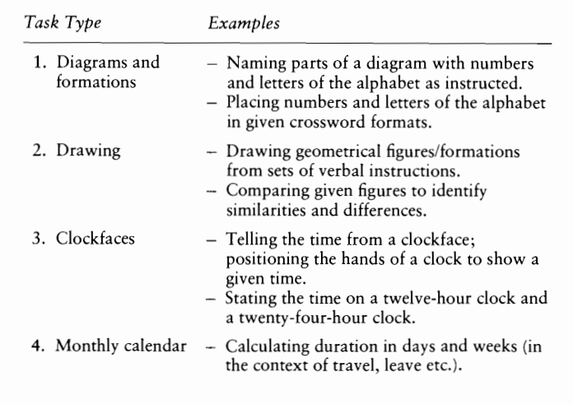

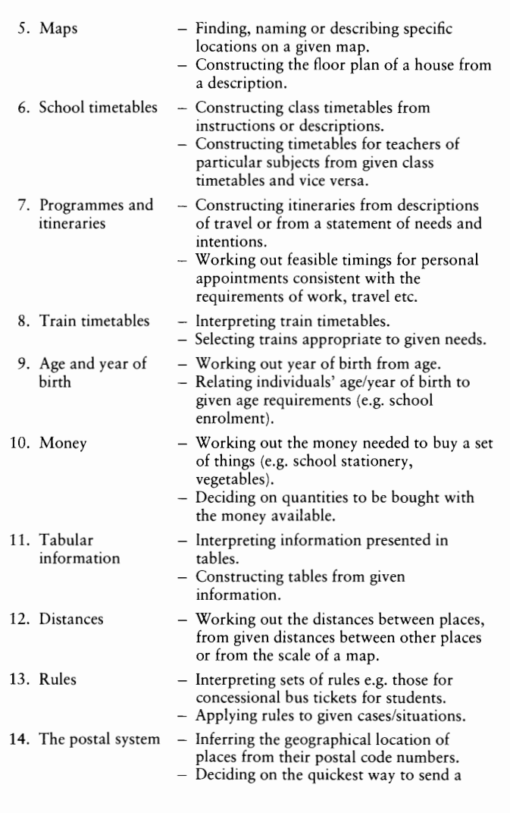

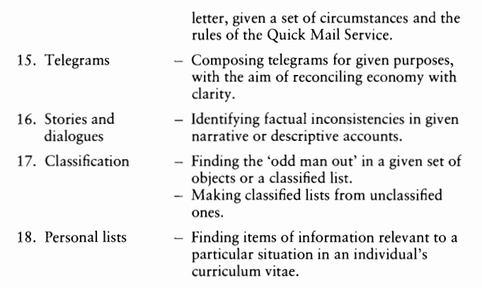

A task is also defined as any structured language endeavour which has particular objective, appropriate content, a specified working procedure and a range of outcomes for those who undertake the task. A task refers to a set of workplans which have the purpose of facilitating language learning from simple and brief to more complex and lengthy activities.

In general, the communicative task as a piece of classroom work involves learners in comprehending, manipulating, producing or interacting in the target language while their attention is principally focused on meaning rather than form. It is not easy to draw a distinction between communicative and non- communicative tasks for several reasons, one of which is the fact that meaning and form are closely interrelated. Different grammatical forms are used to signal differences in meaning.

1. **Components of a Task**

Tasks contain some form of input data that might be verbal (a dialogue or reading passage) or non- verbal ( a picture sequence) and an activity which is derived from the input which sets out what learners will do in relation to the output. The task will have explicitly or implicitly a goal and roles for teachers and learners. In synthetic terms, we will find lessons and units of work will consist of sequence of tasks, and the coherent of such lessons will depend on the extent to which the tasks have been integrated and sequenced in some principle way.

A task is a piece of meaning- focused work involving learners in comprehending, producing, or interacting in the target language, those tasks are categorized or analyzed according to their goals, input data, activities, settings, and roles.

**3.1. Goals**

They are the general intentions behind any given task. They provide a point of contact between the task and the broader curriculum. Why did you let your learners engage in a task? The answer generally will take the form of some sort of goal statement. The possible answers:

- I want to develop their confidence in speaking.

- I want to develop their personal writing skill.

- I want to develop their study skills.

Goals may be related to a range of general outcomes (communicative, effective, or cognitive) or may describe directly the teacher or the learner behaviour. Goals are not explicitly stated, it can be interpreted from an examination of tasks. There is a rarely a simple one to one relationship between goals and tasks. Sometimes a complex task involves a set of activities that may move learners toward several goals.

**3.2. Input**

It refers to data that form the point of departure for the task. Input for communicative tasks can be derived from a wide range of sources:

- Letters (formal /informal)- newspapers extract- picture stories- business cards- memo note- photographs- family tree- drawings- shopping list- postcards- passport- street map- menu- recipe- diary.

Here we can rise a question of authenticity: what mixture of authentic and especially written materials is valid?

1. **3. Activities**

They specify what learners will do with the input which form the point of departure for the learning task. There are three general ways for characterizing activities.

**\* Authenticity:** the tasks should be analyzed according to the extent to which they require learners to rehearse in class the sort of of skilled behaviour they might be expected to perform in the communicative interaction outside the classroom. It is said that classroom activities should parallel the world as closely as possible, since language is a tool for communication, methods and materials should concentrate on the message not the medium. For instance, the purpose of reading in class should be the same as in real life. To obtain a specific fact (scanning), to obtain the general idea (skimming), and to obtain comprehension, and to evaluate information in order to determine whether it fits into one’s own belief (critical reading).

* **Skill Getting and Skill Using:** this is related to the traditional distinction between controlled practice activities in which learners manipulate phonological and grammatical forms an transfer activities in which learners apply their newly mastery of linguistic forms to the production or comprehension of communicative lay.

**\* Accuracy and Fluency:** the demand to produce work for display to the teacher in order to be evaluated and given feedback for the demand to perform adequately in the kind of natural circumstances because teaching is a preparation. Language of evaluation lead to a concern of accuracy, monitoring, reference rules, possible explicit knowledge, problem solving, and skill getting. Language use needs fluency, rules, reliance on implicit knowledge and automatic performance. In some occasions, it requires monitoring and problem solving strategies. This is not the most prominent feature, the student produces, the teacher corrects, and the student tries again. The fluency/ accuracy distinction is related to another dimension which can be used to analyze activities. This is the degree of teacher/learner control inherent in any activity. In classroom activities, control is usually with the teacher while in simulation, role plays, the learners have much control.

**3.4. Learners Roles**

A role refers to the part that learners and teachers are expected to play in carrying out learning tasks as well as the social and interpersonal relationships between participants. Any task reflects assumptions about the contributions that learners can make to the learning process. There are variety of roles, learners can perform in the classroom.

- There is a past recipient of an outside stimuli.

- The learner is an interactor and negotiator who is capable of giving as well as asking.

- The learner is a listener and performer who has a little control over the content of learning.

- The learner is involved in the process of personal growth.

- The learner is involved in a social activity, and the social and interpersonal roles of learners.

- learners must take responsibility of their own learning, developing autonomy and skills.

**3.5. Teacher’s Roles**

Richards and Rodgers (1986) suggested that learners roles are closely relate to the functions and status of the teacher. They point out that some methods are totally teacher dependent, while others view the teacher as a catalyst, consultant, or guide. Teacher’s roles are related to the following issues:

-The types of functions teachers are expected to fulfil whether a practice, director, counselor, or model.

- The degree of control the teacher has over how learning takes place.

- The degree to which the teacher is responsible for content.

- The interaction patterns that are developed between teachers and learners.

**3.6. Settings**

It refers to classroom arrangements specified or implied in the task and it also requires consideration of whether the task is to be carried out wholly or partly in the classroom. Nunan ( 1985) distinguishes between two aspects of learning situation: mode and environment. Learning mode refers to whether the learner is operating on an individual or group basis. If operating on an individual basis, the learner is self- paced but if the learner is operating as a part of the group, the answer depends on other factors. There is a need to know if the task is for a whole class, a small group, or pair work? Each of these configurations has implications for task design. Environment refers to whether the learning is taking place. It might be conventional classroom in a language center, a community class, an industrial or occupational setting.

1. **Types of Activities**

In classroom centered research, there is a question: what classroom activities and patterns of organization stimulate interactive language use?

It was found small groups, one way and two way information gap tasks seem to be particularly appropriate for stimulating such language. In one way task, the information follow from one person to another, as when a learner describes a picture to his partner. Here the information that is being conveyed is held by one person. In two way tasks, each participant has some knowledge not shared by other participants. The participants set a task or a problem which can be solved if they pool their information. There is information exchange whereby both parties are there in the task. For example in a story completion task, each participant may hold a portion of information.

Bangalore suggested three principle activities:

1. **Information Gap Activity** which involves transforming information from one person to another, from one form to another, or from one place to another. It is calling for the decoding or encoding of information from or into language. One example is pair work in which each member of the pair has a part of the total information (for example an incomplete picture and learners try to convey it verbally to another. Another example is completing a tabular representation with information available in a given text. The activity involves the selection of relevant information, and learners may meet criteria of completeness and correctness in making the transfer.
2. **The Reasoning Gap Activity** involves deriving some new information from given information through the process of inference, deduction, practical reasoning, or perception of relationship or patterns. One example is working out a teacher’s time table on the basis of a given class timetable. Another is deciding what course of action is best for a given purpose and within given constraints. The activity involves comprehending and conveying information as an information gap activity but the information to be conveyed is not identical with that initially comprehended. There is a piece of reasoning that is conducting the two.
3. **The Opinion Gap Activity** involves identifying and articulating a personal preference, feeling, attitude in response to a given situation. One example is story completion, another is taking part in a discussion of a social issue. The activity may involve using factual information and formulating arguments to justify one’s opinion, but there is neither an objective procedure for demonstrating outcomes as right or wrong, nor a reason to expect the same outcome from different individuals or in different occasions.

Pattison (1987) proposed seven activities:

1. **Question and Answer:** these activities are based on the notion of creating an information gap by letting learners make a personal and secret choice from a list of language items which fit into a given frame to discover their classmates secret choices. This activity can be used to practice almost any structure, function, or notion.
2. **Dialogue and Role Plays:** these can wholly scripted or wholly improvised. If learners are given a choice of what to say, and if there is a clear aim to be achieved by what they say in their role plays, thy may participate more willingly and learn more thoroughly than when they are told to simply repeat a given dialogue in pairs.
3. **Matching Activities:** the task for the learner is to recognize matching items or to complete pairs or sets.
4. **Communicative Strategies:** these activities designed to encourage learners to practise communication strategies such as: paraphrasing, borrowing, or inventing words, using gestures, or asking for feedback.
5. **Picture and Picture Stories:** many communicative activities can be simulated through the use of pictures (spot the difference, memory test, sequencing pictures to tell a story).

**\* Picture Description:** many picture description activities are information gap activities. Successful activities completion depends on learners’ starting point. In many tasks, it is important to ensure that if someone is describing a picture to another. The describer’ picture cannot be seen. When this is the case, individuals (2 or more) are separated by a barrier. This barrier can be a card, a board, or whatever. What matters that the picture cannot be seen. In some versions of picture description, one can be given a task to be described with some instructions that the other one can draw it. When someone wants to manipulate different type of input, recorded instructions and descriptions may be appropriate. In some cases, the teacher wants standardized input for all the participants. In this situation, the teacher can prepare a recording or a transcript and then use it.

**\* Spot the Difference:** here different pictures are used in pre-determined ways. Participants are asked to find the differences, and the number of differences can be pre-specified so that participants have a goal to work toward. These pictures can be used to elicit locatives, plurals, or questions. The vocabulary is somewhat difficult, but it can work with advanced learners by using a pre- taught vocabulary. The picture can be modified to meet the needs of an appropriate pair or a group of participants.

1. **Puzzle Problems:** there are many types of puzzles and problems. These require learners to make guesses, draw on their general knowledge and personal experience, use their imagination and test their powers of logical reasoning.
2. **Discussion and Decision:** these require learners to collect and share information to reach a decision.

Other activities can be :

**\* Jigsaw activities** are two way tasks, individuals have different pieces of information to solve the task. They must interact orally to put the piece together. An example of jigsaw task is a map in which participants are given a map of a section of city. Each participants is provided with different information about te streets and which ones are closed and when. Once this portion is completed, they have to work together to determine a route from point A to point B. Another jigsaw activity is story completion, or story sequencing task in which different individuals are given a part of the story ( written or pictorial) with instructions to make a complete story. The important point about jigsaw activity is that they involve information exchange, they require participants to interact to finish the activity.

**\* Consensus activities:** involve pair or group of learners who must come to an agreement on a certain issue. For example, ten individuals are on an island, but only five can fit into a boat to get to the mainland. Characteristics are provided for each individual, and the pair or group must come to an agreement about which five should get into the boat. The task allows for less guided discussion than others, but it does not guarantee that there will be an interaction. One individual might not participate, or if the activity is not engaging, they might pick up five individuals without giving elaborate justification. Another type of consensus activities is dictagloss where learners work together to reconstruct the text that has been read to them. It is possible to read the text based on vocabulary, content, and particular grammatical structures. It is normal mode of delivery, the text is read aloud twice at normal speed. Participants can take notes on the second reading. This depends on the goals because the text is read at normal speed, the participants cannot write everything. Following the reading, participants can work in dyads (pairs) or small groups to reconstruct the text maintaining keeping the meaning of the original.

**\* Consciousness Raising Activities:** intend to facilitate learners’ cognitive process in terms of awareness of some language area or linguistic structure. In these activities, learners are required to verbalize their thoughts about language and their way to a solution. For example, each participant in the group is given a sentence, some are correct others are not. Each student reads the sentence aloud to the others and then using a work sheet, the student determines which verb could or could not use a specific structure for instance.

1. **Computer Mediated Research:** involves learners communicative exchange using the computer. CMC is a computer based medium that may amplify a less stressful environment for second language practice and production. It may be the CMC that provide richer data than face to face oral exchange for second language learners. CMC software allows users to engage in both simultaneous chat based and asynchronous forum based communication. What is typed is stored, and users, teachers, and researchers can retrieve prior convention if desired. The forums generally include open, moderated, closed, and restricted formats, and some have support for distance learning.

**5.Tasks, Activities, and Exercises**

These terms are understood differently depending on who defines them.

**An Exercise** is a teaching procedure that involve controlled, guided, or open ended practice of some aspects of language. A drill, a close activity, reading comprehension passage can all be regarded as exercises.

**An Activity** is more general and refer to any kind of purposeful classroom procedure that involves learners in doing something that is related to the goal of the course. Singing a song, playing a game, teaching part in a debate, having a group discussion are different kinds of teaching activities.

**A Task** is something learners do or carry out using their existing language resources or those that have been provided in a pre-task work.

- It has an outcome which is not simply linked to learning language. Language acquisition may occur as the learner carries out the task.

- It is relevant to learners’ needs.

- It involves a focus on meaning.

- The use of information strategies and instructional skills.

- It provides opportunities for reflection on language use.