**Lesson One: Designing a Syllabus or a Course Component**

**Session one**

**Introduction**

The information discussed here are taken from Graves (1996, pp. 12- 43).

Have you developed a course before? Are there any guidelines? Is there a procedure to follow? What do you do? Where do you start?

The answer to these questions has to do with the nature of each teacher´s situation. Some schools need a course for preteens who had finished their children´s course but they are too young for the teen course. In practice, the answer is yes and no. Yes because there are modules, guidelines, and principles to consider that can help teachers make sense of the situation, mobilize resources , and organize their progress. Those guidelines have to do needs assessment, goals and objectives setting, conceptualizing and organizing content, choosing or adapting materials and activities, evaluation and consideration of constraints and resources. That framework of components that overlap both conceptually and temporally raises issues for the teacher to consider. No because the guidelines are not a recipe. There is no set of procedures to follow that will grantee a successful course because each teacher and each teachers´situation is different. It is not a question to answer, it is an answer to find.

The process that proceeds a course design ranges from: situation, decision, challenges, and population is called problematizing. A teacher needs to understand the constraints and resources of the situation and how to perceive them. While proceeding, he/she needs to understand the givens of the situation, to identify the challenges that will shape his/her decision, and figure out what must be done. Problematizing depends on the teacher´s perception of the context, out of which arise problems to be solved. Asking questions and identifying problems are obvious means of probematizing. The latter requires that the teacher organizes the values of his/her experience because no starting of the course from scratch. The role played by experience is an important source of answer as the teacher problimatizes the situation. The teacher is an expert in his/her settings, and past experience and success can serve as bridges to new situation. The experience of developing a course enables teachers to make sense of the theories and expertise of others because it gives them opportunities to clarify their understanding of theory and make it concrete. Their practice in turn changes their understanding of theories. For example, examining needs assessment tools, understanding the rationale of two different models for integrating content, or

examining other syllabuses can trigger the appropriate steps and solutions. If they find it difficult, they can seek answers from people they consider experts.

Designing a course is a challenge, but teachers should know how to design the course they should teach. First, the teacher should have experience to answer his/her questions. Second, this provides them with a conceptual framework for making sense of the course development and recognize that such experience can be a basis for developing a new course or modify the existing one. In other words, the teacher´s experience and theories of others help the designer find a framework or frameworks of components of course development that simplify this complex process.The process of curriculum development is similar to that of course development. Course includes planning a course, teaching it and modifying the plan while the course is progress and after the course is over. In traditional view of curriculum development, teachers have no role in the planning stage, and specialists determine the purposes, plan the syllabus, and develop the materials that teachers are supposed to use in their classroom. Like in course, in curriculum modification is a continuing and cyclical process of development, revision, maintenance, and renewal which needs to continue throughout the life of the curriculum.Teachers who have never planned a course have experience in course development because a course is planning and teaching, and teachers have experienced such stage. All teachers have experience with stage two (teaching) even when they follow an assigned text or syllabus, a teacher must take decisions about what to emphasize, leave out, augment, and review, and how to practice, how much, with whom and when. Most teachers have experience with modifying and reteaching because they are using the book one semester after the other, and change the way they teach according to their experience.

Before proceeding further, these three terms should be highlighted:

1. **Curriculum, Syllabus, and Course**

* Nunan (1987) discussed three ways by which the term curriculum is interpreted by teachers. (1) As a product or a set of items to be taught, (2) process for deriving materials and methodology, (3) as the planning phase for the program. Curriculum has to do with the purposes, design, and implementation.

* A syllabus is defined as the specification or ordering of the content of course or courses.

* A course is an integrated series of teaching learning experiences, where the ultimate aim is to lead the learner to particular state of knowledge.

Syllabus design is a part of course development, and a course is a part of the curriculum.

Curruculum design specialists have developed various frameworks that break down the process of curriculum and course development into components and subcomponents. A framework of components is useful for several reasons:

- It provides an organized way of conceiving of a complex process.

- It sets forth domains of inquiry for the teacher to pursue.

- It provides a set of terms currently used in talking about course development and a common professional vocabulary and access to ideas of others.

This table summarizes the framework suggested by Graves (1996, p. 13):

1. **Graves’ Framework**

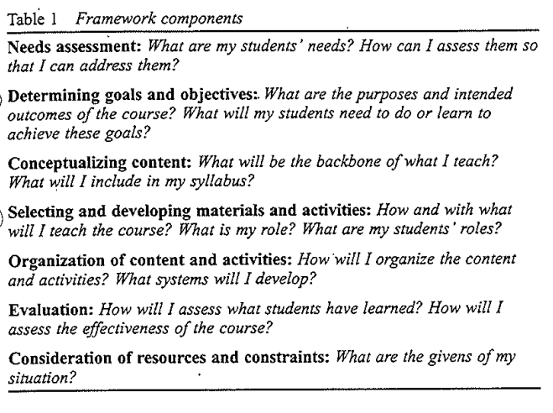

* 1. **Needs Assessment**

What are my students needs? How can I assess them so that I can address them?

Needs assessment involves finding what the learners know and can do and what they need to learn or do so that the course can bridge the gap ( or some part of it). Needs assessment involves seeking and interpreting information about ones students´needs so the course will address them effectively. One way of conceptualizing needs is distinguishing between:

Objective and Subjective Needs, objective needs are derivable from different kinds of factual information about learners, their use of language in real life communication situations as well as their current language proficiency and language difficulties; subjective needs are the cognitive and effective needs of the learner in the learning situation, derivable from information about effective and cognitive factors such as personality, confidence, attitudes, learners´ wants and expectations with regard to the learning of English and their cognitive style an learning strategies.

In assessing objective needs, one can include information about students´ background, country and culture, education, family, profession, age, language spoken, etc; students´abilities or proficiency in speaking, understanding, reading, and writing; and students needs with respect to how they will use or deal with English in real world. In assessing subjective needs, one can include information about students´attitudes toward the target language and culture, toward learning,and toward themselves as learners; students´expectations of themselves and of the course; students´underlying purposes in studying English; and students preferences with respect to how they will learn. Different students have different needs, and needs assessment help teachers choose what to teach and how to teach it. Needs assessment can include input from students as well as from various people connected to the course, such as teachers, funders, parents, administration, and employers. In a university ESL setting, information from the students´ future professors regarding what the students will be expected to read, research and present can help the teacher shape his/ her course. Teachers may work with conception of needs determined by their institution or other party and conduct their assessment accordingly.

Needs assessment can be conducted in the planning stage, teaching stage, the re-planning stage. Teachers who have contact with their students prior to teaching the course can undertake a precourse needs assessment. In many cases, a formal procedure needs assessment is neither necessary nor appropriate because some teachers are able to make fairly accurate assumptions about their students´needs with respect to the course on the basis of prior experience with the course or with those particular students.

Teachers can use a variety of methods to conduct needs assessment. Questionnaires are common needs assessment tool. They can be written in English or in the native language of students. Interviews with students and other professors and employees are another common way of finding out students´needs. Observation of participants in situation where students use English. Tests and interviews that measure proficiency are also a part of needs assessment because they help to determine what students´already know and where they are lacking.

Hutchinson and Waters (1987) make a distinction between target needs , it means what learners need to learn in the target situation. Learning needs; what learners need to do in order to learn. Needs assessment is a clearly a sensible undertaking when students have target needs - real life language needs and a context for using the language skills gained in class. Though needs are clear, the teacher has to find ways to assess and define them so that they can be translated into realistic goals. In other context such as EFL classrooms, teachers face a different problem because many of their students have no target needs. English my be acquired for passing an exit or entrance exam. The focus of needs assessment shifts to the learning needs or subjective needs of the students so as to increase motivation and to help students find purposes and interests in what they are doing in the course.