**LECTURE THREE**

1. **The History of Computer Assisted Language Learning**

Variation and shift in second language acquisition theories marked and is reflected in the evolution of CALL overtime. Henceforth, the history of CALL can be divided into three main eras: the behaviouristic, the communicative and the integrative era.

* 1. **The Behaviouristic Era**

At the beginning, during the 1960s and 1970s, the use of technology was influenced by behaviouristic learning and structural linguistics; it was restricted to student-computer interactions to practice grammatical and lexical drills or to do some transformation exercises i.e. focus was on language itself (vocabulary and grammar). At this period, the computer played the role of a ‘tutor’ that provided learners with grammar and vocabulary exercises (see Appendix A for sample activities), then, gave them feedback at the learners’ pace. It was sometimes used to replace the teacher (Brett & Gonzàlez-LLoret, 2009; LeBaron-Earle, 2013).

PLATO (Programmed Logic for Automatic Teaching Operations) and TICCIT (Time-shared, Interactive, Computer Controlled Information Television) project were created in American universities and best illustrate this era. The first version of PLATO, in 1960, consisted of a single terminal. By 1975, the *PLATO IV* system consisted of over 900 terminals at 146 different sites. The aim of the PLATO project was to introduce the computer to

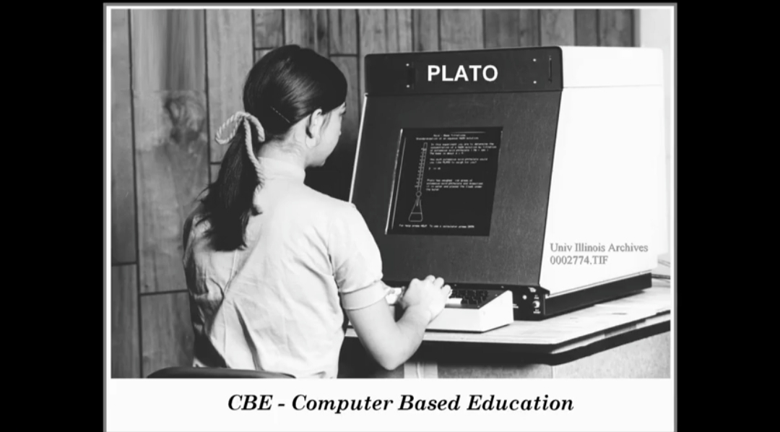

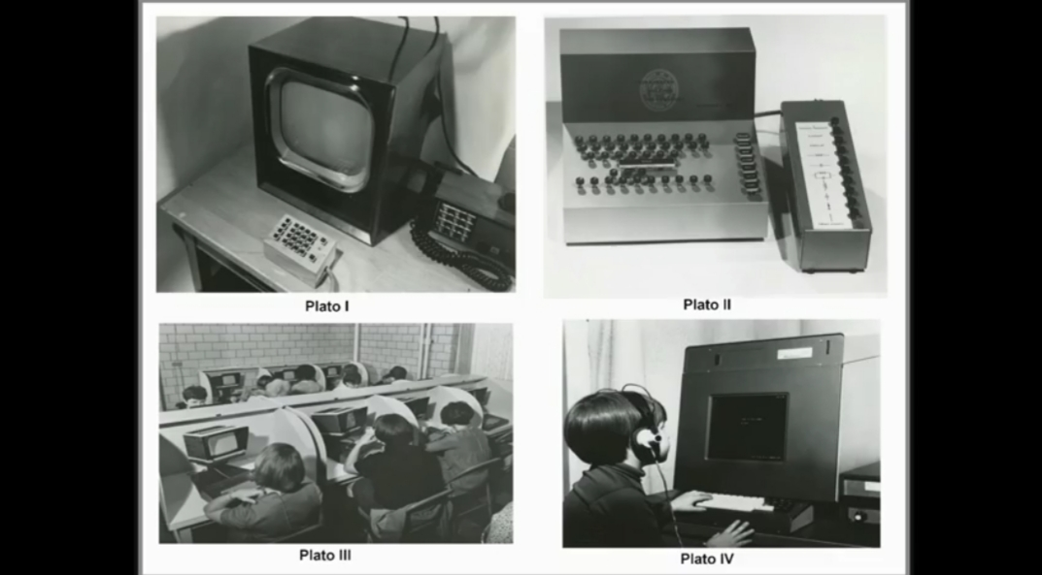

education. TICCIT was launched in the early 1970’s, it utilized the minicomputers as the engines for learning environments instead of the mainframes used for the PLATO project (Hagler and Marcy, 1999). TICCIT is thought to be the first computer system that integrated text, audio and video multimedia, but with remarkable difficulties in usage (Le Baron-Earle, 2013 p. 51)

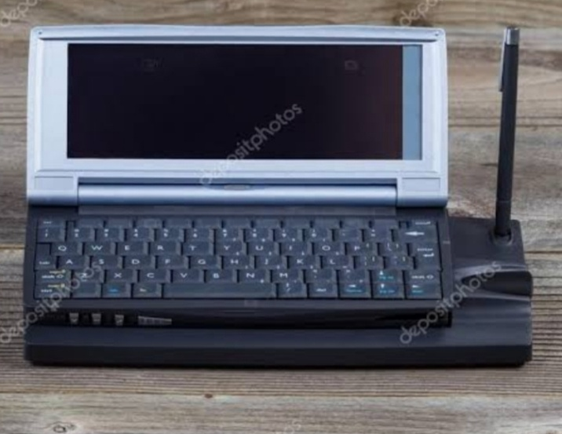 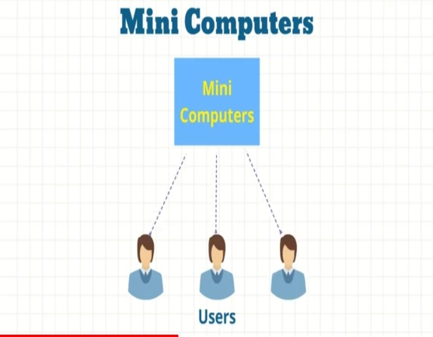

However, these programs were linear i.e. they required learners to follow the same steps with rewards for correct answers, then, advancement to more difficult level. The tasks were typical to those in traditional textbooks, in other words, they did not profit from the features of the computer. Besides, other major weaknesses that were noticed within this phase were the lack of embodiment or contextualizing the language learnt, the absence of the teacher, together with a failure in fulfilling learners’ needs including speaking and listening (Jordan et.al. 2008 p. 228; LeBaron-Earle, 2013).

* 1. **The Communicative Era**

With the advent of the communicative approach, the focus shifted to be put on meaning, on the communicative competence and on the four skills. Therefore, the role and the use of computers changed from a tool for individual learning (or a tutor) to a tool that facilitates interaction (Brett & Gonzàlez-LLoret, 2009), although learners did not interact with other humans but with characters.

In the 1980s, the focus was on developing the communicative competence and cultural awareness, and thus, teaching the target language through interaction was the guiding principle. However, albeit the teaching material was carefully selected (e.g. maps, newspapers) to be authentic, the learning contexts and the human characters with whom learners interact were not authentic. At this period, the computer was used as a ‘tool’ or ‘medium’ for interaction, and it did not aim at replacing the teachers, but at assisting their work (LeBaron-Earle, 2013).

Three main projects can be listed to illustrate this phase: the Athena Language Learning Project (ALLP), the Computer-assisted Multimedia Interactive Language Learning Environment (CAMILLE) Project, and the Minitel Project. First, the ALLP was the result of a collaboration between the Massachusetts Institute of Technology, IBM, and Digital Equipment Corporation to produce learning prototypes for learners of French, German, Spanish, Russian, English, and Japanese. Through these programs, learners could interact with real life characters through videos (simulation), immersed in real life tasks (such as job interviews and searching for an apartment), and provided with authentic materials (such as maps, newspapers ads, location photos…). Second, the CAMILLE Project provided various tools for learners including a textbook of learning activities, a grammatical aid, a dictionary with recordings of a native speaker pronouncing the words, audio and video files and a book on the target culture. All of these are at the learners’ disposition on the homepage of the environment. Last, “the Minitel is an online service made accessible through telephone lines provided by *Poste, Téléphone et telecommunication (PTT),* the French postal and phone services” (LeBaron-Earle, 2013 p. 54). In 1986, the Minitel was used to link students in France, Italy, and Portugal who were required to write fictitious tales. The use of the Minitel enabled genuine authentic intercultural exchange between learners.

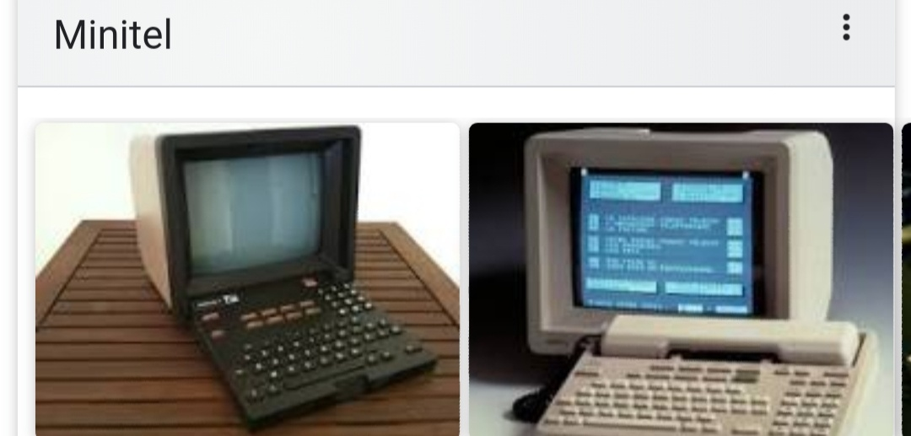

Despite the efforts to provide ‘authentic’ material and real-life situations and characters, the learning contexts and characters were not authentic; they were simulated. Therefore, CALL in this era was beneficial on the linguistic level, but not on the intercultural level. For the use of the Minitel, its use was isolated, limited and unrepeated. Educationists looked for to actual authentic learning contexts rather than artificial communicative learning situations (LeBaron-Earle, 2013).

* 1. **The Integrative Era**

With the integrative phase, “students learn to use a variety of technological tools as an ongoing process of language learning and use, rather than visiting the computer lab on a once a week basis for isolated exercises” (Warshauer and Healy, 1998 cite in LeBaron-Earle, 2013 p 55). The fast development of computers and technology together with the emergence of the Internet, in the 1990s, aided the educationalists’ claims for more authentic situations and social learning. The latter was reflected in Computer Mediated Communication (CMC) through which communication takes place between learners and teachers with the help of computers and the Internet (LeBaron-Earle, 2013).

Jordan et.al (2008, p. 228) echoed this view stating that “the computer now operates as a communication device rather than a teaching machine. This compromise addresses the problem of embodiment and materials”. In other words, through facilitating face-to-face interaction between human beings, the need for authentic and highly prescriptive teaching materials, together with the search for the most appropriate method to implement are already addressed problems.

Recently, technology has been much more integrated in the teaching/ learning process, albeit those technologies were not invented to support leaning (e.g. e-mail). The International E-mail Tandem Network or *eTandem* launched by Helmut Brammerts in 1993 exemplifies learning in the integrative phase. Two language learners who want to learn the language of each other use e-mails to exchange written content and attached multimedia files. The *Cultura Project*  is another major contribution that can be used for illustration. It was a collaboration between the Massachusetts Institute of Technology and l’Institut National des Télécommunications in 1999 which aimed at developing learners’ intercultural communicative competence. It followed a blended learning approach i.e. learners discussions were carried out online via forums and then in the classroom.

The use of various web 2.0 services, including online games and social media (MySpace, Facebook, YouTube…), has become a part of social media assisted language learning (SMALL). Besides, the integrative CALL period is characterized by the use of telecollaborative projects in language teaching/ learning. Telecollaborative pedagogy is characterized by the use of internet communication tools to bring together geographically distant groups of language learners and teachers in institutionalized settings for the sake of developing their foreign language skills and intercultural competence through social interaction, telecollaborative tasks, and project work (Belz, 2007, O’D’owd, 2013). This kind of pedagogy “is commonly characterised as ethnographic, dialogic and critical” (Belz, 2007 p.138). It takes place “under the careful guidance of languacultural experts” (ibid, p.158) i.e. under the supervision of teachers. Telecollaborative learning became one of the main pillars of CALL (O’Dowd, 2011).

**References**

Bennacer,F (2019). *Using Telecollaboration through Facebook to Develop the English as a Foreign Language Learners’ Intercultural Communicative Competence.* Unpublished Doctorat thesis. University of Mentouri Brothers, Constantine 1.

Brett, D. & Gonzàlez-LLoret. (2009). Technology- enhanced materials. In M.H. Long & C.J. doughty (ed). *The handbook of language teaching.* (pp. 351-369). Wiley-Blackwell.

Jordan,A.; Carlile,O. & Stack,A.(2008). *Approaches to learning: a guide for teachers.* Open University Press.

LeBaron-Earle, F. (2013). *Social media and language learning: enhancing intercultural communicative competence.* University of Limerick.

O‟Dowd, R. (2011). Intercultural communicative competence through telecollaboration. In J. Jackson (ed). The Routledge Handbook of language and intercultural communication (pp 342-358). Routledge Taylor & Francis Group.