

***People's Democratic Republic of Algeria***

***Ministry of higher education and scientific research***

***Abdelhafid Boussouf university center – Mila***

***Institute of science and technology***

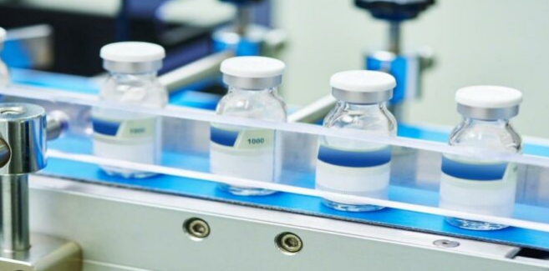

***Module: Pharmaceutical Processes***

***Third year LMD; Process Engineering***

**Presented by:**

**Dr. Imane MAYOUF**

***2023 - 2024***

**Content of the material:**

**Chapter 1: Drugs/medicine**

• Introduction

• Definitions

• The stages of drug development

• Different classifications of drugs

• Active ingredients

• Excipients

• The conditioning

• Drug activity and toxicity

• Become active ingredients in the body

**Chapter 2: synthesis operations**

• Sources of active ingredients

• Methods for obtaining natural substances

• Synthetic methods

• Biotechnological methods

**Chapter 3: Preformulation**

• Routes of administration

• Choice of dosage forms

• Biopharmaceutical classification (solubility, permeability)

• Dissociation coefficient, partition coefficient

**Chapter 4: Manufacturing Environment**

• Pharmaceutical company

• Manufacturing of pharmaceutical water

• Air treatment

• Concept of quality in the pharmaceutical industry

***Chapter 2: Synthesis operations***

***01/ Sources of active ingredients***

**The active ingredient may have a natural origin: vegetable, mineral, animal, microbiological, or synthetic, semi-synthetic.**

***01.01/ Vegetable origin:***

**The substance can be obtained from plants (terrestrial or marine) using either:**

* **Whole plants or parts of plants: Use in herbal tea.**
* **Herbal preparations,**
* **Chemical substances defined and isolated from plants, obtained by extraction and purification.**

***01.02/ Mineral origin:***

**Various elements or their salts such as sulfur, iodides,** **phosphates, salts of iron, calcium, magnesium, mercury,** **talc..., formerly used as remedies, still make** **part of the therapeutic medicines.**

* **Sodium bicarbonate: pH corrector for gastric acidity;**
* **Magnesium aluminum silicate: gastrointestinal dressing;**
* **Sodium and magnesium sulfates: purgatives;**
* **Zinc oxide and copper sulfate: antiseptics;**
* **Zinc chloride: anti-inflammatory in the treatment of acne.**

***01.03/ Animal origin:***

**In the past, animal organs were used to prepare hormones (insulin).Ancient therapy, called opotherapy, used to treat physiological insufficiencies: Liver to treat anemia. It developed quite widely in the 20th century thanks to conservation technology by the cold (cold chain), but, the highlighting of risks of transmission of viruses triggered its disappearance in favor of other products.**

**Examples**

* **Fresh human blood is an untreated product,**
* **Pure active constituents obtained by extraction and purification: Insulin (pancreas) for type 1 diabetics (insulin dependent),**

***01.04/ Microbiological origin:***

**The best known are Penicillin used as antibiotics, however we also use:**

* **Viruses and bacteria,**
* **Products produced by microorganisms cultivated in a liquid medium,**
* **Streptomycin: treatment of tuberculosis (isolated in 1947),**
* **Chloramphenicol: treatment of urinary infections,**
* **Cyclosporin: immunosuppressant isolated in 1970 and used since 1983 during transplants to avoid rejection by the recipient…**

***01.05/ Biotechnological origin:***

**Microorganisms are cultivated for the production of molecules identical to those produced by man.**

* **Identification of the human gene encoding the X protein**
* **Reproduction of the DNA fragment**
* **Introduction of the DNA fragment into the bacteria**
* **Culture: clones synthesizing protein**
* **Insulin (diabetics), regulator of the inflammatory and immune response (treatment of leukemia, cancer, chronic hepatitis of origin viral).**

***01.06/ Synthetic & semi-synthetic origin***

**Very numerous and obtained by semi-synthesis or synthesis. For semi-synthetic products, a modification is required to obtain the final product and to improve its therapeutic performances by:**

* **Increased absorption by the body,**
* **Reduction of harmful side effects,**
* **Modification of lipophilicity to promote trans-membrane passage,**
* **Modification of a chemical interaction with a pathogen,**

**Example: penicillins all have a beta-lactam core. We carry out chemical modifications around this nucleus, giving penicillins more effective.**

***02/ Methods for obtaining natural substances***

**Plants are popular used as a common source in medicinal agents, food additives, cosmeceuticals and nutraceuticals.**

**Although, the medicinal properties of plants have gained attention, many research studies are still conducted to discover their values because the utilisation of synthetic drugs to heal or control most chronic diseases have caused several long–term effects.**

**There is rising approach regarding the application of herbal medicinal plants in treating diseases with minimal or no aftereffects. Therefore, the extraction of bioactive compounds from herbal medicinal plants offers great potentials for new drug discoveries.**

**These therapeutically useful medicinal compounds in plants are extracted or separated by using selective solvents through a standard procedure. Generally, the extraction techniques can be divided into two categories, namely classical technique and modern technique. The former technique faces several limitations, such as the use of excess solvents, time–consuming and a long heating time which could risk the degradation of bioactive compounds. In most cases, extraction by using these solvents was hazardous and toxic to human health and the environment.**

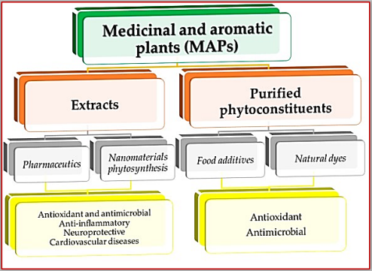

**Figure 01. Some of the potential applications of medicinal and aromatic plants.**

**Contrary to the hazardous classical techniques, environmentally friendly extraction approaches like ‘green solvents’, ‘green processing’ and ‘green product’ are favoured. Green extraction methods should be applied to encourage efficient and safe extraction method. Green extraction methods reduce energy consumption which allow the use of alternative solvents and renewable natural sources to produce a safe and high–quality product. Therefore, these modern extraction techniques are considered as green processing. These techniques reduce the usage of organic solvents, minimise bioactive compounds degradation in the sample and improve extraction efficiency.**

**Extraction, as the term is used pharmaceutically, involves the separation of medicinally active portions of plant or animal tissues from the inactive or inert components by using selective solvents in standard extraction procedures. The products so obtained from plants are relatively impure liquids, semisolids or powders intended only for oral or external use. These include classes of preparations known asdecoctions, infusions, fluid extracts, tinctures, pilular (semisolid) extracts and powdered extracts. Such preparations popularly have been called galenicals, named after Galen, the second century Greek physician.**

**The extract thus obtained may be ready for use as a medicinal agent in the form of tinctures and fluid extracts, it may be further processed to be incorporated in any dosage form such as tablets or capsules, or it may be fractionated to isolate individual chemical entities such as ajmalicine, hyoscine and vincristine, which are modem drugs. Thus, standardization of extraction procedures contributes signifi cantly to the final quality of the herbal drug.**

**In the production of medicinal and aromatic plants the quality of the products is given by the content in active principles. The amount of active principles in the plant is conditioned by ecological factors, the zoning of the species, the cultivation technology, the biological value of the cultivar (population, variety, hybrid, etc.) and last but not least, the processing .**

**In the extraction operation, the choice of solvent is made depending on the nature of the substance to be extracted and the nature of the raw material. The actual solubilization of bioactive compounds is achieved by treating the finely chopped plant with water, saline solutions, hydroalcoholic solutions, etc. The chemical nature of the optimal extraction medium, its molarity and pH, as well as the time required for optimal extraction are determined experimentally.**

**In the preparation of extracts, in particular, the influence of the following factors must be taken into account:**

* **Nature of the solvent: solvents must dissolve and extract most of the active components in a high yield and contain as few inert materials as possible without therapeutic value; the most used solvents used in the plant extract industry are: water (for alkaloid salts, glycosides, sugars, proteins, enzymes, tannins, etc.), 50% or 70% alcohol (for biofertilizers, hydrocarbons, tannins, base alkaloids and salts of glycosides, resins, chlorophyll, etc.), ethyl ether (for base alkaloids, resins, biofertilizers, etc.), oil, vinegar;**
* **Degree of crushing of the plant: more the plant is crushed, large is the contact surface, so the extraction is complete;**
* **The ratio between the amount of plant and solvent: must be proportional, if there are a small quantity of the solvent in front of a big quantity of plants the extraction will not been completed;**
* **Contact time between plant and solvent: differs depending on the extraction technique applied, but also on the type of extract; for aqueous extracts it is 5–6 hours, and for alcoholic ones 6–10 days;**
* **The temperature at which it is worked: it positively influences the extraction efficiency, due to the increased solubility of the hot active principles;**
* **Separation of the mixture and how to recover the active compounds from the solid residue.**

**In the case of preparation of aqueous or hydroalcoholic extractive solutions by maceration, the degree of crushing plays a very important role. This correlated with the nature of the solvent used and the intensity of stirring determines the contact time for the extraction of soluble components until the concentration balance between the solid phase and the liquid phase is reached.**

**Extraction can be performed by batch processes (maceration, percolation, infusion, decoction, as well as new high– performance methods: accelerated solvent extraction, microwave–assisted extraction, supercritical fluid extraction) and continuous processes (continuous extraction with organic solvents, continuous percolation, Soxhlet extraction):**

* ***Soxhlet extraction* is a common conventional method used for extracting heat–stable compounds. The advantage of this method is that large amounts of drug can be extracted with a much smaller quantity of solvent. This is tremendously economic in terms of time, energy, and consequently financial inputs. The Soxhlet extractor consists of a distillation flask, an extractor, and a condenser. The solvent in the distillation flask is heated and the resulting vapor is condensed in the condenser. The condensed solvent from the condenser fills into the thimble holder containing the sample that needs to be extracted. When the solution in the extractor reaches the overflow level, a siphon aspirates the solution of the thimble holder and unloads it back into the distillation flask, carrying dissolved solute into the bulk liquid. The solute is left in the distillation flask while the solvent is evaporated, condensed, and passed back into the sample solid bed. This process is repeated 3–5 times or until a complete extraction is achieved.**

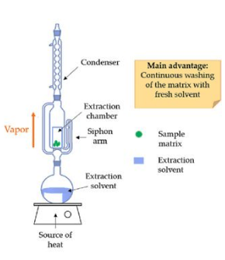

**Figure 03. Soxhlet extractor.**

* ***Extraction by Maceration:* consists in treating the crushed vegetable product with a required amount of solvent, keeping in contact for a certain period (macerated in water 8–12 hours), simultaneously with continuous or intermittent stirring and then separating the extractive solution from the residue by filtration or settling; in the case of macerations in other solutions (alcohol, oil, vinegar), the maceration time increases, reaching a few weeks. Maceration can be done in the cold (17–22 ° C) as well in the hot at 40–60 ° C.**

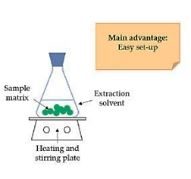

**Figure 04. Extraction by maceration.**

* ***Percolation:* the process by which the active principles are extracted from plants, cold, using solvent in countercurrent. The process takes place as follows: before the solvent becomes saturated in the extracted active ingredients, it is displaced by another layer of solvent in which the plant product undergoes a short maceration and yields another part of the active ingredients. This phenomenon is continuous, each portion of solvent added coming into contact with the plant product until its complete depletion.**

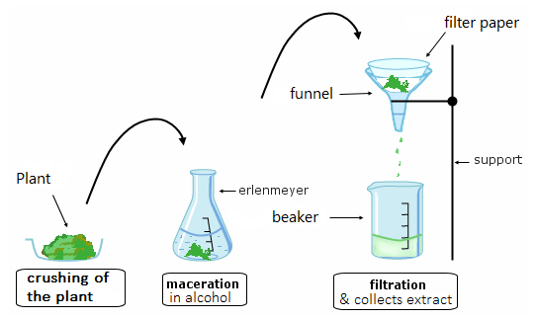

**Figure 05. Extraction by percolation.**

***03/ Synthetic Methods for obtaining Active ingredients (chemical method)***

**In general, the Active Ingredients Process Development and Production involve a number of processing processes, including reaction, crystallization, separation and purification, filtration, washing, solvent swapping, and solvent exchange.**

**Synthetic Active ingredients are divided into innovative and generic synthetic based on the synthesis process, it can also been divided into soluble or insoluble based on their solubility. A large amount of drug products in the pharmaceutical industry is made up of small molecules.**

**The choice of pharmaceutical manufacturing machinery for blending, extrusion, drying, milling, and micronization constitutes a significant portion of the process of development of drug products. Aspirin is the most known medicine made by synthetic method (chemical reaction between acetic anhydride and salicylic acid, then carrying out vacuum distillation).**

**The synthetic manufacturing of active ingredients (they can also named Active Pharmaceutical Ingredient API) passed throw four stages:**

**1st stage: Starting synthesis**

**The different raw materials for the synthesis of the active ingredient are added into big reactors;**

**2nd stage: production of the intermediate**

**Inside the reactor, the chemical reaction will take place, and an intermediate is produced;**

**3rd stage: isolation and purification**

**The intermediate produced is then filtered, crystallized, centrifuged and finally dried;**

**4th stage: physical processing and packaging**

**Once the drying is completed, the dried product will be milled and the final Active ingredient will be packed in containers.**

* ***This method is called also the “bulk pharmaceutical industry”.***

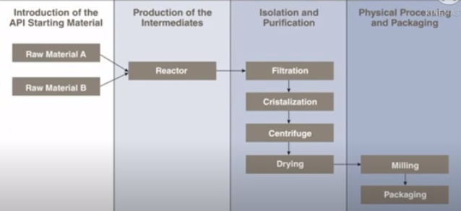

**Figure 06. Stages of chemical manufacturing active pharmaceutical ingredients (APIs).**

* ***Continuous flow reactions as innovated process of API synthesis:***

**The synthesis of complex biologically and pharmacologically relevant molecules traditionally proceeds through multistep batchwise reactions.**

**In the past two decades, there has been a steep increase in the development and use of continuous flow reactions in organic synthesis. This initially concerned single reactions, but in the past few years involved more and more multistep sequences in which consecutive reactions carried out in a so-called one-flow system lead to a complete synthesis of small functional molecules from the beginning to the end without stop and in the same equipment.**

**This operation have many benefits among them:**

* **In such an approach the use of relatively small and mobile dedicated equipment, cartridges of suitable reagents and solvents, vital drugs can be produced in a straightforward manner and in reasonable amounts due to the continuous character of the process.**
* **This is also considered a safe approach owing to the reproducibility, efficient heat transfer and small dimensions of the actual reaction vessels.**
* **Additionally, in a one-flow process workup and intermediate purification steps are excluded leading to faster production and more environmentally benign processes.**

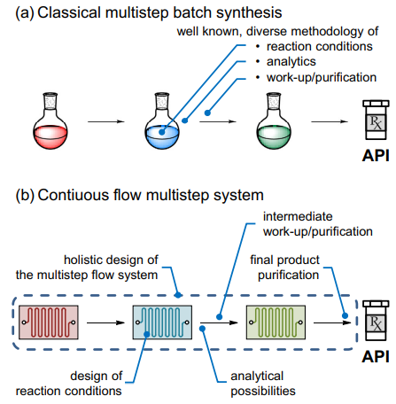

**Figure 07. Steps of chemical manufacturing active pharmaceutical ingredients (APIs) with classical and modern process.**

* **Barriers in Active Pharmaceutical Ingredient (API) Process Development:**

**Only 10% of new drug candidates succeed in reaching the market because commercializing a drug is not an easy process. There are a few barriers and unique challenges in API Process development.**

* **The most frequent cause of failure is a lack of clinical efficacy,**
* **The creation of subpar formulations with poor drug-like qualities,**
* **Lab technicians and scientists must decide how to create the active pharmaceutical ingredient (API) into an appropriate dose form for pilot production during this stage. The same method should subsequently be scaled up for commercial manufacturing if clinical studies are successful.**

***04/ Biotechnological Methods for obtaining Active ingredients***

**Nearly more than 1000 tons of pharmaceutical products are consumed all over the globe (e.g. Europe alone covers up to 24% of the consumption of medicinal products). Therefore, the generation of these APIs has stimulated the release of chemicals in the environment and thereby led to the spreading of pollution. Concurrently, this enormous generation of pollution has called the worldwide attention that requires an immediate alteration in the policies and regulations. Thereby, considering the negative impacts of these chemical channels that are responsible for generating API, the pharmaceutical companies are rendering approval to the microbial-based fermentation using bacteria or yeast.**

**Presently, the environmental amicably processes are becoming tremendously popular for the conversion of biomass to APIs. As following this route, we can be able to bring reduction in the rate of global warming. There are multiple processes that can convert lignocellulosic biomass to APIs in terms of fermentation to form pharmaceutical ingredients. Likewise, the inclination toward microbial-based manufacturing of recombinants has been increased in the past decade and these manufacturings are liable for the approvals of FDA for the human use. Adding to the fact, the microbial-based biopharmaceuticals created the returns of around $100 billion in 2017.**

**The pathway of biotechnological approaches explored the usage of biocatalyst (enzymes) or cells for the transformation of biomass into utility chemicals. In nutshell, it is considered as one of the most easy, simple, and convenient methods for the formation of industrial products from biomass. In contrast to chemical conversions that involve high temperatures and pressures, biological conversions are relatively mild. However, the concept of these biotechnological-based conversions is not the novel addition because earlier as well the various commercially used chemicals are being produced from yeast and bacteria (in terms of acetone-butanol, citric acid ethanol, lactic acid, etc.). The merits of less formation time of by-products and higher yield of product and selectivity (of biocatalysts) to convert renewable resources into chemicals have created fascination in recent time.**

**The word “biocatalysis” indicate the application of enzymes in organic synthesis. This technic is a rapidly developing field for the production of a vast array of APIs. With the advent of a greater understanding of biological processes, advances in molecular biology and bioinformatics techniques and the increased speed of gene synthesis and sequencing, the field of biocatalysis has greatly expanded to cover a much broader range of transformations that are of increased value to synthetic chemists.**

***04-01/ Recombinant DNA technology (rDNA)***

**Based on molecular biology techniques, allowing to:**

**– Cut DNA in a defined and reproducible manner, using restriction enzymes;**

**– Integrate DNA into vectors, DNA molecules used as material transfer tools genetics in a host cell;**

**– Transcribe an RNA in vitro in DNAc sequence at using reverse transcriptase.**

***04-02/ Why rDNA technology?***

**• Eliminate the problem of availability of resources in to extract proteins;**

**• Avoid security and transmission issues diseases from natural biological sources (blood products);**

**• Possibility of change in the structure of a protein to give birth to new entities with advantages over protein original (rapid insulin);**

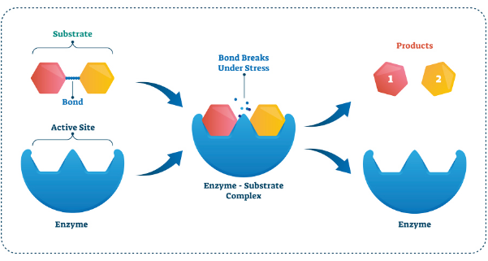

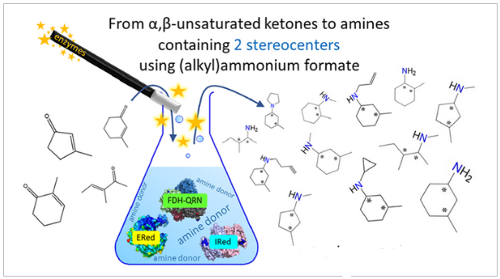

**Figure 08. Schematization of biotechnological synthesis of APIs using enzymatic method.**

***04-03/ Advantages of biotechnological synthesis***

* **It increases conversion efficiency for significantly higher yields with fewer by-products, equating to faster and more cost-effective production.**
* **Pharmaceutical companies are choosing to evaluate biocatalytic processes during early-stage drug development to avoid missing opportunities for capitalizing on these gains.**
* **Biocatalysis also helps to avoid pollution and reduce global environmental impact as it helps minimize the use of rare metals, which often require extensive mining and processing operations.**
* **Biosynthesis of APIs is more eco-efficient than conventional methods. This is because enzymes, being originally derived from natural products, generally perform best under mild conditions.**
* **The superior enantio- and regioselectivity of enzymes results in higher yields of purer product—typically comprising just a single enantiomer that has been modified on only a specific site.**
* **It should be noted that the majority of biocatalytic reactions are typically carried out in water (sometimes with DMSO as a co-solvent) at pH7 and temperatures of 25–30 °C.**

***04-04/ Disadvantages of biotechnological synthesis***

**Although there are certain limitations in the biosynthesis of APIs owing to:**

* **Various variations in the pathway of microorganisms,**
* **Low variety of products,**
* **Therefore, the only way to bring variety and resolve the limitations of biotechnological pathways is to involve the technologies based on genetic engineering and recombinant DNA technology, which can alter the gene coding.**