Nom:

Prénom:

Groupe:

NOTE : /20

**TP  : Cycle de Erisson**

**I*.* Objectif Du TP**

Le but de ce TP est la simulation numérique du cycle de Carnot simple. Le logiciel utilisé pour le calcul est le logiciel EES (Engineering Equation Solver).

**II. Description**

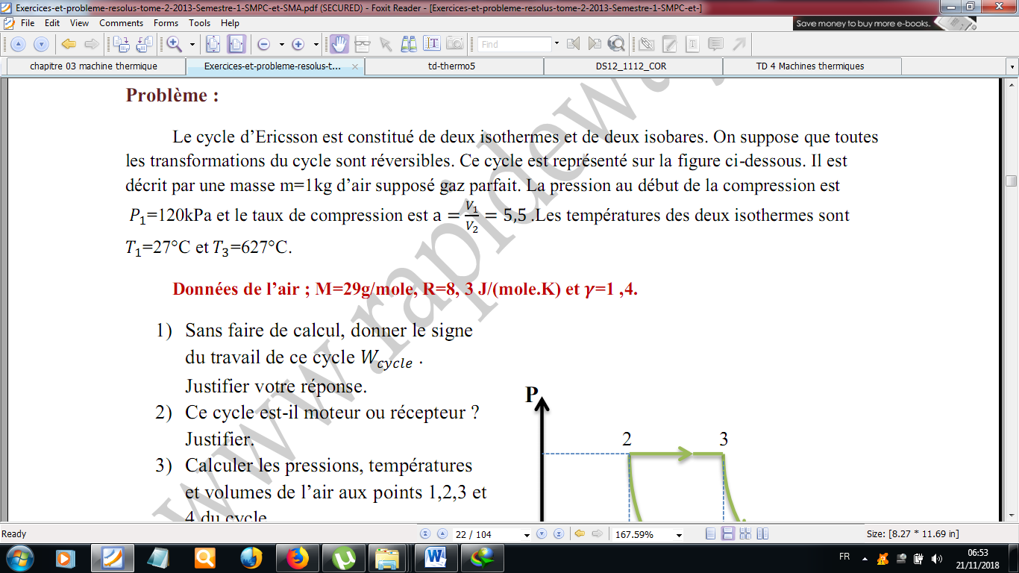**III. Travail demandé**

Calculer en utilisant EES:

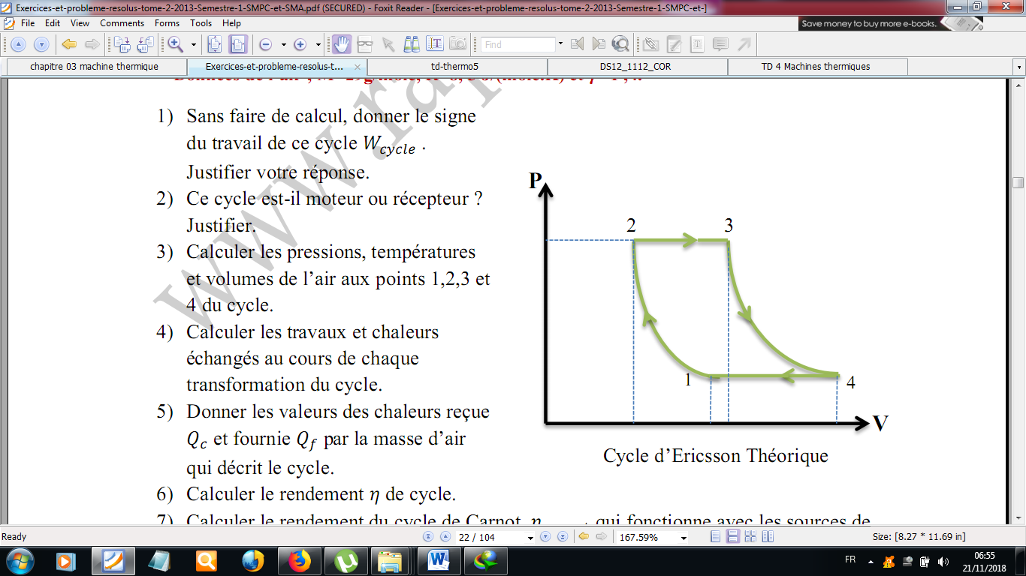

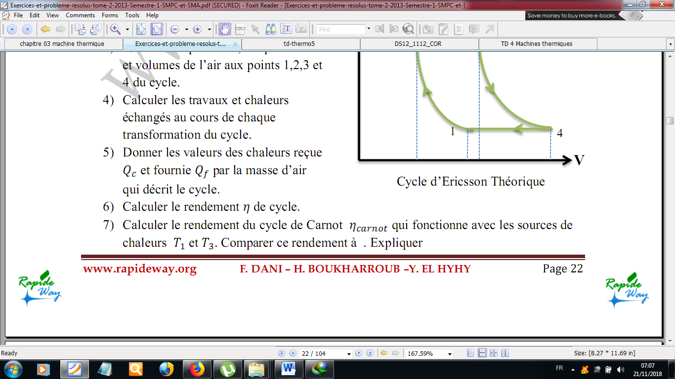

1-………………………………………………………………..

2-……………………………………………………………………….

3-

|  |  |  |  |  |
| --- | --- | --- | --- | --- |
|  | 1 | 2 | 3 | 4 |
| p |  |  |  |  |
| v |  |  |  |  |
| T |  |  |  |  |

4-……………………………………………………………………………..

5-……………………………………………………………………………….

6-……………………………………………………………………………..

7-…………………………………………………………………………………..

III.2 Remplir le tableau

|  |  |  |  |  |  |  |
| --- | --- | --- | --- | --- | --- | --- |
|  | T1 | T3 | ΔT | ƞ | ƞ Carnot |  |
| 1 | 27 | 627 |  |  |  |  |
| 2 | 47 |  |  |  |  |  |
| 3 | 67 |  |  |  |  |  |
| 4 | 87 |  |  |  |  |  |
| 5 | 107 |  |  |  |  |  |
| 6 | 127 |  |  |  |  |  |
| 7 | 147 |  |  |  |  |  |
| 8 | 167 |  |  |  |  |  |

III.2 Tracer le graphe ƞ =*f* (T1) et ƞ Carnot=*f* (T1)

III.2 Interpréter les résultats …………………………………………………………………………………………………………………………………………………………………………………………………………………………………………………………………………………….………………………………………………………………………………………………………………………………………………………………………………………………………………………………………………………………

III.3 Conclusion générale

…………………………………………………………………………………………………………………………………………………………………………………………………………………………………………………………………………………….………………………………………………………………………………………………………………………………………………………………………………………………………………………………………………………………