**An Evaluation of a Coursebook/Textbook**

Both textbooks and coursebooks are instructional materials used in educational settings. However, a coursebook is specifically designed for particular course or programme, while the textbook is a more general resource that covers a broader range of topics.

1. **Selecting Coursebooks**

There are lot of materials for English language teaching which are available in the market and which make the selection of the right coursebook a challenging task. We need to make appropriate choices when selecting a coursebook or an appropriate material. Learners are becoming more sophisticated, particularly through the influence of technology, and they expect high standard of production and presentation. They also expect textbooks to make learning easier and more enjoyable. So how can we make our choices?

Selecting the coursebook involves matching the material against the context in which it is going to be used. No coursebook is designed for general market will be ideal for a particular group of learners. It aims to find the best possible fit, with adapting or supplementing parts of the material where it is inadequate or unsuitable. Before selecting the coursebook, you should:

1. Identify the aims and the objectives of your teaching programme.
2. Analyze the learner situation in which the material will be used.
3. Make a list of potential coursebook, using information from publisher, advice from colleagues, or your own experience. The list will contain 5 coursebooks, 3 of them will be the subject of in depth evaluation using the criteria which are relevant to the needs of teachers and learners, and the circumstances. There will be a combination of ready made criteria.

Material evaluation is a complex matter, as there are many variables that affect the success or failure of the coursebook when they are in use. The number of variables is reflected in the range and multiplicity of possible evaluation criteria. However, it is important to limit the number of the criteria used. The selected criteria will make the profile of the coursebook being examined. The profile should match the coursebook teaching/learning context. The coursebook that fits the requirements and context will be the best available

**2.Approaches to Evaluation**

We can form a general impression of a coursebook very quickly, by looking through it and getting an overview of its possibilities and its strengths and weaknesses. There are certain features such as visuals, layout, ad whole course package, the overview which gives us a general introduction to the material.

Selecting a coursebook may involve some strategic decisions:

- Try out or pilot the new material before adopting it. A teacher can test a number of coursebooks for many years, then the results compared. The information gained from this trial can be of a high value.

- Another approach is to seek the opinion of other teachers within or outside your institution.

- Students’ views on the usefulness of coursebooks are also worth because they specify the coursebooks they like and the ones which they do not like. Some students can give reasons and preferences.

When there is no chance to talk to people and piloting is not feasible, a detailed analysis of the material is the best way of becoming familiar with it. The detailed analysis is at the core of the evaluation process, and if it is carried out appropriately, a good deal of information can be derived.

The analysis seeks information in a range of categories and provide the necessary data for the second stage of the process. The interpretation of the data obtained that has to do with professional experience judgement. The third stage is the evaluation. It involves value judgments on the part of those involved . Those judgments will be subjective to some extent and will reflect the views and priorities of those making them. They will be based on a number of factors: learners and teachers expectations, methodological preferences, needs of learners, syllabus requirements and personal preferences. The fourth stage is selection. It involves matching the features identified during the previous stages against the requirements of a particular learning/teaching situation.

**3. Uses of the coursebook**

The roles of the coursebook in the learning/teaching process can vary, reflecting the partnership between the teacher and the coursebook. The amount of reliance placed on the coursebook by the teacher and the extent to which he /she depends on the book is related to the learning/teaching process. This can be related to the underlying approach of the educational system.

In some cases the book will be followed very closely and in the exact order of presentations. Each text will be closely studied and each exercise is dealt with. This is generally done in schools where the syllabus is set centrally and where an official proved coursebook is prescribed; Similarly, a summer coursebook employing inexperienced and untrained teachers.

Disadvantages of this approach include the following:

- A possible lack of variety in teaching procedure.

- Reduced range of response to individual students needs and problems.

- Lack of spontaneity.

- Reduced level of creativity in teaching techniques and language use.

In other words, heavy dependence on coursebooks is far from ideal as it reduces individuals contribution that teachers make at all levels in the teaching process. It can stifle innovation and limit flexibility. A more balanced relationship between the teacher and the coursebook holds where teachers are able to select materials from a range of alternative courses, or where there is a coursebook supported with a variety of supplementary materials. An approach of this kind has a number of advantages:

- There is a common framework provided by the coursebook.

- Less experienced teachers can use the coursebook as heavily as they need to.

- There is a scope for replacing the weaker parts of the standard coursebook with other books.

-More variety of classroom activities and teaching techniques are possible.

- A more flexible response to individual students’ needs is possible.

There are some schools where there is a syllabus but no set coursebook, and where teachers work with the overall syllabus, construct their own lessons and sequence them from a large array of published materials, at house or individually produced materials. The scope of creativity, flexibility, and originality in such circumstances is limited only by teacher’s ability, energy, and time. Such approach is rewarding but very demanding and time consuming.

Factors influencing the degree of dependence or autonomy in using coursebooks include these:

- The type of the educational system.

- Syllabus/materials constraints imposed by authorities.

- Culture and expectation from learning.

- Nature and amount of training teachers

- Teachers experience and confidence.

- Teachers command of English.

- Availability of other coursebooks and resources for material production.

**4.Guidelines for Evaluation**

1. Coursebooks should correspond with learners needs. They should match the aims and objectives of language learning programme. Aims and objectives can reflect learners’ needs in terms of both language content and communicative abilities. A coursebook should be selected to attain these objectives. The aims and objectives of a teaching /learning material should determine which course material is used and not the vise versa. It is important that the coursebook facilitates learners’ progress and takes them forward as effectively as possible toward their goal. The content of the material should correspond to what students need to learn, in terms of language items, skills and communicative strategies.
2. The coursebook should reflect the uses (present and future) which learners will make of the language. The learning/teaching programme should have as its base a clear view of what students need to learn in order to make effective use of language in personal, professional, academic or whatever other situations are relevant. The most suitable coursebook will reflect as closely as possible the language content, language skills, and patterns of language use that are needed. This involves looking beyond the confines of the classroom and focusing attention on the use which learners made about what they have learned. Learner- centered language teaching aims to bring learners to a point where they reach a degree of autonomy and be able to use the language themselves in real situations, outside the classroom. Coursebook can contribute in achieving this aim by incorporating authentic materials, creating realistic solutions, and encouraging learners to participate in activities which help in developing communicative skills and strategies.
3. Coursebooks should take into account students’ needs as learners should facilitate their learning process, without imposing a rigid method. Coursebooks help learners to learn in a number of ways. They select the items to be learned (grammar, function, skill) break them down into mangeable units and sequence them in a way which is designed to lead from the familiar to the unfamiliar and from easier to more difficult items in terms of learnability. A coursebook may implement certain learning strategies. Those strategies can be explicit or implicit and it is important to identify what they are and how they are put forward. The approach adopted in a textbook should allow learners to use styles of learning that suit them for meeting their needs.
4. Coursebook can promote learning by contributing to students’ motivation. Motivation is one of the most important forces for good and effective learning. For motivation to be sustained, learners need to be continually challenged either linguistically or intellectually through texts, activities, and tasks. Learners lose concentration if they are passive, or if the lesson is too easy. A textbook lively, and well presented , with variety of topics, activities and tasks can be a powerful factor in strengthening motivation of learners, and often teachers. Helping students to realize how much progress have made and encourage them to review their achievement will add motivation and enhance learning. This can be done by periodic quizzes which are designed to show learners what they know.
5. Coursebooks should have a clear role as a support for learning. Like teachers they mediate between the target language and the learner. Coursebooks facilitate learning by bringing learners and the target language together but in a controlled way. Teachers and learners are participants in the learning process. Coursebooks support teachers by providing ready made presentation material, ideas for teaching different topics, reading texts, listening passages, and dialogues. They can even provide a methodology or an approach to learning.

**5.Types of Materials**

Evaluation can take place before a coursebook is used, during its use and after use, depending on circumstances and the purposes for which the evaluation is being undertaken.

Pre-evaluation is the most difficult as there is no actual experience of using the book. In this case, the purpose of evaluation is looking at future or potential preference of the coursebook.

In use, evaluation refers to the evaluation of the material while it is in use. For example, nearly introduced textbook is being assessed to see whether it should be considered for replacement.

Post-evaluation provides an assessment of a coursebook performance and can be useful for identifying strengths and weaknesses which emerge over a period of continuous use.

**6.Purposes of Material Evaluation**

There are a lot of reasons for material evaluation:

- To adopt a major coursebook is the major reason.

- To identify strengths and weaknesses in a specific textbook already in use. So that they can benefit from strong points, and the weaker areas can be strengthened through adaptation or by substituting materials from other books.

**7.Specifying the Aims and Analyzing the Learning/Teaching Situation**

There is a comprehensive checklist, it acts as a starting point for looking at the context in which learning material should be evaluated.

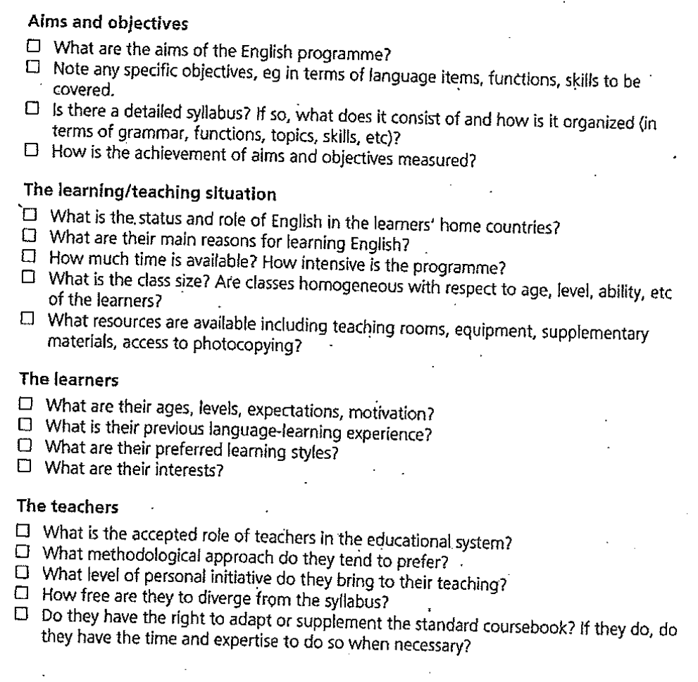

**8.The Role of the Coursebook**

The coursebook is seen as a source in achieving aims and objectives that have already be seen in terms of learners needs. They should not determine the aims themselves or become the aims since the concern is with teaching the language not the textbook. Coursebooks have a lot of roles.

- A source for presenting materials.

- A source for activities for learners practice and communicative interaction.

- A reference source for learners in grammar, vocabulary, and pronunciation.

- A source for stimulation and ideas for classroom language activities.

- A source for self directed learning.

- A support for less experienced teachers.

Generally, the coursebook is considered to be at service of teachers and learners not to be their master. There is a partnership between the teacher and the coursebook. They share common goals to which each side brings its special contribution. The aims of the coursebook should correspond as closely as possible to the aims of the teacher, both should meet the needs of learners to the highest degree. The partnership will be helpful if the aims and objectives are well defined and when the different but complementary roles of the teacher and coursebook clearly perceived and well balanced.

**9.The Coursebook Package**

**9.1.The Make up of the Coursebook Package**

The concern here is with the whole learning package: how it is made up and how the different parts relate to one another. Most course package consists of at least of a students’ book and a teacher’s book. Learners book is the main component in the package, and it is the main point of contact with students. Teachers’ book is important and provides teachers with detailed information that they need in order to make the best use of the whole course. Work book or activities book is also commonly included in a course package. It intends to give students extra-practice. Cassettes are prominent in course package, and used for listening and pronunciation work. The major consideration is the extent to which the different parts of the course package work together to form an integrated passage. Ideas on how to bring the different parts together and suggestions on how and when various components are best used should appear in the teachers’ book. Some parts of the package are more central than others, budgets for purchasing teaching materials are limited, so it is important to know which parts of the package are important.

There is a checklist for the make up of the course.

**9.2.The Organization of the Coursebook**

The next point is concerned with the amount of continuity within the material and the route through the material which is available for learners. In the case of grammar and vocabulary, items do not only need to be met in context and actively practiced, they need to be recycled 3 or 4 times before they become stored in the long term memory. Those items teach the sound or language items through progressive exposure. The course should have a clear policy on recycling. Teachers and students should be satisfied when they have a route through the course.

There is a checklist for the organization of the course.

**9.3.Language Content**

In a coursebook, we have what is being taught as opposed to how it is being taught. Language content can be compared with students’ needs and what is expected to be learned.

**9.3.1. Language Form and Language Use**

Coursebooks are concerned with the teaching and learning of the language. There are many aspects such as themes, topics, communicative strategies, cultural issues, grammar, vocabulary, phonology,etc. It is necessary to analyze the language and divide it into small units for affective teaching learning to take place. At the same time, it is difficult to separate individual aspects of language from the whole.

**9.3.2.Grammar**

The first thing to be considered is the grammar items that are included and how far they correspond to learners’ needs. Grammar is a major component of any general language course. It is the effective teaching of grammar that enable learners to use grammar that equip them with the ability to create their own utterances and use language for their own purposes.

There is a checklist for grammar.

**9.3.3.Vocabulary**

It was neglected area of language teaching till recently it gained its due recognition, as it is said that communication cannot take place without access to vocabulary. Good vocabulary development activities tend to exploit all the following:

- Semantic Relations: word groups according to meaning, synonyms, hyponym, and opposites.

-Situational Relationships: words associated with a particular situation like sport, transport, politics,etc.

- Collocation: words commonly found in association.

- Relationships of Form: word building.

There is a checklist for vocabulary.

**9.3.4.Phonology**

Teaching pronunciation was neglected. However, most recent courses include teaching phonology. Most of them cover the articulation of individual sounds, words’ stress, sentence stress, and some aspects of intonation. Weak forms and connected speech are also common.

There is a checklist for phonology.

**9.3.5.Discourse**

The term discourse is used to refer to the features of language use that go beyond the domain of grammar rules that include areas of sequencing sentences, cohesion, paraphrasing, structuring texts, participating in conversation, etc. Studies in text cohesion, discourse analysis and conversational analysis provide much of theoretical and analytical basis for understanding this area which focus on language use and the conventions that structure how we use language for effective communication.

There is a checklist to discourse.

**9.3.6. Style and Appropriacy**

Language is sensitive to its context of use. We should consider the coursebooks from the angle that they prepare learners to use appropriate style in different situations. The awareness of the importance of appropriacy is derived from the work of Hymes about the communicative competence ‘there are rules of use without which the rules of grammar will be useless’.

There is a checklist to style and appropriacy.

**9.3.7.Varieties of English**

In addition to formal and informal distinction, we need to consider what varieties of English are included in the coursebook. There are two main varieties of English in the world: British English and American English. The standard of these varieties differ to some extent in grammar, vocabulary, and pronunciation.

Cunningsworth, A. (1995). Choosing your Coursebook. Macmillan Heinemann: English Language Teaching.