Technology verbs

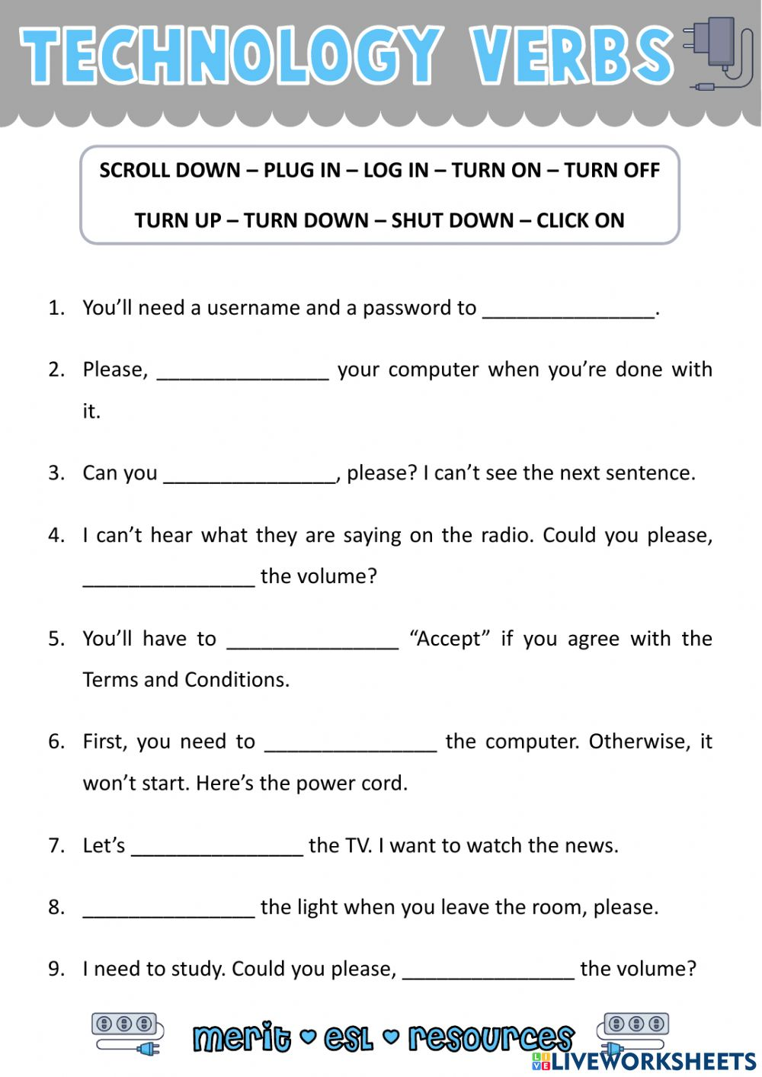

Answers :

Log in

Shut down

Scroll down

Turn up

Click on

Plug in

Turn on

Turn off

Turn down