**Exercise 1:** Place stress where appropriate (two-syllable nouns and adverbs)

Balloon problem bottom support

Slowly perhaps always about however away

Grammar quickly balloon sadly planet almost

**Exercise 2:** Which of the following words is stressed on its ultimate syllable (two-syllable words)

Public until campus refer expect publish vomit profound sustainbesides forward

**Exercise 3:** Place stress where appropriate (three-syllable words)

Abandon inhibit establish undertake recommend overcome undermine ascertain recollect interpose disapprove intersect disappoint volunteer underpin intercept contradict entertain underlie discover abolish exercise recycle imagine graduate

Consistent disinfect inexact minimum impatient brilliant

Family company interest revenge arrogant positive dishonest innocent

Faithfully already completely altogether overseas

invalid diminish hesitant advanture enrichment thanksgiving dependent astonish Washington Republish observant regular

**Exercise 4**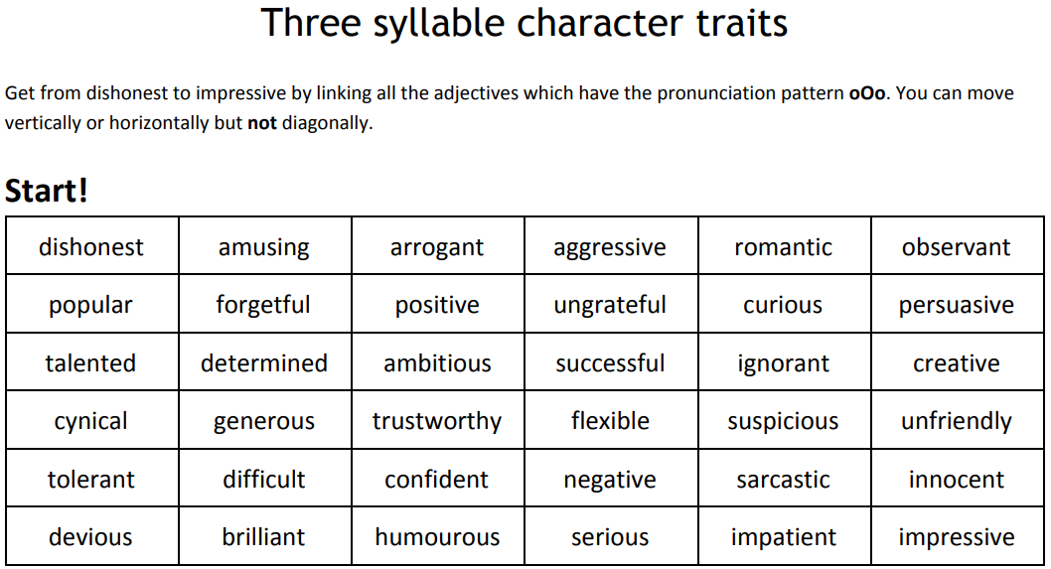

**Exercise 5: a.** Transcribe the following words phonetically. **b.** Place the words in the right column according to their stress patters.

worry, open, member, main, method,

oblige, perfect, morning, monkey,

machine, piano, inside, arrange, candle, coffin

compete, compare, daughter, appear

|  |  |
| --- | --- |
| **Ultimate syllable stressed** | **Penultimate syllable stressed** |
|  |  |

**Exercise 6: a.** Divide the following words into syllables. **b.** Underline the stressed syllable

Nation, eternity, successful, glorious, firefighter, ice cream,

telephone, television, news reader,

export, expensive, Lebanese, database hot dogs, common sense

Evaluation, mission, construal, Effective improvement initiate speechless

**Exercise 7:** Word class pairs. Practice pronouncing these sentences correctly.

1. The Sahara is a vast desert.
2. They were in the middle of the desert in New Mexico.
3. She is an honourable person who would never **desert**her [principles](https://www.scribbr.com/commonly-confused-words/principal-vs-principle/).
4. Martina contented herself with a bowl of soup.
5. Some examples of content include blogs, emailers, newsletters, social media posts, case studies, and more.
6. She has made a [series](https://dictionary.cambridge.org/dictionary/english/series) of [documentaries](https://dictionary.cambridge.org/dictionary/english/documentary) on the subject of [family](https://dictionary.cambridge.org/dictionary/english/family) [relationships](https://dictionary.cambridge.org/dictionary/english/relationship).
7. The [invaders](https://dictionary.cambridge.org/dictionary/english/invader) [quickly](https://dictionary.cambridge.org/dictionary/english/quick) subjected the [local](https://dictionary.cambridge.org/dictionary/english/local) [tribes](https://dictionary.cambridge.org/dictionary/english/tribe).

# We [plan](https://dictionary.cambridge.org/dictionary/english/plan) to go on [Wednesday](https://dictionary.cambridge.org/dictionary/english/wednesday), subject to [your](https://dictionary.cambridge.org/dictionary/english/your) [approval](https://dictionary.cambridge.org/dictionary/english/approval).

1. Food imports from abroad are increasing.
2. Malls may no longer import cheap jeans from Bulgaria

**Exercise 8:** Which of the following words can be pronounced differently depending on whether it is a verb or a noun. Answer attach object arrest act auction shelter echo experience rebel smile export

**Sentence stress**

***Exercise 1*** In the following dialogue, the most stressed syllable is underlined. What kind of stress is it?

Andy: I'm going to the store.

Kris: What are you going to BUY? Andy: A book.

Kris: Oh. So you're going to the BOOKstore. Andy: Yeah.

Kris: What KIND of book are you getting? Andy: A COOKbook.

Kris: What do you want to cook? Andy: I'm going to cook a pot roast. Kris: Do you HAVE a pot roast?

Andy: No, I'll have to go to the store to GET one.

***Exercise 2*** Explain the uses of stress (underlined words) in the following sentences. An example is provided in italics

|  |  |  |
| --- | --- | --- |
| ➢ | I'm going to the store. | ………………………………… |
| ➢ | I'M going to the store. | *Not YOU, but ME!* |
| ➢  ➢ | I AM going to the store. I'm GOING to the store. | ………………………………..  ……………………………….. |

***Exercise 3*** The following table includes sentences with emphatic stress.

• What would they sound as if they were said as statements alone.

• Complete the table with four examples of your own. (the first sentence is done as an example).

|  |  |
| --- | --- |
| **With emphasis:** | **As a statement alone, you would hear:** |
| Do you want pizza or spaghetti? -- I want  pizza AND spaghetti! | I want pizza and spaghetti. |
| You don't know how to swim, do you? -- I  DO know how to swim. |  |
| THAT was a good movie. -- That WAS a  good movie! |  |
|  |  |
|  |  |
|  |  |
|  |  |
|  |  |

**11.** **What are the words that are stressed in what follows? Divide each sentence into its rhythmic units.**

Many students are going on a vacation tomorrow.

I want my brother to win.

We’ll choose the winners on Saturday or Sunday.

This is Sue. She has got a dog.

Jack cannot cycle to the University tomorrow.

My God! It is a plane crash.

**Weak Forms of Words**

a. Give the strong form of this sentence using the phonetic alphabet (IPA). b. Give the weak form of this sentence using the phonetic alphabet (IPA)

Tell him to go arrow3 strong forms /hɪm/ /tu:/ weak form: /**tel** əm tə **gəʊ**/

As you can see, the grammatical words "him" and "to" are unstressed and have a weak form when pronounced inside a sentence.

another example: **I would like some fish and chips**

strong forms arrow3 /aɪ wʊd laɪk sʌm fɪʃ ænd tʃɪps/ This version sounds unnatural and, believe it or not, more difficult to understand for a native speaker.

weak forms arrow3 /ɑ wəd laɪk səm fɪʃ ən tʃɪps/ and we can use weaker forms sometimes: /ɑd laɪk səm fɪʃ ən tʃɪps/

**General Revision**

Revision Dr R. Medjedoub

**Exercises on Weak Forms 4**

**1.** Transcribe the following sentences into ordinary script.

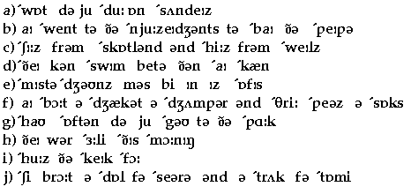

**2.** For each of the five questions underline one correct answer.

i. Which 2-syllable word has a different stress pattern from the others?

a) police c) student

b) mother d) money

ii. Which 2-syllable word has a different stress pattern from the others?

a) career c) balloon

b) shampoo d) problem

iii. Which 3-syllable word has a different stress pattern from the others?

a) cinema c) umbrella

b) Saturday d) manager

iv. Which 3-syllable word has a different stress pattern from the others?

a) potato c) computer

b) paragraph d) professor

v. Which of these adjectives has the stress on the final syllable?

a) Libanese c) instantaneous

b) impossible d) shocking

**3.** Answer these questions**.**

1. What is the maximum structure of a syllable in terms of the structure (v+c)?

………………………………………………………………………………………………….

1. What is the minimum structure of a syllable in terms of the structure (v+c)?

………………………………………………………………………………………………….

1. *Give two examples which correspond to the following description .*

Onset center coda onset center coda

………………………………………………………………………………………………….

1. What do we mean when we say that word stress in English is unpredictable? Give examples?

………………………………………………………………………………………………….

**4.** Divide the following into syllables and indicate the structure of each syllable**.**

UFO ; backfire ; mutual

**5.** Place stress on the right syllable.

Behaviourism, uniqueness, environmental, discovery, CBA, barbecue, requirement, variation, multiplicity, kaleidoscope, horizon, radiographic, psychiatric, Investee, brutalize, typology, preparative , illustrate.

**6.** Transcribe phonetically the following.

Whether you are writing a report, essay, dissertation, presentation, leaflet or case study, introductions always need to do similar jobs for the reader.