

***People's Democratic Republic of Algeria***

***Ministry of higher education and scientific research***

***Abdelhafid Boussouf university center – Mila***

***Institute of science and technology***

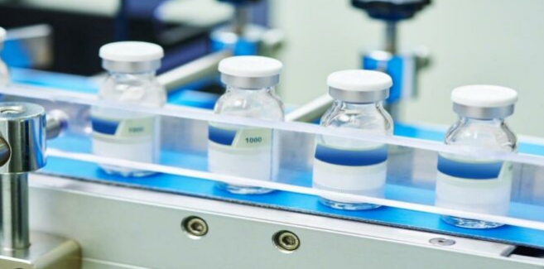

***Module: Pharmaceutical Processes***

***Third year LMD; Process Engineering***

**Presented by:**

**Dr. Imane Mayouf**

***2023 - 2024***

**Content of the material:**

**Chapter 1: Drugs/medicine**

• Introduction

• Definitions

• The stages of drug development

• Different classifications of drugs

• Active ingredients

• Excipients

• The conditioning

• Drug activity and toxicity

• Become active ingredients in the body

**Chapter 2: synthesis operations**

• Sources of active ingredients

• Methods for obtaining natural substances

• Synthetic methods

• Biotechnological methods

**Chapter 3: Preformulation**

• Routes of administration

• Choice of dosage forms

• Biopharmaceutical classification (solubility, permeability)

• Dissociation coefficient, partition coefficient

**Chapter 4: Manufacturing Environment**

• Pharmaceutical company

• Manufacturing of pharmaceutical water

• Air treatment

• Concept of quality in the pharmaceutical industry

***Chapter 1: Drugs/medicine***

***01/ Introduction***

***From drugs to synthetic medicines…***

**Since Antiquity, man has looked in nature not only for food, but also for remedies to relieve or cure his ailments, and has learned to distinguish poisons. Until relatively recently, medicines were only natural, and drugs were used in nature in the form of complex extracts.**

**The history of medicines is returned to the 3000 BC where the name of the plant drugs like “*Opium*” is engraved in the Sumerian tablets that represent the oldest remnants of a pharmacopoeia. In addition to the papyrus of the Chinese Ben Cao, which dates 2900 BC, explain the way of fabrication of medicines and their use in all the part of the body.**

**Alongside plants still used today as tranquilizers (*Poppy, Henbane*), purgatives (*Senna, Castor oil, Colocynth*), diuretics (*Squill*), etc., there were various ingredients: blood, bones, animal fats, and minerals without forget the strong use of magical practices.**

**The great Greek doctor Hippocrates (5th century BC), commonly used narcotics as medicines. His discoveries are then developed and organized by Dioscorides who inventoried more than five hundred drugs of mineral, plant or animal origin in a famous thesis written in 77 AD, and then translated into Latin in the 15th century expanded his work a few centuries later.**

**With the discovery of the new world, the explorers bring back major principles active ingredients such as “*Cinchona”*, “*Ipecac”*, “*Coca”*, “*Coffee”*, etc.**

**The discovery of new drugs has taken a long time limited to observation empirical of the effects produced by certain natural substances on the course of illnesses. It was Paracelsus in the 16th century who advocated need for medication specific for each disease.**

**Thanks to the progress of chemistry and physiology, the 19th century marks a new stage with the isolation of principles active like the isolation of “*morphine*” and “*codeine*” from opium, and the synthesis of “*Aspirine*” in 1853 and commercialized in 1893.**

**The biggest steps in the history of medicine are marked by the synthesis of aspirin in 1897 by Hoffman, next by the discovery of insulin between 1921 and 1922 by Banting and his team (Nobel Prize in Medicine), in addition to many other antibiotics which are synthesized like the antimalarial in 1927.**

**However, the modern era begins with the discovery of the antibacterial action of sulfonamides in 1937, then the discovery of penicillin by Fleming in 1943 (Nobel Prize in Medicine).**

**At the beginning of the 20th century, with advances in chemistry, the preparation of synthetic medicines began. This has led, in the most developed countries, to the development of a highly specialized industry, a branch of the pharmaceutical industry. It is now almost solely up to the latter (refers to chemistry) to carry out the research and preparation of new drugs, their physiological and clinical experimentation, and their formulation into pharmaceutical form.**

**Modern medicines, scientifically prepared, of defined and controlled composition and activity, packaged in a practical and even attractive form, is the indispensable auxiliary of medicine, linked to its progress and its daring. In today's society, it is, in appearance, a consumer good like any other, but it nonetheless remains what it was for primitive man: protection against suffering and death.**

**In a globalized world, the shortage of medicines, the precarious accessibility to care and the falsification of active ingredients, which make up the quality of medicines constitute severe handicaps for the least developed societies, and this generates an unbearable feeling of injustice and inequality within humanity.**

**In this chapter, we will take a general idea about medicines, Definitions, classifications, stages development, active ingredients, excipients, conditioning, toxicity and interaction with human body.**

***02/ Definition***

**The European definition of medicines is specified in directive 65/65/CCE of January 26th, 1965 and which denounces that by medicines, we mean any substance or composition presented as having curative or preventive properties with regard to human or animal diseases, as well as any substance or composition that can be used in humans or animals or can be administered, with a view to establishing a medical diagnosis or to restore, correct or modify their physiological functions by exerting a pharmacological, immunological or metabolic action.**

**The medicines is composed of two kinds of substances: one or more "active principles" and one or more "excipients".**

***03/ The stages of drug development***

**The pharmaceutical industry requires a set of elements that makes the final product commercialized, we cite:**

**Physico-chemical studies**

**Experimental pharmacology (animal)**

**Experimental toxicity (animal)**

**Clinical trials (man)**

**Marketing authorization**

**Marketing**

**Pharmacovigilance**

**In addition to the standard steps cited above, the fabricators of medicines must respect the next lines:**

1. **Quality and scientific image: the medicines must not pass over controls and the processes of fabrication must be standardized. Moreover, the labeling indicating the name of the manufacturer is obligatory.**
2. **Mechanization of pharmaceutical production processes in order not to fall into the deficiency of certain drugs.**
3. **Availability of industrial tools for the production of active ingredients.**
4. **The respect of Pharmaceutical regulations; resumed in product quality control and delivery control.**
5. **The culture of innovation: that includes the identification of medical needs, critical reading of scientific results, Competitor monitoring, Observation of technological progress, Monitoring regulatory developments, Implementation of complex procedures.**

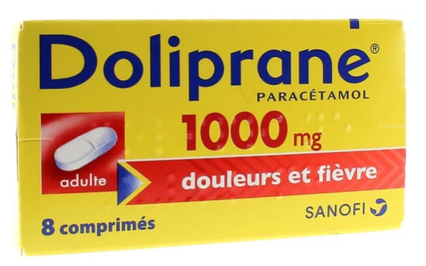

***Trade name***

***Active principal name***

***Production company***

***Dosage***

**Figure 01. Essential information about a medicine.**

***04/ Classifications of drugs***

* ***According to the list:***
* ***Unlisted medicines:* freely accessible, these medications are over-the-counter, available without a prescription, refundable or not.**
* ***Listed medicines:* are divided into two lists (List I and List II). The active ingredients listed on these two lists are labeled “poisonous substances”; they present risks of various kinds (toxic, teratogenic, carcinogenic, mutagenic, etc.). Generally, drugs classified in list I have a higher risk than those in list II and they are always a subject to prescription, dispensation and possession regulations.**
* ***List of narcotics:* these are medications likely to lead to drug addiction. Manufacture, sale, possession and use require special authorization.**
* ***According to originality of the product:***
* ***Original medicine:* also referred to as a "reference" or "innovative" medicine is a medicine whose active substance (or a new dosage or a new presentation) has not yet been used as a medicine for human use.**
* ***Generic drug:* it is a reproduction of an original drug by another pharmaceutical laboratory.**
* ***According to the mode of preparation***
* ***Pharmaceutical specialty:* This name corresponds to any medicine prepared in advance in a company pharmaceutical, placed on the market (or distributed in the form of a medical sample) under a special name and special packaging. The pharmaceutical specialty indeed has a commercial name (example: Parol®, Asepegic®, Neuroféne®….) which is given to it by the company producing it, in agreement with the Ministry of Health. The same active molecule can be used by different pharmaceutical industries, which therefore will give rise to different trade names.**
* ***Magisterial preparation of medicines:*** **This name corresponds to any medicine prepared at the pharmacy by the pharmacist at the requested by the patient, and the formula of which is composed by the prescribing doctor. The box containing the compounded preparation must mention the name of the patient, the name of the prescriber, the date, dosage, composition, and the serial number under which it is recorded in the prescription.**

***05/ Active principal***

***05.01/ Definition***

**The active principal is the principal molecule used in the composition of a drug in order to give it the therapeutic properties; it has been the subject of numerous studies by chemists, toxicologists and pharmacologists. A medicine contains one or more active ingredient (e.g.: Gripex® contains Phenylephrine and Chlorphéniramine) incorporated with one or more excipients (Any other substance added to the active ingredients is called an excipient).**

**Each active ingredient has an International Non-proprietary Name (INN), which is specific to it awarded by the World Health Organization (WHO). This name includes always a prefix, which is related to the molecular structure, and a suffix, which allows identifying the drug class (e.g.: Benzodiazepine, Penicillin, etc.).**

**The active ingredient also has a chemical name: condensed or detailed. The latter is assigned respecting the rules of the IUPAC nomenclature (International Union of Pure and Applied Chemistry). This last name is on the other hand much less used and is not mentioned on the conditioning.**

**Example:**

***Trade name*: Panadol®, Efferalgan®,**

***INN*: Paracetamol,**

***Condensed chemical name*: acetaminophen,**

***Detailed chemical name*: N-(4-hydroxyphenyl)acetamide.**

**The active principle can exist in several crystalline forms or in the form of derivatives such as salts, hydrates, etc. The choice of the crystalline forms of the active ingredient is made based on the method of administration and considerations of stability, solubility and bioavailability.**

**Polymorphism is the ability for an organic or mineral substance to exist in at least two different crystal structures while retaining the same chemical structure.**

**Stability, solubility, dissolution speed, bioavailability, toxicity... the crystalline forms of an active ingredient do not necessarily have identical properties and can therefore influence the activity of the finished product, especially since modifications of the crystalline structure at during production, storage or use of the product are possible.**

**This is why a few years ago, a large international pharmaceutical group was a “victim” of the polymorphism of its active ingredient and had to suspend the marketing of its HIV protease inhibitor drug. A series of production batches did not meet dissolution test specifications due to the appearance of a new crystalline form of the active ingredient.**

**So, when developing a chemical, pharmaceutical or cosmetic product, it is therefore important to take into account the possible different crystalline forms of the active ingredient and to carry out controls, which allow exhaustive knowledge of its polymorphism.**

**Paracetamol is the active ingredient in Doliprane® and Acetylsalicylic acid is the active ingredient in Aspirin®.**

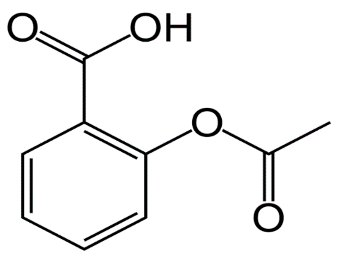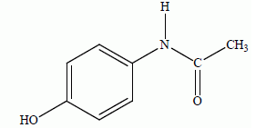

**Figure 02. Chemical structure of: paracetamol and acetylsalicylic.**

***05.02/ Origins***

**The active ingredient may have a natural origin: vegetable, mineral, animal, microbiological, or synthetic, semi-synthetic.**

***06/ Excipient***

***06.01/ Definition***

**The excipient is a substance without any pharmacological activity but necessary for shaping the product. For example. diluents, preservatives... Excipient comes from the Latin “excipere”, which means to receive. In other words, the one who receives the AP (Active Principal).**

**The excipient must present three criteria:**

* **Inert with regard to the AP(s),**
* **Inert to packaging materials,**
* **Inert towards the body.**

**Examples: Water, starch, silica, flavor, sodium bicarbonate, citric acid, etc.**

**The judicious choice of excipients with well-defined characteristics makes it possible to adjust the release speed of the active ingredient.**

**For maximum guarantees, the choice of excipient is essentially based on chemical inertia, it is also oriented towards products of known and fixed chemical composition (physical and mechanical properties) with admissible levels of impurities.**

**A range of characteristics is also desired such as: fluidity, compressibility, sliding power, non-stick power, etc.**

***06.02/ Role of excipients***

**The excipients contribute to the formulation:**

* **By giving the medication a form adapted to the desired route of administration: (tablet, oral solution, capsules, suppository, etc.),**
* **By changing the taste and smell of the medicine,**
* **By modulating the speed of release of the active ingredient in the body (long-acting or delayed forms for example),**
* **By improving the conservation of the medicine,**
* **By facilitating manufacturing,**
* **Protects the active ingredient (gastro-resistant coating: Eudragit L550).**

***07/ The conditioning***

**Primary packaging is essential for Marketing Authorization and the industrialization of a pharmaceutical form, the choice of primary packaging results from long months of stability tests in different temperature and relative humidity conditions, including in real time.**

**It is important that the materials selected for primary packaging present:**

* **Good chemical inertia,**
* **Appropriate permeability,**
* **Satisfactory neutrality (taste).**

**Examples: bottles in glass, plastic container, etc.**

**The secondary packaging is generally made of cardboard, it contains inside: The primary and the instructions, and the sticker outside.**

**Tertiary packaging is generally made of cardboard or plastic, it contains several boxes of medication.**

***08/ Drug activity and toxicity***

**A very broad definition of a drug would include "all chemicals other than food that affect living processes." If the affect helps the body, the drug is a medicine. However, if a drug causes a harmful effect on the body, the drug is a poison. The same chemical can be a medicine and a poison depending on conditions of use and the person using it. Another definition would be "medicinal agents used for diagnosis, prevention, treatment of symptoms, and cure of diseases."**

***08.01/ Drug activity***

**The development of drugs starts with the recognition that some particular pharmacological effect may be useful therapeutically. Sometimes an application can be seen before there is a compound with the desired properties. Past history often suggests the reverse: several important drugs, such as the sulphonamides, have been made by the chemist years before their therapeutic value was realised. In either situation an initial discovery depends upon both an understanding of what may be useful and upon a knowledge of what drugs do; it requires both the flash of genius and the humdrum collection of pharmacological information.**

**Up to this point, drug activity (specifically that of an agonist) is described as observed effect quantified by a dose–response curve. Thus the maximal response and the potency of an agonist (location of the curve along the drug concentration axis) in any specific system yield the measure of activity in that system. Also, the magnitude of the observed organ response is controlled by four factors, two drug-related and two tissue-related. The value in quantifying affinity and efficacy parameters is that they are unique properties of the drug acting on the target, and thus are true for that target in all tissues and organs in which it resides. Therefore if the affinity and efficacy of a given molecule can be determined in one system (referred to as the “test” system), then these parameters may be used to assess drug activity in any other system, including the therapeutic one. This is of great value since drugs are very rarely discovered and studied directly in the therapeutic system. A prerequisite to the determination of the affinity and efficacy of agonists is to know that the agonism is selective for the particular target of interest. There are two main strategies for making this determination.**

***08.02/ Drug toxicity***

[**Drug toxicities**](https://www.sciencedirect.com/topics/medicine-and-dentistry/drug-toxicity)**in humans manifest themselves as functional, biochemical, and/or structural changes. Many times the same receptor systems are involved in both the therapeutic and toxic responses. Functional toxicities are due to the pharmacologic effects that are not necessary for the achievement of the desired action of a**[**drug**](https://www.sciencedirect.com/topics/medicine-and-dentistry/chemotherapeutic-agent)**. These funtional toxicities usually occur following conventional doses of the drug and are reversible on discontinuance of the drug. If such changes were not reversible the agent involved would have very restricted use as a drug. Examples of mild forms of these toxicities are the sedation that accompanies**[**antihistamine drug**](https://www.sciencedirect.com/topics/medicine-and-dentistry/histamine-antagonist)**therapy and the psychostimulation that accompanies such**[**drugs**](https://www.sciencedirect.com/topics/medicine-and-dentistry/chemotherapeutic-agent)**as [iproniazid](https://www.sciencedirect.com/topics/medicine-and-dentistry/iproniazid" \o "Learn more about iproniazid from ScienceDirect's AI-generated Topic Pages). Whereas these changes are mild, functional effects and are reversible on discontinuance of the drug, others may be serious and necessitate withdrawal of the drug from the patient. Examples are the delusions or hallucinations associated with sedative drug use, the cardiac irregularities associated with**[**quinidine**](https://www.sciencedirect.com/topics/medicine-and-dentistry/quinidine)**therapy, asthma associated with**[**beta adrenergic blocking agents**](https://www.sciencedirect.com/topics/medicine-and-dentistry/beta-adrenergic-receptor-blocking-agent)**, and edema associated with calcium blocking drugs.**