**Lecture Two: An Overview of the Origin and Development of Social and Human Sciences**

**Objectives:** Students are expected to:

* Understand the origin and beginnings of social and human sciences.

**Introduction**

Knowledge and its obtention has always been the target of philosophers and scholars over time of human existence. Endeavors to understand the universe with all its components and hidden mysteries is as old as human existence. The ancient Greek philosophers Plato and Aristotle (third and fourth centuries B.C) established the basis for knowledge and various philosophical debates and issues that are the main concern of a number of social and human disciplines in the present time.

**Origin and Development of Social and Human Sciences**

In ***Western civilization*,** the history of social and human sciences dates back to ***ancient Greek times*** when philosophers were interested in studying and explaining their existence and its relation to language, society, knowledge, religion, etc. Human sciences or humanities are somehow distinguished from social sciences.

* The study of language and classical literature, which goes back to the classical antiquity, continued during the *Middle Ages* to include other subjects and areas of study. Those studies flourished during the *Renaissance* and they were referred to as “*studia humanitatis*”. In later times, human sciences were redefined to become suitable to the characteristics of the society.
* During the ***Enlightenment Age*** (18th century), and due to the increasing quantities of knowledge, scholars started to divide the basic bodies of knowledge i.e., *physics* and *philosophy* into various subjects to make it possible for them to specialize into one field or another (Hunt & Colander, 2017). *Social sciences* which were then called *“moral philosophy”* came out and attempted to understand the character of society at that time. Among the pioneers and founders of this discipline, we name: [***Adam Smith***](https://www.investopedia.com/updates/adam-smith-economics/)***, Voltaire, Immanuel Kant, Jean-Jacques Rousseau, Denis Diderot,*** and ***David Hume***. It was not until ***the 19th century*** that they became a distinct and diversified academic field giving rise to various interdisciplinary branches. In this regard, Dönmez and Domigall (2011) state that:

Even though the social interactions in a society have probably been of interest for many centuries, scientific studies of social interactions began as late as during the 19th century with sociological publications including “Suicide” by Émile Durkheim and “Système de politique positive” by Auguste Comte, the latter of which also set stone for a positivist approach to social sciences. (as cited in Ogunnoiki, 2017, p.63)

The rise of these social fields was mainly driven by the changing circumstances most prominent of which is *the Industrial Revolution.* The latter brought about a considerable number of “socio-economic and political problems within and across societies that led to the creation of the social sciences” (Ogunnoiki, 2017, p.63).

The following figure illustrates the origin of social and human sciences in western philosophy:

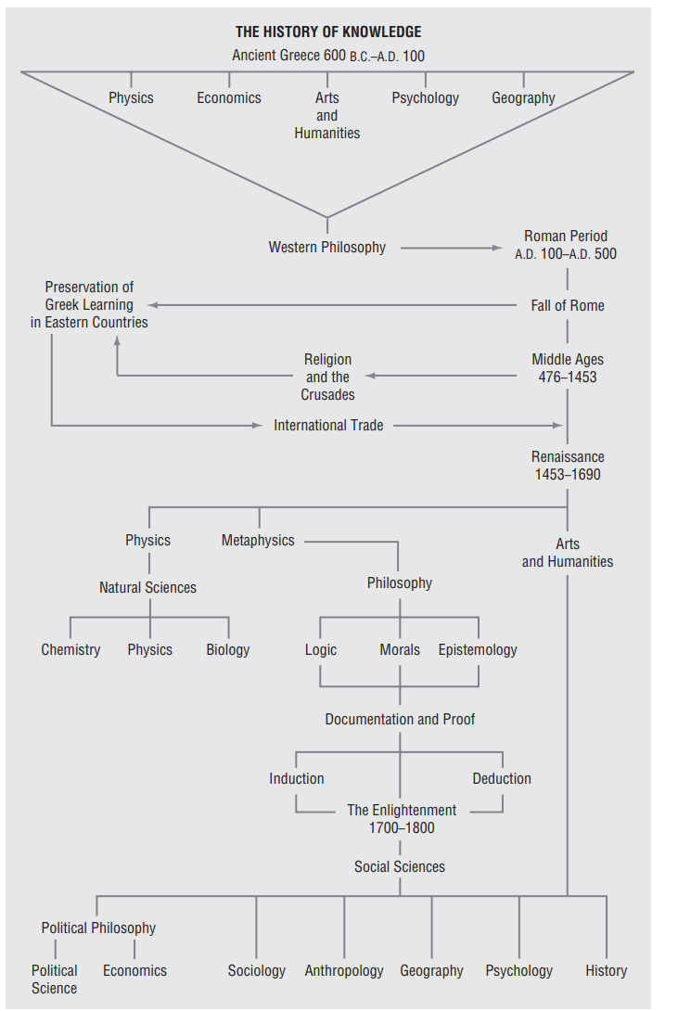

**Figure: The Development of Knowledge (Hunt & Colander, 2017, p.6)**

**References**

Hunt, E.F. & Colander, D.C. (2017). *Social science: An introduction to the study of society* (6th ed.). New York: Routledge.

Ogunnoiki, A.O. (2017). The social sciences: The root and route of political science. *The International Journal of Humanities & Social Studies, 5*(7), 61-68.