University Center A. Elhafidh Boussouf Mila

Institute of Science and Technology

Department of Mechanical and Electromechanical Engineering Process Engineering 2nd year

**Solution Chemistry practical’s Works**

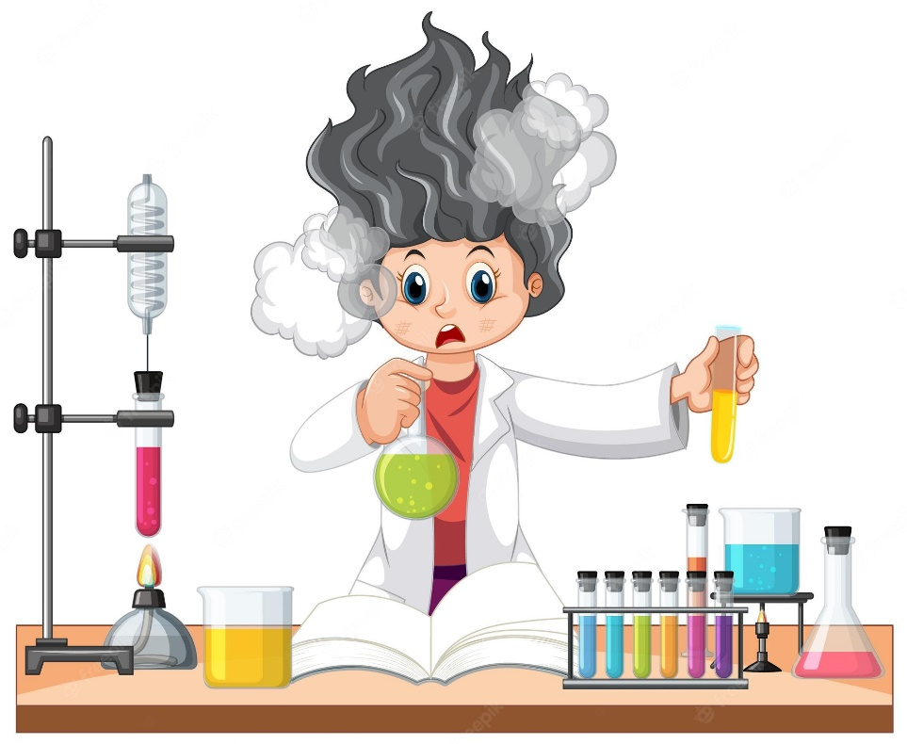

**Dr : Merzouki S.**

**2022/2023**

**Experiment 7 : Determination of water hardness by complexometry**

During this experment, we will determine the calcium and magnesium ion content of a water by complexometry in order to estimate its hardness.

# Introduction :

# Hardness in water is due to the presence of dissolved salts of calcium and magnesium. It is unfit for drinking, bathing, washing and it also forms scales in boilers. Hence it is necessary to estimate the amount of hardness producing substances present in the water sample. Once it is estimated, the amount of chemicals required for the treatment of water can be calculated. The estimation of hardness is based on complexometric titration with a standard solution of ethylene diamine tetra acetic acid (EDTA) which is a complexing agent. Since EDTA is insoluble in water, the disodium salt of EDTA is taken for this experiment. EDTA can form four or six coordination bonds with a metal ion. Two type of hardness is present in water first is temporary hardness and second is permanent hardness. Temporary hardness is due to the presence of bicarbonates of calcium and magnesium ions. It can be easily removed by boiling. Permanent hardness is due to the presence of chlorides and sulphates of calcium and magnesium ions. This type of hardness cannot be removed by boiling.

# reagents

# - Solution of eriochrome black (EBT) in 0,4% absolute ethyl alcohol (keep away from light)

# -Buffer solution: Ammonium chloride 54 g + 25% ammonia 350 ml + Distilled water to 1000 ml

# -EDTA solution: Disodium salt of ethylenediaminetetracetic acid 3,721 g + Distilled water to1000 ml (Store in a polyethylene bottle)

# Procedure:

1. The burette is filled with standard EDTA solution to the zero level.

2. Take 50ml sample water in the beaker. If sample having high Calcium content, then take smaller volume and dilute to 50ml.

3. Add 1ml Ammonia buffer.

4. Add 5 to 6 drop of Ericrome black – T indicator. The solution turns into red colour.

5. Titrate the content against EDTA solution. At the end point colour change from red to blue colour.

6. Note the final reading and record it. Repeat the process till we get concordant value.

7. Take 50ml sample in another flask and boiled it. (Add distilled water to get final volume of water.)

8. Repeat step 3-7.

# QUESTIONS :

1. Give the principle of this experiment
2. give the pictograms of the products used
3. calculate the hardness of the treated water
4. Compare the result and what do you conclude?