

TP1: Installing the C++ DEV IDE

1. **The C++ Dev IDE:**

Dev-C++ is an integrated development environment (IDE) for Windows, it allows you to program in C and C++.

**2. Installing Dev-C++:**

To install Dev-C++ (Version 4.9.9.2) on the computer, follow the following steps:

* Double-click the mouse on the devcpp-4.9.9.2_setup.exe installer icon and click the OK button in the window that appears to start the installation.

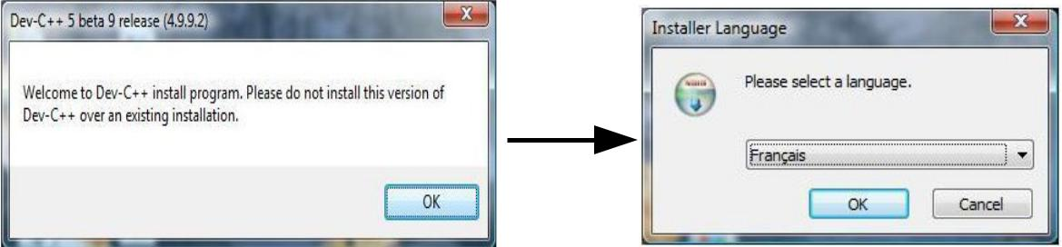

–We then choose the language of the installation (in our case English) and click on the OK buttons then on I accept to accept the terms of the contract, then on Next to choose the components to install.

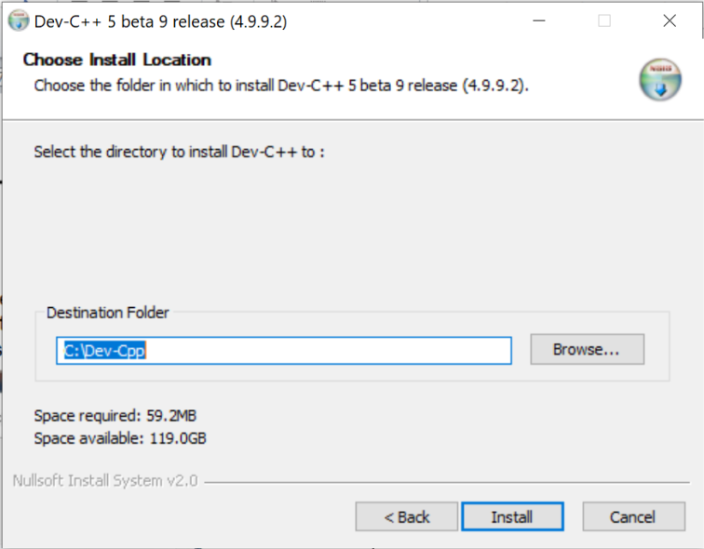

* We then choose the location where to install the program (in our case **C:\Dec-Cpp**) and click on the Install button to copy the program files, then on the Yes button to install Dev C++ in all user accounts.

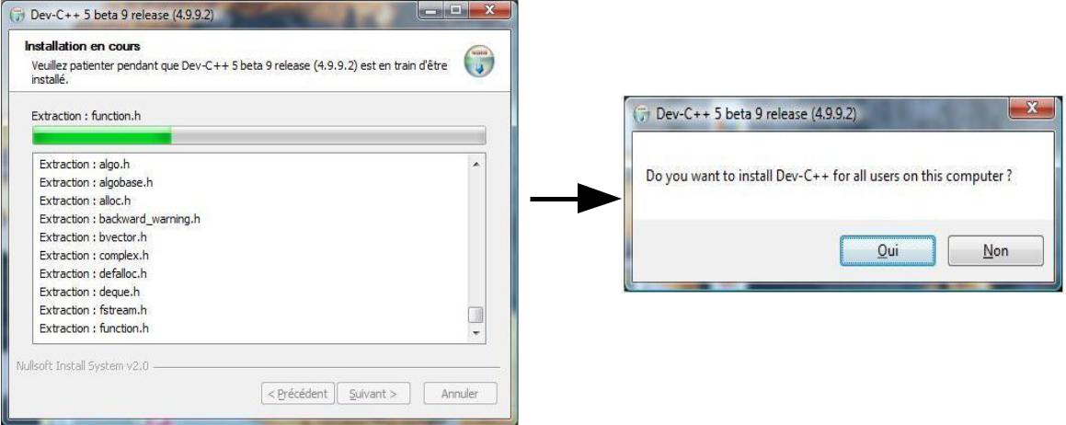

* 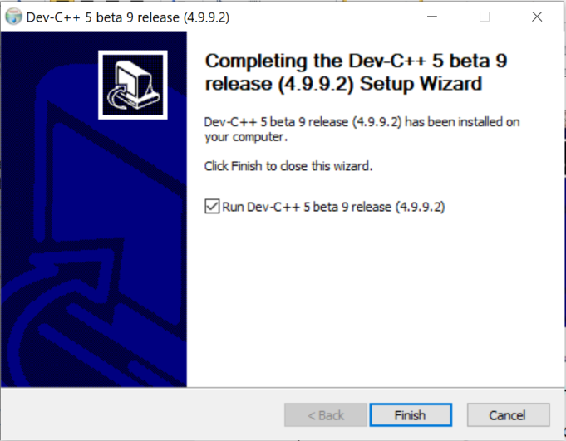Finally we click on the Finish button to complete the installation and start Dev C++.
* When we start Dev C++ for the first time it asks us to choose the language of the interface and to make some optional configurations, in our case we choose English and we click on the Next button three times in a row then on the OK button to complete the setup.

**-1-**

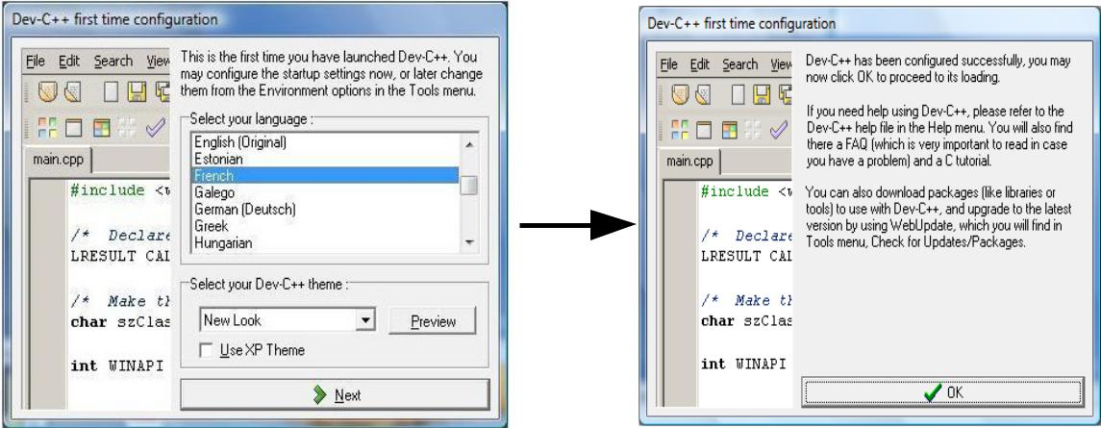

We can now use Dev-C++ to compile and run our C or C++ programs.

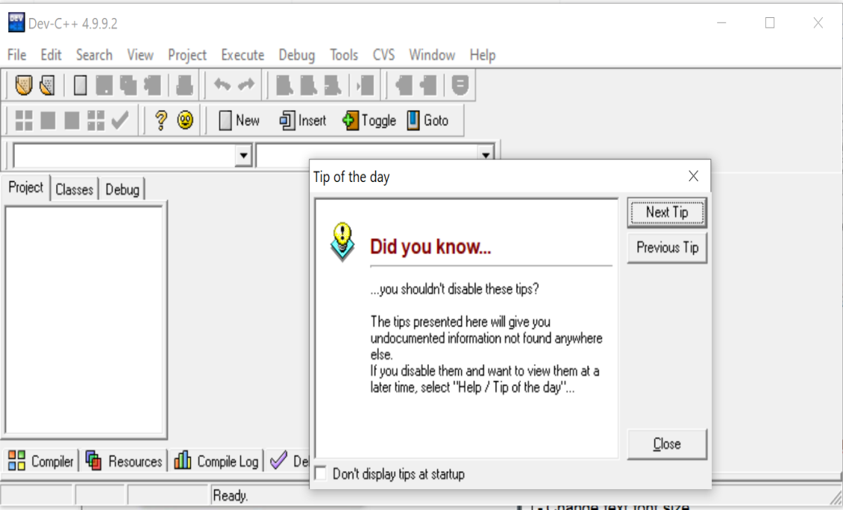

**2. Editor Properties**

To modify the editor properties, click on: (Tools → Editor Options).

To display the line number in the program source code, you must check the ''Line number'' option in the display tab (Tools → Editor Options → Display)



To enlarge the editor font, modify the size in the display tab

* ***Tools → Editor Options → Display****).*

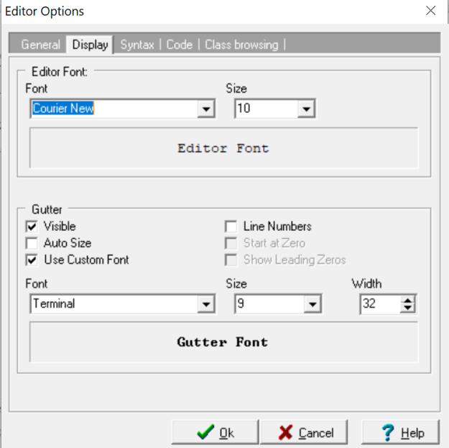

|  |  |  |
| --- | --- | --- |
| Text style | Text size |  |
|  |  |

To display line numbers

**Practical work:**

- Write the following symbols using the Dev C++ editor

**MILA mila int float x1 { } '' % # & ( ) + - / \ , ;**

**/* */ /*comment*/ '' message'' //commentat the end**

* Show editor line number
* Change text font size
* modify the preceding text using copy and paste as follows:

**/* */ /*comment*/ '' message'' //comment at the end**

**'' '' { } '' % # & ( ) + - / \ , ; MILA mila int float x1**

- Save text to desktop with .cpp extension

**-2-**