**TP 1 (continued)**

**I) Using the Querty keyboard:**

1. ***Choose language***
2. ***With the normal keyboard: we can write the following characters: = [ ]; , .***

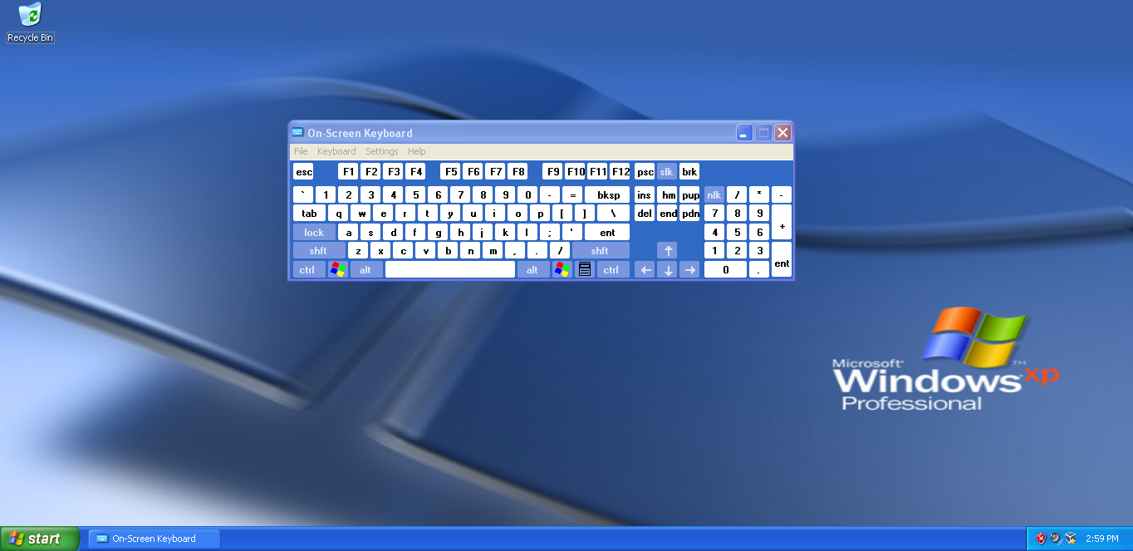

1. ***By clicking on the button SHIFT: we can write the following characters: # ( ) { } [ ] " < >***

***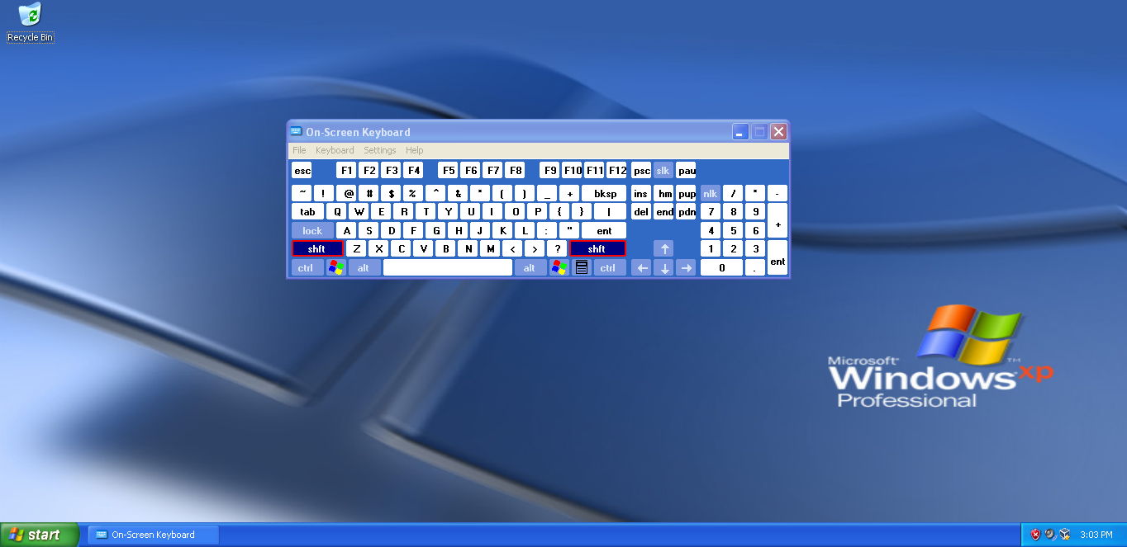***

***II) The steps for executing a program in DEV C++***

1. ***Writing a program in C++ language on the text editor***

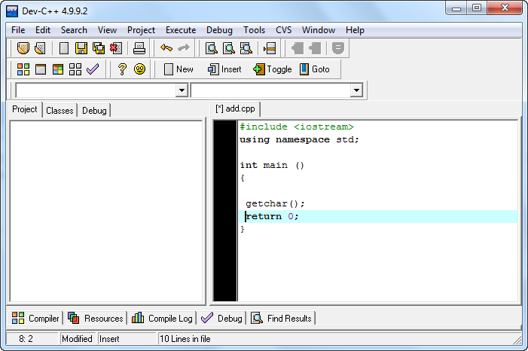

1. ***Saving the code to a file***

We save the source code of the program in a file by clicking on the button ***''Save'' (File → Save),***

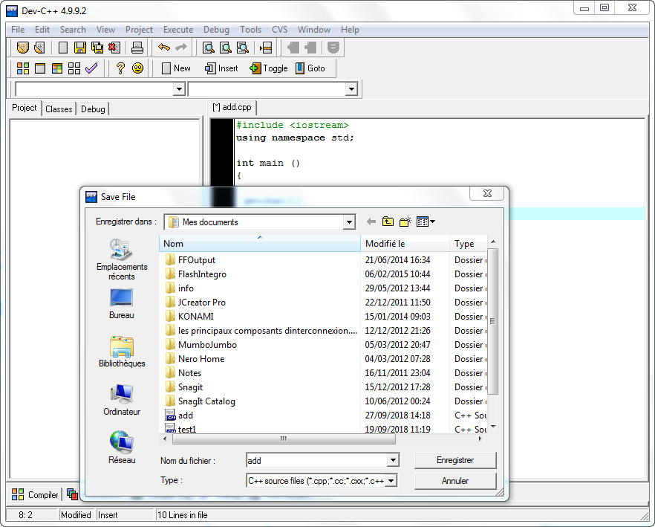

***3. The compilation step***

In this step we translate the ***source code*** of the program in ***machine language*** using special software called ***compiler*,** we then obtain the ***machine code*** from the program, This ***machine code*** is then executed directly by the computer (if there are errors in the code, the compilation will be stopped, you must first correct the errors to continue).

|  |  |
| --- | --- |
| D:\Users\adelo\Desktop\VirtualBox_xp_05_10_2017_23_52_42.png | Source code Machine code |

***4. Execution step***

In this step, we execute and test our program.

* To run the program, double click with the left mouse button on the machine code program file.
* To run the program you can also use the ''Run'' button.

(***Run → Run***) in the Dev C++ menu.

***