Chapter 2: Calculation of Primitives

By Dr. Hocine RANDJI
Abdelhafid Boussouf University Center- Mila- Algeria
Institute of Science and Technology
First Year Engineering
Module: Analysis 2 (Chapter 02)
Semester 2
randji.h@centre-univ-mila.dz

Table of contents

Objectives 3
Introduction 4
I- 1. Definitions and properties (primitive, integral, and definite integral): 5
A. Definitions: 5
B. Properties: 6
C. Quiz 6
D. Quiz 7
E. Quiz 7
F. Quiz 7
G. Quiz 8
H. Integration methods: 8
II- Quiz 13
III- Final exam: 14
Exercises solution 15

Objectives

- Understand and explain the process of integrating functions.
- Identify and apply different methods for integrating functions.
- Demonstrate the ability to simplify and solve integrals.
- Analyze and solve integrals involving rational, trigonometric,or hyperbolic functions.

Introduction

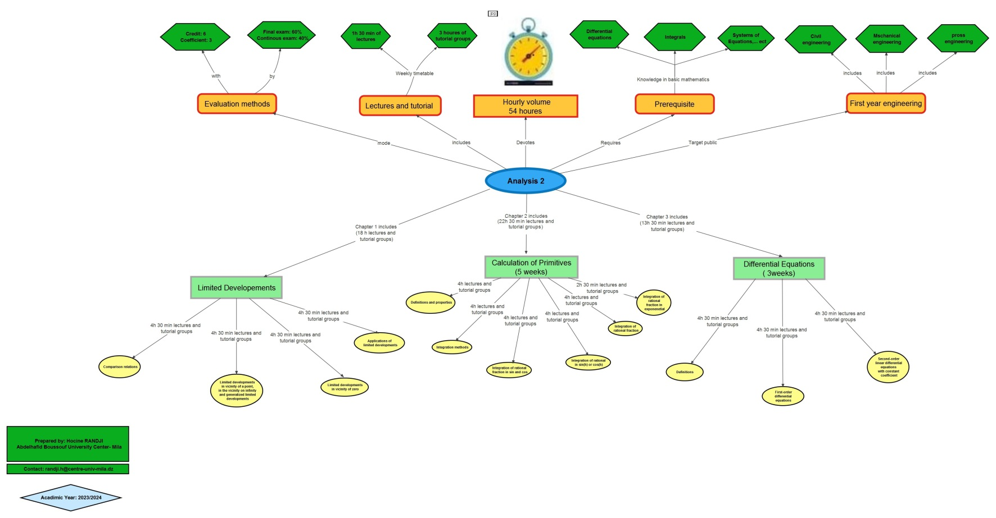

- 1. Definitions and properties (primitive, integral, and definite integral):

I- 1. Definitions and properties (primitive, integral, and definite integral):
I

When delving into the foundation principles of integral and differential calculus and their practical applications, we simultaneously cultivated methodologies for addressing challenges through calculus. This chapter led to the development of strategies for solving problems utilizing the calculation of antiderivatives known also primitives.

  - Definitions:

Definition : Def 1:
Let be a function on a closed interval 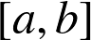 in  , and let 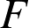 be a function differentiable on . is said to be an antiderivative or primitive of on if
.
Proposition:
If and  are two antiderivatives of on , then
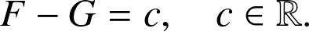
Example : E.g. 1:
The functions and defined on 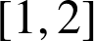 by 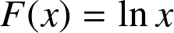 and 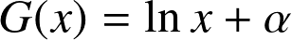 , with 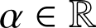 , are two antiderivatives of the function 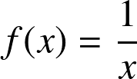 on .
Definition : Def 2:
The set of all antiderivatives of the function 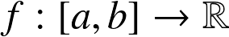 is called the indefinite integral of , denoted 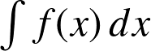 . So if is an antiderivative of on , we have
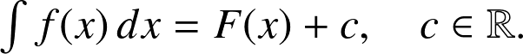
Example : E.g. 2:
For all 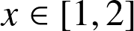 : 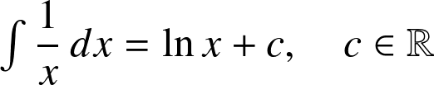 .

  - Properties:

Fundamental
If and are two functions having primitives on 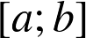, then 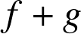 and 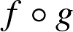 also have primitives, and we have:
- .
- 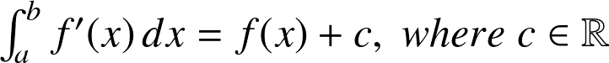
- 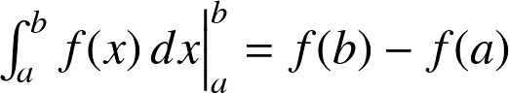
Fundamental : Table of integrals:
Let us give the following table of usual integrals:

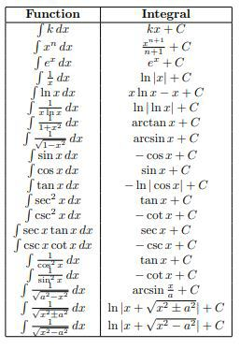

  - Quiz

[Solution n°1 p 15]

What is the integral of 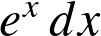 ?
 | 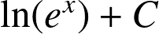
 | 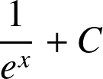
 | 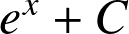
 | 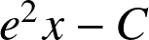
  - Quiz

[Solution n°2 p 15]

What is the definite integral of 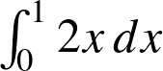 ?
2
1
4
0
  - Quiz

[Solution n°3 p 15]

Which of the following is the indefinite integral of 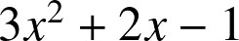
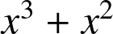
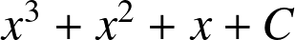
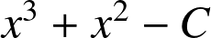
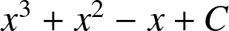
  - Quiz

[Solution n°4 p 15]

What is the integral of 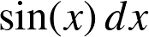 ?
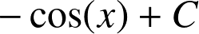
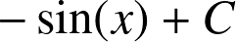
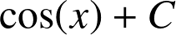
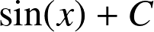
  - Quiz

[Solution n°5 p 16]

Evaluate 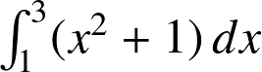 .
8
12
10
6
  - Integration methods:

Integration by parts
Integration by parts is a method in calculus used to find the integral of the product of two functions and . The formula for differentiation of the product of and is expressed as:
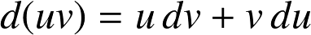
This formula is known as the integration by parts formula. It's primarily used when integrating expressions that can be represented as a product of two functions, and 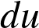, such that finding the function from its differential 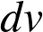 and evaluating the integral 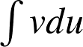 is simpler than directly evaluating 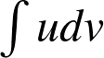.
Example : E.g.
For instance, consider the integral:
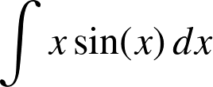
Let and 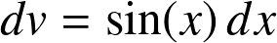. Then, 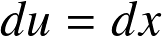 and 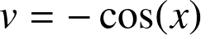. Substituting into the integration by parts formula, we have:
Integration by change of variable:
Let 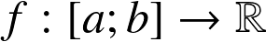 be a continuous function on and let 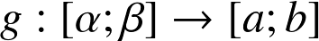 be a continuously differentiable (  ) function such that 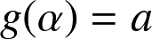 and 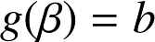 . We aim to show that:
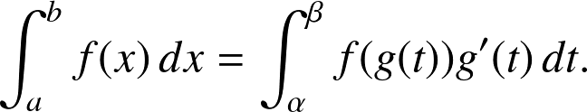
Example : E.g. 1
Evaluate the integral:
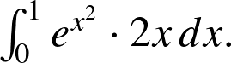
Here, we can choose 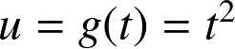 . Then, 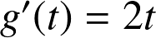 and the limits are from 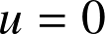 to 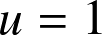 . Therefore:
Example : E.g. 2
Evaluate the integral:
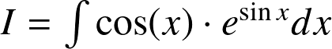
Using the substitution 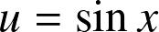 . Then 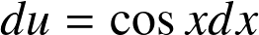, thus:
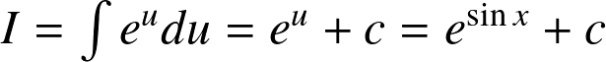 where 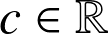.
Integrals of Rational Functions
When dealing with integrals, one important aspect is identifying functions whose integrals can be expressed in terms of elementary functions. Rational functions, a significant class of functions, have integrals that often fall into this category.
Definition
A rational function is defined as a ratio of two polynomials. Specifically, if 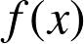 and 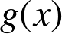 are polynomials, then a rational function can be expressed as:
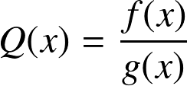
where both and do not share common roots, ensuring the fraction is in its simplest form.
Proper and Improper Fractions:
Rational functions can be categorized into proper and improper fractions based on the degrees of the numerator and the denominator:
Definition
A fraction is proper if the degree of the numerator is less than the degree of the denominator.
Definition
A fraction is improper if the degree of the numerator is equal to or greater than the degree of the denominator.
Simplifying Improper Fractions:
If the rational function is improper, it can be simplified by dividing the numerator by the denominator using polynomial division. This process expresses the improper fraction as the sum of a polynomial and a proper fraction:
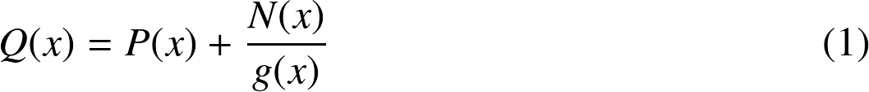
where 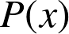 is a polynomial, and 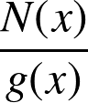 is a proper fraction.
Example
Consider an improper rational function:
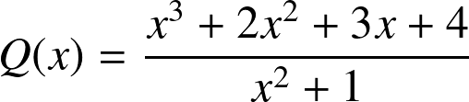
By performing polynomial division, we divide :

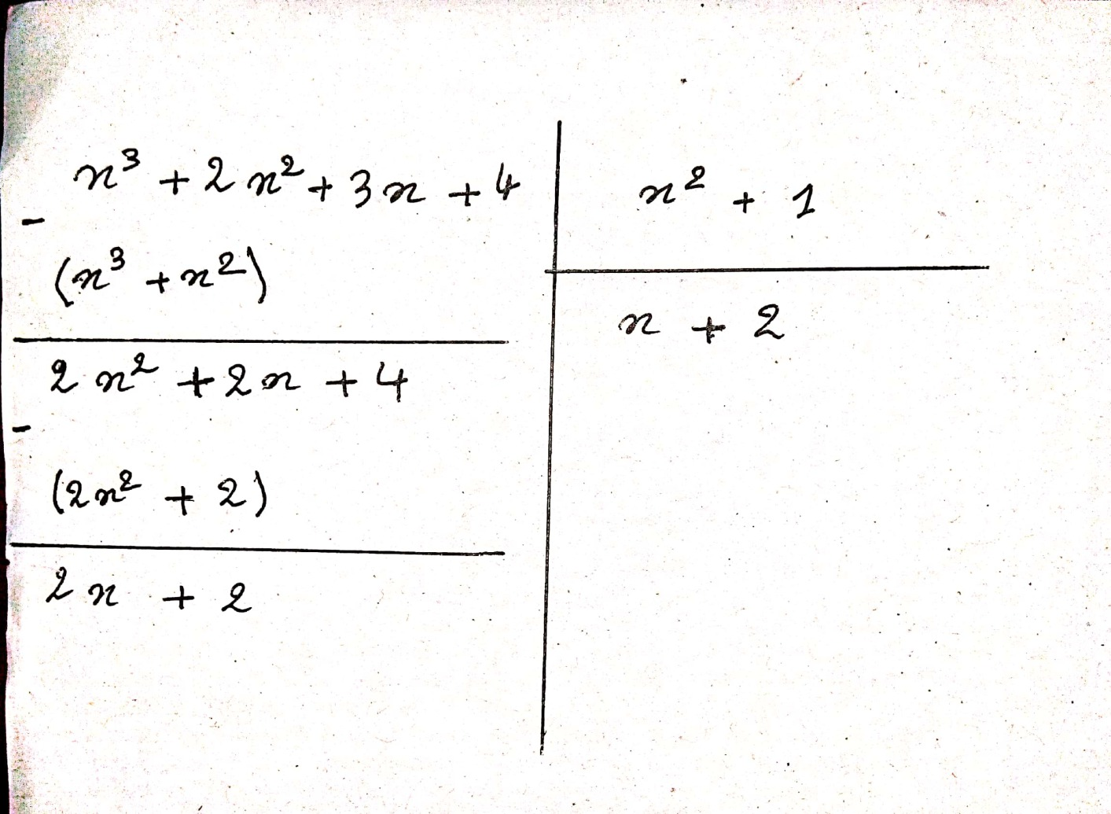

This can be rewritten as:
Here, 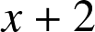 is the polynomial part, and 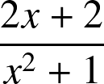 is the proper fraction.
Integrating Rational Functions
The integral of a rational function can be found by integrating its polynomial and proper fraction components separately.
Example
Using the example above:
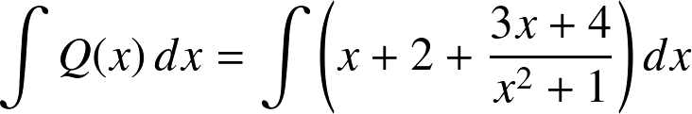
The integral can be broken down into simpler parts:
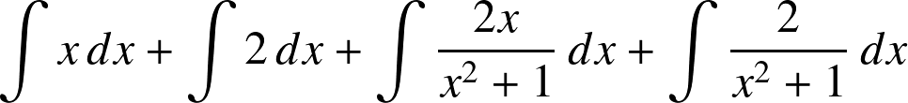
Each of these integrals can be solved using standard integration techniques. So we have:
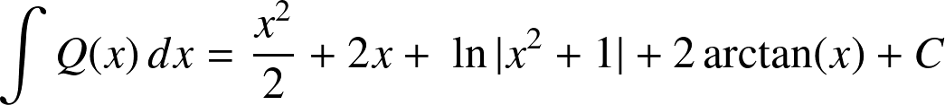
By understanding these principles, one can effectively handle the integration of rational functions.
Integration of a rational fraction in sin and cos:
For integrals involving trigonometric functions, several cases are distinguished.
Method
Integrals of the Form 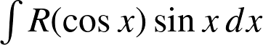:
In this case, we make the change of variables , hence 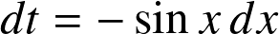 .
Integrals of the Form 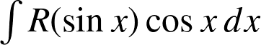:
Here, we make the change of variables 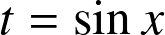 , hence 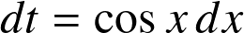 .
Example
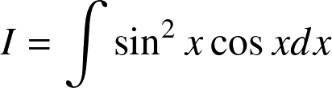
Change of variables: , . Therefore,
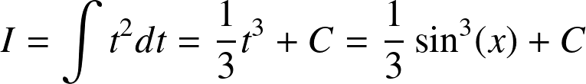
where  is a real number.
Method
Integrals of the Form 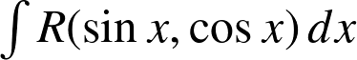:
Here, we make the change of variables 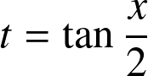 , hence:
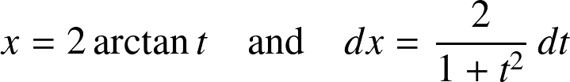
We have:
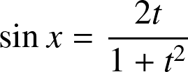
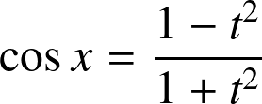
Example
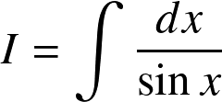
Change of variables: , 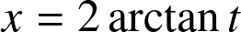 , hence 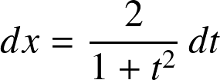 and 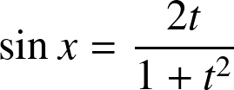 . Therefore,
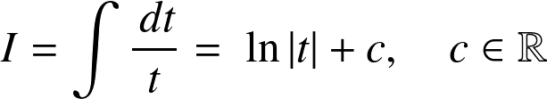
Thus,
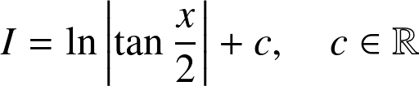
Integration of a rational fraction in exponential:
Integrals involving the exponential function 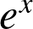 can often be tackled using substitution methods. One common approach is to let 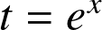 , which simplifies the integral.
Method
For integrals of the form 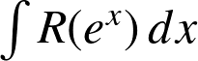 , we use the substitution . Then, we have:
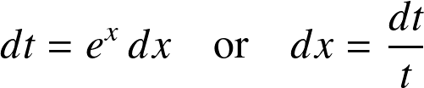
This substitution transforms the integral into a function of .
Example
Consider another integral:
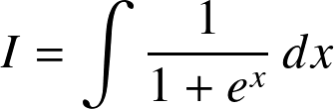
Using the substitution , we have 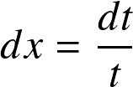 . Therefore,
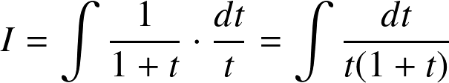
We can further simplify this using partial fractions:
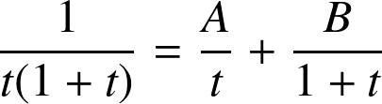
Solving for 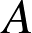 and , we find 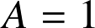 and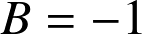 . Hence,
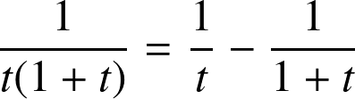
So the integral becomes:
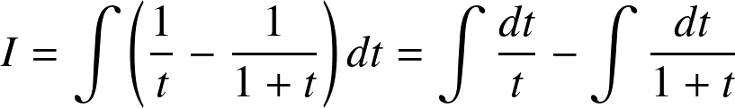
Evaluating these integrals gives:
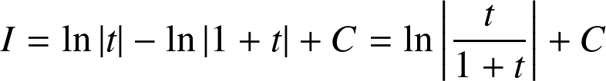
Substituting back , we get:
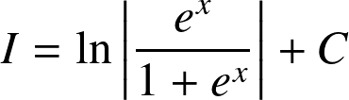
Simplifying further, we obtain:
Thus,
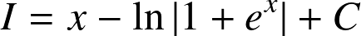
Integration of a rational in sin(h) or cos(h)
For integrals of the form 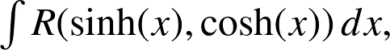 we often use substitutions such as 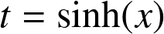 or 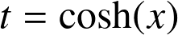 .
Example
Consider another integral:
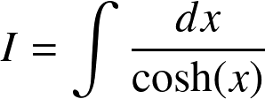
Using the substitution , we have 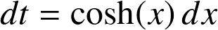 . Therefore,
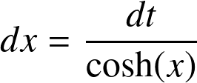
Since 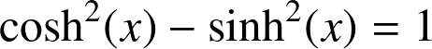, we can write 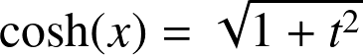. Hence,
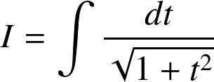
This is a standard integral:
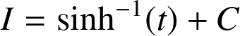
Substituting back , we get:

- Quiz

II- Quiz
II

[Solution n°6 p 16]

An antiderivative for the function 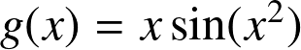 is:
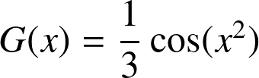
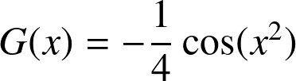
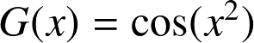
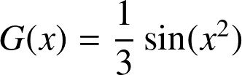
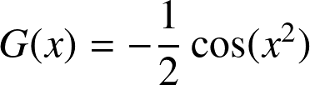

- Final exam:

III- Final exam:
III

Final exam:

Document 1
res.pdf

- Exercises solution

Exercises solution

> Solution n°1 (exercise p. 6)



> Solution n°2 (exercise p. 7)

2
1
4
0

> Solution n°3 (exercise p. 7)

> Solution n°4 (exercise p. 7)

> Solution n°5 (exercise p. 8)

8
12
10
6

> Solution n°6 (exercise p. 13)

