**Shapes in english :**

* ***Triangles :***

An **isosceles triangle** is a triangle with two congruent sides and one unique side and angle.  
Ex. 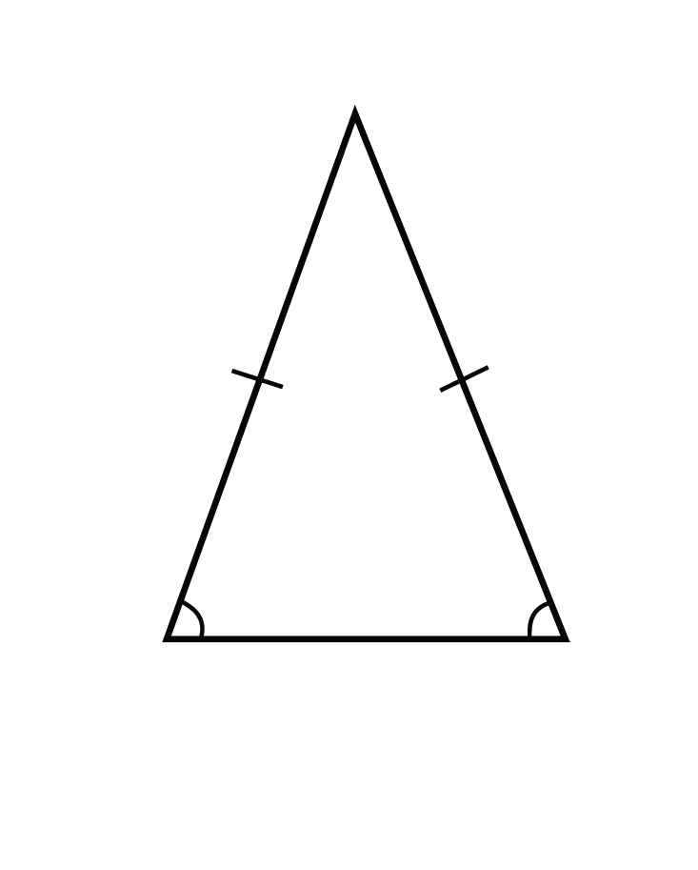

An **equilateral triangle** is a triangle with three congruent sides and three congruent angles.  
Ex. 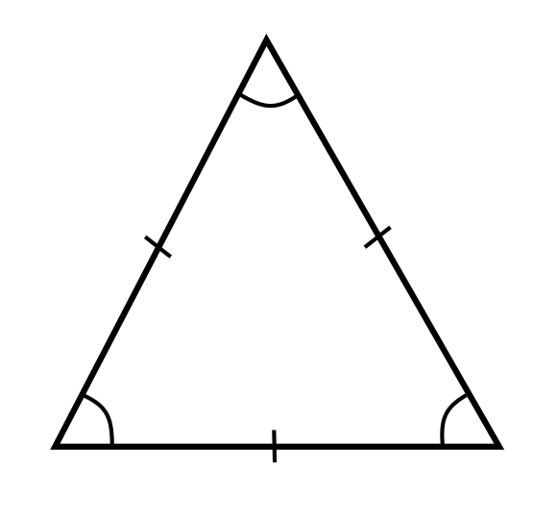

A **right triangle** is a triangle that has one right angle.  
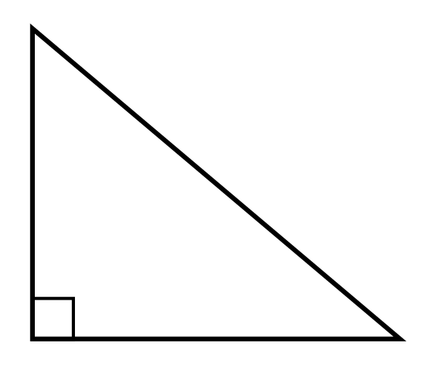

* ***Other shapes :***

1. Square : it has 4 equal sides and 4 equal angles
2. Rectangle: it has 4 sides and 4 right angles
3. Rhombuses: it has 4 equal sides
4. Parallelogram: it has 2pares of parallel sides
5. Trapezoid/ trapezium: it has one pair of parallel sides
6. Pentagon: it has 5 sides and 5 angles
7. Hexagon: it has 6 sides and 6 angles
8. Circle: it has a point in the centre from which each point on the diameter is equidistant
9. Ellipse: an oval shape
10. Cube: it has 6 faces, 12 edges and 8 vertices