**Pronunciation of the final S**

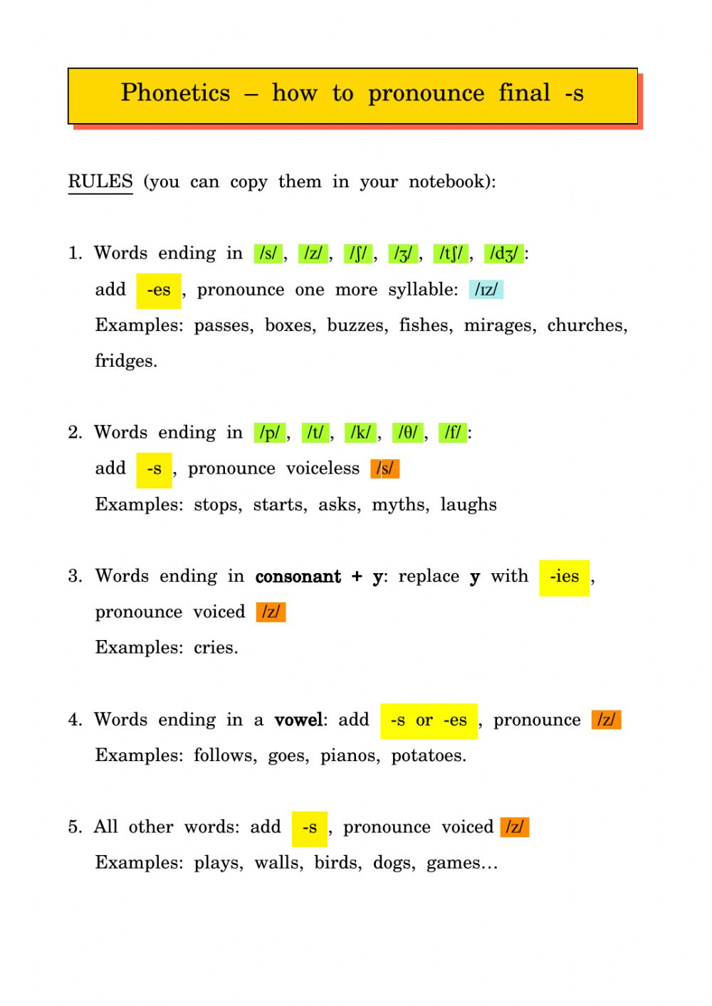

Activity:

|  |  |  |
| --- | --- | --- |
| /S/ | /Z/ | /IZ/ |
| Hurts  Likes  Stops | Cows  Drives  Dries | Prizes  Boxes  ages |