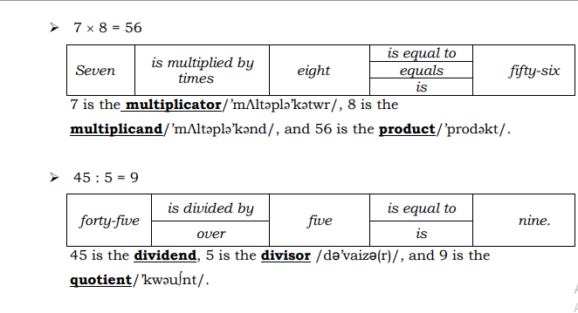

**Fractions**

Fraction is a fraction of the form a/b

Example: p/q

p is called the numerator of the fraction

q is called the denominator of the fraction

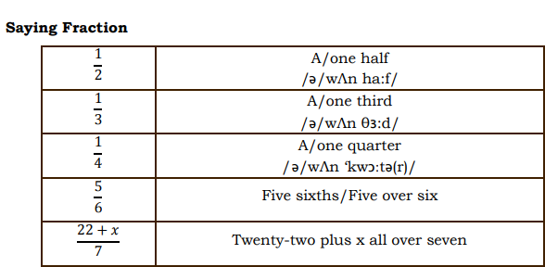

**Common Divisors**

Example: 1,2,3,4,6, and 12 are **divisors** of 12.

1,3,5, and 15 are **divisors** of 15.

1 and 3 are **common divisors** of 12 and 15.

3 is the **greatest common divisor** of 12 and 15

**Common Multiples**

Example: 5,10,15,20,25, …are **multiples** of 5.

4,8,12,16,20,24,… are **multiples** of 4.

5,10,15,20 are **four first multiples** of 5.

4,8,12,16,20 are **five first multiples** of 4.

20,40,60, … are **common multiples** of 4 and 5.

20 is **the least common multiple** of 4 and 5

**Practice** **1** :

Read the following conversation

A : I have two numbers, 36 and 42. Can you say their factors?

B : The factors of 36 are 1,2,3,4,6,9,12,24, and 36. 1,2,3,6,7,14,21, and 42 are factors of 42.

A : So, what are their common factors?

B : They are 1,2,3, and 6.

A : And what is the greatest common divisor of 36 and 42?

B : It‘s 6.

**Powers**

