**Humanistic Learning Theory (Maslow)**

**(**Second Semester)

Maslow and the humanists believed that behaviorism and other psychology theories had a negative perception of learners—for example[operant conditioning](https://www.simplypsychology.org/operant-conditioning.html) in behaviorism psychology suggested that students only acted in a good or bad manner because of the reward or punishment and could be trained based on that desire for a reward. Maslow and humanistic psychology suggests that students are inherently good and will make good decisions when all their needs are met. Humanistic psychology focuses on the idea that learners bring out the best in themselves, and that humans are driven by their feelings more than rewards and punishments. Maslow believed this and wrote many articles to try and demonstrate it.

This belief that humans are driven by feelings causes educators who understand humanistic psychology to focus on the underlying human, emotional issues when they see bad behavior, not to just punish the bad behavior. The humanistic learning theory developed further and harnesses the idea that if students are upset, sad, or distressed, they’re less likely to be able to focus on learning. This encourages teachers to create a classroom environment that helps students feel comfortable and safe so they can focus on their learning. Emotions are at the center of humanism psychology.

Most people are familiar with Abraham Maslow’s Hierarchy of Needs. His research paper, “A Theory of Human Motivation” emphasized that we work toward the attainment of a goal, whether it be getting food because we are hungry, desiring relationships for esteem or growth through self-actualization.

The Key Concepts

Humanistic Learning Theory, often called Humanism, focuses on the specific human capabilities including creativity, personal growth, and choice. Humanists believe people are good and noble. Maslow’s research into hierarchical needs is a major concept in this learning theory, especially Self-Actualization, as it is only at this level the student can truly experience growth.

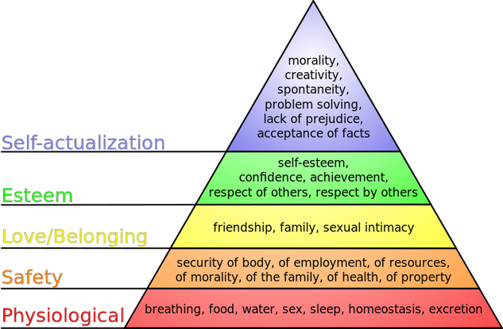

Humanistic Learning Theory can be summarized this way:

1. Learners can be trusted to find their own goals and should have some options or choices in what they learn at school.
2. Students should set their standards and should evaluate their work.
3. The school experience should help students to develop positive relations with their peers

**The principles of humanistic learning theory**

There are several important principles involved in the humanistic learning theory that all lead to self-actualization. Self-actualization is when all your needs are met, you’ve become the best you’ve can, and you are fulfilled. While Maslow and the humanists don’t believe that most people reach self-actualization, their belief is that we are always in search of it, and the closer we are, the more we can learn.

* Student choice. Choice is central to the humanistic learning theory and humanistic psychology. Humanistic learning is student-centered, so students are encouraged to take control over their education. They make choices that can range from daily activities to future goals. Students are encouraged to focus on a specific subject area of interest for a reasonable amount of time that they choose. Teachers who utilize humanistic learning believe that it’s crucial for students to find motivation and engagement in their learning, and that is more likely to happen when students are choosing to learn about something that they really want to know.
* Fostering engagement to inspire students to become self-motivated to learn. The effectiveness of this psychology approach is based on learners feeling engaged and self-motivated so they want to learn. So humanistic learning relies on educators working to engage students, encouraging them to find things they are passionate about so they are excited about learning.
* The importance of self-evaluation. For most humanistic teachers, grades don’t really matter. Self-evaluation is the most meaningful way to evaluate how learning is going. Grading students encourages students to work for the grade, instead of doing things based on their own satisfaction and excitement of learning. Routine testing and rote memorization don’t lead to meaningful learning in this theory, and thus aren’t encouraged by humanistic teachers. Humanistic educators help students perform self-evaluations so they can see how students feel about their progress.
* Feelings and knowledge are both important to the learning process and should not be separated according to humanistic psychology. Humanistic teachers believe that knowledge and feelings go hand-in-hand in the learning process. Cognitive and affective learning are both important to humanistic learning. Lessons and activities should focus on the whole student and their intellect and feelings, not one or the other.
* A safe learning environment. Because humanistic learning focuses on the entire student, humanistic educators understand that they need to create a safe environment so students can have as many as their needs met as possible. They need to feel safe physically, mentally, and emotionally in order to be able to focus on learning. So humanistic educators are passionate about the idea of helping students meet as many of their needs as possible.