Abdelhadif Bossouf Mila University Centre

Department of English

Tutor: Boudjerida Messaouda

Module : Study of Textes of Civilisation

Lecture 1 : The Industrial Revolution in Britain

The Industrial Revolution marked a period of development in the latter half of the 18th century that transformed largely rural, agrarian societies in Europe and America into industrialized, urban ones. Goods that had once been painstakingly crafted by hand started to be produced in mass quantities by machines in factories, thanks to the introduction of new machines and techniques in textiles, iron making and other industries. Fueled by the game-changing use of steam power, the Industrial Revolution began in Britain and spread to the rest of the world, including the United States, by the 1830s and ‘40s. Modern historians often refer to this period as the First Industrial Revolution, to set it apart from a [second period of industrialization](https://www.history.com/news/second-industrial-revolution-advances) that took place from the late 19th to early 20th centuries and saw rapid advances in the steel, electric and automobile industries.

**England: Birthplace of the Industrial Revolution**

Thanks in part to its damp climate, ideal for raising sheep, Britain had a long history of producing textiles like wool, linen and cotton. But prior to the Industrial Revolution, the British textile business was a true “cottage industry,” with the work performed in small workshops or even homes by individual spinners, weavers and dyers.

Starting in the mid-18th century, innovations like the flying shuttle, the spinning jenny, the water frame and the power loom made weaving cloth and spinning yarn and thread much easier. Producing cloth became faster and required less time and far less human labor.

More efficient, mechanized production meant Britain’s new textile factories could meet the growing demand for cloth both at home and abroad, where the nation’s many overseas colonies provided a captive market for its goods. In addition to textiles, the British iron industry also adopted new innovations.

Chief among the new techniques was the smelting of iron ore with coke (a material made by heating coal) instead of the traditional charcoal. This method was both cheaper and produced higher-quality material, enabling Britain’s iron and steel production to expand in response to demand created by the [Napoleonic Wars](https://www.history.com/topics/france/napoleon) (1803-15) and the later growth of the railroad industry.

**Impact of Steam Power**

An icon of the Industrial Revolution broke onto the scene in the early 1700s, when Thomas Newcomen designed the prototype for the first modern [steam engine](https://www.history.com/shows/modern-marvels/videos/steam-engine-drives-a-revolution). Called the “atmospheric steam engine,” Newcomen’s invention was originally applied to power the machines used to pump water out of mine shafts.

In the 1760s, Scottish engineer James Watt began tinkering with one of Newcomen’s models, adding a separate water condenser that made it far more efficient. Watt later collaborated with Matthew Boulton to invent a steam engine with a rotary motion, a key innovation that would allow steam power to spread across British industries, including flour, paper, and cotton mills, iron works, distilleries, waterworks and canals.

Just as steam engines needed coal, steam power allowed miners to go deeper and extract more of this relatively cheap energy source. The demand for coal skyrocketed throughout the Industrial Revolution and beyond, as it would be needed to run not only the factories used to produce manufactured goods, but also the railroads and steamships used for transporting them.

Transportation During the Industrial Revolution

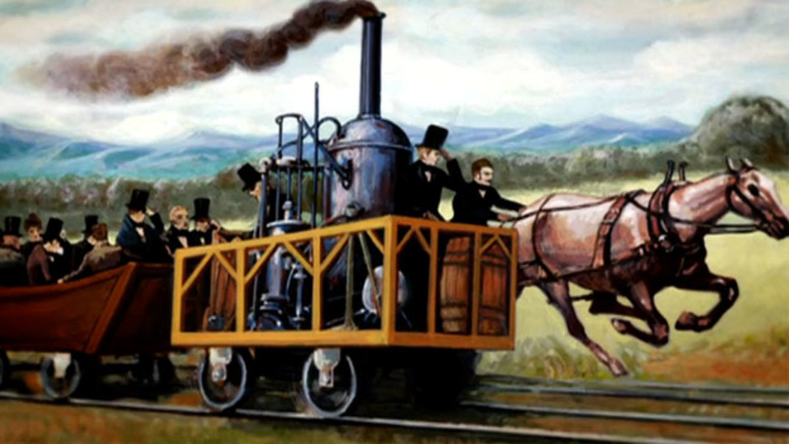

Britain’s road network, which had been relatively primitive prior to industrialization, soon saw substantial improvements, and more than 2,000 miles of canals were in use across Britain by 1815.

In the early 1800s, Richard Trevithick debuted a steam-powered locomotive, and in 1830 similar locomotives started transporting freight (and passengers) between the industrial hubs of Manchester and Liverpool. By that time, steam-powered boats and ships were already in wide use, carrying goods along Britain’s rivers and canals as well as across the Atlantic.

**Communication and Banking in the Industrial Revolution**

The latter part of the Industrial Revolution also saw key advances in communication methods, as people increasingly saw the need to communicate efficiently over long distances. In 1837, British inventors William Cooke and Charles Wheatstone patented the first commercial [telegraphy](https://www.history.com/topics/inventions/telegraph) system, even as [Samuel Morse](https://www.history.com/topics/inventions/telegraph) and other inventors worked on their own versions in the United States. Cooke and Wheatstone’s system would be used for railroad signalling, as the speed of the new trains had created a need for more sophisticated means of communication.

Banks and industrial financiers rose to new prominent during the period, as well as a factory system dependent on owners and managers. A stock exchange was established in London in the 1770s; the New York Stock Exchange was founded in the early 1790s.

In 1776, Scottish social philosopher Adam Smith (1723-1790), who is regarded as the founder of modern economics, published *The Wealth of Nations*. In it, Smith promoted an economic system based on free enterprise, the private ownership of means of production, and lack of government interference.

**Working Conditions**

Though many people in Britain had begun moving to the cities from rural areas before the Industrial Revolution, this process accelerated dramatically with industrialization, as the rise of large factories turned smaller towns into major cities over the span of decades. This rapid urbanization brought significant challenges, as overcrowded cities suffered from pollution, inadequate sanitation and a lack of clean drinking water.

Meanwhile, even as industrialization increased economic output overall and improved the standard of living for the middle and upper classes, poor and working class people continued to struggle. The mechanization of labor created by technological innovation had made working in factories increasingly tedious (and sometimes dangerous), and many workers were forced to work long hours for pitifully low wages. Such dramatic changes fueled opposition to industrialization, including the “[Luddites](https://www.history.com/news/who-were-the-luddites),” known for their [violent resistance](https://www.history.com/news/industrial-revolution-luddites-workers) to changes in Britain’s textile industry.

Did you know? The word "luddite" refers to a person who is opposed to technological change. The term is derived from a group of early 19th century English workers who attacked factories and destroyed machinery as a means of protest. They were supposedly led by a man named Ned Ludd, though he may have been an apocryphal figure.

In the decades to come, outrage over substandard working and living conditions would fuel the formation of [labor unions](https://www.history.com/topics/19th-century/labor), as well as the passage of new [child labor](https://www.history.com/topics/industrial-revolution/child-labor) laws and public health regulations in both Britain and the United States, all aimed at improving life for working class and poor citizens who had been negatively impacted by industrialization.

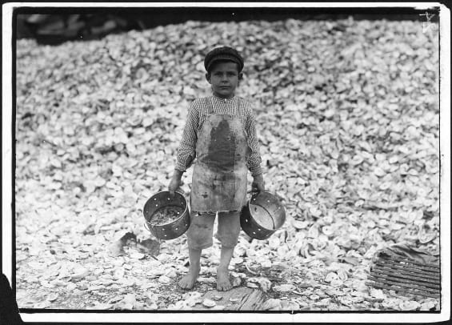

Sources

Robert C. Allen, [The Industrial Revolution: A Very Short Introduction](https://books.google.com/books/about/The_Industrial_Revolution.html?id=Naz_DQAAQBAJ). Oxford: Oxford University Press, 2007

Claire Hopley, “A History of the British Cotton Industry.” [British Heritage Travel](https://britishheritage.com/british-textiles-clothe-the-world), July 29, 2006

William Rosen, [*The Most Powerful Idea in the World: A Story of Steam, Industry, and Invention*](https://books.google.com/books/about/The_Most_Powerful_Idea_in_the_World.html?id=-TStyXy7F6oC&printsec=frontcover&source=kp_read_button#v=onepage&q&f=false). New York: Random House, 2010

Gavin Weightman, [*The Industrial Revolutionaries: The Making of the Modern World, 1776-1914*](https://books.google.com/books/about/The_Industrial_Revolutionaries.html?id=Tg-V5Fr9r8AC&printsec=frontcover&source=kp_read_button#v=onepage&q&f=false)*.*New York: Grove Press, 2007

Matthew White, “Georgian Britain: The Industrial Revolution.” [British Library](https://www.bl.uk/georgian-britain/articles/the-industrial-revolution), October 14, 2009

Citation Information

Article Title

Industrial Revolution

Author

[History.com Editors](https://www.history.com/author/history)

Website Name

HISTORY

URL

<https://www.history.com/topics/industrial-revolution/industrial-revolution>

Access Date

11 décembre 2020

Publisher

A&E Television Networks

Last Updated

September 9, 2019

Original Published Date

October 29, 2009

**BY**

[**HISTORY.COM EDITORS**](https://www.history.com/author/history)