**THE PRESENT APPROACHES TO TEACHING**

**Flliped Approach**

**WHAT, WHY, AND HOW TO IMPLEMENT A FLIPPED CLASSROOM MODEL**

**What is a flipped classroom ?**

A flipped classroom is a [**type of blended learning**](https://www.teachthought.com/learning/12-types-of-blended-learning/) where students are introduced to content at home and practice working through it at school. This is the reverse of the more common practice of introducing new content at school, then assigning homework and projects to completed by the students independently at home.

**The Four Pillars of F-L-I-P™**

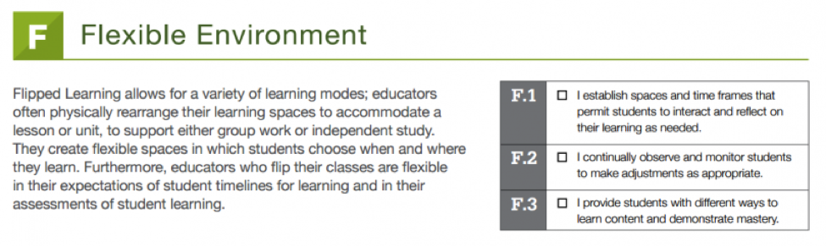

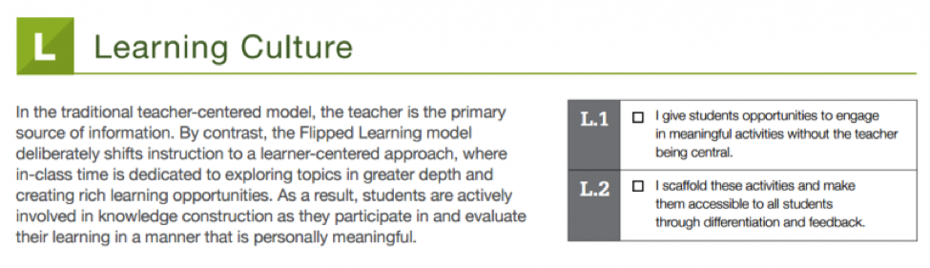

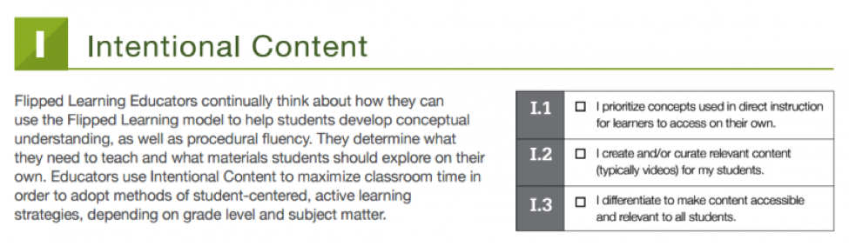

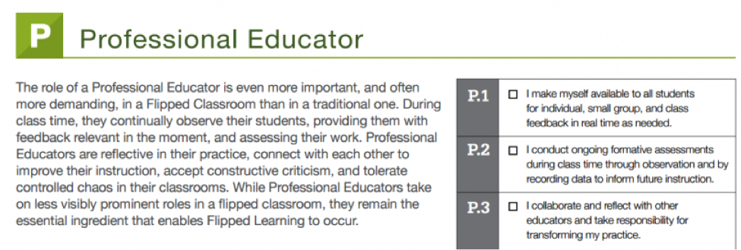

**Fitting with the revised Bloom’s Taxonomy**

In traditional learning, lower level of learning such as remembering and understanding is happening in class, while students are usually left to work on activities that involve higher level of learning outside of classroom. However, in the flipped classroom model, learning is flipped. As you can see from the pyramid, students can finish the lower level of cognitive work before class. And when they come to class, they can engage in higher cognitive levels of learning with peers and teacher present.

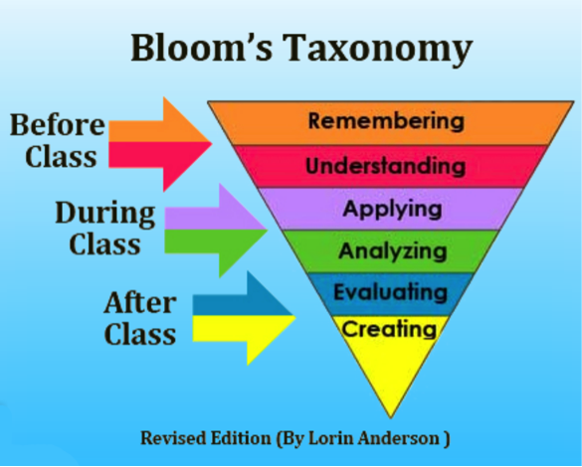

**WHY YOU SHOULD FLIP YOUR CLASSROOM?**

The concept of flipped classroom was first brought up by Jonathan Bergmann and Aaron Sams, who were both high school chemistry teachers. In their book: *Flip your classroom: Reach every student in every class every day* (2012), they discussed a couple of reasons why teachers should consider flipping (p.20-33):

* Flipping speaks the language of today’s students.
* Flipping helps busy students.
* Flipping helps struggling students.
* Flipping helps students of all abilities to excel.
* Flipping allows students to pause and rewind their teacher.
* Flipping increases student-teacher interaction.
* Flipping allows teachers to know their students better.
* Flipping increases student-student interaction.
* Flipping allows for real differentiation.
* Flipping changes classroom management.
* Flipping changes the way we talk to parents.
* Flipping educate parents.
* Flipping makes your class transparent.
* Flipping is a great technique for absent teachers.
* Flipping can lead to the flipped mastery program.

A sidebar in this book also cites 5 “bad reasons for flipping your classroom” (p.21). It is important for teachers to move beyond these perceptions.

* Because some guys who got a book published told you to.
* Because you think it will create a 21st-centry classroom.

*Pedagogy should always drive technology, never the other way around.*

* Because you think you will become cutting edge.

*Flipping does not necessarily use the latest technology.*

* Because you think flipping your classroom exempts you from being a good teacher.

*Teaching is much more than good content delivery.*

* Because you think it will make your job easier.

*Flipping will not make your job any easier.*

**HOW TO IMPLEMENT A FLIPPED CLASSROOM?**

Jeff Dunn (2014) has wrote a short piece on “The 6-step guide to flipping your classroom”, which presented 6 easy steps for implementing flipped classroom.

1. Plan : Figure out which lesson in particular you want to flip. Outline the key learning outcomes and a lesson plan.
2. Record : Instead of teaching this lesson in-person, make a video. A screencast works. Make sure it contains all the key elements you’d mention in the classroom.

In Bergmann and Sams’ book (2012), they also pointed out that do not make a video just for the sake of making a video. Only do so when you feel these are appropriate and necessary. It all depends on the educational goal of your lesson. If making videos better facilitate your instructional goal, then go ahead.

1. Share : Send the video to your students. Make it engaging and clear. Explain that the video’s content will be fully discussed in class.
2. Change : Now that your students have viewed your lesson, they’re prepared to actually go more in-depth than ever before.
3. Group : An effective way to discuss the topic is to separate into groups where students are given a task to perform. Write a poem, a play, make a video, etc.
4. Regroup : Get the class back together to share the individual group’s work with everyone. Ask questions, dive deeper than ever before.

After the six steps, Review, Revise, and Repeat!

Some other strategies that can be used in in-class activities include:

* Active learning. Allow students to apply concepts in class where they can ask peers or instructors for feedback and clarification.
* Peer instruction. Students can teach each other by explaining concepts or working on small problems.
* Collaborative learning. Collaborative learning activities could increase student engagement, enhance student understanding, and promote collective intelligence.
* Problem-based learning. Class time can be spent working on problems that can last for the duration of a semester.
* Discussions or debate. Give students the opportunity to articulate their thoughts on the spot and to develop their arguments in support of their opinions or claims.

**What Students Might Do At Home In A Flipped Classroom**

* Watch an online lecture
* Review online course material
* Read physical or digital texts
* Participate in an online discussion
* Perform research

**What Students Might Do At School In A Flipped Classroom**

* Skill practice (guided or unguided by the teacher)
* In-person, face-to-face discussion with peers
* Debate
* Presentations
* Station learning
* Lab experiments
* Peer assessment and review

This doubles student access to teachers–once with the videos at home, and again in the classroom, increasing the opportunity for personalization and more precise guiding of learning. In the flipped classroom model, students practice under the guidance of the teacher, while accessing content on their own.

A side benefit is that teachers can record lectures that emphasize critical ideas, power standards, and even the pace of a given curriculum map. It also has the side benefit of allowing students to pause, rewind, Google terms, rewatch, etc., as well as creating a ready-made library for student review, make-up work, etc.

**Criticisms Of The Flipped Classroom**

As a learning model, criticisms include reduced opportunity for self-directed critical thinking, decentering the role of the student, encouraging a lecture-driven march through curriculum, and in general simply streamlining an already industrialized approach to learning.

And just like in a regular classroom, success depends greatly on the quality of the teacher, the clarity of communication, and the quality of given curriculum, assessment, and instruction. Further, equity is still a major issue, and it doesn’t address the dated approach most educational systems take to curriculum.

**Kinesthetic Approach**

Kinesthetic leaners are people who learn best through movement. They are known as “doers.” They retain information through experience and physical activity. Kinesthetic learners benefit from demonstrations instead of sitting in a classroom with restrictions of movement. Work environments such as labs allow these learners to manipulate experiments and also be physically active. Kinesthetic learners are often a actors, athletes, or dancers because there is full body motion in these activities. Kinesthetic learners sometimes pace back and forth, or are unable to sit still for long periods of time. (Lengel & Kuczala, 2010)

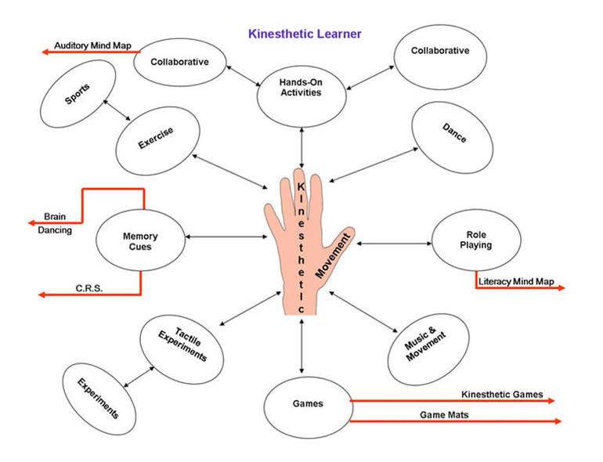

Visual learners commit ideas and concepts to memory using pictures. Similarly  kinesthetic learners can use movement to commit information to memory such as Miley Cyrus in this video of the "Bone Dance."

**Helping Aid Kinesthetic Learning**

Teachers can use many different activities and methods that aid kinesthetic learners. These can be used in different ways and environments.  
For a classroom settings where there is no movement and students are expected to sit still at a desk, a teacher can allow these learners instead to sit in a corner or close to the door where they can move freely without distracting other students. Allowing them to help with tasks that require movement will prevent them from sitting for too long. An example of a task could be handing out papers or washing the desks.

Techniques such as writing, diagramming and mapping are beneficial to these learners for more efficient information intake. When rewriting information, the movement of their hand allows them to save information to memory. Writing on a board in a classroom allows these learners to make larger movements, which are more beneficial to them when retaining information.

 Designing a study activity that involves using an open area of space can be done in a group or individually. One can combine an abstract idea or concept and create pictures or posters to put on the floor or walls. For example, a step-by-step process can be created and placed around a room and a student can then follow the path of the entire process learning it through the movement of following the steps.

Creating dances or skits can allow them to connect movements to help learn certain ideas and memorization. When learning information and performing a certain movement, they can relate the two together when remembering the information. For example, a student learned an equation while jumping, they can recall this information as “the equation that I learned while I was jumping.”

Manipulation of objects and materials benefits these learners. Creating activates that involve the use of different materials such as Legos, clay, or playdough would more efficient than listening to an instructor for an entire class period without movement.

Allowing periodic breaks during class will allow students to maintain focus. When information is dumped on the students in class for long periods of time they will lose focus. To help maintain attention in class, periodic breaks will help the student focus.

Group activities are very helpful when learning. Students partnered with other students that are kinesthetic learners can teach each other new ways and methods to help them study in ways to facilitate their learning style. They can create different learning activities that are used for both partners.

**Balls for Chairs**

Some classrooms now include balls that are used as chairs for students. These balls allow the students who have trouble focusing in class due to their desire to move and wiggle around. Balance balls were first used in the classroom to help improve the strength of core muscles and posture of students. Later, they were suggested for use in the classrooms for students that have trouble sitting still in class. 

**Kinesthetics for Different Age Groups**

Kinesthetic teaching methods are used differently for different age groups. In elementary schools, many different activities have been created to help learn their fundamental knowledge. For example, in this next video 2 x Multiplication factors were taught using the ground and chalk. Shapes were drawn on the ground with numbers, and the student steps from shape to shape performing multiplication.

Kinesthetic learning is easier to incorporate into lower grades. Teachers use more "hands-on" activities in elementary schools. However, kinesthetic learning methods are used less in high school and college because teachers do not focus on different learning styles and primarily focus on getting all of the information presented. It is difficult to incorporate this style of learning in courses such as a literature or history. Classes such as Physical Education, theatre, Science Laboratory classes, etc. are where kinesthetics are incorporated. College is a non-kinesthetic oriented environment, and for these learners to successfully make it through college, the kinesthetic learner must use different methods to gain information if they are to improve their chances for success.

**College Tricks for Kinesthetic Learners**

Kinesthetic teaching methods are used differently for different age groups. In elementary schools, many different activities have been created to help learn their fundamental knowledge. A student can doodle during lecture to help them focus. This form of doodling would be to draw pictures that remind them of the lecture, not to distract them from what is being taught. Some students use multiple colors of pens when taking notes. A student taking notes during lecture is incorporating hand motions which helps their memory.  
  
 When listening to a speaker, a student can chew gum, tap their foot, or use a stress ball. These are all ways the student can remain active while maintaining their focus in class.  
  
 When reading, skimming through the material to understand the main concept, and then returning to the beginning to read more thoroughly helps the person to retain the information. Another technique when reading is to divide the material up into shorter sections to help the level of focus while reading. While reading, highlight and take active notes. Another technique for reading is to read for a short period of time, and then workout for five to ten minutes, then return to the reading task.     

**Favoring different Learning Styles**

A normal classroom setting involves students sitting down and taking notes during a lecture setting. "Most People of college age and older are visual, while most college teaching is verbal" (Felder, 1988). Lectures are given as auditory and visual teaching. This type of teaching does not benefit a kinesthetic learner in the classroom setting.

Teachers commonly use a curriculum suited for visual, aural, and verbal learners. This curriculum is easier to perform in a classroom rather then using a teaching method suited for kinesthetic learners. A method for kinesthetic learners would require more movement and activities in a classroom or lecture hall, which are more difficult for teachers to perform in a large class and it also could be more expensive financially to provide materials used for movement activities. The methods suited for the learning styles other than kinesthetics may work for most students, however, there are students who need to be taught through a movement and activity oriented teaching routine because this is the most beneficial method, and in extreme cases the only method for some students to retain new information.

Teachers should make it a priority to accommodate all types of learners. Kinesthetic methods of teaching such as activities involving movement and group activities may require more work than a regular classroom setting, but the results will show that all types of learners are performing better in class creating a positive learning environment.

**Strengths of Kinesthetic Learners**

Kinesthetic learners have many strengths that will help them achieve success in the classroom:

* Great hand-eye coordination
* Quick reactions
* Excellent motor memory (can duplicate something after doing it once)
* Excellent experimenters
* Good at sports
* Perform well in art and drama
* High levels of energy

**Kinesthetic Learning Tips for Teachers**

Kinesthetic learners need to move their bodies in order to learn. These students are often called "fidgety," and some teachers might interpret their behavior as distracted or bored. However, a kinesthetic learner's movement does not imply a lack of attention—in fact, it means that they're trying to process information in the most effective possible way. Try these strategies for reaching kinesthetic learners in your classroom:

* Allow kinesthetic learners to stand, bounce their legs, or doodle during lectures. You will get more out of them in class if they can move around a little bit.
* Offer various methods of instruction—lectures, paired readings, group work, experiments, projects, plays, etc.
* Ask your kinesthetic learners to complete relevant tasks during the lecture, like filling out a worksheet or [taking notes](https://www.thoughtco.com/how-to-take-notes-3211494).
* Allow kinesthetic learners to perform movement tasks before and after lectures, like handing out quizzes, writing on the chalkboard, or even rearranging desks.
* If you feel the kinesthetic learners slipping away from you in class, pause the lecture and have the whole class do something energetic: marching, stretching, or switching desks.
* Keep your lectures short and sweet! Plan several different activities throughout each class period in order to be mindful of all your students' learning styles.

**Criticism of the Kinesthetic Approach**

Although extensive research has been done in regards to kinesthetic learning, there are still several research projects that have had mixed results due to the ambiguous nature of deducing one's learning style tendencies. As it stands, there is not a sound way to fully deduce an individual's ideal learning style. Although there are proven links to certain stimuli and the two hemispheres of the brain, the idea of kinesthetic learning usually comes under criticism due to its casual use in common vernacular.

**Personalized Approach**

Personalized learning is an educational approach that aims to customize learning for each student’s strengths, needs, skills, and interests.

Each student gets a learning plan that’s based on what they know and how they learn best.

Personalized learning doesn’t replace an IEP, a 504 plan, or intervention programs.

To get an idea of what personalized learning is, try to picture a classroom that doesn’t have a “one size fits all” approach to education. The teacher doesn’t lead all students through the same lessons. Instead, the teacher guides each student on an individualized journey. The what, when, where and how of learning is tailored to meet each student’s [**strengths**](https://www.understood.org/en/friends-feelings/empowering-your-child/building-on-strengths/types-of-strengths-in-kids), skills, needs, and interests.

Students may learn some skills at different paces. But their learning plans still keep them on track to meet the standards for a high school diploma.

That kind of classroom isn’t the reality for most students. But it’s the end goal of personalized learning, which is already being used successfully in some schools and is expanding in several states. Here’s what you need to know.

**What is personalized learning**

Kids learn in different ways and at different paces. Personalized learning is a teaching model based on that premise. Each student gets a “learning plan” based on how they learn, what they know, and what their skills and interests are. It’s the opposite of the “one size fits all” approach used in most schools.

Students work with their teachers to set both short-term and long-term goals. This process helps students take ownership of their learning.

Teachers make sure learning plans or [**project-based learning**](https://www.understood.org/en/community-events/blogs/the-inside-track/2017/08/14/project-based-learning-and-adhd) match up with academic standards. And they check to see if students are demonstrating the skills they’re expected to learn as they progress through their education.

Personalized learning is not a replacement for special education. It’s an approach to general education that can work with an Individualized Education Program (IEP), a 504 plan, response to intervention, or other specialized intervention programs.

But [**accommodations**](https://www.understood.org/en/learning-thinking-differences/treatments-approaches/educational-strategies/accommodations-what-they-are-and-how-they-work), supports, and accessible learning strategies need to be essential parts of personalized learning. If done well, *all*students will be more engaged in their learning. And struggling students will get help sooner. If not done well, students with disabilities could fall further behind.

**How personalized learning works**

No two schools using personalized learning will look exactly the same. But here are four widely used models that schools follow. Each of these models sets high expectations for all students and aligns their learning to a set of rigorous standards.

**1. Schools that use learner profiles.** This type of school keeps an up-to-date record that provides a deep understanding of each student’s individual strengths, needs, motivations, progress and goals. These profiles are updated far more often than a standard report card. And these detailed updates help teachers make decisions to positively impact student learning.

A learner profile also helps students keep track of their own progress. It gives the teacher, the student and, in many schools, the parent a way to know if they need to change a learning method or make changes to goals — *before*the student does poorly or fails.

**2.Schools that use personalized learning paths.** This type of school helps each student customize a learning path that responds or adapts based on progress, motivations, and goals. For instance, a school might create a student’s schedule based on weekly updates about academic progress and interests.

Each student’s schedule is unique. But it’s likely to include several learning methods. (These are often called modalities.) The mix might include project-based learning with a small group of peers, independent work on certain skills or complex tasks, and one-on-one tutoring with a teacher.

A personalized learning path allows a student to work on different skills at different paces. But that doesn’t mean the school will let a student fall far behind in any area. Teachers closely monitor each student and provide extra support as needed.

**3. Schools that use competency-based progression.** This type of school continually assesses students to monitor their progress toward specific goals. This system makes it clear to students what they need to master. These competencies include specific skills, knowledge and mindsets like [**developing resilience**](https://www.understood.org/en/friends-feelings/empowering-your-child/building-on-strengths/building-resilience-in-kids).

Students are given options of how and when to demonstrate their mastery. For example, a student might work with a teacher to [**weave certain math skills into an internship**](https://www.ncld.org/supporting-academic-success#ch3spotlight) at a retail store.

The student might work on several competencies at the same time. When they master one, they move on to the next. Each student gets the necessary support or services to help master the skills. The emphasis isn’t on taking a test and getting a passing or failing grade. Instead, it’s about continuous learning and having many chances to show knowledge.

**4. Schools using flexible learning environments.** This type of school adapts the environment students learn in, based on how they learn best. That includes things like the physical setup of the class, how the school day is structured and how the teachers are allocated.

For example, schools might look for ways to give teachers more time for small group instruction. It’s not easy to redesign the way teachers use space, time and resources in the classroom. But this type of [**design thinking**](https://www.ncld.org/wp-content/uploads/2017/07/SpaceLab.Case-Study.Fin_-1.pdf) can help student needs reshape the learning environment.

**The potential of personalized learning**

Personalized learning isn’t widely used in schools yet. Many aspects still need to be explored. But this approach has the potential to help reduce the stigma of special education and better meet the needs of kids with learning and thinking differences.

IEPs are too often focused mainly on deficits. But personalized learning paths can balance that by focusing on students’ strengths and interests. Together, IEPs and personalized learning can give kids the supports to work on weaknesses and a customized path that engages their interests and helps them “own” their learning.

Personalized learning can also give students the chance to build [**self-advocacy skills**](https://www.understood.org/en/friends-feelings/empowering-your-child/self-advocacy/the-importance-of-self-advocacy). It encourages them to speak up about what interests them. It also allows them to be equal partners in their learning experience.

Personalized learning has a lot of potential, but it also has some risks. Teachers might not have enough [**inclusion**](https://www.understood.org/en/learning-thinking-differences/treatments-approaches/educational-strategies/4-benefits-of-inclusive-classrooms) training to make this approach accessible to all students. They might not know how to support kids with executive functioning issues. They might not know how to track competencies or analyze other kinds of student data.

The key is to make sure that when schools start using personalized learning, teachers have the training to meet your child’s needs. And the more you know, the more involved you can be in the conversation.

**ADVANTAGES OF PERSONALIZED LEARNING**

* 1. *Student-Centered Classrooms*
* Learning activities are meaningful and connect to student interests
* Authentic learning empowers students
  1. *Active Learning Environment*
* Instruction utilizes a variety of learning styles that support every learner
* Personal attention is given to ensure that every child develops their intellectual and creative talents
  1. *Collaborative and Cooperative*
* Students work with others to explore ideas and use knowledge for meaningful tasks
* Teachers are facilitators of learning to guide them in acquiring knowledge
* Opportunities are provided  for students to become “creators of content”
  1. *Creates Positive Attitudes for Learning*
* Enthusiasm for school is increased
* Creates life-long learners
  1. *Caring and Supportive Learning Environment*
* Student-teacher relationships are respectful
* Parents partner with teachers to encourage student achievement

**Inquiry based Approach**

Inquiry-based learning is an approach to learning that emphasizes the student’s role in the learning process. Rather than the teacher telling students what they need to know, students are encouraged to explore the material, ask questions, and share ideas.

Inquiry-based learning uses different approaches to learning, including small-group discussion and guided learning. Instead of memorizing facts and material, students learn by doing. This allows them to build knowledge through exploration, experience, and discussion.

Inquiry-based learning is more than asking a student what he or she wants to know. It’s about triggering curiosity. And activating a student’s curiosity is, I would argue, a far more important and complex goal than mere information delivery.

Despite its complexity, inquiry-based learning can be easier on teachers, partly because it transfers some responsibilities from teachers to students, but mostly because releasing authority engages students.

Teachers who use inquiry-based learning combat the “dunno”—a chronic problem in student engagement.

When you ask a student something like, “What do you want to know about _____?” you’re often met with a shrug or “dunno.” Inquiry-based learning, if front-loaded well, generates such excitement in students that neurons begin to fire, curiosity is triggered, and they can’t wait to become experts in answering their own questions.

What inquiry-based teachers do isn’t easy at all; it’s just hidden, and some people confuse the two. Teachers hide the strategies they use to encourage inquiry, and the students develop their own skills as content-area experts.

**Learning Something New**

Triggering inquiry is about learning something new, and triggering curiosity is no small feat. It takes modeling enthusiasm, and learning something new generates our own enthusiasm, even if it’s something new about the content we’ve covered for years.

Let’s say you’re clicking through your Twitter or Facebook feed and you stumble on a link in your content area. You realize it’s a new factoid, a new perspective on an age-old topic. Maybe it’s a new TED talk or graph with statistics, something that makes a concept more concrete. Maybe it’s an infographic or a photo, something that startles you and leads to furrow your brow and say, “Whaaa?!”

By the way, I think one of the reasons why the whole world seems to be losing its mind over the Broadway production of *Hamilton* is because it presents a fresh take on a story we’ve all heard before. The power of learning something new is undeniable.

You have to bring that “whaaa?!” into your classroom. You have to model your own curiosity quotient—that hunger to learn that defines how we advance our knowledge of the world. According to the [Harvard Business Review](https://hbr.org/2014/08/curiosity-is-as-important-as-intelligence), a higher curiosity quotient can indicate more flexibility and help build a greater ability to handle complexity.

So think about your content area. What is a new take on a topic that you can bring to your classroom? What new piece of information might help you trigger your own enthusiasm that can then trigger your students’ curiosity?

**The 4 Steps of Inquiry-Based Learning**

So you’ve discovered something that generates your own inquiry, and you’ve recreated that moment for your students when your curiosity was triggered. So what comes next in inquiry-based learning? This can be answered in four basic steps that should represent the outline of a simple unit.

**1.** Students develop questions that they are hungry to answer. Have them develop a problem statement that requires them to pitch their question using a constructed response, further inquiry, and citation.

**2.** Research the topic using time in class. It’s crucial to have some of this be classwork so students have access to the head researcher in the room—you. You aren’t going to do the work for them, but you are going to guide them and model methods of researching reliably.

**3.** Have students present what they’ve learned. Students should create and present a culminating artifact. When I have my students present what they’ve learned, I use a rubric with “Able to Teach” as the acme of what to reach for. After all, many people can understand content, but can they communicate it? Students can develop a website using Weebly, or perhaps a slideshow using Google Slides.

**4.** Ask students to reflect on what worked about the process and what didn’t. Reflection is key. And it isn’t just about asking them to think back on their opinion of the topic. It’s about reflecting on the process itself. That’s where you can work in metacognition—thinking about thinking. Have students focus on how they learned in addition to what they learned.

In terms of your content area, imagine a classroom where different kids are presenting their findings on a single, simple aspect of the content. You’d have a classroom that, overall, learns deeper and wider than ever before.

In terms of student achievement, the power of their question should help drive the research, the writing, and the presentation. It should help motivate them to become experts in their self-described field. And the more often a student gets a taste of what it feels like to be an expert, in however small a concept, the more they will want that feeling later on in life.

**THE BENEFITS OF INQUIRY-BASED LEARNING**

Now that you know more about the Inquiry based Approach, let’s take a look at the advantages and benefits of inquiry-based learning.

1. *Enhances learning experiences for children*
2. *Teaches skills needed for all areas of learning*
3. *Fosters curiosity in students*
4. *Deepens students’ understanding of topics*
5. *Allows students to take ownership of their learning*
6. *Increases engagement with the material*
7. *Creates a love of learning*

**Differentiated Approach**

* Differentiated instruction is not the same as individualized instruction.
* Differentiated instruction allows students to show what they know in different ways.
* It can work well in general education classes that include students with learning and thinking differences.

In any general education classroom, there are students with various learning styles. Some learn best by reading and writing. Others prefer to watch a video, listen to a recording, or dig into hands-on activities. Differentiated instruction is a way of teaching that matches a variety of learning styles.

**What is differentiated instruction?**

Teachers who use differentiated instruction tailor their teaching approach to match their students’ learning styles. All the students have the same learning goal. But the teaching approach varies depending on how students prefer to learn.

Instead of using a one-size-fits-all approach, a teacher uses a variety of methods to teach. This can include teaching students in small groups or in one-on-one sessions. Carol Ann Tomlinson, an educator who has done some of the most innovative work in this area, says there are four areas where teachers can differentiate instruction.

* **Content:** Figuring out what a student needs to learn and which resources will help
* **Process:** Activities that help students make sense of what they learn
* **Projects:** A way for students to “show what they know”
* **Learning environment:** How the classroom “feels” and how the class works together

This approach works well with the response to intervention (RTI) process used in some schools. The goal of RTI is to spot learning problems early. Struggling students are given extra support *before*they fall behind their peers.

**Why is differentiated instruction used?**

Differentiated instruction “shakes up” the traditional classroom, says Tomlinson. Students have “multiple options for taking in information, making sense of ideas, and expressing what they learn,” she explains.

Forty years ago, Tomlinson says, the focus was on individualized instruction. But teachers discovered that creating an individual learning plan for each student in a class wasn’t realistic. Differentiated instruction, on the other hand, uses several learning approaches. But it doesn’t require an individual approach for each student. All students have access to the curriculum in a variety of ways. This makes the whole learning experience more effective.

**How differentiated instruction works**

Differentiated instruction can play out differently from one classroom to the next — and from one school to the next. However, the key features of this approach are:

* **Small work groups:** The students in each group rotate in and out. This gives them a chance to participate in many different groups. A group can include a pair of students or a larger group. But in all cases, it’s an opportunity for students to learn from each other.
* **Reciprocal learning:** Sometimes students becomes teachers, sharing what they’ve learned and asking classmates questions.
* **Continual assessment:** Teachers regularly monitor students’ strengths and weaknesses (in both formal and informal ways) to make sure they’re progressing well in their knowledge and mastery of schoolwork.