***Introduction to Biotechnology***

*Bio-Technology*, as the word suggests, is the use of living things especially cells and bacteria for production of various products for benefiting human beings. It is a combination of various technologies, applied together to living cells, including not only biology, but also subjects like mathematics, physics, chemistry and engineering. Its application ranges from agriculture (Animal Husbandry, Cropping system, Soil science and Soil Conservation, Plant Physiology, Seed Technology and Crop Management etc.) to industry (food, pharmaceutical, chemical, byproducts, textiles etc.), medicine, nutrition, environmental conservation, Cell Biology, making it one of the fastest growing fields. In other words, biotechnology is the use of technology to modify or upgrade the part or whole of biological system for getting beneficial products.

1. ***History***

People were using biotechnology techniques thousands years before but they did not named their working field as biotechnology. The name biotechnology was given by Hungarian engineer Karoly Ereky in 1919 to describe a technology based on converting raw materials into a more useful product.

After the end of the second world war some, very crucial discoveries were reported, which paved the path for modern biotechnology and to its current status. The latter provides breakthrough products and technologies to combat rare diseases, reduce our environmental footprint, fight hunger , use less and cleaner energy, and have safer and more efficient industrial manufacturing processes. Currently, there are:

* More than 250 biotechnology health care products and vaccines available to patients, many for previously untreatable diseases.
* More than 13.3 million farmers around the world use agricultural biotechnology to increase yields, prevent damage from pests and reduce farming's impact on the environment.
* More than 50 biorefineries are being built across North America to test and refine technologies to produce biofuels and chemicals from renewable biomass, which can help reduce greenhouse gas emissions.

1. ***Basic Techniques in Biotechnology:***

There are various techniques of biotechnology such as:

1. **Genetic engineering:**

Genetic engineering, also called genetic modification, is the direct manipulation of an organism's genome using biotechnology.

Genes are the chemical blueprints that determine an organism's traits. Moving genes from one organism to another transfers those traits. Through genetic engineering, organisms can be given targeted combinations of new genes, and therefore new combinations of traits that do not occur in nature and, indeed, cannot be developed by natural means. Such an approach is different from classical plant and animal breeding, which operates through selection across many generations for traits of interest.

1. **Tissue culture :**

Tissue culture, a method of biological research in which fragments of tissue from an animal or plant are transferred to an artificial environment in which they can continue to survive and function. The cultured tissue may consist of a single cell, a population of cells, or a whole or part of an organ. Cells in culture may multiply; change size, form, function or interact with other cells.

1. **Cloning:**

Cloning describes the processes used to create an exact genetic replica of another cell, tissue or organism. The copied material, which has the same genetic makeup as the original, is referred to as a clone. The most famous clone was a Scottish sheep named Dolly.

There are three different types of cloning:

* Gene cloning, which creates copies of genes or segments of DNA
* Reproductive cloning, which creates copies of whole animals
* Therapeutic cloning, which creates embryonic stem cells. Researchers hope to use these cells to grow healthy tissue to replace injured or diseased tissues in the human body.

1. ***Biotechnology and its applications:***

Biotechnology has various applications in different fields such as:

1. **Medicine:**

The goal of biotechnology in medicine is to fight and cure diseases. Consequently, biotechnology is applicable in the following areas of medicine: production of drugs and therapeutics, genetically modified organism, analysis of genes in genetic diseases, corrections of genetic defections, etc.

1. **Agriculture:**

Application of biotechnology in agriculture offers tremendous benefits which include increased crop productivity, enhanced crop protection, improvement in food processing, improved nutritional value, better flavour, etc.

1. **Industry :**

Industrial biotechnology is the application of biotechnology for industrial purposes. It refers to the bio-process of crops and other products for non-food uses, that is, industrial uses. Bio- processes include industrial fermentation, the use of cells or micro-organisms or enzymes to produce industrially useful products such as chemicals, feeds, detergents, paper, bio-plastics and so on. By producing products through bio-processes, industrial biotechnology is a way of mitigating against petrochemical based economy and encouraging sustainable economy.

1. **Food:**

Applications of biotechnology in food processing include fermentation bioprocess, the use of food additives and processing aids used in food formulations. Such products are enzymes, amino acids, vitamins, organic acids, certain carbohydrates and flavouring agents produced using genetically modified micro-organism.

1. **Environment:**

Application of biotechnology in the environment is the process of applying microorganisms to improve environmental quality. This process is often termed as environmental biotechnology. The areas of application are conversion of organic wastes, environmental bioremediation of hazardous contaminants, environmental protection and monitoring.

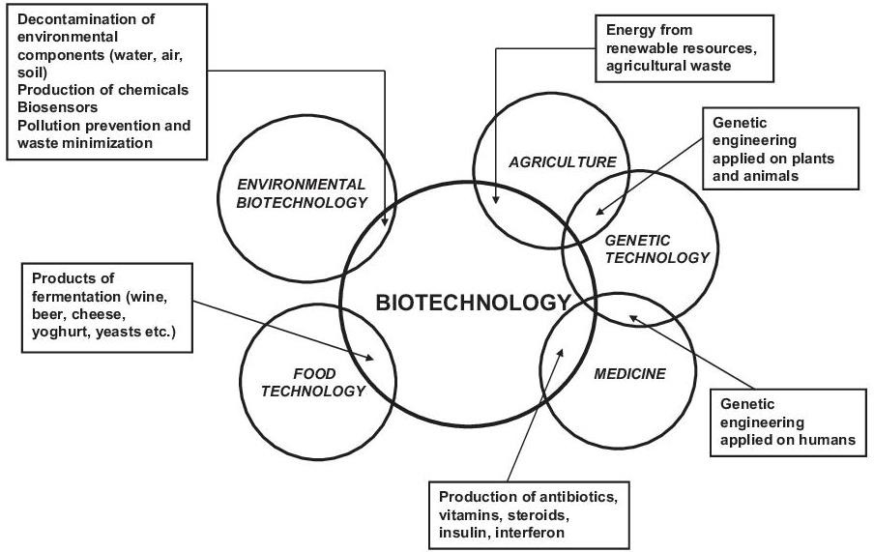

***Figure:*** Various applications of biotechnology

1. ***Types of Biotechnology:***

The different biotechnology applications are grouped into seven colors or research and development areas. In this section, we highlight the most relevant of each of them.

* **Red biotechnology:** this is the health branch which is responsible for the development of more than 250 vaccines and medications such as antibiotics, regenerative therapies and the production of artificial organs.
* **Green biotechnology:** it is used by more than 13 million farmers worldwide to fight pests and nourish crops and strengthen them against microorganisms and [extreme weather events](https://www.iberdrola.com/environment/top-countries-most-affected-by-climate-change), such as droughts and frosts.
* **White biotechnology:** the industrial branch works to improve manufacturing processes, the development of biofuels and other technologies to make industry more efficient and sustainable.
* **Yellow biotechnology:** this branch is focused on food production.
* **Blue biotechnology:** this exploits marine resources to obtain aquaculture, cosmetics and health care products. In addition, it is the branch most widely used to obtain biofuels from certain microalgae.
* **Grey biotechnology:** its purpose is the conservation and restoration of contaminated natural ecosystems through, as mentioned above, bioremediation processes.
* **Gold biotechnology:** also known as bioinformatics it is responsible for obtaining, storing, analyzing and separating biological information, especially that related to DNA and amino acid sequences.

1. ***Impacts of Biotechnology***

The benefits of biotechnology are tangible, but at the same time some warn of its possible adverse effects on the environment, health and ethics. The ***advantages*** of BIO are as follows:

* **It reduces CO2 emissions by 52 %,** optimizes the use of water and reduces waste and chemical processes thanks to techniques such as recombinant DNA.
* **It improves medical diagnosis,** reduces infection rates, minimizes the side effects of medications and favors progress in developing countries.
* **It favors healthy and sustainable agriculture**. Provides more nutritious, toxin and allergen-free food and limits the use of pesticides and chemicals.

Its main ***risks*** include:

* The proliferation of laboratory foods could end crop diversity. It may also affect the balance of ecosystems.
* The risks include unforeseen allergies, poisoning of living organisms and modified bacteria escaping from a laboratory.
* Cloning, the modification of the human genome and assisted reproduction are matters of ethical debate and social controversy.