AbdelhafidBoussouf University Center, Mila Level: 1st year (BA/ LMD)
Institute of Letters and Languages Speaking and Listening
Department of Foreign Languages English Prepared by Dr. Abid m
Topic 3: Energy
The Aims: - To help learners be familiar with energy vocabulary.
- To test learners to talk about the topic for about 5 minutes.
- Motivating them to talk by adding extra points.
Pre-listening | - Discuss the questions below.  - What did people did to generate light and heat before electricity was discovered?  - How did people travel before cars are invented?  - How did people travel before cars were invented?  - What fuel sources do you think we will be using in 100 years time?  - You are going to watch a video about water power. Before you watch, match the words (1-7) to the definitions (a-b).  Dam an artificial like where water is stored.  Reservoir a machine which uses the pressure of a liquid or gas to produce water.  Generator a wall built across a river to stop the river´s flow and collect water.  Turbine a machine that produces electricity.  Tower a tall, narrow structure  Pipe a tube through which a liquid or gas flows.  Shaft a rod in an engine or machine that turns to pass power on to another part of the machine.  - Look to the picture then name the different parts.  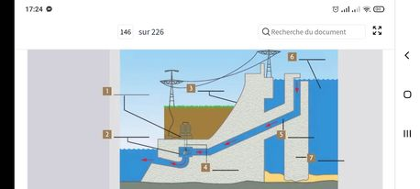
While- listening | - Watch the video. Say whether the statements are true or false.  - Hydroelectric power provides the majority of world´s energy.  - Building dams makes rivers flow faster.  - Building dams often destroys habitats.  - Water in reservoirs is colder than in rivers.  - Watch the video again and order the information in the order you hear.  - Lake Mead is 180 kilometers long.  - California has perfect weather and soil for agriculture.  - Rainfall in California can be a little as 18 centimeters per year.  - Water enters the dam through the towers.  - About 24% of the world´s electricity is generated hydroelectrically.  - The turbines turn 180 times per minute.  - Water from a reservoir may be the wrong temperature for some plants and animals.
Post- listening | Discussion  - Does your country use hydroelectric power? If so, where?  - What other ways is electricity generated in your country?  - What are the benefits of hydroelectric power compared with other sources of energy?  N.B. Some ideas and tasks are inspired from the reference below.  Lansford, L. (2020).Unlock Listening & Speaking 4.(B2)English Profile.

