**Trigonometry:**

It is the study of angle measurement

When you have a right triangle there are 5 things we can know about it

The length of the sides and the measures of the acute angles

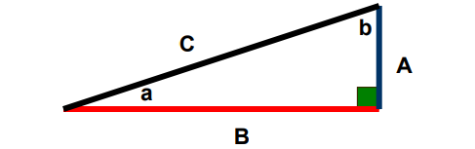

Some terminology:

**The hypotenuse**: will always be the longest side, and opposite from the right angle.

**The opposite**: side is the side directly across from the angle you are considering (angle a). **The adjacent**: side is the side next to angle you are considering.