**People’s Democratic Republic of Algeria**

Ministry of Higher Education and Scientific Research

Mila University Centre

Faculty of Letters and Languages

Department of English Language and Literature

|  |
| --- |
| Computer Assisted Language Learning |

**Mr. Salim BOULBAIR**

**2022**

**Table of Content**

1. Background: Terminology and Basic Concepts
   1. Terminology and Definitions
   2. Intelligent CALL
   3. Basic Concepts
2. Theoretical Background
3. The History of Computer Assisted Language Learning
4. CALL Characteristics, Benefits, and Limitations
5. CALL Research: Trends and Issues
6. CALL and Second Language Classroom Research
7. The Implementation of CALL
   1. Pedagogical Concerns for Classroom Practice
   2. Material Selection and Use
   3. Designing a Telecollaborative Project
   4. The Role of the Teachers and Learners
   5. Computer-Assisted Language Testing
8. Evaluation of CALL
   1. Principles for CALL Evaluation
   2. Evaluation Components
9. **Background: Terminology and Basic Concepts**
   1. **Terminology and Definitions**

Since the invention of the computer in the 1960s, its possible use for education has been increasingly examined resulting in different labels that correspond to its use (LeBaron-Earle, 2013). These labels include:

**CASLA:** Computer Applications in Second Language Acquisition

**CAI:** Computer Assisted Instruction or Computer-Aided Instruction refers to learning at the computer, but not necessarily with a language focus. Although it may not be the intention of all those who use the acronym, the term instruction suggests a teacher-centred approach.

**CAL:** Computer-Assisted Learning, as with CAI, CAL may refer to using a computer to learn any subject (including languages) using a computer. But, in contrast to CAI, CAL emphasizes the learner.

**CALI:** Computer-Assisted Language Instruction, a term once commonly used in North America.

**CALT**: Computer-Assisted Language Teaching, CALL but with emphasis on the teacher.

**CALT:** Computer-Assisted Language Testing or Computer-Adaptive Learning Testing. Computer-adaptive testing refers specifically to situations in which the computer assesses the answer to each question and raises or lowers the level of difficulty accordingly.

**CAT:** Computer-Adaptive Testing using a computer, but not necessarily testing language acquisition.

**CAT**: Computer-Assisted Teaching refers to learning at the computer, but not necessarily with a language focus.

**CBT**: Computer-Based Training tends to refer to programs used for corporate training with narrow and short-term instructional goals but may refer more generally to any kind of training. The term is not often used in the language learning context except where it refers to the teaching of some discrete language learning skills, such as listening.

**CMC:** Computer-Mediated Communication or **CMHC:** Computer- mediated Human Communication refers to a situation in which computer-based discussion may take place but without necessarily involving learning. However, opportunities for learning are inherently present, especially in situations in which learners need to engage in negotiation of meaning with native speakers of the target language or even with peers of non-native proficiency.

**CBI:** Computer Based Instruction or **CMI:** Computer-Mediated Instruction refers to instruction that takes place through the use of a computer and may, for example, include learning that occurs when a learner communicates with a distant tutor through email or simply uses some form of computer hardware and software. Again, the term instruction shows a teacher-centred approach.

**TELL**: Technology-Enhanced Language Learning refers to any technology used in the classroom such as video, tape recorders or even entire listening labs.

**WELL**: Web-Enhanced Language Learning refers to CALL that focuses on the WWW as the medium for instruction (Beatty, 2010).

However, the acronym ‘CALL’ emerged first at 1983 out of the TESOL convention in Toronto, Canada. It refers to “the broad range of activities associated with technology and language learning” (Chappelle, 2005 p.743). It was at the beginning marginal, but it gained recently the interest of researchers. Brett & Gonzàlez LLoret (2009) defined CALL as a wide field “that includes the use of Internet […]; communication tools […]; software and applications designed specifically for language learning, the authoring and publication of web, digital audio and video materials, etc.” (Brett & Gonzàlez LLoret, 2009 p. 351).

Hence, CALL or CBI (computer-based instruction) refers simply to the use of computers in different manners to facilitate the process of teaching and learning. It is “any process in which a learner uses a computer and, as a result, improves his or her language.” (Beatty,2010 p.07); this definition implies the use of a variety of activities and applications to suit a range of learning and teaching styles. Materials for CALL may include those which are purpose-made for language learning and those which adapt existing computer-based materials, video and other materials.

* 1. **Intelligent CALL**

Intelligent Computer-Assisted Language Learning is a field within CALL. It describes software programs which attempt to customize feedback features that cater to individual learners’ input through applying concepts and techniques from artificial intelligence. The latter refers to the science of making intelligent machines such as robots. Research of artificial intelligence which is relevant to CALL is that in the four following branches: (1) natural language processing, (2) user modelling, (3) expert systems and (4) intelligent tutoring systems (Schulze & Heift, 2013).

Natural language processing deals with natural language understanding and natural language generation. In natural language understanding, the software turns the written or spoken language input into a formal representation (e.g., a detailed tree representation) that captures phonological/graphological, grammatical, semantic and pragmatic features of the input. However, I natural language generation, the system affords natural written/ spoken output after being provided by information (e.g., syntactic, semantic and pragmatic rules of certain utterance types or lexicon; a city’s geography…) stored in a database.

User modelling, or more particularly student modelling, offers a student model that observes their actions, maintains them, then, reuses them to infer beliefs about the student’s knowledge and abilities.

Expert systems capture relevant knowledge about a particular domain (e.g. grammatical and linguistic structures). ICALL applications use the expert systems to communicate knowledge about linguistic/ grammatical structures to the student when necessary and upon request.

Intelligent tutoring systems (ITSs) are used in the teaching of various subject matters, domains and instructional settings including various languages and different levels of proficiency. “For instance, *Robo-Sensei* is a commercial ILTS for Japanese for all proficiency levels (Nagata,2009); *Tagarela* teaches beginner learners of Portuguese (Amaral, 2007; Amaral & Meurers, 2007) and The *E-Tutor* is a comprehensive language learning environment for all proficiency levels of German (Heift, 2010b)” (Schulze & Heift, 2013 p. 250).

* 1. **Basic Concepts**

Besides the aforementioned labels, new terms that describe types of learning within which technology may be used emerged, and between which a distinction should be made. These terms include e-learning, online learning, distance learning, and blended learning.

E-learning is the use of technology to learn anytime and anywhere; it may include training, the delivery of just-in- time information or guidance from experts. Falch (2004) distinguished four types of e-learning: e-learning without presence and without communication, occasional e-learning without presence but with communication, e-learning combined with occasional presence, and e-learning used as a tool in classroom teaching (Negash &Wilcox, 2008). In other words, e-learning may take place at home through the use of different technologies such as videos, software, net-applications… (self-learning) without physical presence in class and without e-communication; or learners may be physically absent but keep contact with the instructors through e-communication; or they may be physically present but use e-learning and communication to obtain the lectures they did not attend or to search for more clarifications and explanations; or both face-to-face interaction and e-learning co-occur in the class.

Although e-learning and online learning are most of the time used interchangeably, it is of salient importance to recognize that “e-learning can encompass any form of telecommunications and computer-based learning, while online learning means using specifically the internet and the web” (Bates, 2005, p. 08). In other words, online learning takes place via the net while e-learning occurs with the use of any electronic device and not necessarily online.

Distance learning is that type of learning where the teacher and the learners are apart or distant from each other. In distance learning, both electronic and non-electronic media are used. Within this vein, Anderson (2005) argued that online learning is that kind of learning that takes place via the net, e-learning takes place through all electronic media not only the net. Then, e-learning is broader than online learning, but it is a subset of distance learning.

Blended learning (or Hybrid learning) “represents a compromise, combining a face-to face component with computer-based distance learning where teacher and learner interact dynamically” (Jordan et.al. 2008, p. 228). It is defined as “leaning that combines online activity with more traditional periods of face-to-face contact and classroom interaction” (O’Dowd, 2007 p. 18). The interaction with a variety of materials and technologies gives this kind of learning the advantage of satisfying the needs and the learning styles of a wider audience. Besides, it helps in building learners’ knowledge and enhancing their learning that take place through active engagement and collaboration with peers, teachers and experts. The latter would increase learners’ motivation, reflection and autonomous learning (Jordan et.al. 2008).

Jordan et.al. (2008) identified four main approaches within blended learning; self-regulated approach, pedagogical approach, mixed approach, and learning outcome-based approach. In the first approach, interaction takes place between learners and ICTs without the interference of the teacher, to achieve a particular learning outcome. This approach is very common these days; learners have become familiar with the use of different and multiple ICTs in parallel with their classes. They may use applications on their smart phones or personal computers, e-dictionaries, online translation, and sharing tools/applications such as social media which enable them to learn in an easy and simple manner.

In the second approach, the pedagogical approach, the teacher selects both the teaching method with the appropriate ICTs to be used in a particular context, with the aim of achieving a particular learning/teaching outcome. The selected ICTs may or may not be used at the same time while delivering instruction. On the one hand, the teacher may use ICTs while delivering instruction to present the teaching material (e.g., video, audio), then learners may discuss and reflect on the content with the teacher/ peers, or do some type of activity which does not require the use of ICT. On the other hand, the teacher may not use the ICTs inside class but outside class, the most prominent example to be mentioned in this case is the recent use of videoconferencing to link distant learners with their teachers, or to link them with other speakers/ learners of the language, in order to achieve a particular learning outcome.

In the third approach, the mixed approach, face-to-face instruction is used along with instructional technology during the delivery of lectures. In the Algerian context, the use of data shows to present the material is a very common practice that could be used to illustrate this approach. In other developed countries, other tools e.g. I-pads, are also used.

In the last approach, the learning outcome-based approach, learning outcomes differ throughout the syllabus, and thus, to achieve them different ways of delivery may be needed. Henceforth, the learning outcome determines whether to use face-to-face or technology instruction. In other words, following this approach implies that both the methodology and the ICTs used are carefully selected based on the learning outcome of a particular lesson.

1. **Theoretical Background**

The CALL pedagogy found theoretical backgrounds in the concerns and the interests of a number of language learning theories. The latter include the cognitive theory, the interaction theory, the sociocultural and the sociolinguistic theory.

* 1. **Cognitive Theories**

Cognitive Theories are for the view that SLL process can be better understood through understanding how the brain processes and learns new information. Their central issues are how learners access linguistic knowledge, the strategies they employ, and why some learners are substantially better than others at learning second languages (Mitchell & Myles, 2004).

From the cognitive perspective, among the most prominent [interests] are L2 comprehension, planning and production; motivation; and attention to, and awareness of, L2 meaning and form (Pica 1997 cited in Chapelle, 2005 p. 747)

CALL attracts learners’ attention to the material presented, increases their motivation to learn, and decreases anxiety. Online tools have been proved to allow for more contribution and participation of shy learners. Consequently, more comprehension and awareness of L2 forms and meanings would take place. Besides, CALL helps learners in the process of planning and production providing necessary feedback when needed since CALL technologies “are very good at storing, manipulating and retrieving large amounts of information, making them particularly useful in the area of ‘data-driven learning’” (Warschauser & Healy 1998 cited in LeBaron-Earle 2013p. 63).

* 1. **The Interaction Theory**

Long (1981-1983) argued that to fully understand the nature and the usefulness of SLL input, greater attention should be paid to ‘interactions’ in which learners are engaged. He explained that interaction is not a direct source of TL but it helps in increasing input comprehensibility because after being recycled and paraphrased, it should become increasingly well-targeted to the developmental needs of learners (Mitchell & Myles, 2004).

Over time, researchers in SL interaction became more responsive to the development of both the linguistic and information processing theory within SLA studies. Hence, Long (1996) reformulated the ‘interaction hypothesis’, and placed more emphasis on linking features of input and linguistic environment with ‘learner- internal factors’ explaining how these linkages facilitate language development. This new version highlighted the relevance of the feedback derived from the environmental language (negative evidence) to SLL, on the one hand, and the notion of ‘selective attention’ as the process through which input becomes intake (Mitchell & Myles, 2004).

Within the same vein, Chapelle (2005) posited three main types of interaction:

1/Interpersonal interaction; it takes place between human individuals and it helps in SL acquisition through meaning negotiation, it may take place with the help of technologies (CMC).

2/Human-computer interaction; the computer provides the input or its simplified versions together with means of help (e.g., dictionaries) to clarify meaning. 3/Interapersonal interaction; it takes place within the person’s mind and through which learners process linguistic forms.

Focusing on interaction, Chapelle (2005) discussed the benefits of three types of interaction within three different perspectives; the interaction hypothesis, the sociocultural theory, and the processing theory. These benefits are summarised in the following table:

*Table 01. Benefits of three types of interaction from three perspectives (Chapelle, 2005 p.750)*

|  |  |  |  |
| --- | --- | --- | --- |
| Perspectives on the value of interaction | | | |
| Basic types of interaction | Interaction Hypothesis | Sociocultural Theory | Depth of processing theory |
| Inter between  people  between person  and computer | Negotiation of meaning  Obtaining modified input | Co-constructing meaning  Obtaining help for using language | Prompting attention to language  Prompting attention to language |
| Intra within the  person’s mind | Attending to linguistic form | Stimulating internal mental voice | Cognitive processing of the input |

* 1. **The Sociocultural Theory/ Constructivism**

Vygotsky (1896- 1934) is a Russian developmental psychologist who brought new influential ideas to which new modifications were added with time (Neo-Vygotkyan). The sociocultural theory.

Proposes that humans attain the capacity to voluntarily control or regulate their memory, attention, perception, planning, learning, and development, as they appropriate mediating artifacts, including language, as they are brought into culturally specified and organized activities (Lantolf, 2005 p. 335).

In other words, cognitive development and knowledge is constructed through social interaction not transferred from teachers to learners. Therefore, online foreign language education, including public discussions and collaborations, provides learners with interaction and practice opportunities with other classmates and tutors. They deal with different subjects, they discuss and reflect on each others’ views rather than publishing lectures and class notes only (Dooly,2007).

For Vygotsky, learning is an “assisted performance, whereas development is the ability to regulate mental and social activity as a consequence of having appropriated, or internalized, that assistance” (Lantolf, 2005 p 336). Vygotsky’s idea of assisted learning or scaffolding i.e., to learn in collaboration with adults or more capable peers, was recently extended to include “collaboration with the equal peers” (Dooly, 2007 p.216) where learners support each other, and share resources that help them in the learning process. This idea is reflected in the wide use of technologies these days, mainly social media, to share content and comments. It is also reflected in telecollaboration since the latter requires groups of students to work together on different tasks to attain a common goal. It combines both ‘group goals’ and ‘individual accountability’ i.e., members of the group share with the others the knowledge they have learned to help achieve the group goals (Dooly, 2007).

Furthermore, Vygotsky’s theory posited that collaborative learning helps learners to intellectually perform better, especially if there is a diversity within the group members because “different interpretations, explanations or conceptualizations about what they are studying […] force them to ‘re-think’ their own viewpoints” (Dooly, 2007 p.215). Hence, CALL represents a rich atmosphere for exchanging viewpoints, and rethinking ideas. Research in the fiels of language teaching and learning (e.g., LeBaron-Earle 2013; Bennacer, 2019) has shown that CALL can help learners develop their intercultural communicative competence.

* 1. **The Sociolinguistic Theory**

Lave and Wenger (1992) proposed the concept of ‘the community of practice’ which is defined as a ‘social construct’ where “an aggregate of people who come together around mutual engagement in an endeavour […] practices emerge in the course of this mutual endeavour” (Eckhert and Mc Connell-Ginet, 1992 cited in Mitchell and Myles, 2004 p. 241). A community of practice has three main features: 1) mutual engagement of members 2) members’ jointly negotiated enterprise, and 3) members’ shared repertoire. However, different members, be they core or peripheral members, have different access to the repertoire as they engage in the joint enterprise in different degrees (Mitchell and Myles, 2004; Corder and Meyerhoff, 2007).

The concept of communities of practice focuses on the mutual engagement and constructive nature of individuals and groups. Communities of practice can be built and take place online or through text messaging (Corder and Meyerhoff, 2007). Individuals can actively create and share knowledge; knowledge is not always pre-existing, but constructed from the practices of the group, and knowledge is always ‘situated’, not necessarily within a specific location, but always within a culture and a background (Jordan et.al, 2008). Hence learning is socially situated and is affected by participation in communities of practice i.e., learning possibilities would increase if members tend to establish more relations and participate more within the community of practice (Mitchell and Myles, 2004). Within this view, Byram (1997) explained that learners’ view of themselves as social actors, not imitators of native speakers, and interlocutors with different roles but with equal power and significance, are the advantages of an educational approach that focuses on social interaction.

1. **The History of Computer Assisted Language Learning**

Variation and shift in second language acquisition theories marked and is reflected in the evolution of CALL overtime. Henceforth, the history of CALL can be divided into three main eras: the behaviouristic, the communicative and the integrative era.

* 1. **The Behaviouristic Era**

At the beginning, during the 1960s and 1970s, the use of technology was influenced by behaviouristic learning and structural linguistics; it was restricted to student-computer interactions to practice grammatical and lexical drills or to do some transformation exercises i.e. focus was on language itself (vocabulary and grammar). At this period, the computer played the role of a ‘tutor’ that provided learners with grammar and vocabulary exercises (see Appendix A for sample activities), then, gave them feedback at the learners’ pace. It was sometimes used to replace the teacher (Brett & Gonzàlez-LLoret, 2009; LeBaron-Earle, 2013).

PLATO (Programmed Logic for Automatic Teaching Operations) and TICCIT (Time-shared, Interactive, Computer Controlled Information Television) project were created in American universities and best illustrate this era. The first version of PLATO, in 1960, consisted of a single terminal. By 1975, the *PLATO IV* system consisted of over 900 terminals at 146 different sites. The aim of the PLATO project was to introduce the computer to

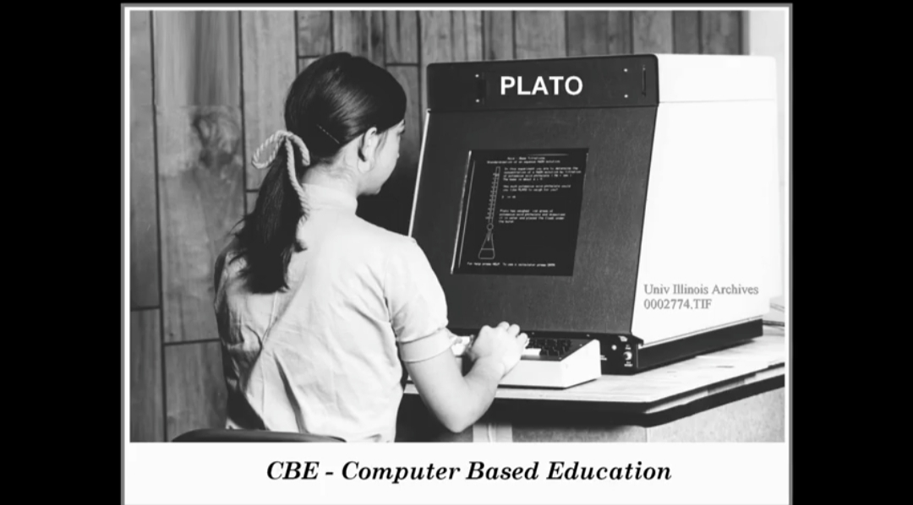

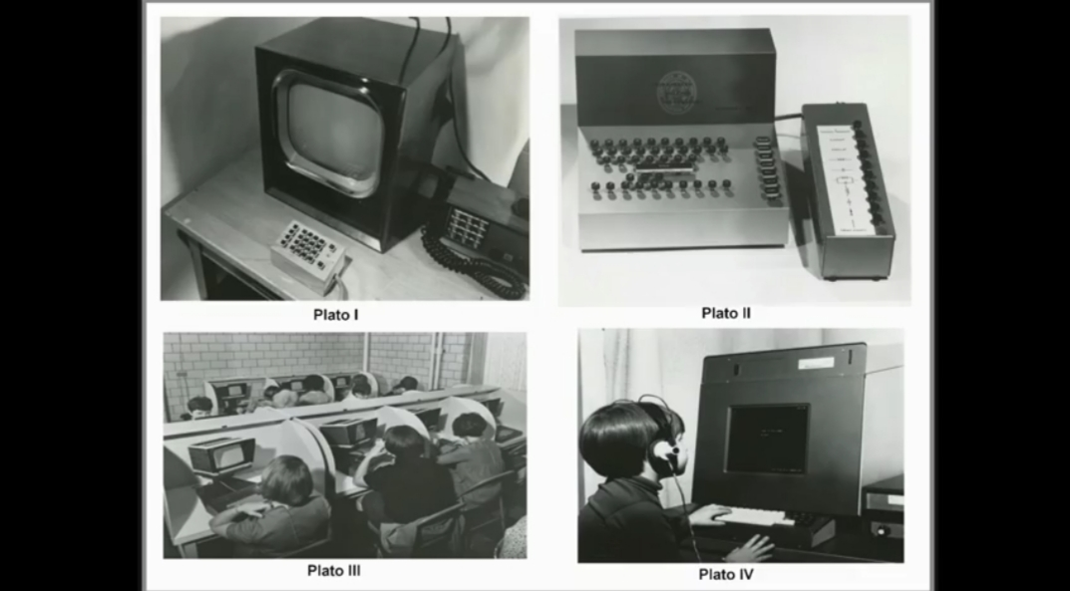

education. TICCIT was launched in the early 1970’s, it utilized the minicomputers as the engines for learning environments instead of the mainframes used for the PLATO project (Hagler and Marcy, 1999). TICCIT is thought to be the first computer system that integrated text, audio and video multimedia, but with remarkable difficulties in usage (Le Baron-Earle, 2013 p. 51)

 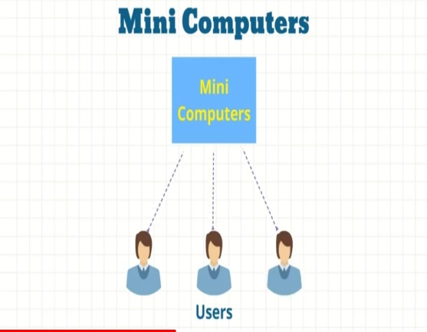

However, these programs were linear i.e. they required learners to follow the same steps with rewards for correct answers, then, advancement to more difficult level. The tasks were typical to those in traditional textbooks, in other words, they did not profit from the features of the computer. Besides, other major weaknesses that were noticed within this phase were the lack of embodiment or contextualizing the language learnt, the absence of the teacher, together with a failure in fulfilling learners’ needs including speaking and listening (Jordan et.al. 2008 p. 228; LeBaron-Earle, 2013).

* 1. **The Communicative Era**

With the advent of the communicative approach, the focus shifted to be put on meaning, on the communicative competence and on the four skills. Therefore, the role and the use of computers changed from a tool for individual learning (or a tutor) to a tool that facilitates interaction (Brett & Gonzàlez-LLoret, 2009), although learners did not interact with other humans but with characters.

In the 1980s, the focus was on developing the communicative competence and cultural awareness, and thus, teaching the target language through interaction was the guiding principle. However, albeit the teaching material was carefully selected (e.g., maps, newspapers) to be authentic, the learning contexts and the human characters with whom learners interact were not authentic. At this period, the computer was used as a ‘tool’ or ‘medium’ for interaction, and it did not aim at replacing the teachers, but at assisting their work (LeBaron-Earle, 2013).

Three main projects can be listed to illustrate this phase: the Athena Language Learning Project (ALLP), the Computer-assisted Multimedia Interactive Language Learning Environment (CAMILLE) Project, and the Minitel Project. First, the ALLP was the result of a collaboration between the Massachusetts Institute of Technology, IBM, and Digital Equipment Corporation to produce learning prototypes for learners of French, German, Spanish, Russian, English, and Japanese. Through these programs, learners could interact with real life characters through videos (simulation), immersed in real life tasks (such as job interviews and searching for an apartment), and provided with authentic materials (such as maps, newspapers ads, location photos…). Second, the CAMILLE Project provided various tools for learners including a textbook of learning activities, a grammatical aid, a dictionary with recordings of a native speaker pronouncing the words, audio and video files and a book on the target culture. All of these are at the learners’ disposition on the homepage of the environment. Last, “the Minitel is an online service made accessible through telephone lines provided by *Poste, Téléphone et telecommunication (PTT),* the French postal and phone services” (LeBaron-Earle, 2013 p. 54). In 1986, the Minitel was used to link students in France, Italy, and Portugal who were required to write fictitious tales. The use of the Minitel enabled genuine authentic intercultural exchange between learners.

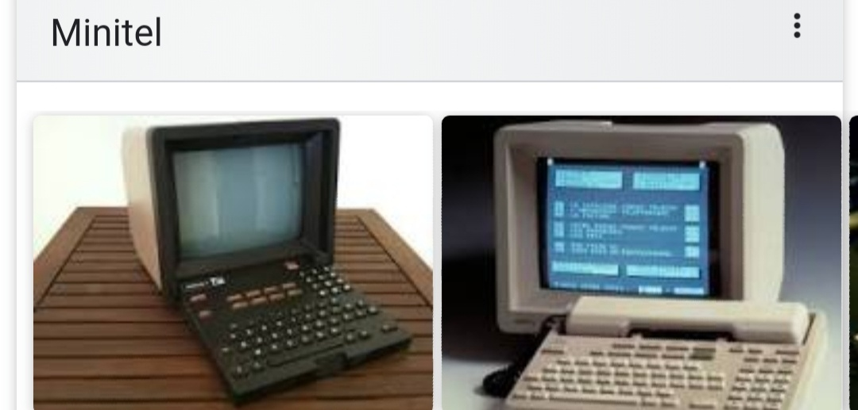

Despite the efforts to provide ‘authentic’ material and real-life situations and characters, the learning contexts and characters were not authentic; they were simulated. Therefore, CALL in this era was beneficial on the linguistic level, but not on the intercultural level. For the use of the Minitel, its use was isolated, limited and unrepeated. Educationists looked for to actual authentic learning contexts rather than artificial communicative learning situations (LeBaron-Earle, 2013).

* 1. **The Integrative Era**

With the integrative phase, “students learn to use a variety of technological tools as an ongoing process of language learning and use, rather than visiting the computer lab on a once-a-week basis for isolated exercises” (Warshauer and Healy, 1998 cite in LeBaron-Earle, 2013 p 55). The fast development of computers and technology together with the emergence of the Internet, in the 1990s, aided the educationalists’ claims for more authentic situations and social learning. The latter was reflected in Computer Mediated Communication (CMC) through which communication takes place between learners and teachers with the help of computers and the Internet (LeBaron-Earle, 2013).

Jordan et.al (2008, p. 228) echoed this view stating that “the computer now operates as a communication device rather than a teaching machine. This compromise addresses the problem of embodiment and materials”. In other words, through facilitating face-to-face interaction between human beings, the need for authentic and highly prescriptive teaching materials, together with the search for the most appropriate method to implement are already addressed problems.

Recently, technology has been much more integrated in the teaching/ learning process, albeit those technologies were not invented to support leaning (e.g., e-mail). The International E-mail Tandem Network or *eTandem* launched by Helmut Brammerts in 1993 exemplifies learning in the integrative phase. Two language learners who want to learn the language of each other use e-mails to exchange written content and attached multimedia files. The *Cultura Project* is another major contribution that can be used for illustration. It was a collaboration between the Massachusetts Institute of Technology and l’Institut National des Télécommunications in 1999 which aimed at developing learners’ intercultural communicative competence. It followed a blended learning approach i.e., learners discussions were carried out online via forums and then in the classroom.

The use of various web 2.0 services, including online games and social media (MySpace, Facebook, YouTube…), has become a part of social media assisted language learning (SMALL). Besides, the integrative CALL period is characterized by the use of telecollaborative projects in language teaching/ learning. Telecollaborative pedagogy is characterized by the use of internet communication tools to bring together geographically distant groups of language learners and teachers in institutionalized settings for the sake of developing their foreign language skills and intercultural competence through social interaction, telecollaborative tasks, and project work (Belz, 2007, O’D’owd, 2013). This kind of pedagogy “is commonly characterised as ethnographic, dialogic and critical” (Belz, 2007 p.138). It takes place “under the careful guidance of languacultural experts” (ibid, p.158) i.e., under the supervision of teachers. Telecollaborative learning became one of the main pillars of CALL (O’Dowd, 2011).

**4.** **CALL Characteristics and Benefits**

**4.1. CALL Characteristics**

The computer has special features that give CALL the potential to be different from traditional classes. These features include: hypertext, hypermedia, and multimedia.

**a/ Hypertext;** it is defined as

link among textual items, often indicated on a computer or website by key words set in underlined blue type, that, when highlighted by a pointer device (e.g., mouse, trackball, finger on a touch-sensitive screen) and selected on clicked, take the reader to the referent. (Beatty, 2010. p.42).

These links are referred to also as hotlinks or hyperlinks. They support the original text with extra information and details that appear in a new page or box or text. These explanations are traditionally provided through footnotes and annotations, but hypertexts include much more details, and they are subject to the reader’s rearrangement and reordering. i.e. unlike reading in a linear manner, that is the case of books, reading is effortless in the case of using hypertexts. (Beatty, 2010).

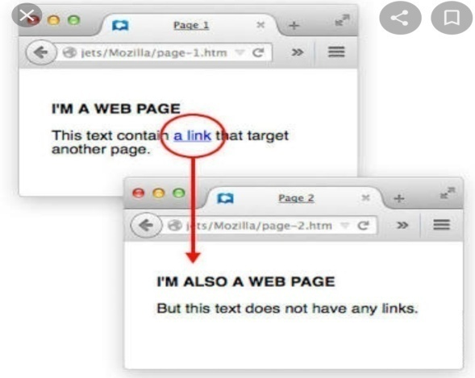 

 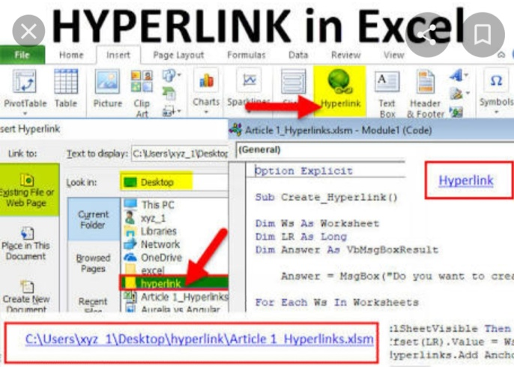

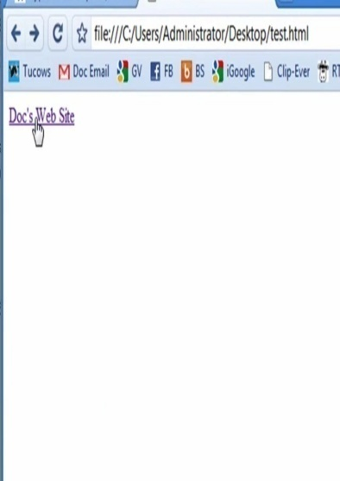 

**b/ Hypermedia;** it refers also to links that could be clicked to support the text by various media such as sound, images, animation and/or video. This media may provide associated pronunciation of words, explanation, clarification… (Beatty, 2010).

**c/ Multimedia;** multimedia refers to the use of several media types including text, images, sounds, videos or animations. It differs from hypermedia that offers only two types of media (e.g text + sound/ text+ image). Thompson et. al (1992) posited that hypermedia has a pedagogical perspective while multimedia is a mode of presentation (cited in Beatty, 2010).

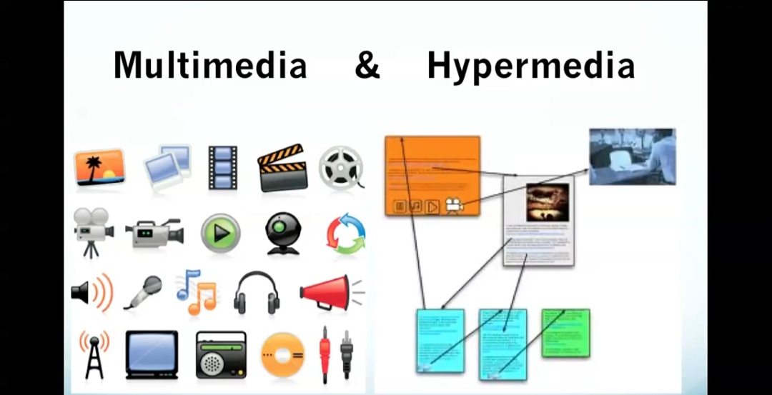

The use of hypertext, hypermedia and multimedia in CALL helps learners overcome the limitations of the printed book, mainly the mismatched between learners’ needs and the organisation of the book (Beatty, 2010). In other words, reading footnotes as soon as they occur in the printed book may distract the learner’s line of thought; they might need to look for an appendix or another book to find further explanation. In the case of footnotes provided in the same page, they generally provide very short explanations that might be of little help for learners. However, a hypertext footnote can be traced backwards and forwards to the referent or reference respectively, as it can be found in several places within the text. Thus, it reduces the need for stating the same information within the text repetitively, and provides extra information whenever learners need it (Beatty, 2010).

Other learners’ needs can be solved through the use of hyperlinks in different ways, for instance:

hypertext underlined blue mark-up hyperlinks that might connect a word to not just its dictionary definition, but also synonyms and antonyms. But, in other cases, such as a misspelling, the hypertext function is buried within a program. If, for example, a learner misspells phone as *\*fone*, a computerized word-processing software program’s spelling checker, such as that in *Microsoft Word*, underscores the word in red jagged line and offers possible correct spellings such as *fine, foe, phone, fond, fore* and *font*. Five of these words (fine, foe, fond, fore and font) have been pre-selected based on the likelihood of the learner making a typing mistake and, looking through a traditional paper dictionary, one might indeed find the latter three variations. However, for *phone*, the learner would never find the correct spelling in the *f* section of the dictionary.

In other cases, such integrated hypertext systems are also used for checking grammar, for example suggesting an additional *s* to complete subject–verb agreement or to change a clause from the passive to the active tense (Beatty, 2010 p.53).

**4.2. CALL Benefits**

The main benefits that can be discussed in relation to CALL are responding to variant learning styles, fostering deep learning/critical thinking, increasing motivation, fostering learner-centered pedagogy, and fostering learner autonomy.

**a/ Responding to Variant Learning Styles**

Learning styles are specific ways that learners use to accomplish different tasks (Dörnyei, 2005), they determine how and to what extent learners can learn a new language and they are consistent across tasks. Learners have different learning styles; they can be for example global, analytic, auditory or visual (Oxford, 2005). CALL respond to those different needs and styles with the use of different types of materials and varied resources.

**b/ Fostering Deep Learning/ Critical Thinking**

Deep learning/ high order learning refers to an educational model that aims at developing learners’ experiences and competences. Deep learners’ characteristics involve linking new acquired concepts and knowledge with prior knowledge and experience instead of considering them separately; developing personal understanding using content examination, argumentation and logic; reflecting on their own learning showing awareness of their progression. In other words, deep learners exclude rote learning, and they are critical thinkers.

Critical thinking or deep learning could be fostered through CALL technologies since they “are very good at storing, manipulating and retrieving large amounts of information” (Warschauer & Healy, 1998 cited in Le Baron-Earle, 2013. p. 63). Besides, the presentation of large amounts of information allows for the establishment of a more rounded thinking that helps learners reflect and develop their own personal understanding instead of following blindly one point of view or perspective. In addition, the communities of practice provided by CALL are fertile environment where meaning negociation can take place, and through which metacognition and critical thinking could be promoted.

**c/ Increasing Motivation**

Various researchers reported that online discussions increase learners’ participation, and proved to be more balanced than face-to-face discussions; shy and silent students participate more in online discussions, they gain confidence since they do not have to reveal their real identity. The collaborative nature of the online discussions motivates the learners to work with their peers in an equal manner and with a shadowy presence of the teacher. (Le Baron-Earle, 2013).

**d/ Fostering Learner Centered Pedagogy**

CALL applications foster student- centered pedagogy. The latter necessitate the engagement of learners in setting their learning objectives, the methods, the content, and evaluation. Learners are active participants in the process of language learning not passive recipients. Learners who can ca appropriately use multimedia links to explore explanations and peripheral information can somewhat lower the teacher-centredness of the classroom. Besides, a well-formed multimedia database of materials can also assist those young and second language learners who lack dictionary and library search skills.

**e/ Fostering Learner Autonomy**

Motivation and autonomy are closely related, as it is not clear which results or leads to the other. “Autonomous language learners are by definition motivated learners” (Ushioda, 1996 cited in Le Baron-Earle 2013. p.84). Furthermore, autonomy is the logical result of learner-centered pedagogy. Autonomy in EFT/L is “the ability to take charge of one’s learning” (Holec, 1981 cited in Le Baron-Earle 2013. p.84). Nowadays, autonomy can be applied in different instructional contexts:

* Self-access centers
* CALL technologies
* Distance learning
* Tandem learning
* Study abroad
* Self-instruction

Three main aspects of CALL have been identified to foster autonomous learning:

**1/ Physical Flexibility;** CALL applications enable learners to study in multiple environments; in class, at home, in the library…

**2/ Adjustable pace of learning;** learners are given the opportunity to study at their own pace and proficiency.

**3/ Learner control over interaction and content;** integrative CALL gave learners the opportunity to gain control over the selection of the materials, the access, the learning content and interaction.

* 1. **Limitations of CALL**

Despite all the advantages that can be gained from CALL, possible drawbacks can be noticed. Holmberg (2005) summarised some of them as follows:

* The risk of falling behind for learners with low motivation or bad study habits,
* The possibility of getting lost or confused about course activities in the absence of the traditional class,
* The absence of the instructor when learners need help,
* The access to course materials may be frustrating because of slow internet connection or old computers,
* The complexity of managing computer files and online learning software for students with beginner-level computer skills,
* The difficulty to stimulate hands-on or lab work in a virtual classroom,
* The feeling of being isolated from instructors and classmates.

In addition to these drawbacks, some multimedia distract the learner from the task, they provide inappropriate and unnecessary interruptions, such as flashing screens and senseless noises.

**Practice**

Select a topic of interest, then, develop related ideas in an extended essay using different hypertexts, hypermedia and multimedia.

**5.CALL Research: Trends and Issues**

* 1. **Early Research and Interests**

The focus of CALL research is changing quickly because of the everyday new technologies introduced to the world. This rapid change has influenced SLA theory, practice and research. Examples of studies that represent declining interests are those that query

* The need of computers in the classroom,
* The comparison between CALL and traditional learning in terms of effectiveness, and
* Students’ ability to access technology.

In other words, the foci of many early studies were on quantitative and qualitative justifications of CALL. In these studies, the aim was to test the computer effectiveness in teaching a discrete set of knowledge in comparison with a traditional class that represents the control group. This kind of research is irrelevant these days since the learners’ and teachers’ technology literacy is undebatable, as it is the computers’ appropriateness for accommodating different learning styles. This kind of research is no longer frequent since the use of computers in classrooms has been perceived as complementary to classroom teaching.

* 1. **Recent Research and Interests**

Research instead shifted to other areas. It is directed into how computers should be best used and for what purposes. The computer is not only a subject of research, but it became an important tool to conduct research with a range of possible uses including presenting and analyzing statistical data, collecting data (creating and distributing surveys), and providing feedback (e.g., research aimed to investigate how and when students decided to accept offered grammar corrections) (Beatty, 2010).

The pace of change in computer technology has led to an extensive duplication of efforts to report the research and make it reach its intended audience before it became out of data or before other improvements in the technology used would appear. This duplication of research is affected also by the modern extensive use of personal computers which necessitates searching learners’ use of technology outside class and how they transfer the skills acquired into their learning. For example, the use of electronic games would lead researchers to ask the following questions:

* What kind of language skills learners acquire to play a particular game?
* Do they transfer these skills to their learning atmospheres?
* Do these games make learners’ less tolerant of educational applications that do not match the computer’s game’s existing presentation of information?
* Do they acquire in these virtual environments, the necessary social competencies needed for real communication?
* Are these environments safe for them?

The inclusion of computer entertainment applications (like games) in education became known as *edutainment*. In most cases, the educational objectives are disguised under game objectives (Beatty, 2010).

Reviewing studies recently published in journals, it has been noticed that they varied in interest. Some of them focused on the different language skills: listening, speaking, writing and reading, vocabulary, grammar, and translation. Writing has gained much of the CALL research regarding its productivity nature; it is easy to report their output on a computer. Speaking is measured through the use of software programs. The latter ask learners to repeat words and sentences to be measured against model pronunciation in a graphic way. However, the quality of the recording material, the background noise, and the specification of speech points that should be modified remained major shortcomings of these software programs. Listening and reading are dealt with through measuring comprehension. However, CALL instruction could promote these four skills through providing platforms for collaboration and cooperation which allow interaction with other users of the language.

Grammar checkers are commonly used in CALL to verify grammar acquisition. However, their evaluation revealed their inadequacy or indifference from other traditional tools used in the classroom. Translation in CALL is referred to as machine translation (MT) programs. The latter were criticized for their inadequacy to deal with natural languages. In other words, they offer low-quality translations; long passages often result in senseless text.

Most of CALL studies addressed issues of developing or creating learning materials, followed by others that dealt with evaluating, but none took the risk of predicting the future of CALL. Recent research shifted to deal more with Internet-based tools or platforms as forums, blogs… rather than CDROMs, DVDs… Emphasis today is shifting to blended learning, online applications, social networking sites and other tools that facilitate communication and language acquisition, besides interest in establishing CALL principles (as the focus on content rather than technology), Models [e.g. that of Gruba, 2006 called End-user development (EUD)], teachers’ and students’ attitudes towards CALL instruction and the extent to which these attitudes are reflected in their learning/ teaching process. The subjects with whom much of CALL research was conducted are university students because university teachers conduct research as part of their academic work (Beatty, 2010).

With the evolution of social media which can be defined to

involve the messy, unpredictable use of human language for motivated, authentic purposes, a phenomenon that does not lend itself to laboratory controls. Social media involve evolving forms of human interaction, forms of interaction that require new approaches to understanding language learning and teaching along with research perspectives, approaches and techniques that serve in building such understanding.

(Mestill and Quah, 2013. p.41).

CALL research turned to focus on three main trends: focus on the online environment, focus on the socio/affective outcomes, and focus on pedagogy.

**a/ The online environment;** research within this trend focus on the online environment. i.e. on the different online tools and platforms such as Wiki, Blogs… in an attempt to find out what the design of these online tools afford for language learning and teaching, and how it affects language/ culture learning of those who take part in the online communicative exchanges. Social spaces, unlike traditional CALL, afford interactive possibilities that are social, authentic and complex.

**b/ The socio-affective dimensions;** this category of research concentrates on learners’ reactions and reflections in terms of community building, learner L2 identity construction, learner confidence…

**c/ Pedagogical processes;** the concerns of language education researchers broadened with the vast evolvement of online communication tools and practices. They moved to focus on blended and online learning perceiving synchronous and asynchronous interaction and communication as valuable and authentic. However, because social media are relatively new, research within this trend centered around publishing attempts of integrating different social media tools into classroom pedagogy. Researchers focus on pedagogical strategies, task design, teacher guidance and practices, curricular coherence, and learner training that allow for a successful integration of a particular social media tool, generally, and the online telecollaboration, particularly (Mestill and Quah, 2013).

Telecollaboration or Online intercultural exchange can take place between classes learning the languages of each other, or between two or more classes using a lingua franca (O’Dowd, 2011; Guth et. al. 2012). O’Dowd (2016) claimed that there is a consensus among researchers in the field that telecollaboration should be integrated into classroom context to include learners’ reflection and interpretation together with teacher’s support and guidance. Hence, although initial projects of telecollaboration were additional activities to which learners’ may not give enough attention and importance, “most telecollaborative activity in recent years has taken a blended approach where learners’ online interactions and their reactions to this interaction has been discussed, analyzed and framed with the help of a languacultural expert (i.e., their teacher)” (O’Dowd, 2016 p.07).

**Practice**

**01/** Consider the following research topics, discuss their suitability in relation to your context; are they good researchable topics?

* Comparing CALL and traditional classes in relation to grammar teaching.
* Investigating the role of MALL in increasing learners’ self-confidence.
* Teachers’ and learners’ attitudes towards the use of Internet in EFL classes.
* Teachers’ and learners’ attitudes towards the use of Social Media for educational purposes.

**02/** Relevant to CALL, suggest some research topics that you find interesting.

1. **CALL and Second Language Classroom Research**
   1. **Conducting CALL Research**

CALL research can be conducted using multiple ways and tools of research, as researchers may follow a primary or secondary research. In primary research, the researcher relies on first hand collected data. In secondary research, the researcher relies on second hand data, or data collected in other studies such as to summarize the findings of some studies related to a particular subject or interest. Within the confines of primary research, various tools can be used: case study, action research, and statistical approaches.

**a/ The Case Study;** a type of research design and analysis that is very familiar in education. It is “the in-depth study of instances of a phenomenon in its natural context and from the perspective of the participants involved in the phenomenon” (Gell et.al. 2003 cited in Duff, 2008. P.22). Case studies allow for generalization, as they can be a sub-set of a broader action research (Blaxter, Hughes & Tight, 2006).

**b/ Action Research;** it is “the systematic collection and analysis of data relating to the improvement of some aspects of professional practice” (Wallace, 1998. P.01). Researchers are involved in the study with the aim of improving the participants’ practice through planning, acting, observing, evaluating and reflecting, and providing feedback.

**c/ Statistical Approaches;** they are divided into survey approaches and experimental approaches.

-Experiments; is a study in which the independent variable (or the experimental group) is carefully manipulated by the researcher to be compared with a control group which is not exposed to any intervention. The experimental and the control group should be identical to avoid any research bias or occurrence of extraneous variables (Blaxter, Hughes & Tight,2006).

- Survey approaches; “surveys involve systematic observation, or systematic interviewing. They ask the questions which the researcher wants to be answered, and often they dictate the range of answers that may be given” (Blaxter, Hughes & Tight, 2006 p. 76). Surveys collect the same information through asking the same exact questions to the sample. They are easy to administer, easily repeated in the future for comparison reasons, they provide huge data quickly, and results that can be generalized. They may include questionnaires, interviews, focus groups…

Research methods that could be used, or which are common in CALL research, especially after the emergence of social media are:

* The focus groups.
* Video records of face to face learner collaboration.
* Learner self-reports.
* Written transcripts of collaborative work (or conversation/ discourse/ interaction analysis).
* Classroom video recordings.
* Written teacher-reflections.

However, recent research has moved towards the use of mixed methods to collect more reliable data. Triangulation is highly recommended; it refers to the use of two or more research tools to collect data. In other words, in a research, conversation analysis can be accompanied by a questionnaire or interview or focus groups to carefully describe a case study.

* 1. **The Computer as a Research Tool**

The computer is no longer a subject of research only; it is nowadays an important tool of research that can be very beneficial in a variety of ways.

1. *To construct surveys*; programs, such as *Survey Monkey (*[*www.surveymonkey.com*](http://www.surveymonkey.com)*),* help novice researchers to design professional-like surveys at a minimal cost (Beatty, 2010 p.190).
2. *To collect data*; online texts, chat and other stored documents can provide a rich source for corpora. Besides, the computer together with the Internet make it easier these days to distribute surveys (using either websites or social networking sites) and collect data from a large audience in a short time.
3. *To manipulate statistical data*; programs such as *Le Sphinx* and the *SPSS(Statistical Package for the Social Sciences)* can be used to easily organize, to calculate ( the mean, the medium, correlations…), to tabulate, and to present data. Moreover, nowadays, some online websites such as *the Social Sciences Statistics(http:wwww.socscistatistics.com)* provide these services for researchers.
4. *To find telecollaborative partners;* in case teachers /researchers want to design a talacollaborative project, they may use platforms such as [www.uni-collaboration.eu](http://www.uni-collaboration.eu),

Google +, or even some Facebook groups such as IATEFL group.

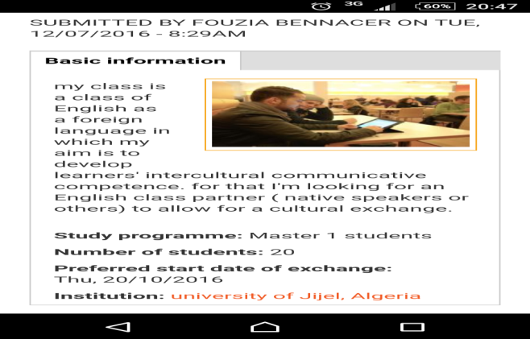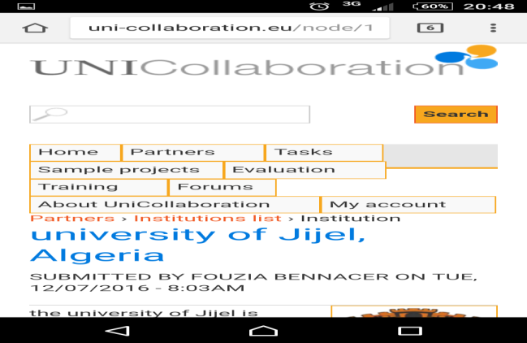

**Practice** (adapted from Dawson, 2016 pp. 907-908)

Consider each of the online tools listed below and choose three of them to find three sources that are relevant to your research topic/ methodology. Cite the sources and Analyse each of the online tools used and provide a short review and critique.

**Online journal databases**. Journal abstracts and full–length articles Together with related works, citations, authors and publications can be found using keywords that match a particular research topic and methodology. Google Scholar (<http://scholar.google.com>) is a familiar Online journal database.

**Online repositories.** Academic papers, peer-reviewed articles, monograghs and book chapters can be freely downloaded. Social science documents can be found on the Social Science Research Network ([www.ssrn.com](http://www.ssrn.com)). Details about repositories are available on The Registry of Open Access Repositories (<http://roar.eprints.org>)

**Datasets.** They provide tabulated data published by a single source, and made free for access and use. ([www.esrc.ac.uk](http://www.esrc.ac.uk)) can be mentioned for illustration.

**Academic blogs.** They offer trustworthy information and opinions for students and researchers.

**Podcasts.** They present academic digital media files (audio or video), mainly in the form of series, they can alert researchers to current thinking in different research fields.

**Newspaper databases.** These are useful sources of up-to-date information about events and issues, the British Newspaper Archive is a Newspaper database that contains over 200 newspapers from the UK and Ireland.

**Image Databases.** Digital images may help students get new insights and be creative.

1. **The Implementation of CALL**
   1. **Pedagogical Concerns for Classroom Practice**

The use of computers as alternatives of teachers was heavily criticized, therefore, the computer has become to be seen as a complementary tool in the classroom that needs human intervention if the aim is an efficient and effective language teaching/ learning. Both teachers and learners should keep in mind the following considerations while being involved in CALL:

**a) Software Objectives**; to find out which skills each software package aims to develop is an important task for both teachers and learners. Therefore, teachers should, as a starting point, discuss with learners their needs and preferences to be able to decide about the kinds of CALL software programs to be included in the classroom. Sharing the decision-making process with learners allows them to organize their own learning, and helps in establishing an effective CALL environment. The latter necessitates different interfaces to suit different learning styles and the requirements of different skills.

**b) Making better Use of Existing Material;** learners’ and teachers’ discussions should not be limited to assessing the needs and setting the objectives, however, reflection on the effectiveness of the CALL program or online resource used is of salient importance. When a CALL program is not suitable, teachers and learners need to examine ways for adaptation and improvement. This feedback could be of major significance for other users of the material together with the material designers.

**c) Establishing an environment where CALL may take place;** CALL activities have a social and interactive nature. Henceforth, flexible learning environment is necessary for collaboration on the computer to take place. In other words, learners’ use of the computer should not be restricted by time and space, as the environment should not be unwelcoming to collaboration (Beatty, 2010).

**7.2. Material Selection and Use**

CALL or CBI (computer-based instruction) refers simply to the use of computers in different manners to facilitate the process of teaching and learning. Designing computer-based instruction is referred to as ‘instructional design’ (ID) (Jordan et.al. 2008, p. 229). In order for the latter to satisfy the needs and objectives of the competency-based learning, the material selected should be

* designed to meet a specific audience with specific learning needs;
* adaptable to different learning styles;
* broken down into discrete modular components;
* ‘chunked’ into discrete sub-sections to suit short-term memory;
* structured and organized to meet specific learning outcomes;
* enriched with hypermedia (sound and pictures) to assist dual coding;
* hyperlinked extensively to allow self-directed exploratory learning;
* sequenced appropriately;
* supported by formative assessment for feedback and for self-regulated learning.

(Jordan et.al. 2008, p. 230)

Besides material selection, Collins (1991) described pedagogical practices and shifts that characterize CALL and differentiate it from traditional learning as follows:

• a shift from whole class to small-group instruction,

• a shift from lecture and recitation to coaching,

• a shift from working with better students to working with weaker ones,

• a shift toward more engaged students,

• a shift from assessment based on test performance to assessment based on products, progress, and effort,

• a shift from a competitive to a co-operative work structure

• a shift from all students learning the same things to different students learning different things

• a shift from the primacy of verbal thinking to the integration of visual and verbal thinking

(Collins, 1991 cited in Beatty 2010 p. 201)

The integration of technology alone does not produce the promising results; it depends on how this technology is integrated and its relationship and suitability to the pedagogy. The technology selected must be easy to access and use without much training so that the focus of both learners and teachers is on the learning process, not on the technology. As the choice of technology tools needs to be evaluated, the number of technologies used should be also carefully decided about to avoid increasing workloads for staff and students unnecessarily. Ultimately, the extent of student engagement in the learning process will not be affected by the instruction or the technology; instead, it will depend on individual learner differences and motivation (Corder &U-Mackey, 2011).

* 1. **Designing a Telecollaborative Project**

In the age of Social Media, telecollaborative projects are common. The design of telecollaborative learning includes finding out partners, the selection of the tool, and the design of the tasks. Finding out collaborating partners may take place through personal communication, or through some online platforms such as google (+), [www.uni-collaboration.eu](http://www.uni-collaboration.eu) (O’Dowd, 2015, Edelstein, 2015).

The chosen tool should be selected in a way that suits learners’ and teachers’ learning process, not the opposite, because “new technologies and telecollaboration is not a cure –all, nor can telecollaboration be perceived as a one-size-fits all effort” (Dooly, 2007 p. 214). To decide about a tool the teacher should decide about the possible way of delivery (synchronous or asynchronous) in the institution that suits learners’ levels and interest.

Although the selection of the tool is of paramount importance, the benefits gained from telecollaboration depend more on the extent to which the designed tasks are suitable (Dooly, 2007). In telecollaboration, a combination of the task type is beneficial but necessitates a careful sequencing. O’Dowd & Waire (2009) argued for three stages/phases. The first is introductory in which learners represent themselves and cultures to get familiar with the partner. The second phase is comparative in the sense that learners are required to establish similarities and differences between the native and the target culture. The final phase, the production of a piece of work requires learners to negotiate meaning and to reflect critically.

* 1. **The Role of Teachers and Learners** 
     1. **The Role of Teachers**

The role of teachers changed overtime. In traditional classes, the teacher was considered to be the holder of knowledge who transmits it to the students to return it back in the exam paper. The teacher at that era played the role of “a sage on the stage” Although in CALL some researchers claimed for teachers to be “Ghosts in the wings” (their role is minimal and associated with ignorance), the teacher is more considered to be a facilitator, his role changed to “a guide on the side” i.e. s/he is no more the only source of knowledge; the latter could be gained from a variety of sources, but s/he needs to be flexible and adapts to learners’ needs (Le Baron-Earle, 2013).

Although the teachers’ role was primarily underestimated because of the focus on learners’ autonomy using the new media, it has recently gained much attention and focus. This view is supported by Müller-Hartmann (2007 p. 168) who stated that

the new technology did not replace the teacher, but put him in the midst of designing the new living environment, allowing him to develop professionally, conjointly with his partner teacher(s) abroad, in the process of these intercultural projects

Because of the continuously emerging and developing ICTs, and because the use of technology in education cannot be effective unless teachers are aware of their new roles (Kramsch, 1993), teachers are required to develop some skills. The latter are manifested in four main models as shown in the following table:

*Table 07. Models of ICT competence for teachers (O’Dowd, 2013 p.05)*

|  |  |  |  |
| --- | --- | --- | --- |
| Skills pyramid for successful online FL teaching Hempel and Stickler (2005) | Technology standards performance indicators for teachers ISTE (2008) | ICT competency standards for teachers UNISCO (2008) | E-moderator competencies (2003) |
| - basic ICT competence  - tech competence with software  - dealing with constraints of the medium  - online socialization  - facilitating communicative competence  - creativity and choice  - own style | - facilitating and inspiring student learning  - designing digital-age learning experiences and assessments  - model digital-age work and learning  - promote digital citizenship and responsibility  - engage in professional growth and leadership | - educational policy  - curriculum and assessment  -pedagogy  - ICT (technical) competence  - organization and administration  - teacher professional development | - understanding of online processes  - technical skills  - online communication skills  - content expertise  - personal characteristics |

In addition to these ICT skills, O’Dowd (2013) claimed that telecollaborative teachers should 1) aim at developing ICC, 2) be themselves interculturally competent to be able to collaborate with other teachers within the project, and 3) relate telecollaborative tasks to those tackled in class during a long-term period. He posited a model of telecollaborative teachers’ competences that contains four sections: organizational, pedagogical, digital competences and attitudes and beliefs, with a total of 40 descriptors. To develop these competencies, O’Dowd (2015) valued sociocultural approaches to FL teacher education where emphasis is put on the relation between training periods at university and realities of language classrooms.

Nevertheless, teachers may be afraid of their new roles in telecollaboration because of the pitfalls of technology, changing the role they have accustomed to, and not being able to control their learners online (Müller-Hartmann, 2007). However, teachers’ role does not require them to control their learners, and their active participation within online interaction is not necessary. Hence, their role encompasses the organization of the exchange (selecting the partners, the tool and preparing learners), developing, sequencing and implementing real-world tasks that are meaningful (following a task-based approach), setting objectives and time constraints, and evaluating the learning outcome (O’Dowd, 2013; Müller-Hartman, 2007; O’Dowd, 2015).

In preparing learners, teachers should make sure that learners are not frustrated by the use of a particular ICT tool (Dooly, 2007). ‘Electronic literacies’ i.e., skills related to computer use, connectively and knowledge about online behavior should be considered to guarantee learners’ benefit from online language learning (O’Dowd, 2007). Besides, learners should be sensitized towards differences that may occur in their online interactions and may lead to misunderstanding and stereotypes (O’Dowd, 2015).

Kiddle (2013) reported that although it has been claimed long ago that “technology will not replace teachers, but teachers who use technology will replace those who don’t” (p. 190), teachers still resist the use of technology for a variety of reasons. The latter may include:

* Extent of the curriculum that needs to be covered during the year,
* Time constraints,
* Time required for preparing ICT-based activities,
* Availability of infrastructure,
* Amount of quality content,
* Lack of in-classroom teacher support,
* Lack of participation of teachers in decision-making,
* Need for professional development, besides
* Difficulty to keeping pace with the rapid proliferation of information, software tools, and devices (p. 191).
  + 1. **The Role of the Learner**

In CALL and the era of Social Media, learners are claimed to have four main roles: “active participants”, “researchers”, “ethnographers”, and “authors”.

Learners’ role shifted from passive recipients of the information given by their teacher, to active participants who are responsible for their own learning; they work independently and collaboratively with peers, teachers and other users of the language around the world, they interact with other to create and negotiate meaning. They can search for information in different sources, collect it and compare it to construct meaning and generate a rounded understanding. As ethnographers, learners observe human interactions, and collect information about the human behaviour, cultural artifacts and attitudes. Then, they reflect on these experiences and note them. The availability of journals, forums, blogs… has given learners the opportunity to act as authors; they can write about their interaction and learning experiences and share them with others (Le Baron-Earle, 2013).

* 1. **Computer-Assisted Language Testing**

CALL technologies could be used for learning and teaching as it could be used for testing. The benefits that could be derived from Computer-adaptive language testing CALT are: shorter tests; examinee self-pacing; test individualization to examinees’ ability levels; enhanced test security; faster scoring and feedback; greater measurement precision; and use of multimedia (Corder &U-Mackey, 2011).

In the past, four issues were addressed in relation to CALL testing: item banking, using the new technologies, computer-adaptive language testing and the effectiveness of computers in language testing. Most of that research was practical in nature. Recently, researches on computer-based language testing (CBLT) has focused on the following topics: overviews of the CBLT literature itself, CBLT delivery issues (including computer-adaptive language testing, computer vs traditional testing formats, Web-based language testing, interface architecture, the test takers’ experience with CBLT and CBLT training for teachers), CBLT content (including computer assessment of vocabulary, computer assessment of speaking or oral skills, computer assessment of writing, computer assessment of listening and reading), example CBLTs and CBLT tools/resources. CBLT is not a new area of research, but it is growing and generating a good deal of excitement within language testing (Brown, 2013).

1. **Evaluation of CALL**
   1. **Principles for CALL Evaluation**

To evaluate CALL, many guidelines, checklists, and evaluation rubrics for CALL materials have been developed as a means of setting some criteria to determine good CALL. For an effective evaluation of CALL, the evaluation principles are further explicated in the following table:

*Table. Summary of principles for evaluating CALL (cited in Chappelle, 2001 p. 52)*

|  |  |
| --- | --- |
| Principle | Implication |
| Evaluation of CALL is a situation specific argument.  CALL should be evaluated through two  perspectives: judgemental analysis of software and planned tasks, and empirical analysis of learners' performance.  Criteria for CALL task quality should come from theory and research on instructed SLA.  Criteria should be applied in view of the purpose of the task.  Language learning potential should be the central criterion in evaluation of CALL. | CALL developers need to be familiar with criteria for evaluation which should be applied relative to a particular context.  Methodologies for both types of analyses are needed.  CALL evaluators need to keep up with  and make links to research on instructed SLA.  CALL tasks should have a clearly articulated purpose.  Language learning should be one aspect of the purpose of CALL tasks. |

The table presents five main principles for CALL evaluation. First, the evaluation should result in an argument that addresses the appropriateness of a particular CALL task for particular learners at a particular time. Second, the evaluation argument should be built on the basis of both the judgemental and empirical analyses. The former should examine the characteristics of the software and tasks using theory-supported criteria, while the latter uses the same criteria to analyse empirically gathered data that reflect learners’ use of CALL and learning outcome. Third, the evaluation criteria should be based on SLA theory findings, the way of application of such criteria should be clarified, and the criteria should be applied to both the software and the teachers’ and learners’ tasks. Fourth, the task should have a clearly stated purpose, although the task may have different purposes throughout the instruction. The last principle emphasizes the significance of ‘language learning potential’ and considers it to be the most important among the others.

* 1. **Evaluation Components**

The evaluation of CALL software and tasks should be twofold: judgemental and empirical. While judgemental evaluation “offers a methodology for making systematic hypotheses about the benefits to be attained through CALL tasks” (Chappelle, 2001 p. 66), empirical evaluation provides data and evidence to support these hypotheses.

* + 1. **Judgemental Evaluation of CALL**

The judgemental analysis is intended to assess the appropriateness of a task – be it defined by the software or designed by the teacher- for particular learners at a particular point in time.

**Criteria for CALL Task Appropriateness**

Based on SLA theory, some criteria can be put to guide the evaluation of CALL. These criteria are briefly summarized in the following table.

*Table: Criteria for CALL Task Appropriateness* (chappelle, 2001 p 55)

|  |
| --- |
| **Language learning** The degree of opportunity present for beneficial focus on form.  **potential**  **Learner fit** The amount of opportunity for engagement with language  under appropriate conditions given learner characteristics.  **Meaning focus** The extent to which learners' attention is directed toward the  meaning of the language.  **Authenticity**  The degree of correspondence between the CALL activity and target  language activities of interest to learners out of the classroom.  **Positive impact** The positive effects of the CALL activity on those who participate in it**.**  **Practicality** The adequacy of resources to support the use of the CALL activity. |

The first criterion ‘*language learning potential’* refers to the extent to which a CALL task is a language learning activity not only an opportunity for language use. In this sense, the task should boost beneficial *focus on form* through encompassing characteristics such as “interactional modification, modification of output, time pressure, modality, support, surprise, control, and stakes” outlined by Skehan (Chappelle, 2001 p. 55).

The second criterion ‘*learner fit’* refers to the extent to which the CALL task takes into consideration the individual differences in both the non-linguistic characteristics such as age, willingness to communicate, learning preferred style… and the linguistic ability level, i.e., the task should neither be very easy nor very difficult.

The third criterion ‘*meaning focus* refers the extent to which the CALL task directs learners’ attention towards the meaning of the language, and the extent to which they can use the language presented in the task – be it oral or written- to accomplish a particular goal.

The fourth criterion ‘*authenticity’* evaluates the extent to which the CALL task corresponds to those that the learner encounters outside class. The authenticity of tasks increases learners’ interest and motivation to participate.

The fifth criterion ‘*positive impact’* refers to the extent to which the task help learners develop their metacognitive strategies to be able to learn inside class and stretch their knowledge to contexts outside class. The task should aim at developing learners’ pragmatic abilities and intercultural competence to encourage them seek communication opportunities outside class.

The last criterion ‘*practicality’* refers to the possibility and easiness of implementing the task by both teachers and learners in a particular context. As a way of illustration, the availability of CALL material to learners and teachers may affect the instruction’s success or failure.

Besides questioning the sequencing of tasks and the learners’ opportunities to practice, examples of questions that can be used to guide the judgemental evaluation are suggested by Chappelle (2001 p. 59) as shown in the following table.

*Table. Questions for judgemental analysis of CALL appropriateness* (Chappelle (2001 p. 59)

|  |  |
| --- | --- |
| Qualities | Questions |
| **Language learning**  **potential** | Do task conditions present sufficient opportunity for beneficial focus on form? |
| **Learner fit** | Is the difficulty level of the targeted linguistic forms appropriate for the learners to increase their language ability?  Is the task appropriate for learners with the characteristicsof the intended learners? |
| **Meaning focus** | Is learners' attention directed primarily toward the meaning of the language? |
| **Authenticity** | Is there a strong correspondence between the CALL task and second language tasks of interest to learners outside the classroom?  Will learners be able to see the connection between the CALL task and tasks outside the  classroom? |
| **Impact** | Will learners learn more about the target language and about strategies for language learning through the use of the task?  Will instructors observe sound second language pedagogical practices by using the task?  Will both learners and teachers have a positive learning experience with technology through the use of the task? |
| **Practicality** | Are hardware, software, and personnel resources sufficient to allow the CALL task to succeed? |

‘Computer-assisted classroom discussion (CACD)’, ‘a microworld’, ‘text analyses, and are examples of CALL tasks that have been evaluated judgementally.

In the case of *Computer-assisted classroom discussions (CACD),* learners are given a story, for example, beforehand, then, when they come to class, they use computers individually to respond to the instructor’s questions, and to participate in a class discussion each with his/her own pace i.e., learners post their responses to the others when they feel satisfied. Kelm (1992 cited in Chappelle 2001) reported that this task raised the participation of all learners. Evaluating this task Chappelle (2001 p. 60) manifested that:

The fact that the meaning was expressed in written mode would be expected to

provide opportunity for some focus on form, and the real-time interaction might make

modified interaction, and modified output, possible. The language was intended to be

the appropriate difficulty level for the learners because it was centered on the language

of the story that they were reading for their class […] On the other hand, individual

differences may not have been considered as the task is designed to have all learners

playing the same role. The learners would no doubt have seen the task as a classroom

experiment rather than as preparatory for future language use. The task was intended

to be fun and to provide learners with the opportunity to use the target language

without the teacher-frontedness of many classroom activities - a change that was seen

as having a positive impact by the instructor. The activity required a local area

network, synchronous communication software, and a teacher who knew how to use it,

which apparently were all available.

**Instruction for Further Practice**

Using the criteria of the judgemental evaluation, and following the example of the *Computer-assisted classroom discussions (CACD),* given earlier, evaluate the following tasks:

1. The *Microworld* task has been designed for beginners. The latter are asked to imagine that they are living in the year 2101 with a tidy robot which cannot find anything in a messy room and asks the learner about the place of different things. The learner types the answer on the computer.
2. *Text analysis;* Following a process-oriented approach in which learners were required to write a first draft responding to an instruction, participate in peer editing, receive comments from the instructor related to content, organisation and grammatical problems, and revise their drafts on the computer. Then, they can use the grammar checker.
   * 1. **Empirical Evaluation of CALL**

Each of the qualities, mentioned before in the judgemental evaluation, implies particular types of research questions and associated methods. The following table provides sample questions.

*Table. Questions for the empirical evaluation of CALL tasks (Chappelle, 2001 p. 68)*

|  |  |
| --- | --- |
| Qualities | Questions |
| **Language learning**  **potential** | What evidence suggests that the learner has acquired the target forms that were focused on during the CALL task?  What evidence indicates that learners focused on form during the CALL task? |
| **Learner fit** | What evidence suggests that the targeted linguistic forms are at an appropriate level of difficulty for the learners?  What evidence suggests that the task is appropriate to learners' individual characteristics (e.g., age, learning style, computer experience)? |
| **Meaning focus** | What evidence suggests that learners' construction of linguistic meaning aids language learning?  What evidence indicates that learners use the language during the task for constructing and interpreting meaning? |
| **Authenticity** | What evidence suggests that learners' performance in the CALL task corresponds to what one would expect to see outside the CALL task?  What evidence suggests that learners see the connection between the CALL task and tasks outside the classroom? |
| **Impact** | What evidence suggests that learners learn more about the target language and about strategies for language learning through the use of the task?  What evidence suggests that instructors engage in sound second language pedagogical practices by using the task?  What evidence suggests that learners and teachers had a positive experience with technology through the use of the task? |
| **Practicality** | What evidence suggests that hardware, software, and personnel resources prove to be sufficient to allow the CALL task to succeed? |

For the empirical research methods to be used in evaluating L2 classroom tasks, researchers have recently shifted from evaluating language instruction through measurement of learning outcomes to investigating classroom processes. However, no one can deny the significance of the measurement of learners’ performance, and still, “the most convincing way to demonstrate the language learning potential of a CALL activity is through the study of learning outcomes” (Chappelle, 2001p.74), this evidence is more convincing if the experimental design is followed. Further, the evidence can also be strengthened with retention studies that prove positive results shown by learners after a period of time. Learner fit can also be assessed through more systematic research methods including observation of working processes, assessment of learning outcomes, and questioning learners about their opinions.

**References**

Anderson, J. (2005). IT, e-learning and teacher development. In *International Education Journal.5*(5), pp. 1-14. ISSN: 1443-1475. Shannon Research Press.

Bates, A.W. (2005). *Technology, e-learning and distance education (2nd ed).* Routledge Taylor& Francis group. London and New York.

Beatty,K(2010). *Teaching and researching computer assisted language learning (2nd ed.).* Pearson.

Bennacer,F (2019). *Using Telecollaboration through Facebook to Develop the English as a Foreign Language Learners’ Intercultural Communicative Competence.* Unpublished Doctorat thesis. University of Mentouri Brothers, Constantine 1.

Blaxter, L; Hughes, C & Tight, M (2006). *How to Research* (3rd ed). Open University Press.

Brett, D. & Gonzàlez-LLoret. (2009). Technology- enhanced materials. In M.H. Long & C.J. doughty (ed). *The handbook of language teaching.* (pp. 351-369). Wiley-Blackwell.

Brown,J.D. (2013). Research on computers in language testing: Past, present and future. In M.Thomas, H. Reinders and M.Warschauer (ed). *Contemporary Computer-Assisted Language Learning.* Bloomsbury.

Chapelle, C.A. (2001). Computer Applications in Second Language Acquisition: Foundations for Teaching, Testing and Research. Cambridge University Press.

Chapelle, C.A. (2005). Computer-assisted language learning. In E.Hinkel. H*andbook of research in second language teaching and learning* (pp. 743-756)*.* Lawrence Erlbaum Associates publishers. Mahwah, New Jersey, London.

Corder,D. & U-Mackey,A. (2011). Integration of Technology for Effective Learning, Teaching, and Assessment. In M. Levy, F. Blin, C. B. Siskin and O. Takeuchi (eds)*. WorldCALL: International Perspectives on Computer-Assisted Language Learning.* Routledge:Taylor & Francis.

Dawson, C. (2016). *100 Activities for teaching research methodology*. Sage publications Ltd.

Dooly, M. (2007). Choosing the appropriate communication tools for an online exchange. In R.O’Dowd (ed). *Online intercultural exchange: an introduction for foreign language teachers* (pp. 213-234)*.* Multilingual Matters LTD. Clevedon, Buffalo, Toronto.

Dörnyei. Z (2005).  *The psychology of the language learner: Individual differences in second language acquisition*. Lawrence Erlbaum Associates, Inc.

Duff. A. P. (2008). *Case Study Research in Applied Linguistics.* Taylor & Francis Group, LLC.

Edelstein, C.C. (2015). Developing intercultural competence through mediated triple – intercultural classroom collaboration. In *Global partners in education journa. 5*(1), pp. 58-67. ISSN 2163-758X.

Hagler, M. and W. M. Marcy (1999). Computer-Aided Instruction. In J. G. Webster (ed.), *Encyclopedia of Electrical and Electronics Engineering*, **3**, 648-668, Wiley, New York, 1999.

Holmberg,B (2005). The evolution, principles and practices of distance education. In *Studien und Berichte der Arbeitsstelle Fernstudienforschung der Carl von Ossietsky Universität Oldenburg.* BIS-Verlag der Carl von Ossietsky Universität Oldenburg*.*

Jordan,A.; Carlile,O. & Stack,A.(2008). *Approaches to learning: a guide for teachers.* Open University Press.

Kiddle, T. (2013). Developing Digital Language Learning Materials (2nd ed.). In Tomlinson, B.(ed) *Developing Materials for Language Teaching.* Bloomsbury Academic.

Kramsch, C. (1993). *Context and culture in language teaching*. Oxford University Press.

LeBaron-Earle, F. (2013). *Social media and language learning: enhancing intercultural communicative competence.* University of Limerick.

Meskill, C; Quah, J (2013), Researching Language Learning in the Age of Social Media. In M, Thomas; H. reinders & M, Warschauer (ed). *Contemporary computer-Assisted Language Learning*. Bloomsbury

Müller-Hartman, A. (2007). Teacher role in telecollaboration: Setting up and managing exchanges. In R.O’Dowd (ed). *Online intercultural exchange: an introduction for foreign language teachers* (pp.167-191)*.* Multilingual Matters LTD. Clevedon, Buffalo, Toronto.

Negash,S & Wilcox, M (2008). Elearning classifications: Differences and Similarities. In S.Negash; M.E. Whiteman; A.B. Woszcynski; K.Hoganson & H. Mattord. *Handbook of distance learning for real-time and asynchronous information technology education.* Information Science Reference.

O’Dowd, R. (2007). Foreign language education and the rise of online communication: A review of promises and realities. In R.O’Dowd (ed). *Online intercultural exchange: an introduction for foreign language teachers (pp. 17-37).* Multilingual Matters LTD. Clevedon, Buffalo, Toronto.

O’Dowd, R. (2013). The competences of the telecollaborative teacher. In *The Language Learning Journal.* DOI: 10.1080-09571736.2013.853374.

O’Dowd, R. (2015). Supporting in-service language educators in learning to collaborate. In *language learning and technology, 19*(1), pp. 63-82.

O’Dowd, R. & Waire, P. (2009). Critical issues in telecollaborative task design. In *Computer Assisted Language learning, 22*(2), pp. 173-188. April 2009. Routledge taylor & Francis group.

Oxford. R.L (2001). Language learning styles and strategies. In M. Celce Mercia. Teaching English as a foreign language. Heinle & Heinle.

Schulze, M. & Heift, T. (2013). Intelligent CALL. In M. Thomas; H. Reinders and M. Warschauer (eds). *Contemporary Computer-Assisted Language Learning*. Bloomsbury Academic.

**Appendix A**

**Sample Grammar and Vocabulary Activities**

**Exercise 01**

Put in the correct preposition.

►Rachel was lying on the grass reading a book.

1 It’s my holiday next week. I'm going ........................ Spain.

2 There was a big crowd ............................the shop waiting for it to open.

3 That man is an idiot. He pushed me ....................... the swimming-pool.

4 I went .......................... the chemist's just now, but I didn't notice if it was open.

5 David hurt himself. He fell ........................... his bike.

6 There’s a cafe.…………… ........ top of the mountain. You can have a coffee there before you go down.

7 The sheep got out ........................ a hole in the fence.

8 Pompeii is quite ............................Sorrento. It's only a short train ride.

9 There’s such a crowd. You won't find your friend ………………… all these people.

**Exercise 02**

***Practice in Using Parts of Speech***

For each of the words listed below,write several sentences,using the word as each of the various parts of speech indicated .

1.love—verb, noun, adjective

2.back—verb, noun, adverb

3.right—adjective, adverb

4.fast—verb, noun, adjective, adverb

5.any—pronoun, adjective

**Exercise 03**

In these texts, use one of the following tenses for the verb in brackets: present simple, present

continuous, past simple, past continuous.

1-Concern………………. (mount) for the safety of two British climbers who (miss) .................. in the Andes. Their three companions, all French, ……………. (raise) the alarm when the climbers ……………. (fail) to arrive back at their base camp two days ago. It …………………. (Now become) clear that a number of avalanches……………......(hit) the area last week.

2-Alex……………………. (work) in the accounts department when I……………………. (become) advertising manager at the firm. At first, I ………………(find) him to be very efficient, but after a while his work………………………(start) to deteriorate. He …………………. (Forever lose) important documents and…………………. (make) excuses when there were delays.

3- A: John ……………………. (Not looking) well these days. Is he okay?

Sounds like something……………………………. (worry) him.

B: Well, that' s part of the problem. he……………………………. (work) for Teardown, the engineers

A: Yes, ever since he……………………………. (leave) university.

B: That's right. Well, at the moment he………………(work) on a major road-building scheme in Liverpool, so he ……………………. (drive) up there every day, which …………………...(take) a couple of hours each way. And on top of that , he ………………….(suffer) from a cold .

**Appendix B**

**The Evaluation of the Micoworld task (Chappelle 2001 p. 61-62)**

“Conditions for language use in this activity allow for written production, with opportunity for interactional modifications and modified output. Focus on form would be expected to occur when the output could not be interpreted by the computer, which would then point to the error for the learner to correct. The activity is intended for beginning level learners of German, and in fact requires knowledge of a very limited range of language including declarative statements and interrogatives about locations, which would be expected to be appropriate for beginners. Aside from allowing learners to work at their own pace, it is not clear whether individual differences have been taken into account. The task is intended to focus learners' attention on meaning by constructing a scenario in which the computer and learner play roles as language users engaging in a dialogue. Despite the meaning focus of each question the computer addresses to the learner, the task does not have an overall communication goal, e.g., to find a particular number of items or to collaborate to make the room neat; therefore, the task relies on the learner to develop an agenda. The interaction with the computer using written language would not have been authentic relative to learners' language use outside the classroom in the early 1990s. It was not clear from the authors' description what the impact would be on learners and teachers, but one might speculate that if the software worked as planned and helped learners to identify errors in their output, the experience would be expected to seem worthwhile to them. In the setting the authors described, the required equipment and instructor knowledge were present.

**The Evaluation of the Text Analysis task (Chappelle 2001 p. 62-63)**

The use of the grammar checker in this activity should be expected to focus learners' attention on grammatical form and prompt them to modify their linguistic output. The written mode and absence of time pressure would also favour attention to grammar. It is not clear how an appropriate language level was targeted because learners were able to choose language within the broad range allowed by the topic selected by the instructor. Individual differences were not explicitly considered. Writing to the assigned topics was expected to have primarily a meaning focus, with attention to grammatical form during grammar checking and revision. The writing process described was similar to what learners might find outside the classroom […] Despite the quality of error correction afforded by the grammar checker developed specifically for this project versus what language users would find in general-purpose software, the learners would be expected to see the process of writing and revising with the use of a grammar checker as authentic relative to their future work with English. The impact of this activity on learners would include the experience they should gain in examining and evaluating their linguistic output for its grammatical correctness. However, the learners' enthusiasm for continuing to work with grammar checkers in the future would depend on the quality of the analysis provided to the learner by the software. The writing activity appeared to be constrained by some limited access to the computer equipment as the learners were scheduled carefully to proceed through the assigned steps of the composing process, using the computer equipment only as needed, but it is unknown whether this was by pedagogical design or practical necessity.