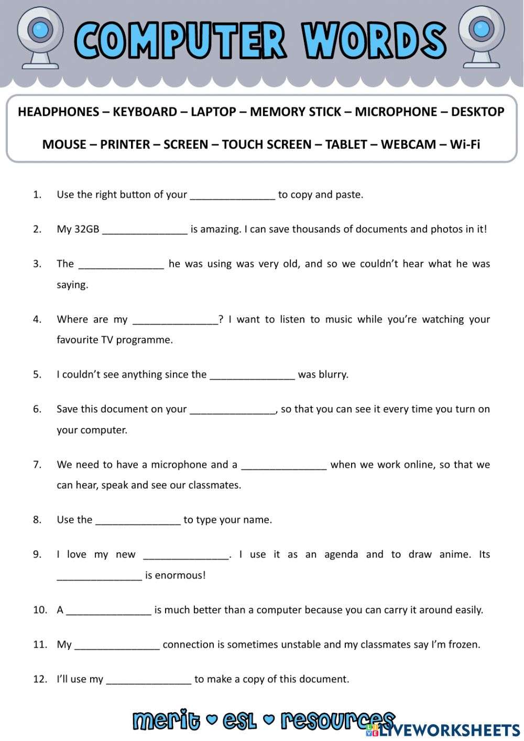

Answers :

1. Mouse
2. Memory stick
3. Microphone
4. Headphones
5. Screen
6. Desktop
7. Webcam
8. Keyboard
9. Tablet
10. Touch screen
11. Laptop
12. Printer